Team 24 Demo Day Proposal: LaneRoom
Nov 6, 2026 · The Gen Academy, Mastering Agentic AI · Bala Mallampati, Ravindranath Konduru (Ravi), Deepthi Avula and Neha Madhao Pande
LaneRoom is a team of AI agents that runs a shipper's freight tender committee in about 25 seconds. Give it a lane, such as "Dallas→Atlanta dry van, 500 weekly loads", and it reads the carriers' SEC 10-K filings and the shipper's lane scorecard, has a Cost advocate and a Resilience advocate argue how to split the loads, checks every claim against the page or scorecard row it cites, and hands a human a cited memo with a recommended allocation % per carrier. It is the logistics sibling of our DealRoom project: same agentic architecture, new documents, new agents and a new decision.

Submission summary
Form field | Answer
Team number | 24
Contributing members | Bala Mallampati, Ravindranath Konduru (Ravi), Deepthi Avula and Neha Madhao Pande
One-line pitch | A multi-agent tender committee: research carriers, debate cost against resilience, verify every claim and recommend a cited allocation % per carrier
GitHub link | https://github.com/balum211/LaneRoom
Live app | https://laneroom-team24.streamlit.app
Video demo | Google Drive link to a 2 to 3 minute screen recording (script in the Demo script section)
Track | LangChain + LangGraph multi-agent system

Data note. J.B. Hunt (JBHT), C.H. Robinson (CHRW) and Old Dominion (ODFL) figures come from their real FY2025 Form 10-K filings on SEC EDGAR and are cited by page. Armada is privately held and files nothing with the SEC, so its profile is synthetic demo data, labelled on every page and capped at 25% of any lane. Public filings never report a shipper's tender acceptance, on-time %, rate per mile or claims %, so the lane scorecard is synthetic for all four providers.

Problem and users
Shippers re-bid their lanes every year and re-allocate them every peak season. A procurement analyst has to weigh tender acceptance, on-time service, rate per mile and claims from the TMS against each carrier's capacity and financial health from its 10-K, then defend the split to operations and finance. Today that is a spreadsheet, several 100-page filings and a gut call. Plain chatbots fall short in three ways:
- No decision. They summarise carriers but do not produce an allocation that follows procurement rules.
- Unverifiable numbers. A rate or an operating ratio without a source cannot go into an award memo.
- One lens. Cheapest-rate thinking ignores peak-season capacity risk, and the reverse.

Primary users
User | Job to be done | What they get from LaneRoom
Transportation procurement analyst | Split a lane's weekly loads across carriers | A cited allocation with loads per week and the rules applied
Logistics or operations manager | Protect service in peak season | The Resilience case, Q4 acceptance and backup capacity
Finance or category lead | Understand the cost trade-off | The Cost case, rate per mile and carrier financial health

Solution overview
The user types one request. A guardrail checks it, a Planner works out the lane, the carriers and the load count, and the committee runs. Why this is agentic, not just RAG:
- Planning. The Planner splits the request into capacity and reliability, cost, financial health, service fit and risk sub-questions per provider.
- Tool use and MCP. Agents call a hybrid filing search, a table-reading metrics tool, a lane scorecard tool and a change calculator. The same tools are served by an MCP server.
- Multi-agent debate. Cost and Resilience advocates get the same evidence but opposite briefs, run in parallel, then rebut each other.
- Self-correction. A Verifier rejects claims whose quote is not on the cited page or scorecard row, or whose numbers are not in the source, and sends them back (max 2 loops).
- Decision. A Judge scores each carrier and allocates 100% of loads under tender rules: at most 60% per carrier, at least 10% backup share, an 80% acceptance floor and a 25% cap on synthetic-only evidence.
- Human in the loop and memory. LangGraph interrupt() pauses before anything is awarded. Long-term memory keeps the shipper's mandate (cost-first, balanced or service-first), preferred KPIs, incumbent and past awards, and the mandate changes the award.
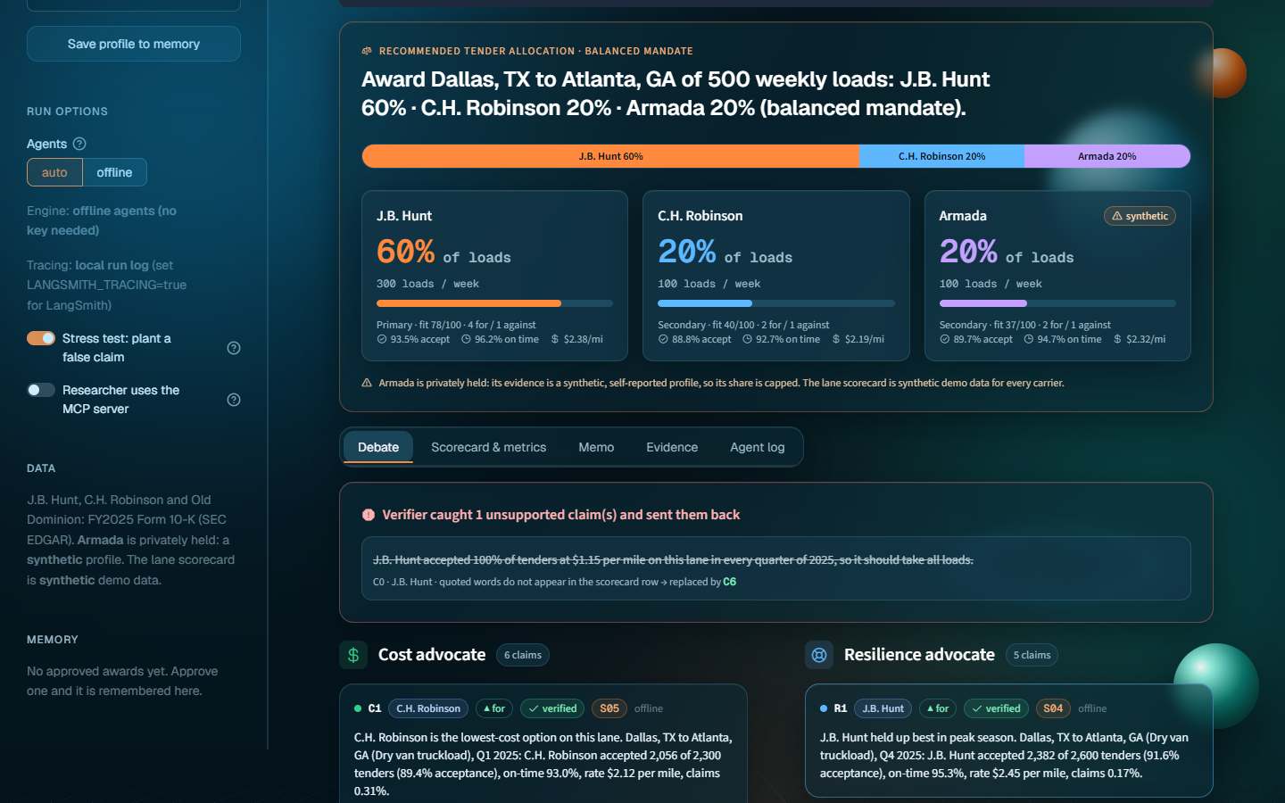
The committee's recommended allocation for Dallas→Atlanta: J.B. Hunt 60% (300 loads), C.H. Robinson 20%, Armada 20% (capped).

Agent design
Eight agents share one LangGraph state object: the request, the lane, the plan, an evidence list with citations (E# for 10-K pages, S## for scorecard rows), the metrics, both advocates' claims, the allocation and the memo.
Agent | Role | Tools
Guardrail | Blocks prompt injection, off-topic requests and carriers outside the knowledge base; flags stock questions and synthetic data | rules
Planner | Finds the lane, providers and weekly loads; writes sub-questions per provider | LLM or rules
Researcher | Hybrid search over the filings in parallel, re-searches weak results with a reformulated query, adds the lane's scorecard rows | search_filings (MCP), lane_scorecard
Quant | Revenue, operating income, net income, cash flow and operating ratio from the 10-K tables; acceptance, Q4 acceptance, on-time, rate per mile and claims per carrier | key_metrics, compute_change
Cost advocate | Argues for the lowest-cost split | LLM or extractive
Resilience advocate | Argues for service and capacity; files "against" points from risk factors | LLM or extractive
Verifier | Checks every claim against its page or row; sends failures back | rules + LLM judge
Judge | Mandate-weighted fit score and allocation % under tender rules | scoring
Writer | One-page cited memo; strips stock advice and adds a disclaimer | LLM or template

Data, retrieval and tech stack
Layer | Choice
Data | FY2025 Form 10-K for JBHT, CHRW and ODFL (EDGAR HTML printed to PDF to keep page numbers), a synthetic Armada profile, and a synthetic 48-row lane scorecard (4 lanes, 4 quarters of 2025)
Retrieval | 1,014 semantic chunks, Chroma (MiniLM ONNX) + BM25, Reciprocal Rank Fusion, local reranker, provider filters (reused from our Week 2 FilingSight project)
Orchestration | LangGraph: parallel fan-out, conditional retry loop, interrupt for human review, checkpointer
LLM | Any OpenAI-compatible model (Nebius Llama-3.3-70B by default, OpenAI or local Ollama); deterministic offline agents with no key
Tools | MCP server laneroom-carriers: search_filings, get_page, list_companies, lane_scorecard, key_metrics, compute_change
UI | Streamlit 3D glass theme with a freight-orange accent, deployed on Streamlit Community Cloud
Quality | 38 pytest tests, evaluation suite, GitHub Actions CI, per-agent token and cost tracking, JSONL run traces

Guardrails and evaluation
- Input: prompt injection, empty, oversized and off-topic requests and unknown carriers are refused; stock questions get a freight allocation instead of investment advice.
- Evidence and grounding: instruction-like lines in retrieved text are stripped; a claim that fails verification never reaches the memo.
- Output: stock buy/sell language removed, disclaimer always added, synthetic data labelled in the UI, memo and README.
- Cost and loops: at most 2 verification retries and 1 rebuttal round; tokens and cost tracked per agent.

Results (offline agents, no API key)
Metric | Result | Target
Citation faithfulness (verified claims in final memos) | 100% | ≥ 95%
Planted false claim caught by the Verifier | 100% | 100%
Valid allocations (sum to 100%, caps respected) | 100% | 100%
Mandate changes the award (cost-first vs service-first) | yes | yes
10-K figures read correctly by the Quant | 17/17 | all
Retrieval hit@5 / MRR (22 labelled questions) | 100% / 0.93 | ≥ 85% / 0.70
Guardrail decisions correct | 8/8 | all
Median time per memo (laptop CPU) | ~24 s | < 180 s

Against plain RAG (our Week 2 pipeline on the same corpus), LaneRoom produces an allocation in 100% of runs versus 0%, weighs both cost and service evidence in 100% versus 0%, and cites 9.5 sources per answer versus 4.7.

Demo script (about 3 minutes)
- Click Dallas→Atlanta 500 loads and Convene committee, with the stress test on.
- Narrate the pipeline: Planner, Researcher (hybrid search, MCP), Quant reading 10-K tables.
- Debate tab: Cost vs Resilience advocates, then the rejected planted claim and its replacement.
- Verdict: 60% J.B. Hunt, with the 60% concentration cap, the 10% backup floor and Armada's synthetic-data cap.
- Switch the mandate to service-first and run Peak surge: the award shifts toward Old Dominion.
- Agent log (tokens and cost), Approve allocation, Evaluation tab, Course map tab.

Team and roles
One owner per workstream; everyone reviews and rehearses the demo.
Team member | Owns
Bala Mallampati | LangGraph orchestration, the advocate and Judge agents, allocation rules, human review and memory
Ravindranath Konduru | EDGAR ingestion, chunking, hybrid retrieval, the lane scorecard and the MCP carrier server
Deepthi Avula | Streamlit UI, allocation and debate views, README, live app and the demo video
Neha Madhao Pande | Evaluation set, LLM judge, guardrails, synthetic-data labelling and the Demo Day slides

Risks and fallbacks
Risk | Fallback
LLM slow or rate limited on stage | Offline agents run the same graph with no key; a recorded run as backup
Judges ask whether the tender data is real | Every screen and the memo label the scorecard and Armada as synthetic; the 10-K figures are real and page-cited
Live app cold start | Open the Streamlit Cloud app once before the demo; run locally with run.bat as backup
Filing tables parse badly | Quant reads named table rows and is tested against the printed figures (17 of 17 match)

Future work: upload a real TMS scorecard instead of the synthetic one, live EDGAR fetch for any carrier ticker, more carriers (Knight-Swift, Werner, Saia), multi-lane network optimisation, and pushing approved awards back to the TMS.

