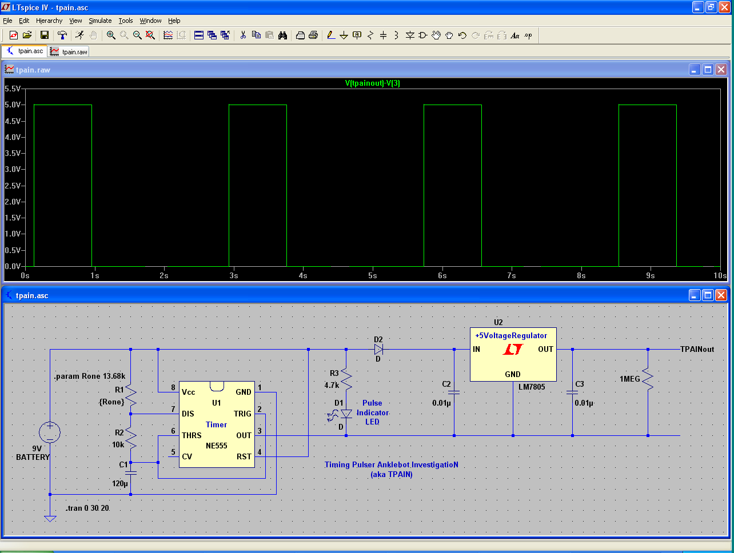

**PW = 1s**

**T = 2.8s**