[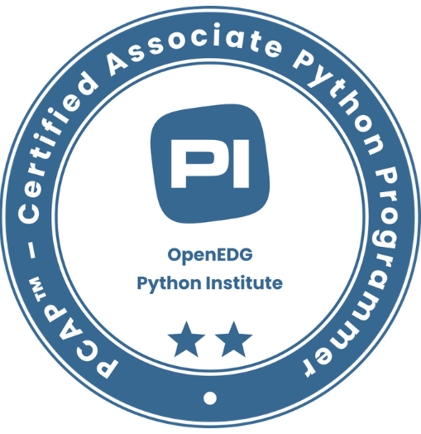](https://verify.openedg.org/?id=pyOA.vwau.F2Gi)[](https://www.credly.com/badges/be544407-0f0d-4b80-85b2-f268f58af58f/public_url)[](https://www.credly.com/badges/00510e36-b2fc-4395-9a8d-22e8020dba4f/public_url)

# SUMMARY

Data Scientist with three years of experience in Artificial Intelligence, Data Science, Machine Learning, Natural Language Processing. Proficient in statistical modeling, time series forecasting, and developing GenAI solutions to address complex business challenges.

# EXPERIENCE

# BMW Financial Services NA, LLC – Columbus, OH, USA September 2024 – Present

***Data Scientist Intern****[Python, GenAI, Amazon Bedrock, Langchain, LangGraph, Docker, OpenAI, Tableau, SQL Server]*

* Employed adaptive Retrieval-Augmented Generation (**RAG**) on AWS Cloud for the GenAI Titles use case, achieving **95%** model accuracy and reducing call handling time by **30%**.
* Pioneered **three** GenAI use cases on BMW's AI Platform as the first adopter, each containing more than **800** policy and financial documents, leveraging fine-tuning (DPO, RLHF and LORA) and developing scalable training architectures to drive BMW employee adoption.
* Worked on Agent Orchestration, utilizing tools to integrate multiple IT applications, including Jira and Confluence.
* Created dashboard analytics for customer support utilization of AI App, improving operational efficiency by **25%** while ensuring data quality, CI/CD and governance using LLMOps for the industrialization of the end-to-end GenAI application.

# Tata Consultancy Services Ltd – Hyderabad, India October 2021 – September 2023

***Data Scientist*** *[Python, Machine Learning, Data Science, Statistics, Matplotlib, Scikit-Learn, Statsmodels, Plotly, TensorFlow, OpenCV]*

* Developed an end-to-end machine learning pipeline utilizing advanced deep learning and time-series analysis techniques to assess gearbox health from sensor data with a sampling rate of **3000**.
* Built a predictive forecasting model leveraging Auto_Arima, TimeGPT, and Temporal Fusion Transformers, enabling **82%** accurate prediction of future plant stoppages based on historical data.
* Achieved over **85%** accuracy in particle size analysis for cone crushers using a novel computer vision system with a modified DexiNed network. This system leverages edge detection, contour refinement, and mass estimation techniques.

# Cognizant - Hyderabad, India March 2021 – July 2021

***Programmer Analyst Intern*** *[Python, Apache Spark, SQL, Tableau, Hadoop, HDFS, Pytorch, DevOps]*

* Implemented ETL processes with SSIS, formulated SQL transactional queries, optimizing data processing and reducing query time by **30%**.
* Merged Apache Spark with Hadoop for efficient large-scale data processing, generating client-facing reports using Tableau, improving data-driven decision-making by **20%**.

# SKILLS

* **Programming**: Python, SQL, C++, C, Java, R
* **Frameworks:** TensorFlow, PyTorch, Scikit-learn, Hugging Face, LangChain, Llamaindex, FAISS, OpenAI, LangGraph, LangSmith, FastAPI, LangFlow, Streamlit, Flask, ChromaDB, Pydantic, AutoGPT
* **Tools:** Jupyter Notebook, GitHub, Docker, Kubernetes, Tableau, Power BI, MLflow, Data Version Control, Microsoft Excel, GitHub Actions
* **Databases & Cloud:** MySQL, MongoDB, Azure (OpenAI Platform, Document Intelligence, EC2, Machine Learning), AWS (S3, Lambda, EC2, VPC, CloudFront, SageMaker, API Gateway, Bedrock)

# EDUCATION

**University of Cincinnati,** Master of Engineering in Computer Science **CGPA**:3.62 | August 2023 – Present

*Coursework: Cloud Computing, Advanced Machine Learning, Artificial Intelligence, Deep Learning*

**VNR Vignana Jyothi Institute of Technology**, BTech in Electronics and Communication Engineering **CGPA**:3.64 | August 2017 – May 2021

*Coursework: Artificial Neural Networks and Fuzzy Logic, Data Structures, DBMS, Web Development*

# PROJECTS

**AI Multi-Agent RAG Based Chatbot***[LangGraph, Pydantic, RAG, FAISS, Llama, Tools, Docker, Hugging Face, FastAPI, Uvicorn, PostgreSQL]*

* Engineered an advanced question-answering chatbot using LangGraph, LangChain, and RAG with researcher, supervisor, prompt enhancer, and validator nodes, improving accuracy by **35%**.
* Integrated chunking, embedding, and similarity search pipeline with FAISS, enabling seamless information extraction from PDFs, Docx, Txt files, and websites, reducing manual effort by **40%**.
* Optimized PostgreSQL query management and Dockerized the solution, improving performance.

**AI-Powered Multimodal Assistant** *[Python, Hugging Face, DALL-E, Whisper, LangChain, FastAPI, Docker, Hugging Face Spaces]*

* Innovated a multimodal assistant generating images from text, converting text to speech, and responding in both text and voice using DALL-E 2 and Whisper.
* Deployed the solution on Hugging Face Spaces with a FastAPI backend, optimizing performance and enabling seamless interactions, improving user engagement by **50%.**

**Fake News Classification Using LSTM** *[ Python, TensorFlow, Keras, NLTK, Scikit-learn, Seaborn, Pandas, NumPy, LSTM, Pytorch]*

* Preprocessed data by removing stop words, performing lemmatization, and conducting n-gram analysis, improving data quality by **30%**.
* Attained **92%** classification accuracy in detecting fake news by implementing an LSTM model with one-hot encoding and pre-padding.

**Detection Of Alzheimer’s Disease** *[Flask, Random Forest, Gradient Boosting, LightGBM, Logistic Regression, Decision Tree]*

* Prepared data and applied machine learning models (Random Forest, Gradient Boosting, Adaptive Boosting, Logistic Regression, Decision Tree), achieving **92%** precision and **89%** recall with RandomizedSearchCV hyperparameter tuning.
* Crafted an interactive website with the machine learning model via the Flask framework, enhancing user engagement.