Experiment 2.Character Stuffing (Java)
import java.util.*;
class Main {
public static void main(String[] args) {
Scanner sc = new Scanner(System.in);
System.out.print("Enter data: ");
String s = sc.nextLine(), r = "F";
for (char c : s.toCharArray()) {
if (c == 'F' || c == 'E') r += "E";
r += c;
}
System.out.println("Framed data: " + r + "F");
}
}
OUTPUT
Enter data: AFB
Framed data: FAEFBF

Bit Stuffing (Java)
import java.util.*;
class Main {
public static void main(String[] args) {
Scanner sc = new Scanner(System.in);
System.out.print("Enter bits: ");
String s = sc.next(), r = "";
int n = 0;
for (char c : s.toCharArray()) {
r += c;
if (c == '1') {
if (++n == 5) { r += "0"; n = 0; }
} else n = 0;
}
System.out.println("Flag: 01111110");
System.out.println("Stuffed bits: 01111110" + r + "01111110");
}
}
Output:
Enter bits: 111110
Flag: 01111110
Stuffed bits: 01111110111110001111110

2. Character Stuffing — C Program
#include <stdio.h>
#include <string.h>
int main() {
char s[100];
printf("Enter data: ");
scanf("%s", s);
printf("Framed data: F");
for (int i=0; s[i]; i++) {
if (s[i]=='F' || s[i]=='E') printf("E");
printf("%c", s[i]);
}
printf("F\n");
return 0;
}
Output:
Enter data: AFB
Framed data: FAEFBF

2. Bit Stuffing — C Program
#include <stdio.h>
int main() {
char s[100];
int n=0;
printf("Enter bits: ");
scanf("%s", s);
printf("Stuffed bits: 01111110");
for (int i=0; s[i]; i++) {
printf("%c", s[i]);
if (s[i]=='1') {
if (++n==5) { printf("0"); n=0; }
} else n=0;
}
printf("01111110\n");
return 0;
}
Output:
Enter bits: 111110
Stuffed bits: 01111110111110001111110

Experiment 3: Checksum

1. C Program

#include <stdio.h>
#include <stdlib.h>

int main() {
int n, i, sum = 0, a[10], c;
char b[10];

printf("Enter number of data words: ");
scanf("%d", &n);
printf("Enter 4-bit data words:\n");

for (i = 0; i < n; i++) {
scanf("%s", b);
a[i] = strtol(b, NULL, 2);
sum += a[i];
}

while (sum > 15) sum = (sum & 15) + (sum >> 4);
c = 15 - sum;

printf("Checksum = ");
for (i = 3; i >= 0; i--) printf("%d", (c >> i) & 1);

sum = c;
for (i = 0; i < n; i++) sum += a[i];
while (sum > 15) sum = (sum & 15) + (sum >> 4);

printf("\nReceiver: %s\n", sum == 15 ? "No Error" : "Error Detected");
return 0;
}
Output:
Enter number of data words: 2
Enter 4-bit data words:
1001
0101
Checksum = 0001
Receiver: No Error

2. Java Program

import java.util.*;

class Main {
public static void main(String[] args) {
Scanner sc = new Scanner(System.in);
System.out.print("Enter number of data words: ");
int n = sc.nextInt(), a[] = new int[n], sum = 0;

System.out.println("Enter 4-bit data words:");
for (int i = 0; i < n; i++) {
a[i] = Integer.parseInt(sc.next(), 2);
sum += a[i];
}

while (sum > 15) sum = (sum & 15) + (sum >> 4);
int c = 15 - sum;
System.out.printf("Checksum = %4s\n",
Integer.toBinaryString(c).replace(' ', '0'));

sum = c;
for (int x : a) sum += x;
while (sum > 15) sum = (sum & 15) + (sum >> 4);

System.out.println("Receiver: " +
(sum == 15 ? "No Error" : "Error Detected"));
}
}
Output:
Enter number of data words: 2
Enter 4-bit data words:
1001
0101
Checksum = 0001
Receiver: No Error

Experiment 4. C Program

#include <stdio.h>

int main() {
int c[8] = {0}, r[8], i, p1, p2, p4, error;
char data[5], received[8];

printf("Enter 4-bit data: ");
scanf("%4s", data);

c[3] = data[0] - '0';
c[5] = data[1] - '0';
c[6] = data[2] - '0';
c[7] = data[3] - '0';

c[1] = c[3] ^ c[5] ^ c[7];
c[2] = c[3] ^ c[6] ^ c[7];
c[4] = c[5] ^ c[6] ^ c[7];

printf("Hamming Code: ");
for (i = 1; i <= 7; i++) printf("%d", c[i]);

printf("\nEnter received 7-bit code: ");
scanf("%7s", received);
for (i = 1; i <= 7; i++) r[i] = received[i-1] - '0';

p1 = r[1] ^ r[3] ^ r[5] ^ r[7];
p2 = r[2] ^ r[3] ^ r[6] ^ r[7];
p4 = r[4] ^ r[5] ^ r[6] ^ r[7];

error = p1 + 2 * p2 + 4 * p4;

if (error == 0)
printf("No Error Detected\n");
else {
printf("Error at position: %d\n", error);
r[error] ^= 1;
printf("Corrected Code: ");
for (i = 1; i <= 7; i++) printf("%d", r[i]);
printf("\n");
}

return 0;
}

Java Program

import java.util.*;

class Main {
public static void main(String[] args) {
Scanner sc = new Scanner(System.in);
int[] c = new int[8], r = new int[8];

System.out.print("Enter 4-bit data: ");
String data = sc.next();

c[3] = data.charAt(0) - '0';
c[5] = data.charAt(1) - '0';
c[6] = data.charAt(2) - '0';
c[7] = data.charAt(3) - '0';

c[1] = c[3] ^ c[5] ^ c[7];
c[2] = c[3] ^ c[6] ^ c[7];
c[4] = c[5] ^ c[6] ^ c[7];

System.out.print("Hamming Code: ");
for (int i = 1; i <= 7; i++)
System.out.print(c[i]);

System.out.print("\nEnter received 7-bit code: ");
String received = sc.next();

for (int i = 1; i <= 7; i++)
r[i] = received.charAt(i - 1) - '0';

int p1 = r[1] ^ r[3] ^ r[5] ^ r[7];
int p2 = r[2] ^ r[3] ^ r[6] ^ r[7];
int p4 = r[4] ^ r[5] ^ r[6] ^ r[7];

int error = p1 + 2 * p2 + 4 * p4;

if (error == 0)
System.out.println("\nNo Error Detected");
else {
System.out.println("\nError at position: " + error);
r[error] ^= 1;
System.out.print("Corrected Code: ");
for (int i = 1; i <= 7; i++)
System.out.print(r[i]);
System.out.println();
}
}
}

Sample Output
Enter 4-bit data: 1011
Hamming Code: 0110011
Enter received 7-bit code: 0110001
Error at position: 6
Corrected Code: 0110011

Experiment 5. C Program

#include <stdio.h>
#include <string.h>

int main() {
char data[100];
int crc12 = 0, crc16 = 0, ccitt = 0;
int i;

printf("Enter character data: ");
scanf("%99s", data);

for (i = 0; data[i] != '\0'; i++) {
crc12 = (crc12 + data[i]) % 4096;
crc16 = (crc16 + data[i]) % 65536;
ccitt = (ccitt + data[i]) % 65536;
}

printf("CRC-12: %03X\n", crc12);
printf("CRC-16: %04X\n", crc16);
printf("CRC-CCITT: %04X\n", ccitt);

return 0;
}

Java Program

import java.util.*;

class Main {
public static void main(String[] args) {
Scanner sc = new Scanner(System.in);

System.out.print("Enter character data: ");
String data = sc.next();

int crc12 = 0, crc16 = 0, ccitt = 0;

for (int i = 0; i < data.length(); i++) {
crc12 = (crc12 + data.charAt(i)) % 4096;
crc16 = (crc16 + data.charAt(i)) % 65536;
ccitt = (ccitt + data.charAt(i)) % 65536;
}

System.out.printf("CRC-12: %03X%n", crc12);
System.out.printf("CRC-16: %04X%n", crc16);
System.out.printf("CRC-CCITT: %04X%n", ccitt);
}
}
OUTPUT
Enter character data: 123456789
CRC-12 : F5B
CRC-16 : FEE8
CRC-CCITT : 31C3

Experiment 6.C Program — Go-Back-N

#include <stdio.h>

int main() {
int n, w, i, lost;

printf("Enter frames and window size: ");
scanf("%d%d", &n, &w);
printf("Enter lost frame (0 for none): ");
scanf("%d", &lost);

for (i = 1; i <= n; i++) {
printf("Sending frame %d\n", i);

if (i == lost) {
printf("Retransmitting frame %d\n", i);
lost = 0;
}
}

printf("All frames sent successfully\n");
return 0;
}

Output

Enter frames and window size: 5 3
Enter lost frame (0 for none): 2
Sending frame 1
Sending frame 2
Retransmitting frame 2
Sending frame 3
Sending frame 4
Sending frame 5
All frames sent successfully

Java Program

import java.util.*;

class Main {
public static void main(String[] args) {
Scanner sc = new Scanner(System.in);

System.out.print("Enter number of frames: ");
int n = sc.nextInt();
System.out.print("Enter window size: ");
int w = sc.nextInt();
System.out.print("Enter lost frame (0 for none): ");
int lost = sc.nextInt();

int i = 1;
while (i <= n) {
int end = Math.min(i + w - 1, n);
boolean error = lost >= i && lost <= end;

for (int j = i; j <= end; j++)
System.out.println("Sending frame " + j);

if (error) {
for (int j = lost; j <= end; j++)
System.out.println("Retransmitting frame " + j);
lost = 0;
}

for (int j = i; j <= end; j++)
System.out.println("ACK received for frame " + j);

i = end + 1;
}

System.out.println("Transmission completed");
sc.close();
}
}

Sample Output
Enter number of frames: 5
Enter window size: 3
Enter lost frame (0 for none): 2
Sending frame 1
Sending frame 2
Sending frame 3
Retransmitting frame 2
Retransmitting frame 3
ACK received for frame 1
ACK received for frame 2
ACK received for frame 3
Sending frame 4
Sending frame 5
ACK received for frame 4
ACK received for frame 5
Transmission completed

Experiment-7:

import java.util.*;
class c{
public static void main(String[] args) {
Scanner sc = new Scanner(System.in);
System.out.print("Enter number of frames: ");
int n = sc.nextInt();
System.out.print("Enter window size: ");
int w = sc.nextInt();
int i = 1;
while (i <= n) {
int end = Math.min(i + w - 1, n);
for (int j = i; j <= end; j++)
System.out.println("Sending frame " + j);
System.out.print("Enter lost frame number (0 for none): ");
int lost = sc.nextInt();
for (int j = i; j <= end; j++) {
if (j == lost)
System.out.println("Retransmitting frame " + j);
else
System.out.println("Acknowledgment received for frame " + j);
}
i = end + 1;
}
sc.close();
}
}
Output:
out:
C:\Users\vtaga>javac c.java
C:\Users\vtaga>java c
Enter number of frames: 4
Enter window size: 4
Sending frame 1
Sending frame 2
Sending frame 3
Sending frame 4
Enter lost frame number (0 for none): 1
Retransmitting frame 1
Acknowledgment received for frame 2
Acknowledgment received for frame 3
Acknowledgment received for frame 4

Experiment-8:
import java.util.*;
class c {
public static void main(String[] args) {
Scanner sc = new Scanner(System.in);
System.out.print("Enter number of frames: ");
int n = sc.nextInt();
for (int i = 1; i <= n; i++) {
System.out.println("Sending frame " + i);
System.out.print("Is frame " + i + " lost? (1=yes, 0=no): ");
int lost = sc.nextInt();
while (lost == 1) {
System.out.println("Frame " + i + " lost");
System.out.println("Retransmitting frame " + i);
System.out.print("Is frame " + i + " lost again? (1=yes, 0=no): ");
lost = sc.nextInt();
}
System.out.println("Waiting for acknowledgment");
System.out.println("Acknowledgment received for frame " + i);
}
sc.close();
}
}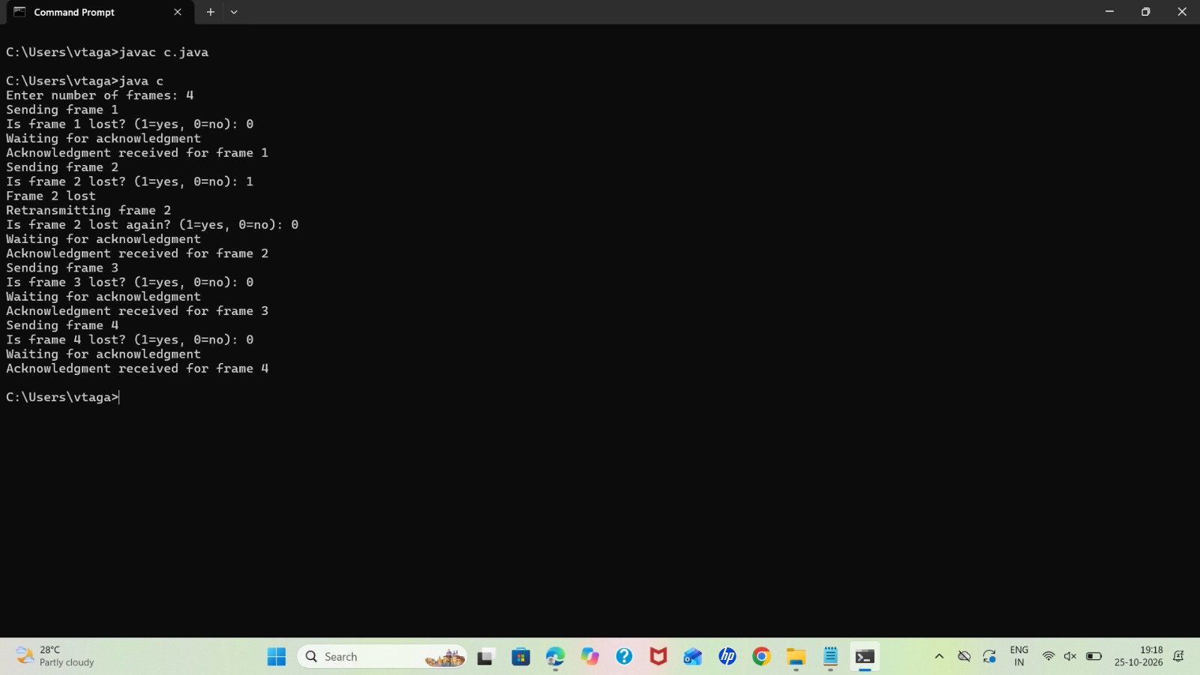

Experiment-9:

import java.util.*;
class c {
public static void main(String[] args) {
Scanner sc = new Scanner(System.in);
System.out.print("Enter bucket capacity: ");
int cap = sc.nextInt();
System.out.print("Enter output rate: ");
int rate = sc.nextInt();
System.out.print("Enter number of packets: ");
int n = sc.nextInt();
int bucket = 0;
for (int i = 1; i <= n; i++) {
System.out.print("Enter packet size: ");
int packet = sc.nextInt();
if (bucket + packet <= cap) {
bucket += packet;
System.out.println("Packet accepted");
} else {
System.out.println("Packet dropped");
}
int sent = Math.min(bucket, rate);
bucket -= sent;
System.out.println("Sent: " + sent);
System.out.println("Remaining: " + bucket);
}
sc.close();
}
}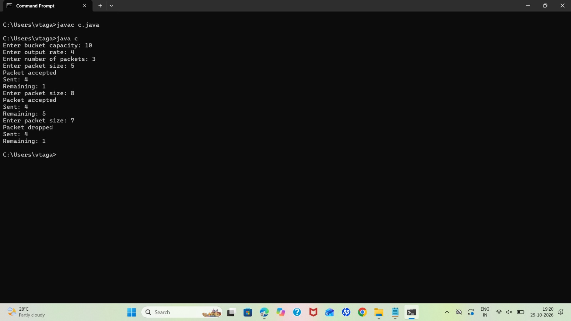

Experiment-10:

import java.util.*;

class c{
public static void main(String[] args) {
Scanner sc = new Scanner(System.in);

System.out.print("Enter number of vertices: ");
int n = sc.nextInt();

int[][] a = new int[n][n];

System.out.println("Enter adjacency matrix:");
for (int i = 0; i < n; i++)
for (int j = 0; j < n; j++)
a[i][j] = sc.nextInt();

System.out.print("Enter source vertex (0 to " + (n - 1) + "): ");
int src = sc.nextInt();

int[] d = new int[n];
boolean[] visited = new boolean[n];

Arrays.fill(d, Integer.MAX_VALUE);
d[src] = 0;

for (int i = 0; i < n; i++) {
int u = -1;

for (int j = 0; j < n; j++)
if (!visited[j] &&
(u == -1 || d[j] < d[u]))
u = j;

if (u == -1 || d[u] == Integer.MAX_VALUE)
break;

visited[u] = true;

for (int v = 0; v < n; v++)
if (a[u][v] > 0 && !visited[v] &&
d[u] + a[u][v] < d[v])
d[v] = d[u] + a[u][v];
}

System.out.println("Vertex\tDistance");
for (int i = 0; i < n; i++)
System.out.println(i + "\t" +
(d[i] == Integer.MAX_VALUE ? "INF" : d[i]));

sc.close();
}
}
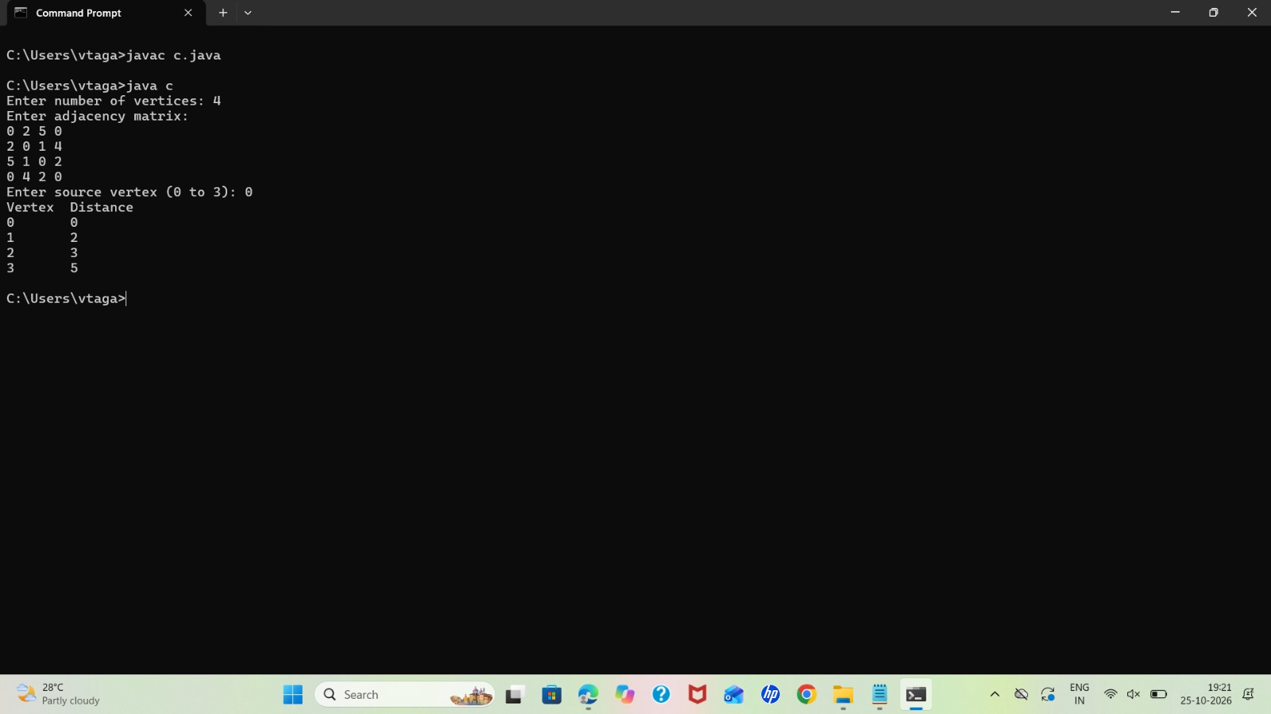Experiment-11:
import java.util.*;

class c {
public static void main(String[] args) {
Scanner sc = new Scanner(System.in);

System.out.print("Enter number of nodes: ");
int n = sc.nextInt();

int[][] d = new int[n][n];
int[][] next = new int[n][n];

System.out.println("Enter cost matrix (999 for no link):");

for (int i = 0; i < n; i++)
for (int j = 0; j < n; j++) {
d[i][j] = sc.nextInt();
next[i][j] = j;
}

for (int k = 0; k < n; k++)
for (int i = 0; i < n; i++)
for (int j = 0; j < n; j++)
if (d[i][k] != 999 && d[k][j] != 999 &&
d[i][k] + d[k][j] < d[i][j]) {
d[i][j] = d[i][k] + d[k][j];
next[i][j] = next[i][k];
}

for (int i = 0; i < n; i++) {
System.out.println("\nRouting table for node " + i);
System.out.println("Destination\tNext Hop\tCost");

for (int j = 0; j < n; j++)
System.out.println(j + "\t\t" +
(d[i][j] == 999 ? "-" : next[i][j]) +
"\t\t" + d[i][j]);
}

sc.close();
}
}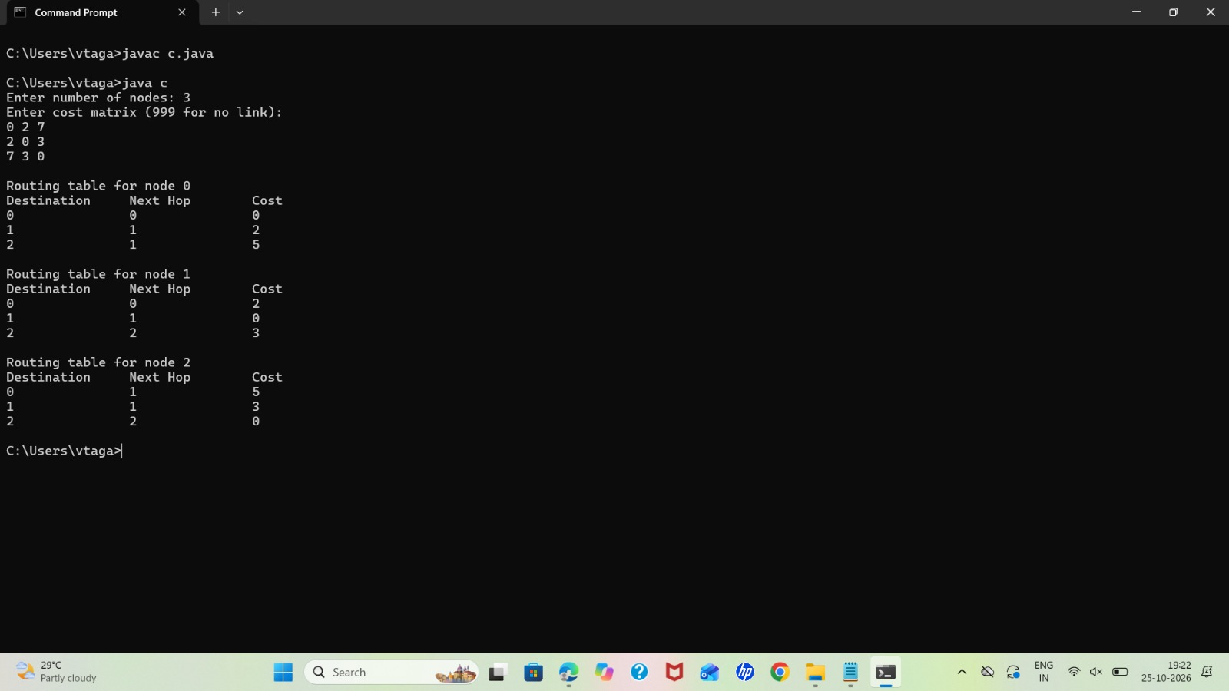
Experiment-12:

import java.util.*;

class c{
public static void main(String[] args) {
Scanner sc = new Scanner(System.in);

System.out.print("Enter number of hosts: ");
int n = sc.nextInt();

int[][] a = new int[n][n];

System.out.println("Enter adjacency matrix:");
for (int i = 0; i < n; i++)
for (int j = 0; j < n; j++)
a[i][j] = sc.nextInt();

System.out.print("Enter source host: ");
int src = sc.nextInt();

boolean[] visited = new boolean[n];
Queue<Integer> q = new LinkedList<>();

visited[src] = true;
q.add(src);

System.out.println("Broadcast Tree Edges:");

while (!q.isEmpty()) {
int u = q.poll();

for (int v = 0; v < n; v++) {
if (a[u][v] == 1 && !visited[v]) {
visited[v] = true;
q.add(v);
System.out.println(u + " -> " + v);
}
}
}

sc.close();
}
}

