**R O M Â N I A**

**MINISTERUL APĂRĂRII NAŢIONALE**

Academia Tehnică Militară ”Ferdinand I”



**PROJECT**

**la disciplina APLICAȚII CU BAZE DE DATE**

**Topic: System For Booking Train Tickets**

**Group C113B**

**Jipianu Toraș Mihnea**

**Băluți Ilie Cristian**

**- BUCUREŞTI -**

**2022**

**Requirements:**

Customers can search in the application to make reservations for local trains and to obtain online booking receipts. Customers can export receipts in PDF format.

The application includes two accounts, one for the administrator and the other being a user account. Using the Admin account, the Administrator can view all the tickets reserved by a user. During the use of the application, users must complete a ticket reservation form to make a reservation.

Additionally, they can view their history (once the history is saved, the user cannot make modifications to it).

**Introduction:**

This WPF application written in C# manages trains and tickets. Users can plan a trip by selecting the departure and arrival station, date, and receive a card verification form for payment.

The ticket is then sent via email that the user entered during registration or login. Users can also view all the trains and search for a specific train. New users can register and have the option to select whether they are senior citizens or students.

Administrators can verify accounts claiming to be senior citizens or students and can view all the reserved tickets.

**Features**:

* Trip planning: Users can plan a trip by selecting the departure and arrival station, date, and train.
* Ticket verification: Users receive a card verification form for payment when they plan a trip.
* Email ticket: The ticket is sent via email that the user entered during registration or login.
* Viewing all trains: Users can view all available trains.
* Search for a specific train: Users can search for a specific train by number.
* Registration: New users can register and have the option to select whether they are senior citizens or students.
* Account verification: Administrators can verify accounts claiming to be senior citizens or students.
* Viewing reserved tickets: Administrators can view all reserved tickets.

**User interface:**

Login: Users are greeted by a window where they can enter their credentials to connect to their accounts.

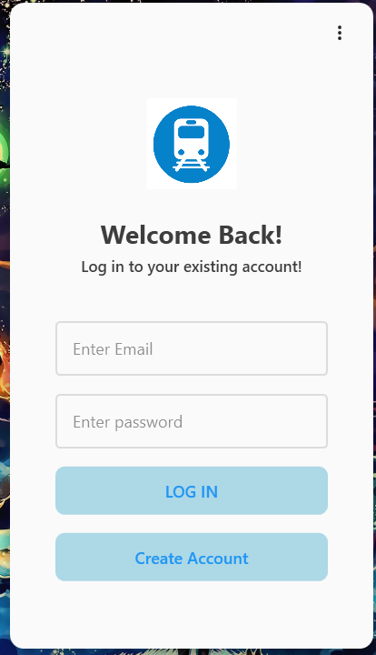

Registration: New users can register through a button (Create Account) or menu option from the main interface. The registration form includes fields for email, password, and options to select whether they are adults or students.

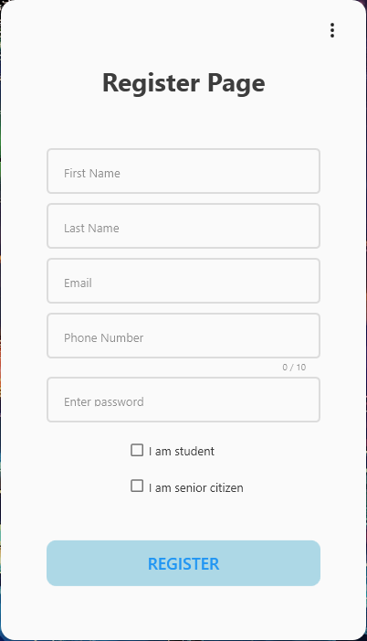

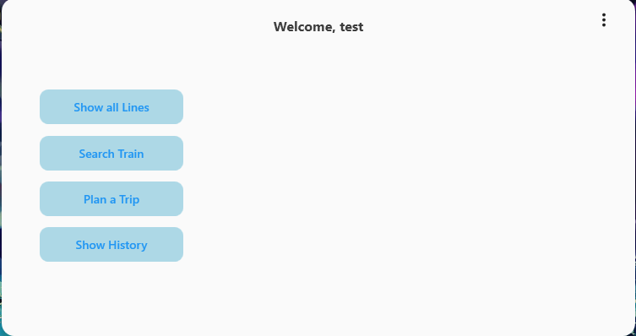After registration (in case the user did not have an account), they can log in by pressing the "Log In" button. Upon logging in, the user is sent to the main page of the application.

Trip Planning: Users can access the trip planning feature through a menu button on the main interface ("Plan a Trip").

The form for planning a trip includes fields for departure and arrival station, date, train, and a button to submit the information ("Book"). Available trains are automatically updated based on the information entered in a grid.

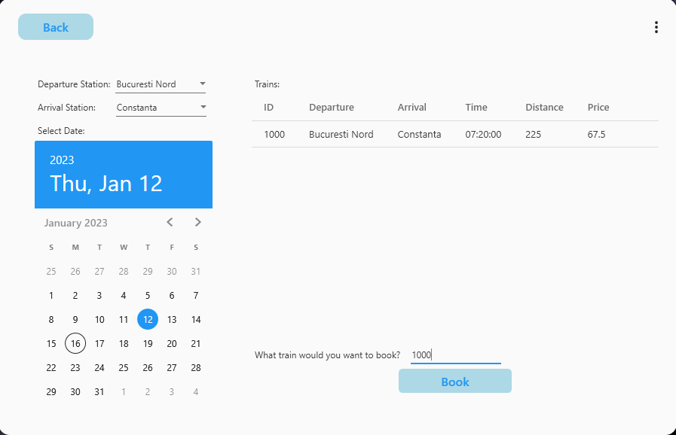

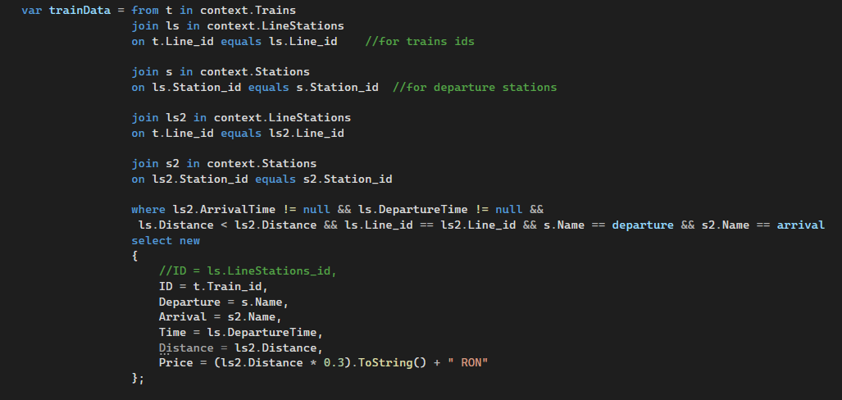The code that selects trains based on comboBoxes:

Ticket Verification: After planning a trip, users are directed to a debit card verificationwindow where they can make payment. (There is also a bypass option.) 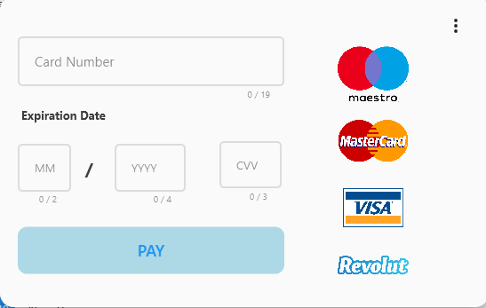

The code that verifies the validity of the card number is:

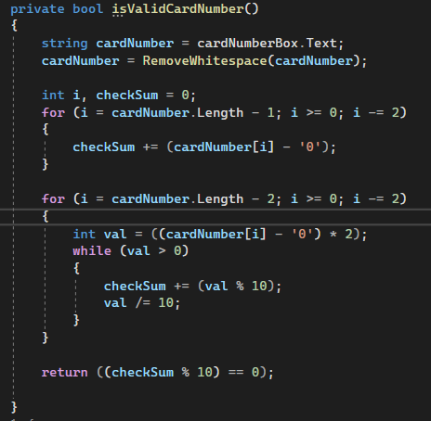

Ticket: After verification, the ticket is sent to the email address that the user provided during registration or login. The ticket contains the departure and arrival information, departure time, arrival time, train number, car number, and seat location.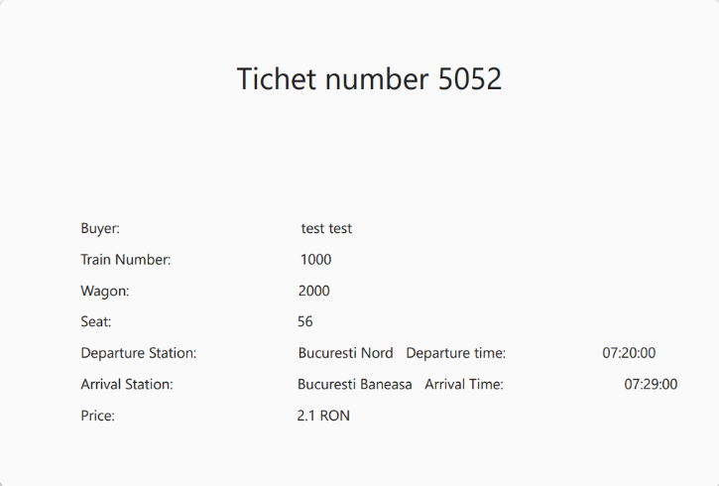

View All Trains: Users can view all available trains through a button or menu option in the main interface.

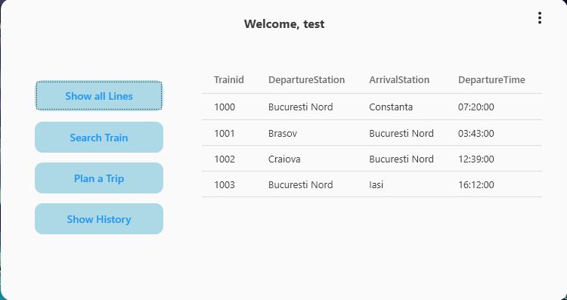

Search for a Specific Train: Users can search for a specific train by its number or name through a search bar in the main interface.

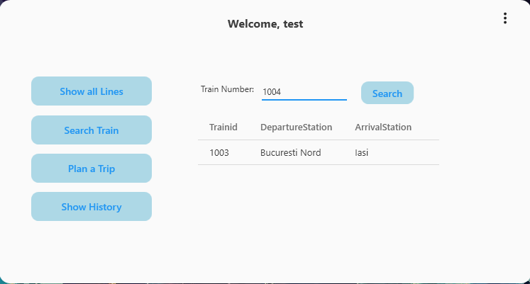

Administrators can access their dedicated menu by clicking on the "Admin Portal" button visible only to them.

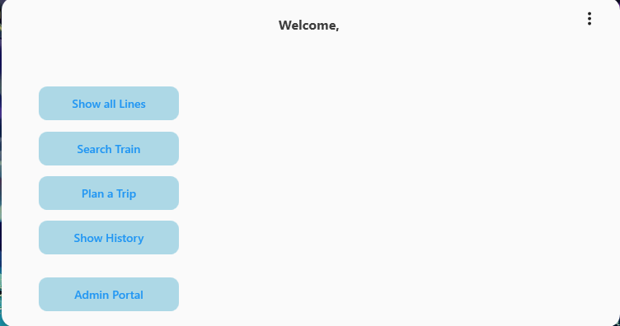

Account Verification: Administrators can verify accounts through a button or menu option in the main interface.

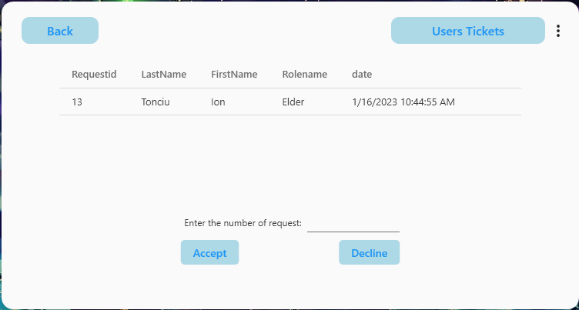

View Reserved Tickets: Administrators can view all reserved tickets through a button in the interface labeled "Users Tickets."

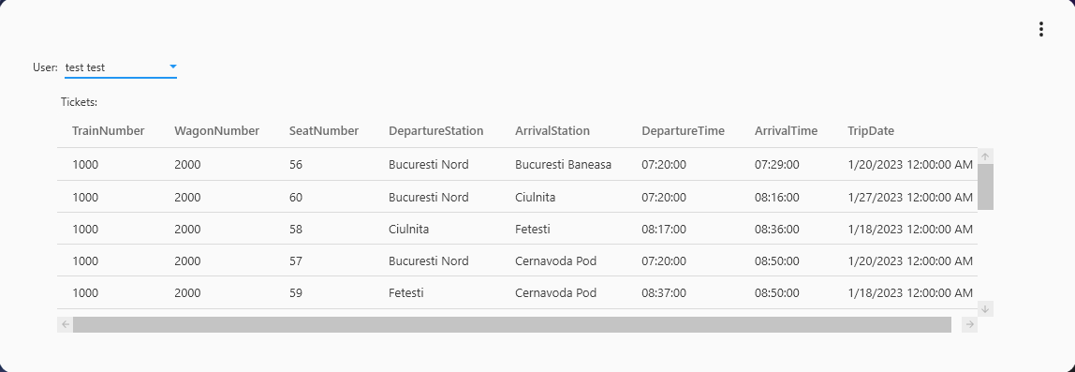

Entity Framework was used to develop the project.

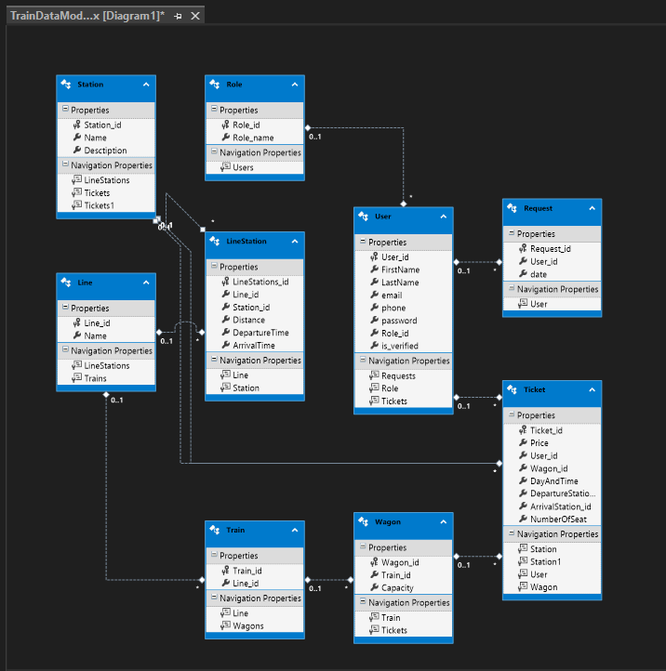

Packages used for the project:

* **EntityFramework** – used to connect and interact with the database.
* **MaterialDesignThemes + MaterialDesignColors** – used for creating the graphical interface.
* **iTextSharp + kenjiuno**.**PdfSharp.Xps + Syncfusion.Pdf.Wpf –** used for creating the PDF ticket.
* **MimeKit** – used for creating the email message, which includes the attached PDF ticket.
* **Nlog.MailKit –** used for sending the email.

**Conclusion:**

This WPF Train Scheduler application written in C# provides users with an easy and convenient way to plan and reserve train trips, while the administrator can manage user accounts. The application offers a wide range of features, including trip planning, ticket checking, email tickets, viewing all trains, searching for specific trains, registration, account checking, and viewing all reserved tickets. The user-friendly interface facilitates navigation and access to all functions from the menu on the main interface.