Linux Commands Assignment

1. Creating and Renaming Files/Directories
Commands:
mkdir test_dir
cd test_dir
touch example.txt
mv example.txt renamed_example.txt
Explanation:
mkdir creates a directory.
cd is used to enter the directory.
touch creates an empty file.
mv renames or moves a file.
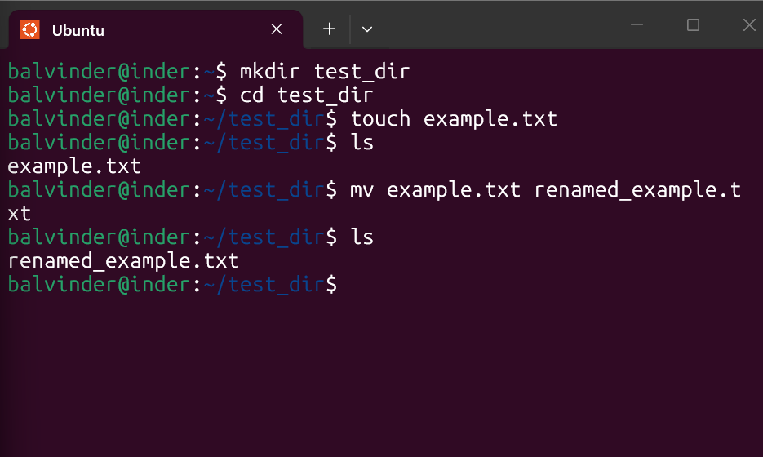

2. Viewing File Contents
Commands:
cat /etc/passwd
head -n 5 /etc/passwd
tail -n 5 /etc/passwd
Explanation:
cat displays full file content.
head shows first 5 lines.
tail shows last 5 lines.
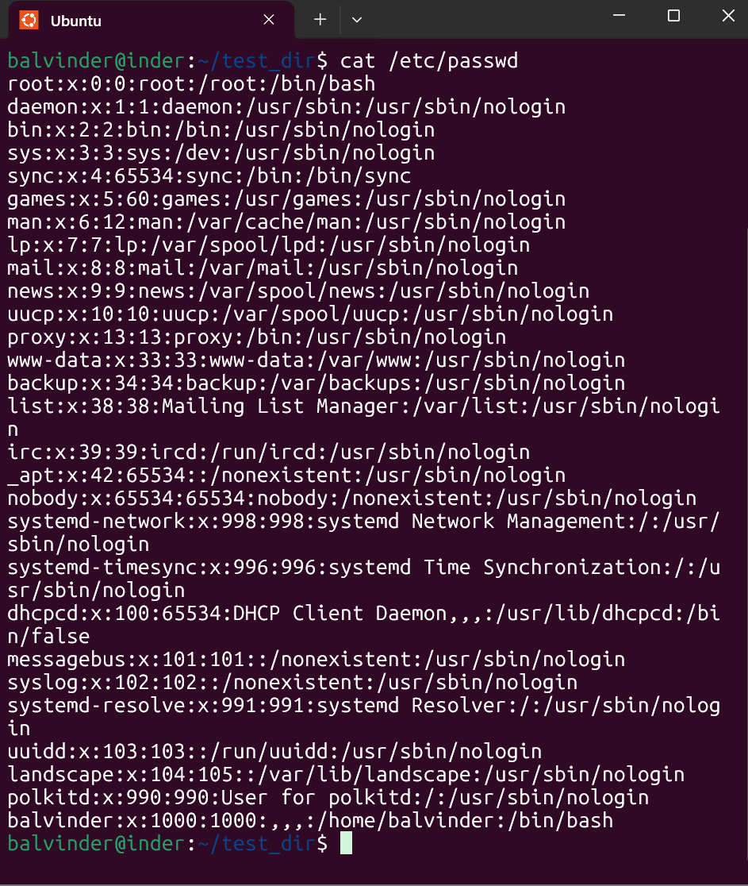
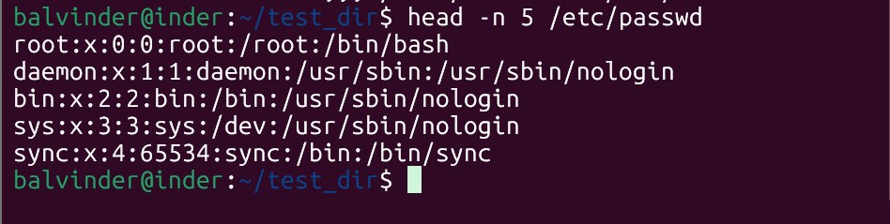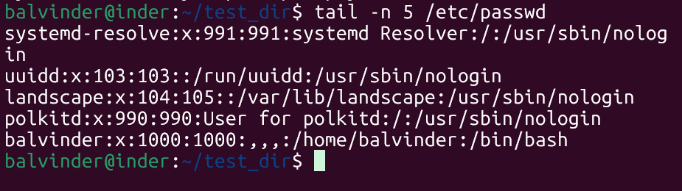

3. Searching for Patterns
Commands:
grep "root" /etc/passwd
Explanation:
grep searches for specific text patterns inside a file.
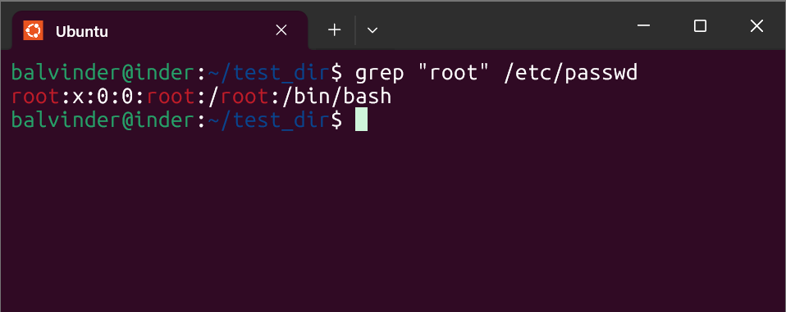

4. Zipping and Unzipping
Commands:
zip -r test_dir.zip test_dir
unzip test_dir.zip -d unzipped_dir
Explanation:
zip compresses files and directories.
unzip extracts compressed files.
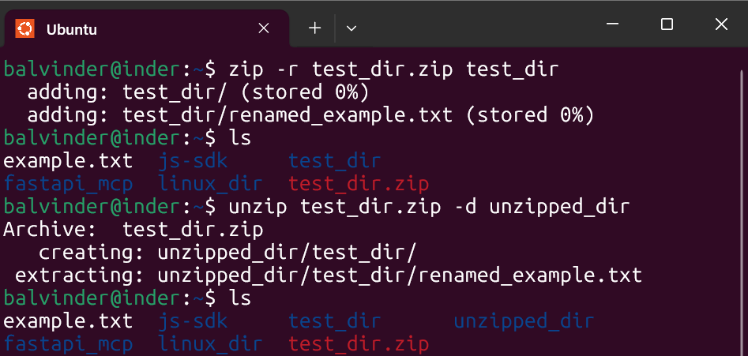

5. Downloading Files
Commands:
wget https://www.learningcontainer.com/wp-content/uploads/2020/04/sample-text-file.txt
Explanation:
wget downloads files from the internet using a URL.
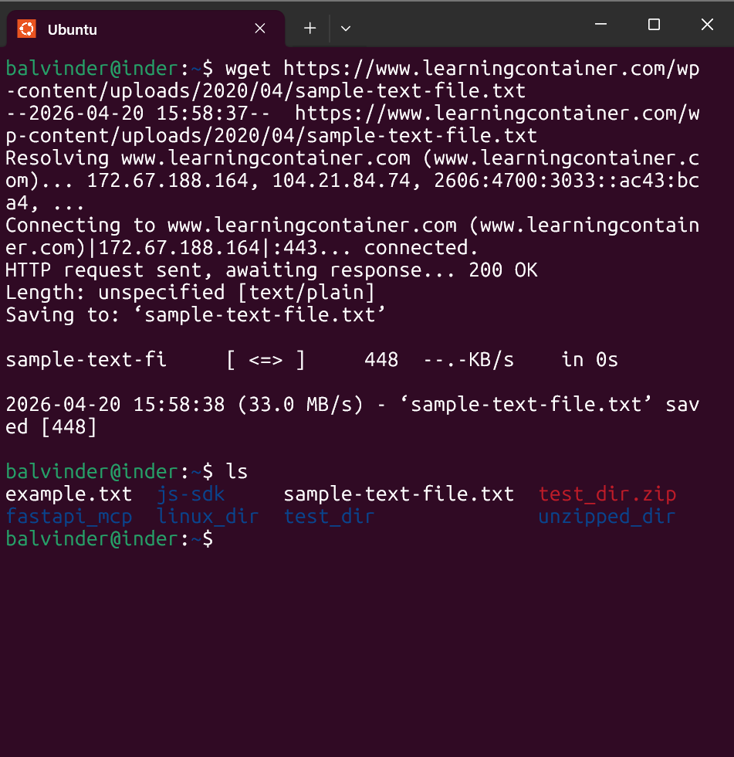

6. Changing Permissions
Commands:
touch secure.txt
chmod 444 secure.txt
Explanation:
chmod 444 makes the file read-only for all users.
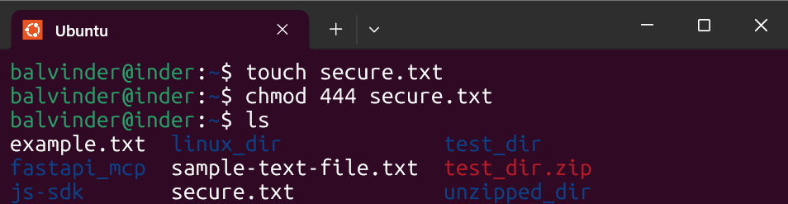

7. Working with Environment Variables
Commands:
export MY_VAR="Hello, Linux!"
echo $MY_VAR
Explanation:
export creates an environment variable.
echo displays its value.
