**Project: Blind Typing Software**

**Group Members: 2**

**6.1 About Project**

This Project has been done during Summer Internship under the guidance of Valid Page Company.

**Features**

* By using Java Programming Language a software was developed **to check typing accuracy**.
* This project is developed using core Java concepts like **Inheritance, Constructors, Swing, packages**, etc.

**6.2 Paradigms of Project**

* + This project is developed using core Java concepts like **Inheritance, Constructors, Swing,** etc.
  + By using Java Programming Language a software was developed **to check typing accuracy**.
* **Duration:** 20 days
* **Platform:** Java
* **Software:** Eclipse

**FLOW OF CONTROL**

Admin class

Login class

Blind Typning class

Stop class

Score class

**HOW TO RUN**

Open the **cmd**, type **javac Admin .java**

Then type **java Admin**

1. **Admin window** will open

User Name: **abc**

Passward: **abc**

Then press **Login button**

1. **Login Window** will open

Fill the details like name, roll no. etc

Then after filling all the details press **Register button**

1. **BlindTyping Window** will open (Workspace)

Type the text as fast as you can with minimum mistakes.

Then finally press **Submit button**.

1. On pressing **Submit button** , **Stop class** will calculate the time taken to type the text.
2. Finally **Score window** will open.
3. A file is stored in C: drive with name as username and containing all datails of user ,typed text and score.

**6.3 Screenshots of Project :**

**Admin-Window**

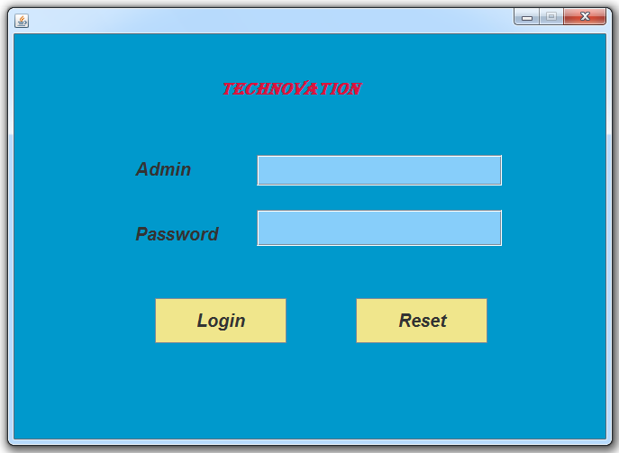

**Registration-Window**

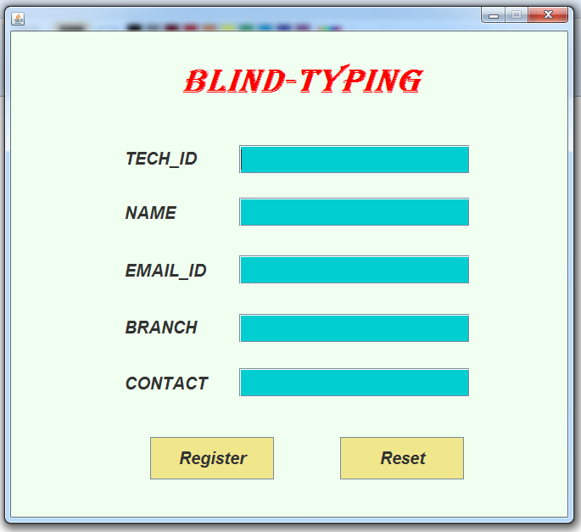

**Registration-Window**

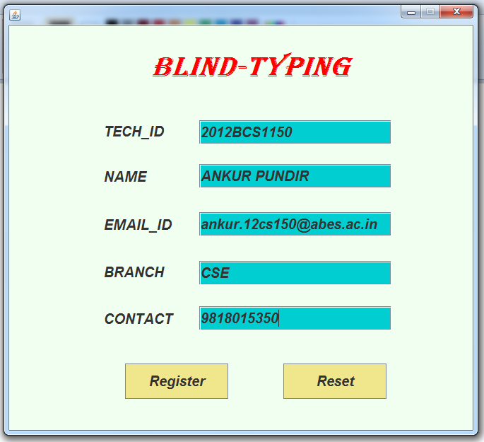

**Workspace**

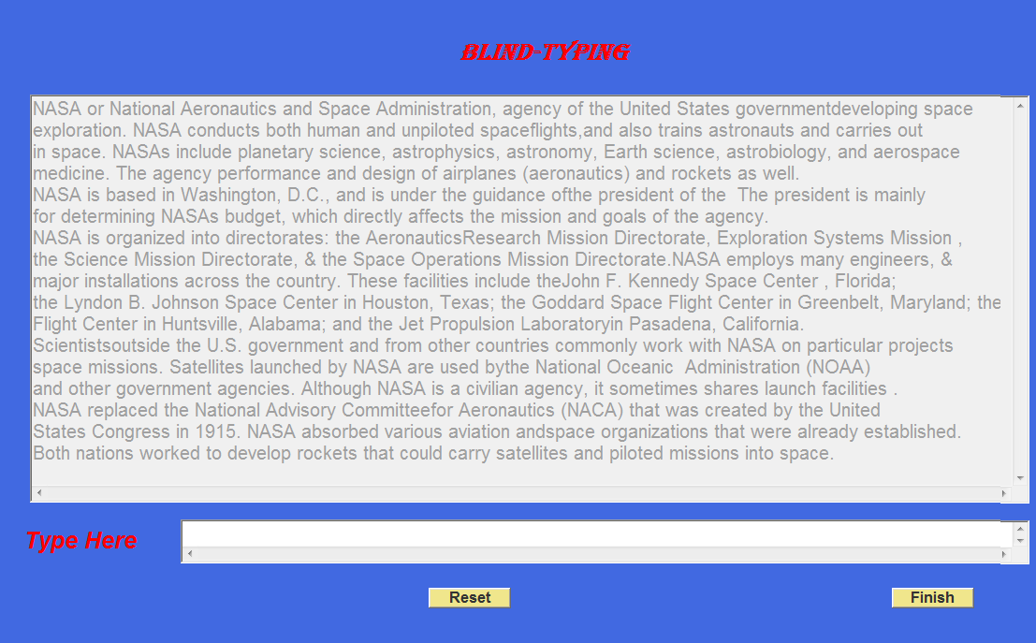

**Score-Window**

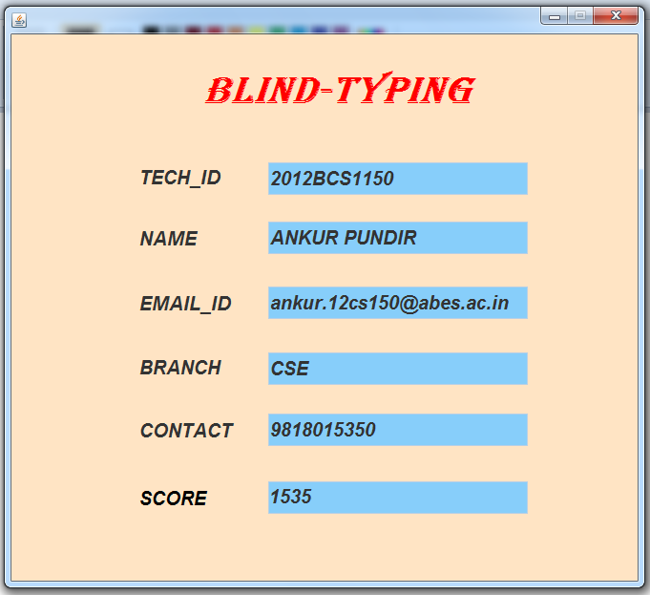

**//ADMIN WINDOW CODE (user name : abc passward: abc)**

import java.awt.BorderLayout;

import java.awt.EventQueue;

import javax.swing.JFrame;

import javax.swing.JPanel;

import javax.swing.border.EmptyBorder;

import javax.swing.JLabel;

import java.awt.Font;

import javax.swing.ImageIcon;

import javax.swing.JTextField;

import javax.swing.JButton;

import javax.swing.JPasswordField;

import java.awt.event.ActionListener;

import java.awt.event.ActionEvent;

import java.awt.Color;

public class Admin extends JFrame {

private JTextField textField;

private JPasswordField passwordField;

public static void main(String[] args) {

Admin admin =new Admin();

admin.setVisible(true); }

public Admin() {

getContentPane().setBackground(new Color(0, 153, 204));

setResizable(false);

setDefaultCloseOperation(JFrame.EXIT_ON_CLOSE);

setBounds(100, 100, 662, 477);

this.getContentPane().setLayout(null);

JLabel lblNewLabel = new JLabel("TECHNOVATION");

lblNewLabel.setForeground(new Color(220, 20, 60));

lblNewLabel.setFont(new Font("Algerian", Font.BOLD | Font.ITALIC, 20));

lblNewLabel.setBounds(228, 34, 297, 52);

getContentPane().add(lblNewLabel);

textField = new JTextField();

textField.setBackground(new Color(135, 206, 250));

textField.setFont(new Font("Arial", Font.BOLD | Font.ITALIC, 20));

textField.setBounds(269, 134, 272, 34);

getContentPane().add(textField);

textField.setColumns(10);

textField.setText(null);

JLabel lblUserName = new JLabel("Admin ");

lblUserName.setFont(new Font("Arial", Font.BOLD | Font.ITALIC, 20));

lblUserName.setBounds(134, 134, 137, 32);

getContentPane().add(lblUserName);

JLabel lblPassword = new JLabel("Password");

lblPassword.setFont(new Font("Arial", Font.BOLD | Font.ITALIC, 20));

lblPassword.setBounds(134, 206, 137, 32);

getContentPane().add(lblPassword);

JButton btnRegister = new JButton("Login");

btnRegister.setBackground(new Color(240, 230, 140));

btnRegister.addActionListener(new ActionListener() {

public void actionPerformed(ActionEvent arg0) {

if(textField.getText().equalsIgnoreCase("") || passwordField.getText().equalsIgnoreCase(""))

{ textField.setText(null);

passwordField.setText(null);

}

else if(textField.getText().equals("abc")&&passwordField.getText().equals("abc"))

{ setVisible(false);

Login login=new Login();

login.setVisible(true);

}

else

{

textField.setText("Enter Admin Login");

passwordField.setText(null);

}

}

});

btnRegister.setFont(new Font("Arial", Font.BOLD | Font.ITALIC, 20));

btnRegister.setBounds(156, 293, 146, 50);

getContentPane().add(btnRegister);

JButton btnReset = new JButton("Reset");

btnReset.setBackground(new Color(240, 230, 140));

btnReset.addActionListener(new ActionListener() {

public void actionPerformed(ActionEvent arg0) {

passwordField.setText(null);

textField.setText(null);

}

});

btnReset.setFont(new Font("Arial", Font.BOLD | Font.ITALIC, 20));

btnReset.setBounds(379, 293, 146, 50);

getContentPane().add(btnReset);

passwordField = new JPasswordField();

passwordField.setBackground(new Color(135, 206, 250));

passwordField.setEchoChar('*');

passwordField.setBounds(269, 195, 272, 40);

getContentPane().add(passwordField);

}

}

**// LOGIN WINDOW CODE**

import java.awt.BorderLayout;

import java.awt.EventQueue;

import javax.swing.JFrame;

import javax.swing.JPanel;

import javax.swing.border.EmptyBorder;

import javax.swing.JLabel;

import java.awt.Font;

import javax.swing.ImageIcon;

import javax.swing.JTextField;

import javax.swing.JButton;

import javax.swing.JPasswordField;

import java.awt.event.ActionListener;

import java.awt.event.ActionEvent;

import java.awt.Color;

public class Login extends JFrame {

private JTextField textField;

private JTextField textField_1;

private JTextField textField_2;

private JTextField textField_3;

private JTextField textField_4;

public Login() {

setResizable(false);

getContentPane().setBackground(new Color(240, 255, 240));

setDefaultCloseOperation(JFrame.EXIT_ON_CLOSE);

setBounds(100, 100, 662, 600);

this.getContentPane().setLayout(null);

JLabel lblNewLabel = new JLabel("Blind-Typing");

lblNewLabel.setForeground(new Color(255, 0, 0));

lblNewLabel.setBackground(new Color(255, 0, 0));

lblNewLabel.setFont(new Font("Algerian", Font.BOLD | Font.ITALIC, 40));

lblNewLabel.setBounds(201, 33, 321, 52);

getContentPane().add(lblNewLabel);

textField = new JTextField();

textField.setBackground(new Color(0, 206, 209));

textField.setFont(new Font("Arial", Font.BOLD | Font.ITALIC, 20));

textField.setBounds(269, 134, 272, 34);

getContentPane().add(textField);

textField.setColumns(10);

textField.setText(null);

JLabel lblUserName = new JLabel("TECH_ID");

lblUserName.setFont(new Font("Arial", Font.BOLD | Font.ITALIC, 20));

lblUserName.setBounds(134, 134, 137, 32);

getContentPane().add(lblUserName);

JButton btnRegister = new JButton("Register");

btnRegister.setBackground(new Color(240, 230, 140));

btnRegister.addActionListener(new ActionListener() {

public void actionPerformed(ActionEvent arg0) {

if(textField.getText().equalsIgnoreCase("") ||textField_1.getText().equalsIgnoreCase("") || textField_2.getText().equalsIgnoreCase("") ||textField_3.getText().equalsIgnoreCase("") ||textField_4.getText().equalsIgnoreCase("") )

{

textField.setText(null);

textField_1.setText(null);

textField_2.setText(null);

textField_3.setText(null);

textField_4.setText(null);

}

else{

setVisible(false);

BlindTyping blindTyping=new BlindTyping();

blindTyping.setVisible(true);

blindTyping.id=textField.getText();

blindTyping.name=textField_1.getText();

blindTyping.email=textField_2.getText();

blindTyping.branch=textField_3.getText();

blindTyping.mob=textField_4.getText();

}

}

});

btnRegister.setFont(new Font("Arial", Font.BOLD | Font.ITALIC, 20));

btnRegister.setBounds(164, 478, 146, 50);

getContentPane().add(btnRegister);

JButton btnReset = new JButton("Reset");

btnReset.setBackground(new Color(240, 230, 140));

btnReset.addActionListener(new ActionListener() {

public void actionPerformed(ActionEvent arg0) {

textField.setText(null);

textField_1.setText(null);

textField_2.setText(null);

textField_3.setText(null);

textField_4.setText(null);

}

});

btnReset.setFont(new Font("Arial", Font.BOLD | Font.ITALIC, 20));

btnReset.setBounds(388, 478, 146, 50);

getContentPane().add(btnReset);

JLabel lblName = new JLabel("NAME");

lblName.setFont(new Font("Arial", Font.BOLD | Font.ITALIC, 20));

lblName.setBounds(134, 198, 137, 32);

getContentPane().add(lblName);

JLabel lblEmailid = new JLabel("EMAIL_ID");

lblEmailid.setFont(new Font("Arial", Font.BOLD | Font.ITALIC, 20));

lblEmailid.setBounds(134, 266, 137, 32);

getContentPane().add(lblEmailid);

JLabel lblContactno = new JLabel("BRANCH");

lblContactno.setFont(new Font("Arial", Font.BOLD | Font.ITALIC, 20));

lblContactno.setBounds(134, 333, 137, 32);

getContentPane().add(lblContactno);

JLabel lblMobileno = new JLabel("CONTACT");

lblMobileno.setFont(new Font("Arial", Font.BOLD | Font.ITALIC, 20));

lblMobileno.setBounds(134, 399, 137, 32);

getContentPane().add(lblMobileno);

textField_1 = new JTextField();

textField_1.setBackground(new Color(0, 206, 209));

textField_1.setText((String) null);

textField_1.setFont(new Font("Arial", Font.BOLD | Font.ITALIC, 20));

textField_1.setColumns(10);

textField_1.setBounds(269, 196, 272, 34);

getContentPane().add(textField_1);

textField_2 = new JTextField();

textField_2.setBackground(new Color(0, 206, 209));

textField_2.setText((String) null);

textField_2.setFont(new Font("Arial", Font.BOLD | Font.ITALIC, 20));

textField_2.setColumns(10);

textField_2.setBounds(269, 264, 272, 34);

getContentPane().add(textField_2);

textField_3 = new JTextField();

textField_3.setBackground(new Color(0, 206, 209));

textField_3.setText((String) null);

textField_3.setFont(new Font("Arial", Font.BOLD | Font.ITALIC, 20));

textField_3.setColumns(10);

textField_3.setBounds(269, 333, 272, 34);

getContentPane().add(textField_3);

textField_4 = new JTextField();

textField_4.setBackground(new Color(0, 206, 209));

textField_4.setText((String) null);

textField_4.setFont(new Font("Arial", Font.BOLD | Font.ITALIC, 20));

textField_4.setColumns(10);

textField_4.setBounds(269, 397, 272, 34);

getContentPane().add(textField_4);

}

}

**// WORKSPACE WINDOW**

import java.awt.BorderLayout;

import java.awt.Color;

import java.awt.Cursor;

import java.awt.EventQueue;

import javax.swing.JFrame;

import javax.swing.JPanel;

import javax.swing.border.EmptyBorder;

import java.awt.TextArea;

import java.awt.Font;

import java.awt.Button;

import java.awt.event.ActionListener;

import java.awt.event.ActionEvent;

import java.sql.Time;

import java.util.Timer;

import javax.swing.JLabel;

import javax.swing.JTextField;

import java.awt.event.KeyAdapter;

import java.awt.event.KeyEvent;

import java.io.*;

import java.util.Scanner;

import javax.swing.UIManager;

public class BlindTyping extends JFrame {

TextArea textArea = new TextArea();

TextArea textArea_1 = new TextArea();

private final JLabel lblTypeHere = new JLabel("Type Here");

Button button_1 = new Button("Reset");

Button button_2 = new Button("Finish");

public double marks=0;

public String name;

public String id;

public String email;

public String branch;

public String mob;

Stop stop=new Stop();

public BlindTyping() {

stop.start();

getContentPane().setBackground(new Color(65, 105, 225));

textArea.setEditable(false);

textArea.setEnabled(false);

textArea.setText(input1);

setDefaultCloseOperation(JFrame.EXIT_ON_CLOSE);

setBounds(0, 0,1375,730);

this.getContentPane().setLayout(null);

textArea.setFont(new Font("Arial", Font.PLAIN, 20));

textArea.setForeground(Color.BLACK);

textArea.setBounds(46, 103, 1303, 436);

getContentPane().add(textArea);

textArea.setBackground(new Color(255, 255, 255));

textArea_1.setForeground(Color.WHITE);

textArea_1.setFont(new Font("Arial", Font.PLAIN, 1));

textArea_1.setBackground(new Color(255, 255, 255));

textArea_1.setBounds(207, 557, 1142, 47);

getContentPane().add(textArea_1);

textArea_1.setCursor(null);

JLabel lblBlindtyping = new JLabel("BLIND-TYPING");

lblBlindtyping.setForeground(Color.RED);

lblBlindtyping.setFont(new Font("Algerian", Font.BOLD | Font.ITALIC, 26));

lblBlindtyping.setBounds(505, 34, 342, 47);

getContentPane().add(lblBlindtyping);

lblTypeHere.setForeground(Color.RED);

lblTypeHere.setFont(new Font("Arial", Font.BOLD | Font.ITALIC, 25));

lblTypeHere.setBounds(40, 554, 200, 50);

getContentPane().add(lblTypeHere);

button_1.setBackground(new Color(240, 230, 140));

button_1.addActionListener(new ActionListener() {

public void actionPerformed(ActionEvent arg0) {

textArea_1.setText(" ");

}

});

button_1.setFont(new Font("Arial", Font.BOLD, 16));

button_1.setBounds(472, 630, 88, 22);

getContentPane().add(button_1);

button_2.setBackground(new Color(240, 230, 140));

button_2.addActionListener(new ActionListener() {

public void actionPerformed(ActionEvent arg0) {

fun();

setVisible(false);

Score score=new Score();

score.setVisible(true);

score.textField.setText(id);

score.textField_1.setText(name);

score.textField_2.setText(email);

score.textField_3.setText(branch);

score.textField_4.setText(mob);

score.textField_5.setText(Double.toString(marks));

try {

fileWrite();

} catch (IOException e) {

// TODO Auto-generated catch block

e.printStackTrace();

}

}

});

button_2.setFont(new Font("Arial", Font.BOLD, 16));

button_2.setBounds(967, 630, 88, 22);

getContentPane().add(button_2);

} String input1="NASA or National Aeronautics and Space Administration, agency of "

+ "the United States governmentdeveloping space "

+ "\nexploration. NASA conducts both human and unpiloted spaceflights,"

+ "and also trains astronauts and carries out "

+ "\nin space. NASAs include planetary science, "

+ "astrophysics, astronomy, Earth science, astrobiology, and aerospace "

+ "\nmedicine. The agency performance and design of airplanes "

+ "(aeronautics) and rockets as well. "

+ "\nNASA is based in Washington, D.C., and is under the guidance of"

+ "the president of the The president is mainly "

+ "\nfor determining NASAs budget, which directly affects "

+ "the mission and goals of the agency."

+ "\nNASA is organized into directorates: the Aeronautics"

+ "Research Mission Directorate, Exploration Systems Mission ,"

+ "\nthe Science Mission Directorate, & the Space Operations Mission Directorate."

+ "NASA employs many engineers, & "

+ "\nmajor installations across the country. These facilities include the"

+ "John F. Kennedy Space Center , Florida; "

+ "\nthe Lyndon B. Johnson Space Center in Houston, Texas; the Goddard Space "

+ "Flight Center in Greenbelt, Maryland; the "

+ "\nFlight Center in Huntsville, Alabama; and the Jet Propulsion Laboratory"

+ "in Pasadena, California."

+ "\nScientistsoutside the U.S. government and from "

+ "other countries commonly work with NASA on particular projects "

+ "\nspace missions. Satellites launched by NASA are used by"

+ "the National Oceanic Administration (NOAA) "

+ "\nand other government agencies. Although NASA is a civilian agency, "

+ "it sometimes shares launch facilities ."

+ "\nNASA replaced the National Advisory Committee"

+ "for Aeronautics (NACA) that was created by the United"

+ "\nStates Congress in 1915. NASA absorbed various aviation and"

+ "space organizations that were already established."

+"\nBoth nations worked to develop rockets that could "

+ "carry satellites and piloted missions into space.";

public void fun()

{

stop.stopp();

Long time=stop.getElapsedTimeSecs();

String string1="",string2="";

String input[] = new String[500];

String userInput[] = new String[500];

int k=0;

String bothString=input1;

String temp=textArea_1.getText();

String text= temp.replaceAll("\n","");

int length1=bothString.length();

int length2=text.length();

int j=0;

for(int i=0;i<length1;i++)

{

while(j<length2 && i<length1)

{

char ch1=bothString.charAt(i);

char ch2=temp.charAt(j);

if(ch1=='.')

{

j=j+2;

}

if(ch1==ch2)

{

marks=marks+5;

j++;

}

else

{

marks= marks-0.5;

j++;

}

break;

}

}

if(length1==length2)

{

marks=marks+20;

}

for(int i=0;i<length1;i++)

{

char ch=bothString.charAt(i);

if(ch!=' ')

{string1=string1+ch;}

else

{

input[k]=string1;k++;string1="";}

}

k=0;

for( int i=0;i<length2;i++)

{ char ch=temp.charAt(i);

if(ch!=' ')

{string2=string2+ch;}

else

{

userInput[k]=string2;

k++;string2="";}

}

for( j=0;j<k;j++)

{

if(input[j].equalsIgnoreCase(userInput[j]))

{

marks=marks+10;

}

else

{

marks=marks-1;

}

}

}

public void fileWrite() throws IOException

{

//String path="/home/test/Documents/".concat(name).concat(".pdf");

//FileOutputStream fo = new FileOutputStream(path,true);

String path="E:\\".concat(name).concat(".pdf");

FileOutputStream fo = new FileOutputStream(path,true);

String message = "\n".concat(id).concat("\n").concat(name).concat("\n").concat(email).concat("\n").concat(branch).concat("\n").concat(mob).concat("\n").concat("marks").concat(Double.toString(marks)).concat("\n").concat(textArea_1.getText()).concat("\n");

fo.write(message.getBytes());

fo.close();

}

}

**//SCORE WINDOW CODE**

import java.awt.BorderLayout;

import java.awt.EventQueue;

import javax.swing.JFrame;

import javax.swing.JPanel;

import javax.swing.border.EmptyBorder;

import javax.swing.JLabel;

import java.awt.Font;

import javax.swing.ImageIcon;

import javax.swing.JTextField;

import javax.swing.JButton;

import javax.swing.JPasswordField;

import java.awt.event.ActionListener;

import java.awt.event.ActionEvent;

import java.awt.Color;

public class Score extends JFrame {

public JTextField textField;

public JTextField textField_1;

public JTextField textField_2;

public JTextField textField_3;

public JTextField textField_4;

public JTextField textField_5;

public Score() {

setResizable(false);

getContentPane().setBackground(new Color(255, 228, 196));

setDefaultCloseOperation(JFrame.EXIT_ON_CLOSE);

setBounds(100, 80, 662, 600);

this.getContentPane().setLayout(null);

JLabel lblNewLabel = new JLabel("Blind-Typing");

lblNewLabel.setForeground(new Color(255, 0, 0));

lblNewLabel.setFont(new Font("Algerian", Font.BOLD | Font.ITALIC, 40));

lblNewLabel.setBounds(201, 33, 340, 52);

getContentPane().add(lblNewLabel);

textField = new JTextField();

textField.setBackground(new Color(135, 206, 250));

textField.setEditable(false);

textField.setFont(new Font("Arial", Font.BOLD | Font.ITALIC, 20));

textField.setBounds(269, 134, 272, 34);

getContentPane().add(textField);

textField.setColumns(10);

textField.setText(null);

JLabel lblUserName = new JLabel("TECH_ID");

lblUserName.setFont(new Font("Arial", Font.BOLD | Font.ITALIC, 20));

lblUserName.setBounds(134, 134, 137, 32);

getContentPane().add(lblUserName);

JLabel lblName = new JLabel("NAME");

lblName.setFont(new Font("Arial", Font.BOLD | Font.ITALIC, 20));

lblName.setBounds(134, 198, 137, 32);

getContentPane().add(lblName);

JLabel lblEmailid = new JLabel("EMAIL_ID");

lblEmailid.setFont(new Font("Arial", Font.BOLD | Font.ITALIC, 20));

lblEmailid.setBounds(134, 266, 137, 32);

getContentPane().add(lblEmailid);

JLabel lblContactno = new JLabel("BRANCH");

lblContactno.setFont(new Font("Arial", Font.BOLD | Font.ITALIC, 20));

lblContactno.setBounds(134, 333, 137, 32);

getContentPane().add(lblContactno);

JLabel lblMobileno = new JLabel("CONTACT");

lblMobileno.setFont(new Font("Arial", Font.BOLD | Font.ITALIC, 20));

lblMobileno.setBounds(134, 399, 137, 32);

getContentPane().add(lblMobileno);

textField_1 = new JTextField();

textField_1.setBackground(new Color(135, 206, 250));

textField_1.setEditable(false);

textField_1.setText((String) null);

textField_1.setFont(new Font("Arial", Font.BOLD | Font.ITALIC, 20));

textField_1.setColumns(10);

textField_1.setBounds(269, 196, 272, 34);

getContentPane().add(textField_1);

textField_2 = new JTextField();

textField_2.setBackground(new Color(135, 206, 250));

textField_2.setEditable(false);

textField_2.setText((String) null);

textField_2.setFont(new Font("Arial", Font.BOLD | Font.ITALIC, 20));

textField_2.setColumns(10);

textField_2.setBounds(269, 264, 272, 34);

getContentPane().add(textField_2);

textField_3 = new JTextField();

textField_3.setBackground(new Color(135, 206, 250));

textField_3.setEditable(false);

textField_3.setText((String) null);

textField_3.setFont(new Font("Arial", Font.BOLD | Font.ITALIC, 20));

textField_3.setColumns(10);

textField_3.setBounds(269, 333, 272, 34);

getContentPane().add(textField_3);

textField_4 = new JTextField();

textField_4.setBackground(new Color(135, 206, 250));

textField_4.setEditable(false);

textField_4.setText((String) null);

textField_4.setFont(new Font("Arial", Font.BOLD | Font.ITALIC, 20));

textField_4.setColumns(10);

textField_4.setBounds(269, 397, 272, 34);

getContentPane().add(textField_4);

JLabel lblScore = new JLabel("SCORE");

lblScore.setForeground(Color.BLACK);

lblScore.setFont(new Font("Arial", Font.BOLD | Font.ITALIC, 20));

lblScore.setBounds(134, 470, 137, 32);

getContentPane().add(lblScore);

textField_5 = new JTextField();

textField_5.setBackground(new Color(135, 206, 250));

textField_5.setText((String) null);

textField_5.setFont(new Font("Arial", Font.BOLD | Font.ITALIC, 20));

textField_5.setEditable(false);

textField_5.setColumns(10);

textField_5.setBounds(269, 468, 272, 34);

getContentPane().add(textField_5);

}

}

**//STOP CLASS CODE ( TO STOP THE CLOCK TO CALCULATE TIME )**

public class Stop {

private long startTime = 0;

private long stopTime = 0;

private boolean running = false;

public void start() {

this.startTime = System.currentTimeMillis();

this.running = true;

}

public void stopp() {

this.stopTime = System.currentTimeMillis();

this.running = false;

}

//elaspsed time in milliseconds

public long getElapsedTime() {

long elapsed;

if (running) {

elapsed = (System.currentTimeMillis() - startTime);

}

else {

elapsed = (stopTime - startTime);

}

return elapsed;

}

//elaspsed time in seconds

public long getElapsedTimeSecs() {

long elapsed;

if (running) {

elapsed = ((System.currentTimeMillis() - startTime) / 1000);

}

else {

elapsed = ((stopTime - startTime) / 1000);

}

return elapsed;

}

}