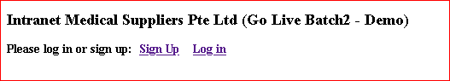

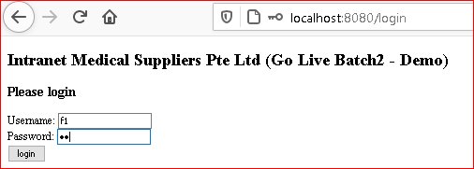

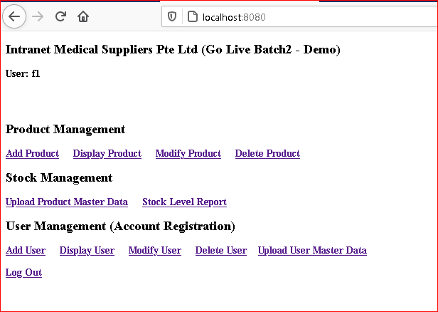

Stock Management

Products can be uploaded from a CSV file.

If records in the file are not in the database already, then these will be added
otherwise, records will be updated or unchanged

Current stock

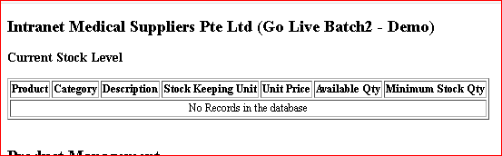

CSV
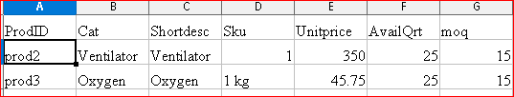

after upload

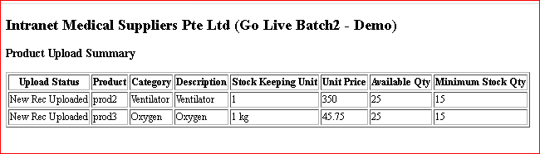

now upload 3 records - one changed, unchanged & one new products

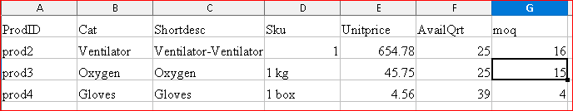

After upload

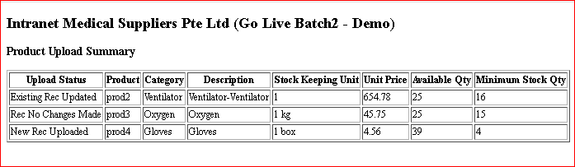

Stock report

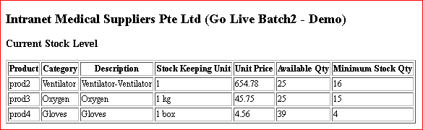

User Management
users can be uploaded from a CSV file.

2 new records will be uplaoded now

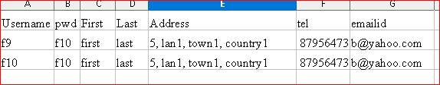

After upload

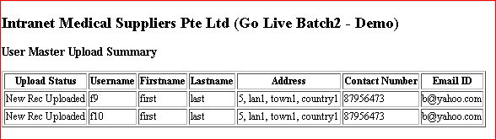

now upload 3 records - one changed, unchanged & one new users

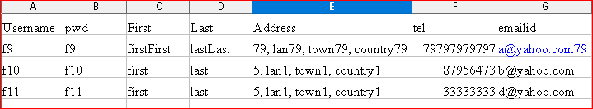

after upload

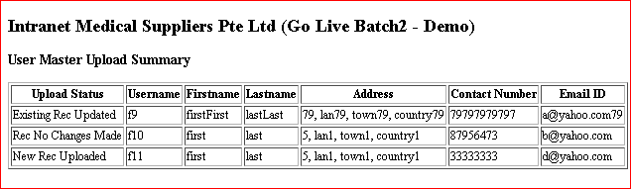

The rest of the features are self-explanatory.

