**Python installation steps:**

Step 1: **Download** python version 3.7.3 from python.org.

Step 2: **Run** the setup file.

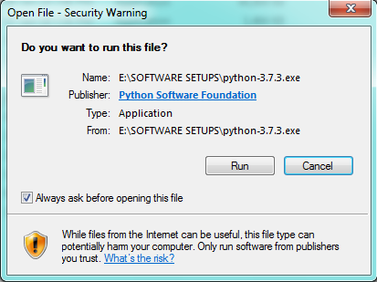

Step 3: **Check** add python 3.7 to path and **click** customize installation.

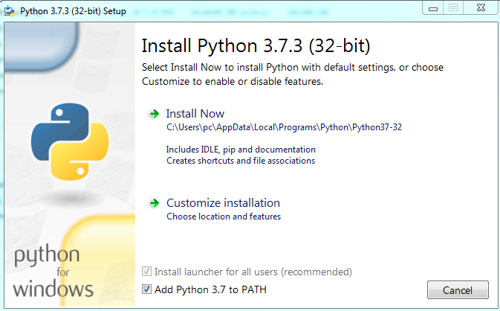

Step 4: **Click** on next.

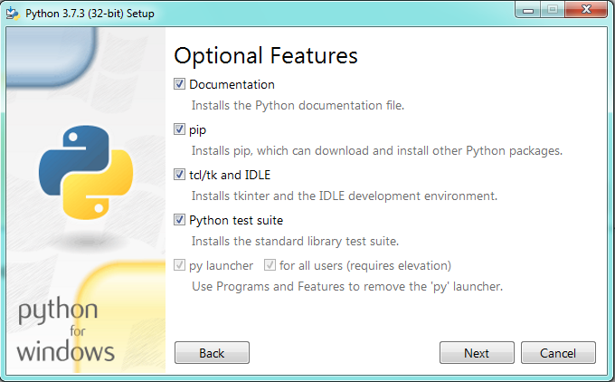

Step 5: **Customize** install location and **click** install.



Step 6: Setup is complete.

