. What is Agile Testing?
Agile testing is a software testing practice that follows the principles of agile software development. It is an iterative software development methodology where requirements keep changing as per the customer needs. Testing is done in parallel to the development of an iterative model. Test team receives frequent code changes from the development team for testing an application.
Agile Manifesto
. Individuals and interactions over process and tools
ii. Working software over comprehensive documentation
iii. Customer collaboration over contract negotiation
iv. Responding to change over following a plan

. What are the principles of Agile Software Development?
1. Highest priority is to satisfy the customer through early and continuous delivery of business valuable software
2. Welcome changing requirements, even late in development
3. Deliver working software frequently
4. Business people and developers must work together with transparency on daily basis throughout the project
5. Build projects around motivated individuals
6. The best form of communication is to do face-to-face conversation
7. Working software is the primary measure of progress
8. Able to maintain a constant pace
9. Continuous attention to technical excellence
10. Simplicity – the art of maximizing the amount of work not done – is essential
11. Self-organizing teams
12. At regular intervals, the team reflects on how to become more effective, then tunes and adjusts its behavior accordingly

What are the main roles in Scrum?
Scrum consists of three main roles:
Product Owner: Product Owner usually represents the Client and acts as a point of contact from the Client side. The one who prioritizes the list of Product Backlogs which Scrum Team should finish and release.
Scrum Master: Scrum Master acts as a facilitator to the Scrum Development Team. Clarifies the queries and organizes the team from distractions and teach the team how to use scrum and also concentrates on Return on Investment (ROI). Responsible for managing the sprint.
Scrum Development Team: Developer’s, QA’s. Who develops the product. Scrum development team decides the effort estimation to complete a Product Backlog Item.
Scrum Team: A cross-functional, self-organizing group of dedicated people (Group of Product Owner, Business Analyst, Developer’s and QA’s). Recommended size of a scrum team is 7 plus or minus 2 (i.e, between 5 to 9 members in a team).

What approach do you follow when requirements change continuously?
In Agile methodology, change in requirement is possible. It’s not like other traditional methodologies where the requirements are locked down at the requirement phase. Every team member should be ready to handle the changes in the project.
The team should work closely with the Product Owner to understand the scope of requirement change and to negotiate to keep the requirement changes to a minimum or to adopt those changes in the next sprint. Based on the requirement changes Test Team could update the Test Plan and Test Cases to achieve the deadlines. The team should understand the risk in the requirement change and prepare a contingency plan. It is a best practice not to go for the automation process until requirements are finalized.

How is Agile Testing different from other traditional Software Development Models?
It is one of the common Agile Testing Interview Questions.
In Agile Methodology, testing is not a phase like other traditional models. It is an activity parallel to development in the Agile. The time slot for the testing is less in the Agile compared to the traditional models. The testing team works on small features in Agile whereas the test team works on a complete application after development in the traditional models.
In Agile methodology, the code is broken down into small branches and only one branch is developed and tested at a time. At one particular time, only one particular branch is developed and tested. Agile teams follow several processes in the agile methodology like continuous communication with the team, frequent changes to get the optimal results etc. This makes the agile process more flexible and focused. This is not the case with other development methodologies.

When do we use Agile Scrum Methodology?
i. When the client is not so clear on requirements
ii. When the client expects quick releases
iii. When the client doesn’t give all the requirements at a time

What is a Sprint?
In Scrum, the project is divided into Sprints. Each Sprint has a specified timeline (2 weeks to 1 month). This timeline will be agreed by a Scrum Team during the Sprint Planning Meeting. Here, User Stories are split into different modules. The end result of every Sprint should be a potentially shippable product.
Product Backlog: Product Backlog is a repository where the list of Product Backlog Items stored and maintained by the Product Owner. The list of Product Backlog Items are prioritized by the Product Owner as high and low and also could re-prioritize the product backlog constantly.
Sprint Backlog: Group of user stories which scrum development team agreed to do during the current sprint (Committed Product Backlog items). It is a subset of the product backlog.

What is the difference between Burn-up and Burn-down chart?
Burn Down Charts provide proof that the project is on track or not. Both the burn-up and burn-down charts are graphs used to track the progress of a project.
Burn-up charts represent how much work has been completed in a project whereas Burn-down chart represents the remaining work left in a project.

12. What are the types of burn-down charts?
There are four popularly used burn down charts in Agile.
i. Product burndown chart
ii. Sprint burndown chart
iii. Release burndown chart
iv. Defect burndown chart

13. What is Product Burndown Chart?
A graph which shows how many Product Backlog Items (User Stories) implemented/not implemented.

14. What is Sprint Burndown Chart?
A graph which shows how many Sprints implemented/not implemented by the Scrum Team.

15. What is Release Burndown Chart?
A graph which shows List of releases still pending, which Scrum Team have planned.

16. What is Defect Burndown Chart?
A graph which shows how many defects identified and fixed.

What is a Daily Stand-up Meeting?
Daily Stand-up Meeting is a daily routine meeting. It brings everyone up to date on the information and helps the team to stay organized.
Each team member reports to the peers the following:
- What did you complete yesterday?
- Any impediments in your way?
- What do you commit to today?
- When do you think you will be done with that?
In general, it’s not a recorded meeting. Reporting will be between peers not to Scrum Master or Product Owner. It is normally timeboxed to a maximum of 15 minutes. It is aka 15 Minute Stand-up Meeting.

. What is a Sprint Planning Meeting?
The first step of Scrum is the Sprint Planning Meeting where the entire Scrum Team attends. Here the Product Owner selects the Product Backlog Items (User Stories) from the Product Backlog.
Most important User Stories at the top of the list and least important User Stories at the bottom. Scrum Development Team decides and provides effort estimation.

19. What is a Sprint Review Meeting?
In the Sprint Review Meeting, Scrum Development Team presents a demonstration of a potentially shippable product. Product Owner declares which items are completed and not completed. Product Owner adds the additional items to the product backlog based on the stakeholder’s feedback.

20. What is a Sprint Retrospective Meeting?
Scrum Team meets again after the Sprint Review Meeting and documents the lessons learned in the earlier sprint such as “What went well”, “What could be improved”. It helps the Scrum Team to avoid the mistakes in the next Sprints.

What is a Task Board?
A task board is a dashboard which illustrates the progress that an agile team is making in achieving their sprint goals.
In general, the columns used in a task board are as follows
i. User Story: Actual Business Requirement (Description)
ii. To Do: All the tasks of current sprint
iii. In Progress: Any task being worked on
iv. To Verify: Tasks pending for verification
v. Done: Tasks which are completed

What is DevOps?
The term DevOps was formed by combining “Development” and “Operations”. DevOps is an operational philosophy that promotes collaboration between development and operation teams. DevOps focuses on bringing development and operations team together in order to build, test, and release software faster and more reliably.

Agile | Waterfall
Testing is done in parallel with the development activity which means that as the development progresses so does the testing | Testing is generally done at the end of the development
Agile is an incremental approach | It is a sequential design process where design, development, testing and other phases happens one after another in a sequential way
Testing is performed concurrently with software development | "Testing" phase comes after the "Build" phase
Agile methodology is known for its flexibility | Waterfall is a structured software development methodology, and often times can be quite rigid
It believes in constant feedback and accepts changes to requirements | Customer feedback is usually not collected until the very end of the project, and changes are discouraged
Agile focuses on collaboration, small releases and customer feedback | Team coordination is very limited
Self-motivated and self-organizing teams drive the project | Project manager drives the project as a central controlling authority

How long were your sprints?
An ideal sprint length is anywhere between 1 week to 4 weeks. 2 week-long Sprints are most common for IT and software product development.

26. What are the disadvantages of the agile model?
Some of the disadvantages of using the agile model are as follows:
- It is not easy to predict. When you encounter a large project, it becomes more problematic to estimate the amount of effort needed in the project
- In case the guidelines given by the customers is not understood properly, then the final outcome of the project will not meet the customer requirements. It leads to the customer dissatisfaction
- It is not possible to properly focus on the design and documentation of a project sometimes
- Basically, High-level decision making is in the hands of the higher authorities. The team members with little or no experience are not involved in decision-making, thus they don’t get a chance to advance their knowledge

What is an impediment in Scrum?
Impediments are the obstacles faced by the scrum team. Any obstacle that keeps the team from getting work done and that slows velocity is known as Impediment. Scrum Master is responsible for removing impediments.
In Agile Scrum interviews, you may be asked to give some examples of impediments.

28. What are the examples of impediments?
Impediments come in many forms. Some of the impediments are mentioned below
- Resource unavailability (Sick team member)
- Lack of management support
- Business issues
- Lack of skill
- Technical, operational issues
- Even external issues such as weather

What kind of impediments should a scrum master remove?
Scrum Master’s main responsibility is to identify, track and help remove impediments. Scrum Master shouldn’t remove impediments initially even though Scrum Master can remove impediments on behalf of the Scrum team. The Scrum Master should not pamper nor overrule the Scrum Team. Scrum Master should motivate the Scrum team to become independent enough to face problems and take a decision and perform every task by themselves. The Scrum team should be able to make their own decisions. The Scrum master supports and guides the Scrum Team to operate as efficiently as possible. Sometimes, impediments are beyond the ability of the Scrum Team to remove. In such cases, the Scrum Master may get support from outside of the Scrum Team
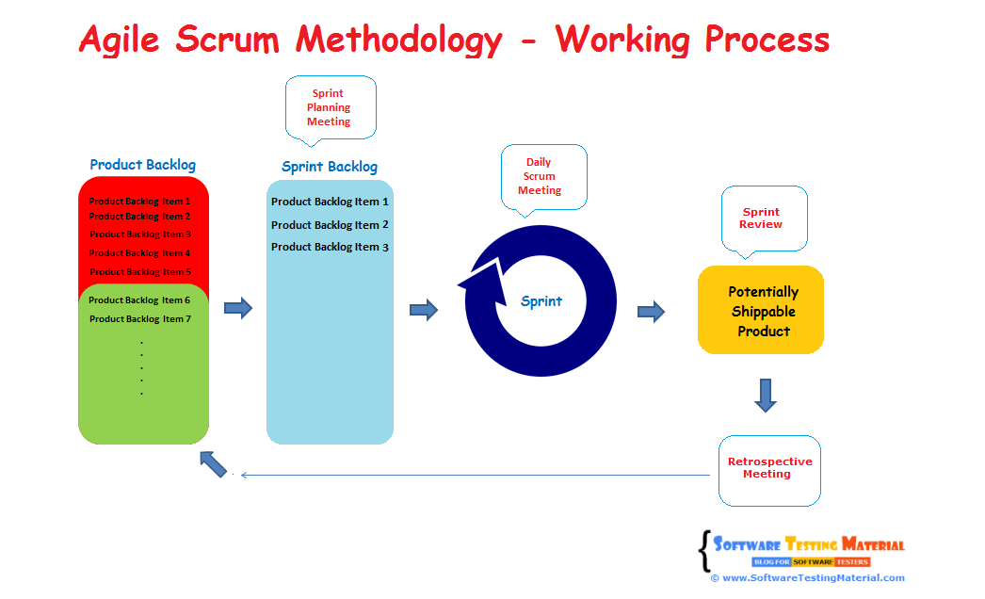
The main difference between agile methodology and other traditional methodologies is that agile methodology follows an incremental development model whereas traditional methodologies follow a sequential model.
In agile methodology, the development phase and testing phase run simultaneously. In traditional methodology, the testing phase starts once the development phase is over.
The agile methodology provides flexibility as introducing changes is easier. In traditional methodology, incorporating changes is difficult as before the development work starts, requirements are frozen.
The agile methodology needs less documentation; due to quick delivery, developers make the changes in the code based on the need. While in traditional methodology, the development process starts only after the completed documented requirements are available with the team.
Customers are involved in every stage of the agile software life cycle, reviewing the product and suggesting changes if required. In traditional methodology, customers are mainly involved in the requirements gathering phase; they usually see the finished product during the last stages of the development life cycle. The main difference between agile methodology and other traditional methodologies is that agile methodology follows an incremental development model whereas traditional methodologies follow a sequential model.
3. Can you name some agile frameworks?
Ans. The following are some agile frameworks:
- Scrum
- Crystal
- Dynamic Systems Development Method (DSDM)
- Feature Driven Development (FDD)
- Kanban
- Adaptive Software Development (ASD)
- Lean Software Development (LSD)
What is extreme programming?
Ans. Extreme programming or XP is one of the popular approaches to agile software development. It uses an object-oriented approach and it follows the same practices included in the agile manifesto.
Extreme programming is responsible for introducing concepts that are now widely used as standard practices such as user stories, continuous integration and test-driven development. One of the advantages of extreme programming is that it gives the flexibility of incorporating changing requirements at any point in the development life cycle.
he following are the four framework activities of extreme programming:
- Planning
- Design
- Coding
- Testing
What is refactoring?
Ans. Refactoring is the process of changing the existing source code without changing its functionality.
. What is pair programming?
Ans. Pair programming is a technique used in agile software development where two developers work as a team. One of the two developers writes code and is known as a driver, while the other reviews the code and is known as an observer. When required they can switch their roles.
What are the benefits of pair programming?
Ans. The following are various advantages of pair programming:
- Pair programming results in improved code quality and fewer mistakes in the code as the other developer keeps reviewing the code as it is written.
- Pair programming makes it easier to find solutions to any problem faced during the coding as the other partner can help.
- It allows easy knowledge transfer as if one partner is more experienced, s/he can teach the other developer
What are the various estimation techniques in agile?
Ans. Agile estimation techniques are used to estimate work efforts. The following are some of the agile estimation techniques:
- Planning Poker
- T-shirt sizes
- Affinity Estimation
- Sorting Method
- The Bucket System
- Three-Point Method
- Dot Vote
What is the planning poker technique?
Ans. Planning poker is an estimation technique that involves collaboration among team members. It is conducted before an iteration starts with the help of developers.
- Each member is given a deck of planning poker cards. The values of the cards are similar to Fibonacci numbers. These numbers represent story points or days.
- The product owner reads and explains the user story to the team. Developers can discuss further if they have any questions.
- After the discussion, each member estimates the efforts in developing the story and selects any card privately that represents the effort.
- All the cards are revealed simultaneously and if all are same then the story is estimated based on the card value.
- If there are different card values, further discussion happens, and it goes on until all the team members agree upon the same num
What is a t-shirt sizing technique?
Ans. T-shirt sizing is an estimation technique used to measure the size of the user story and it is mainly used when there are relatively large backlog items to be estimated. In t-shirt sizing, the sizes of the t-shirts (XS, S, M, L, XL) are used to estimate the story. The decision about the size requires an open discussion.
Ques.16. What is Lean Software Development (LSD)?
Ans. Lean software development is an iterative agile methodology that has borrowed principles of the lean manufacturing process and implemented them in the software development process.
Some of the lean principles that have been adapted are fast delivery, elimination of waste, optimization of development time and resources, building quality in the product, etc.
What is Kanban?
Ans. Like Scrum, Kanban is also one of the popular frameworks used in agile software development. Kanban is a Japanese word for signboard. In this framework, work items or user stories are displayed on the Kanban board, the team can see the status of each user story on the board. Kanban allows the product to be developed in one large development cycle rather than having iterations (like scrum). Kanban is incremental, not iterative.
What is Test-Driven Development (TDD)?
Ans. Test-Driven Development (TDD) is a software development process where the test cases are written first and then the coding is done. Test cases are written to validate what the code should do.
The following are the basic rules of TDD development process:
- First, a unit test is written to describe a feature of the system
- Next step is to run the test; it will fail because the feature does not exist in the system
- Write the code to accommodate the feature in the system; basic idea is to write a simple test so that the test case will pass
- Refactor the code as required
- Repeat the above steps for other features of the system
What are the difference and similarities between scrum and agile?
- Agile methodology is used in software development; it focuses on incremental development methods where the objective of the methodology is to quickly deliver the product. Whereas scrum is one of the frameworks of agile that falls under the agile project management umbrella; it is also used for software development.
- Agile follows an incremental and iterative approach to complete the projects. Scrum is also incremental and iterative in nature.
What approach should you follow as an agile tester when requirements change continuously?
- First, while creating test cases, an agile testing team should focus on writing generic test cases that can be helpful in changing the test cases in the future.
- An agile tester should collaborate with the product owner and business analyst to understand the changed requirement and risks associated with the change to modify the test cases.
- The testing team should go with automation testing only after the requirements are frozen.
What are some qualities of a good agile tester?
Ans. The following are some important qualities that a good agile tester should possess:
- An agile tester should have in-depth knowledge of the agile principles and concepts.
- An agile tester should be able to understand project requirements quickly and clearly.
- S/he should be a good communicator as an agile process encourages continuous interaction with business analysts, developers, and other testers.
- An agile tester should be able to handle changing requirements; s/he should be able to understand the risk arising due to the change and should be able to modify the test cases based on the changing requirements.
What are the stages of an agile testing life cycle?
Ans. Agile testing lifecycle is split into the following stages:
- Agile Test Planning – In this phase, test plan schedules and the deliverables to be tested are created by the stakeholders.
- Daily Scrums – These meetings include discussion of the status of the testing activity done on the previous day and setting testing goals for the day.
- Test Agility Review – These meetings are conducted weekly with the stakeholders to review the progress.
- Release Readiness – In this phase, the review of features is conducted to check the readiness of the features to go live on the production.
- Impact Analysis – In this phase, feedback from the stakeholders is collected and goals for the next life cycle are prepared.

