HomeWork 3 Balaji Suresh(bs 681)

To run the first part of the code just run the function cailb_3D .

To run the second part of the code just run the function calib_2D

For the third part run the function augumented_reality_image

For the 2nd part of the 3rd question run cube_adding

None of these functions take any arguments and can be run directly

1.

Part 1

The image points results is as below

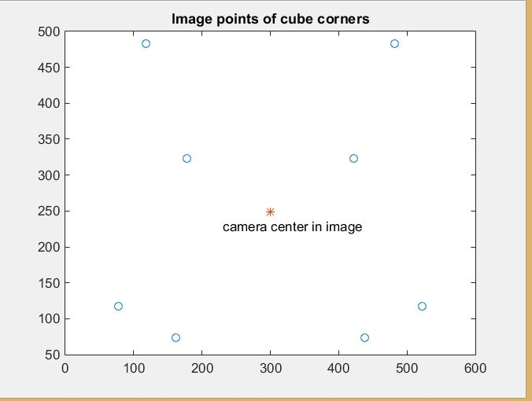

Part 2&3

The matrix P obtained is

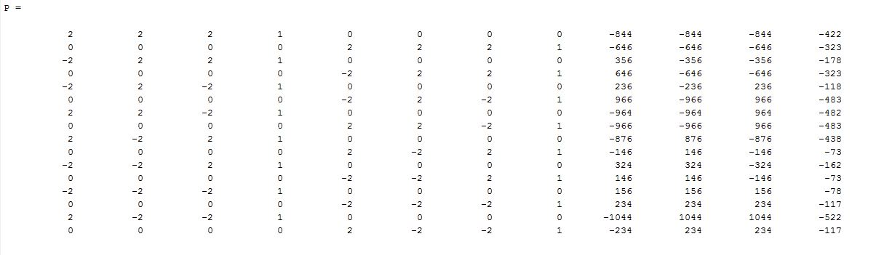

Part 4

The matrix M obtained is

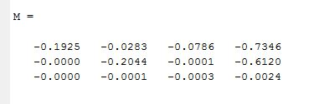

Part 5

The camera center obtained is

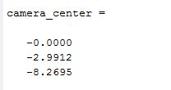

Part 6

The matrix M’ is

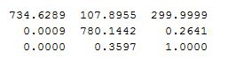

Part 7

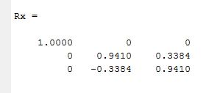

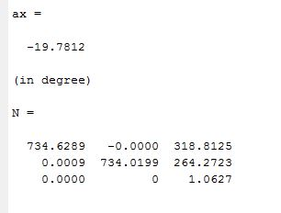

Part 8

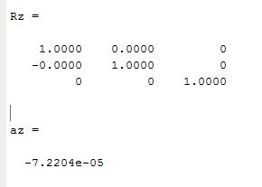

Part 9

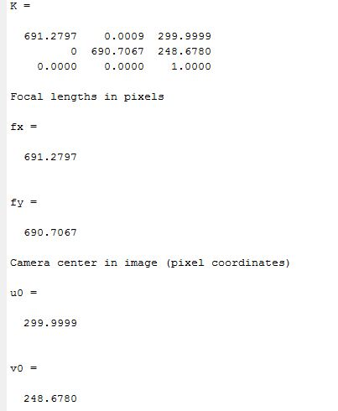

2

The Homography values for different images are

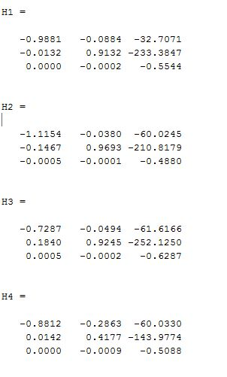

The value of B is

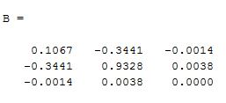

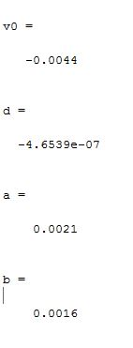

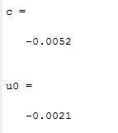

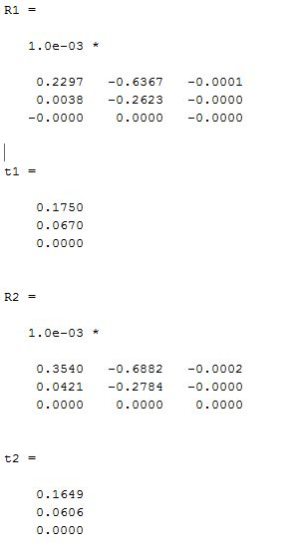

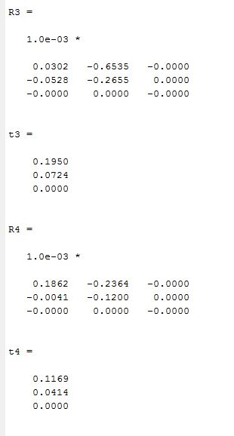

R2_enforced =

0.6995 -0.7146 -0.0008

-0.7146 -0.6995 -0.0004

0.0003 -0.0008 1.0000

R’ x R =

1.0000 0.0000 -0.0000

0.0000 1.0000 0.0000

-0.0000 0.0000 1.0000

R3_enforced =

0.3862 -0.9224 0.0003

-0.9224 -0.3862 0.0001

0.0000 -0.0003 -1.0000

R’ x R =

1.0000 -0.0000 0.0000

-0.0000 1.0000 -0.0000

0.0000 -0.0000 1.0000

R4_enforced =

0.7864 -0.6177 0.0002

-0.6177 -0.7864 0.0001

0.0001 -0.0002 -1.0000

R’ x R =

1.0000 -0.0000 0.0000

-0.0000 1.0000 -0.0000

0.0000 -0.0000 1.0000

Improving accuracy

The p_approx all the four images and its points in the actual image

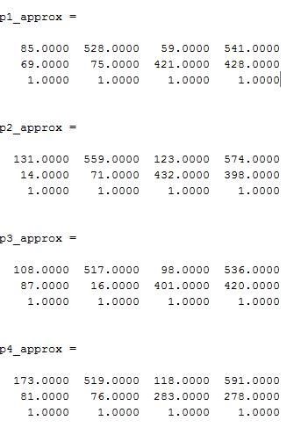

The figures of the image grid with the approximate grid locations are as below

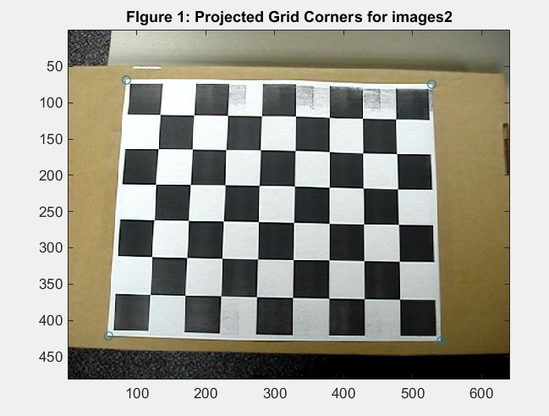

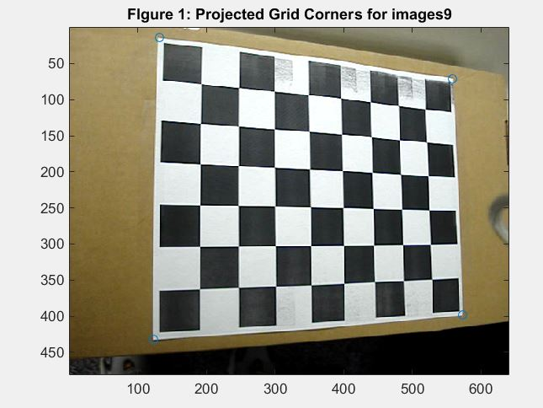

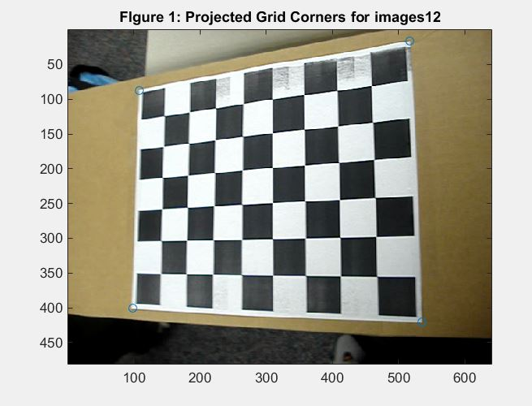

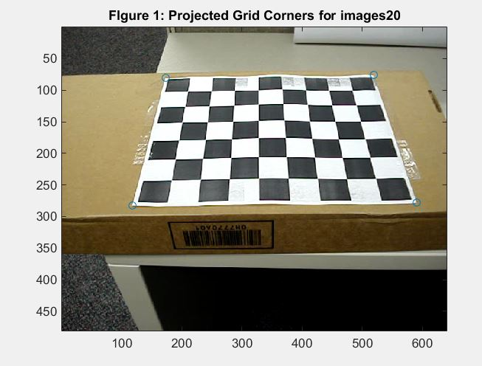

The Image results for Harris corner are as below

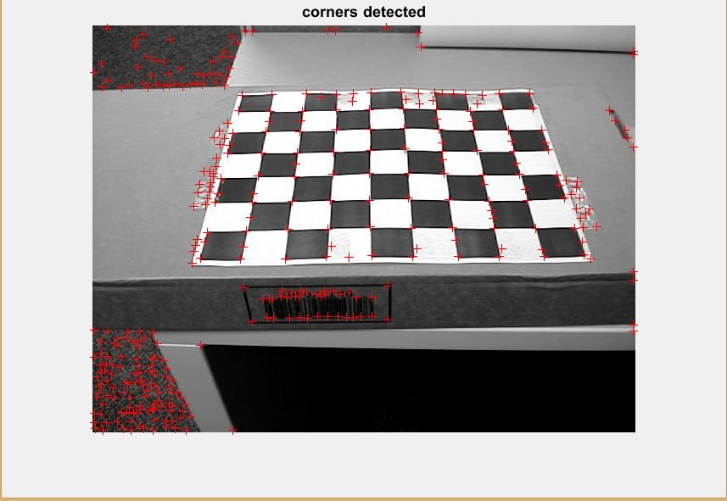

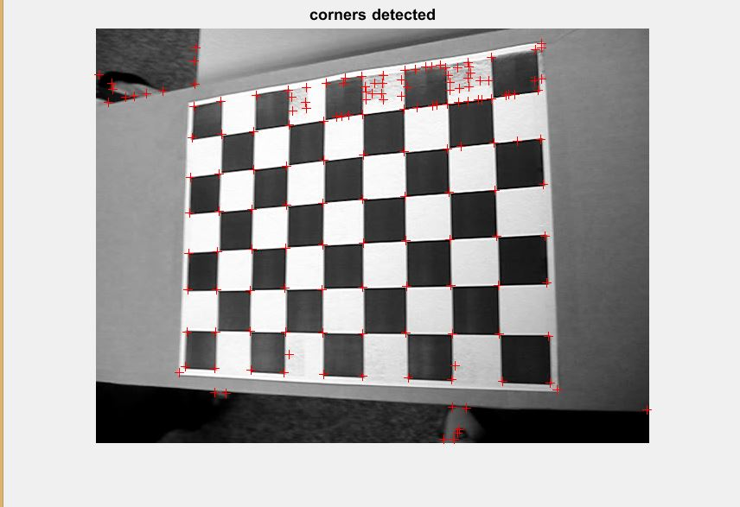

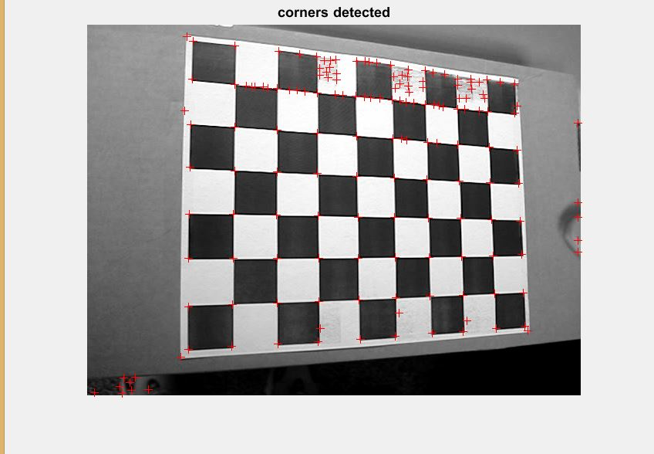

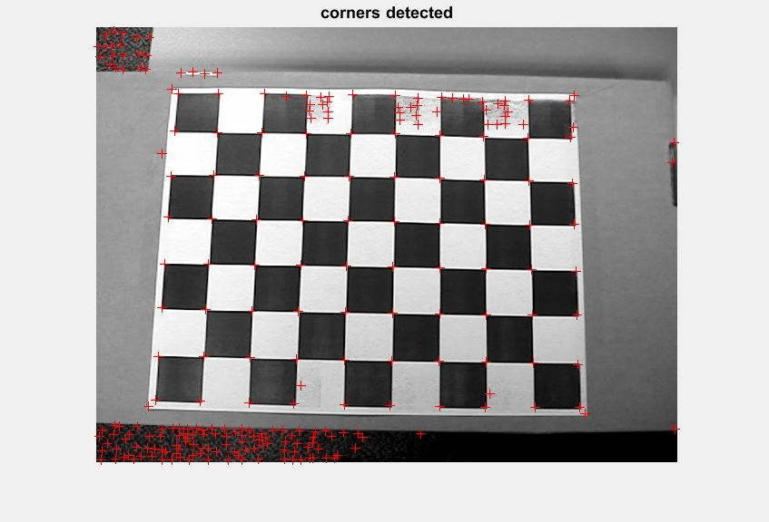

The new homographies are as given below

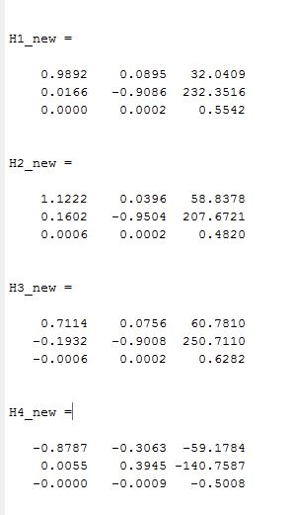

The value of A,R,T and the rotation matrix for each image is given below

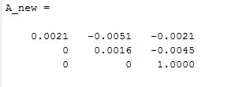

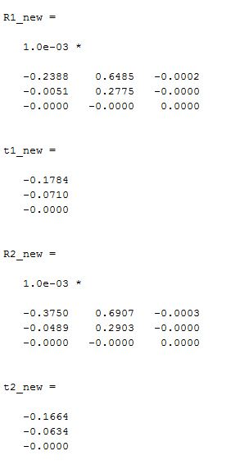

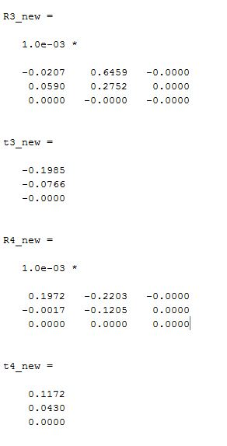

R1_new_enforced =

-0.6259 0.7799 0.0006

0.7799 0.6259 0.0002

0.0002 -0.0006 1.0000

R2_new_enforced =

-0.7197 0.6942 0.0008

0.6942 0.7197 0.0004

0.0003 -0.0008 1.0000

R3_new_enforced =

-0.3870 0.9221 0.0003

0.9221 0.3870 0.0001

-0.0000 0.0003 -1.0000

R4_new_enforced =

0.8197 -0.5728 -0.0002

-0.5728 -0.8197 -0.0001

0.0001 -0.0002 1.0000

err_reprojection1 =

0.3838

2.5167

4.3776

4.7330

err_reprojection2 =

3.9326

54.0893

2.1980

5.0303

err_reprojection3 =

48.2156

4.7287

5.2207

6.5119

err_reprojection4 =

23.7276

32.7428

3.6733

10.7711

3.

The last 4 digits of my RUID is 6042 . Thus I used the 2nd image for this part

Image 1

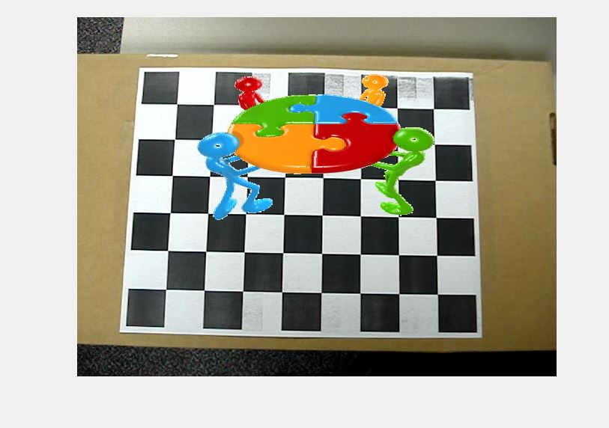

Image 2

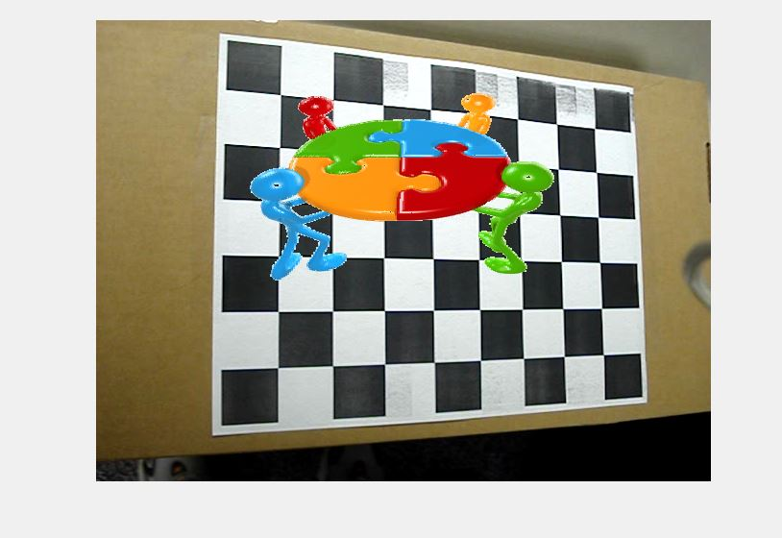

Image 3

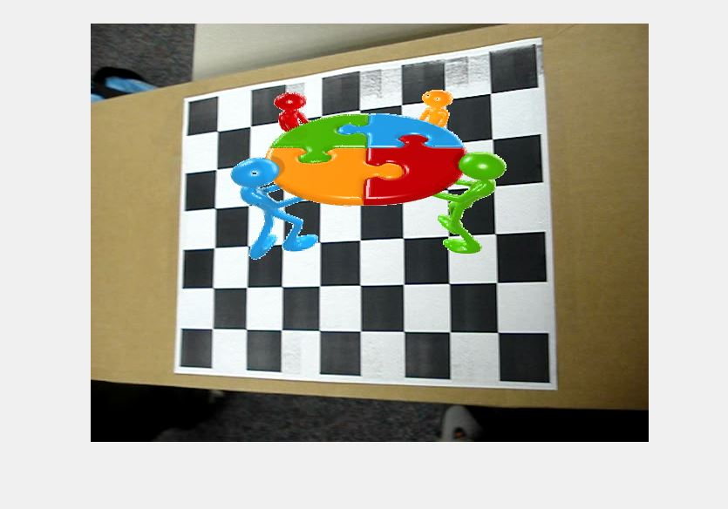

Image 4

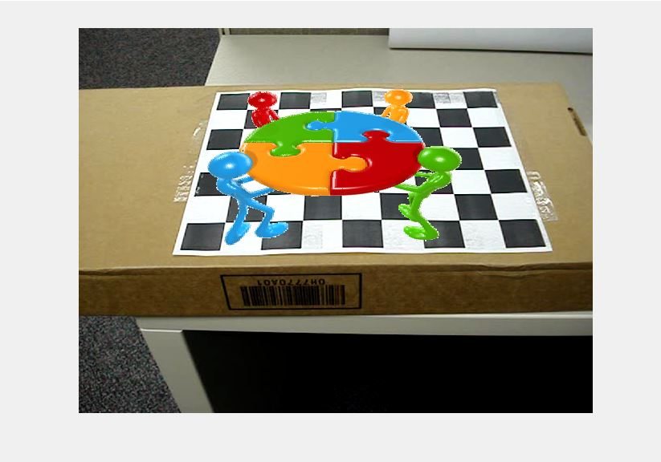

Part 2

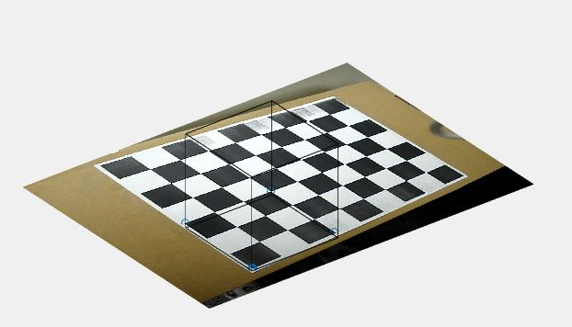

Extra Credit

2.

Since we have 5 intrinsic parameters we end up having four equations .Thus we have infinite number of solutions. Hence lets make an assumption that gamma(y)=0.This makes us get 4 intrinsic parameters by adding the constraint [0,1,0,0,0,0]b = 0 to the equation Vb=0.With the assumptions we can solve all the intrinsic parameters and hence the matrix A can be computed . Once we get A we can compute the other extrinsic parameters. Thus we can solve the intrinsic and extrinsic parameters