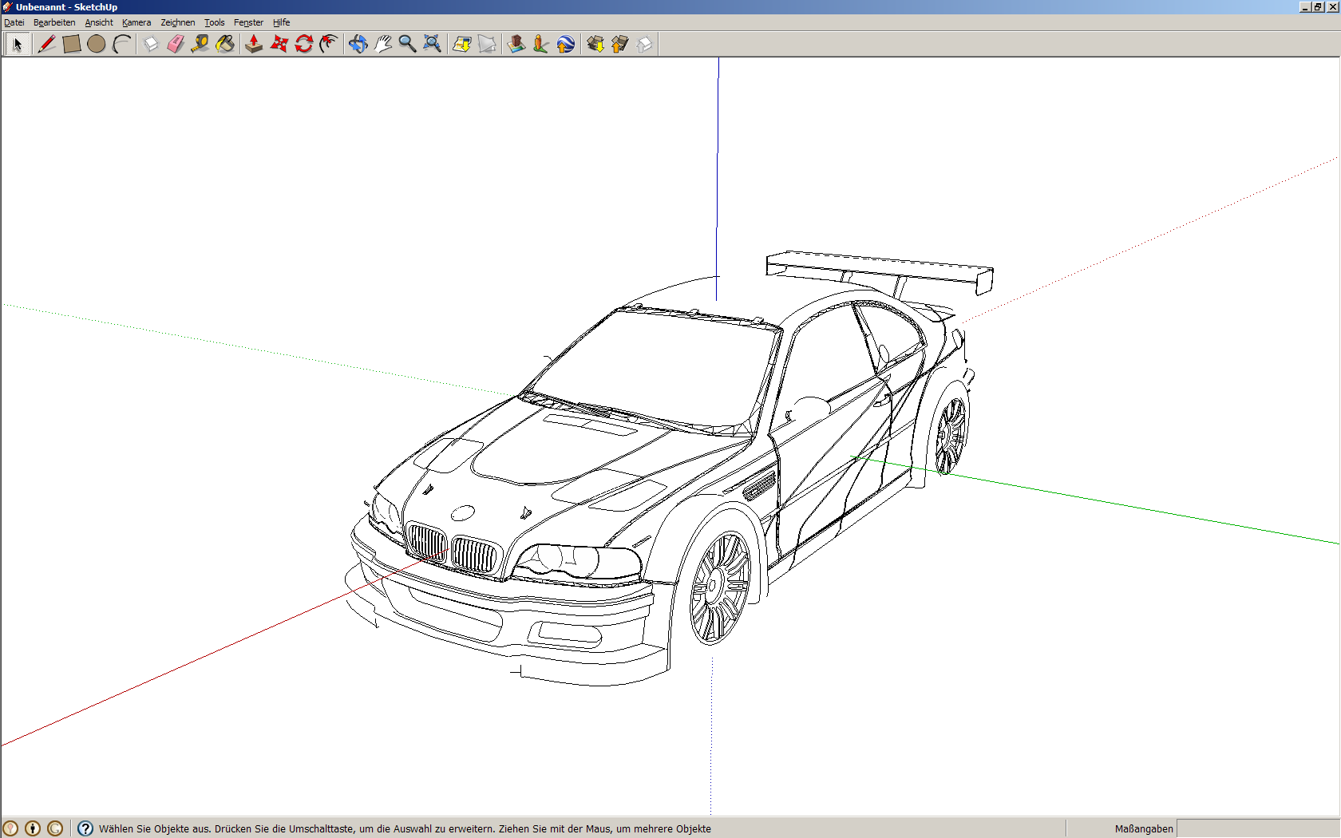

+X  
East

+Y   
North

ENU  
vehicle fixed

+Heading

+Sideslip

+v

+Z

+Yaw

+Roll

+Pitch



+Sideslip

+v

+Z

+Yaw

+Roll

+Pitch