# Feature #1 Results

# Results for Cyclus – PWR MOX

**Reactor Description**

The reactor model used for this analysis, is based on the CLASS model to compute fuel depletion based on reaction’s cross sections predicted using neural networks. The reactor configuration/model is the same as the one described in the CLASS part of the exercise. The reactor settings are slightly different than the one used in the CLASS work:

* Heavy mass: 72 tons
* Thermal power: 2.7 GWth
* Burnup at the end of irradiation: 41.09 GWd/t
* Loading factor: 100%

**Stock Pu Composition @ Beginning Of Cycle**

The Pu composition at Beginning Of Cycle (BOC) is sampled from a Latin Hyper Square (LHS) algorithm. The following isotopic space/limits have been used to sample the LHS:

|  |  |  |
| --- | --- | --- |
| Isotope | Min. Frac. In Pu (Mass %) | Max. Frac. In Pu (Mass %) |
| 238Pu | 0 | 7.5 |
| 240Pu | 10 | 30 |
| 241Pu | 0 | 20 |
| 242Pu | 0 | 20 |
| 241Am | 0 | 7 |

The 239Pu is used as the buffer to ensure the normalization of the plutonium composition. 1000 simulations with plutonium composition have been sampled.

**Methodology description**

* Fuel loading Model:

The fuel loading model used is based on the Baker & Ross, (Equivalent plutonium theory), attempting to reproduce the reactivity of the reference fuel (4.5% of 239Pu) using the available plutonium.

Predicted fuel fractions ranged between 5% and 15% of plutonium in the fuel.

On Figure 1 on can observe on the upper triangle the distribution of the plutonium compositions (one plutonium versus another), on the diagonal the distribution each plutonium isotope individually, and on the lower diagonal, the plutonium fraction predicted by the model for each plutonium composition.

* Fixed Fraction:

The fixed fraction used for this work correspond to the mean plutonium fraction of predicted by the B&R Pu-equivalent theory (same reference as previously) on additional 100 random plutonium compositions of been generated (on a LHS). The used fixed fraction is 7.807%.

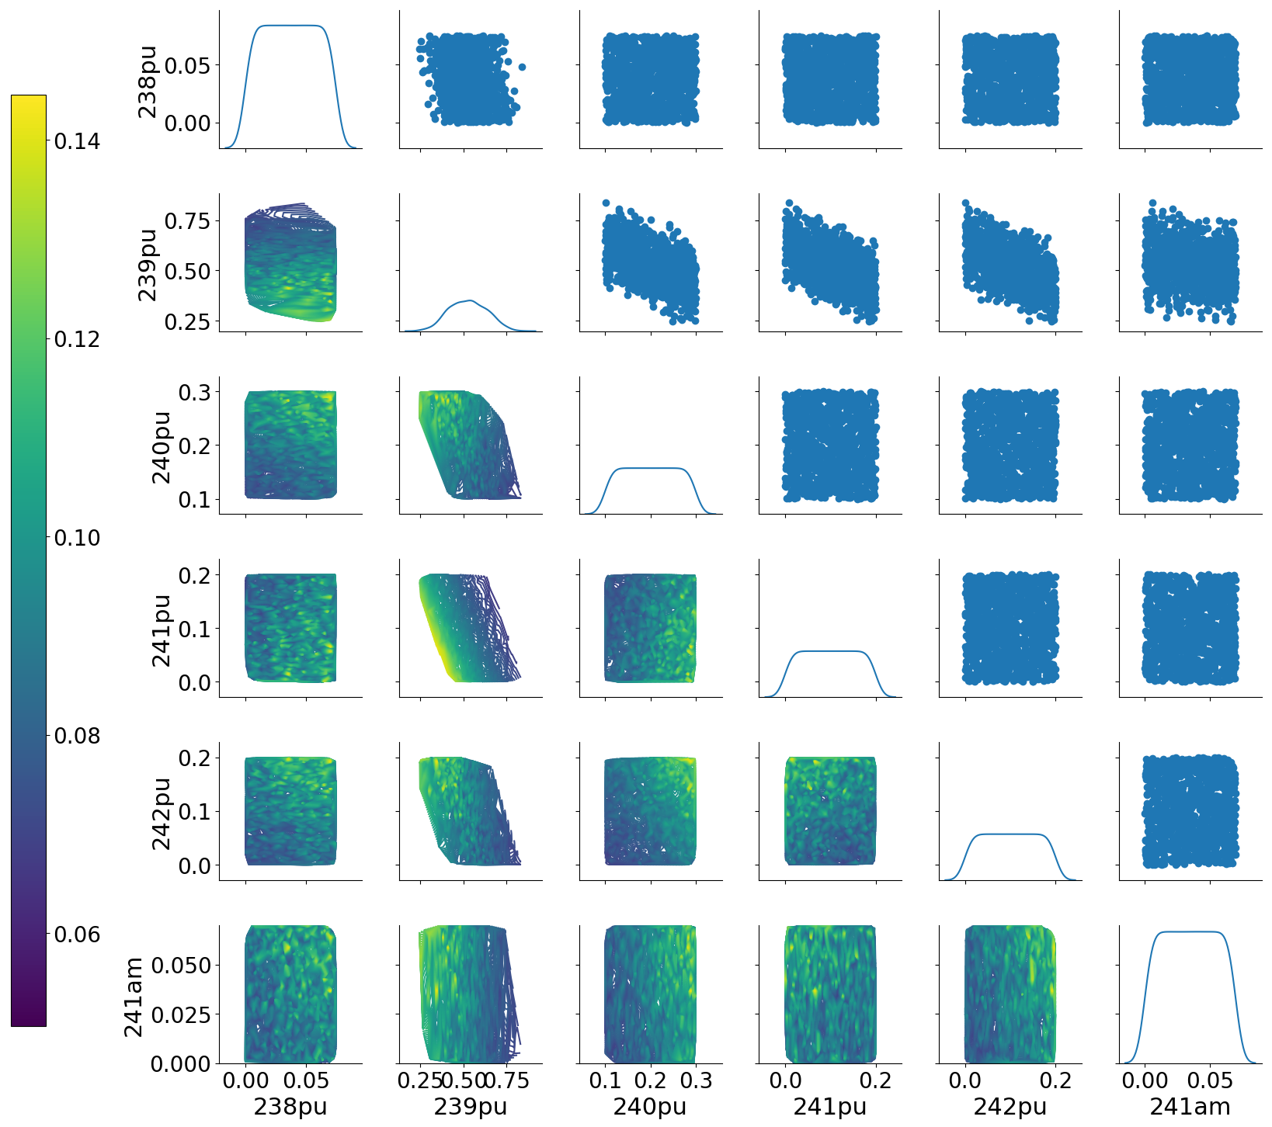

Figure 1 : Plutonium fraction in the fresh fuel at beginning of cycle.

**Data analysis**

**Output metric**

The output metrics defined in CLASS analysis have been used (estimator #1, #2, #3).

For all three estimators, similar conclusions as the CLASS PWR MOX analysis can be reached.

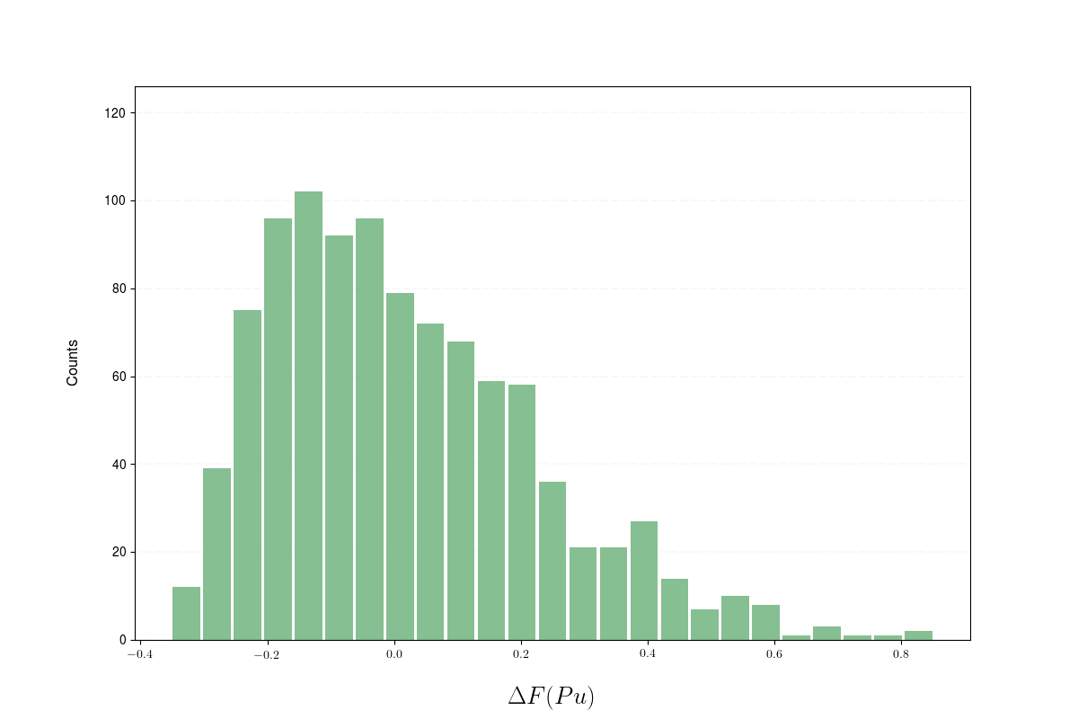

Figure 2: Estimator#1 Relative plutonium fraction deviation between FLM and FF approach distribution. The deviation is plotted in %.

A variation ranging between - 20% and 80% (relative to the fixed fraction) can be observed between the fixed fraction and the plutonium equivalent model. This effect might lead to variation on the localization of the plutonium stock, moving it from the upstream storage (with respect to the reactors) to the downstream storage.

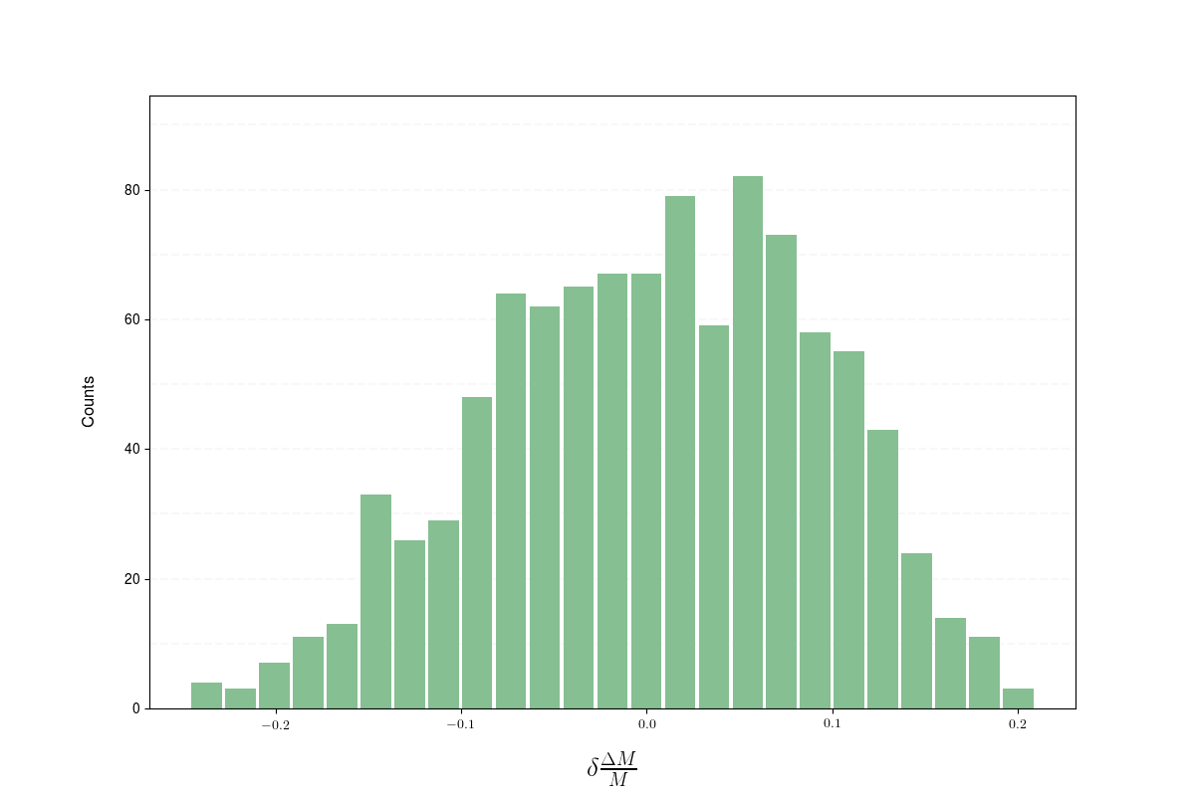

Figure 3: Estimator 2 normalized distribution in % for all the simulations.

As for the CLASS analysis, the relative amount of plutonium burnup in the reactor varies from -20 to +20% (relative to amount burned in the fixed fraction case) — see Figure 3.

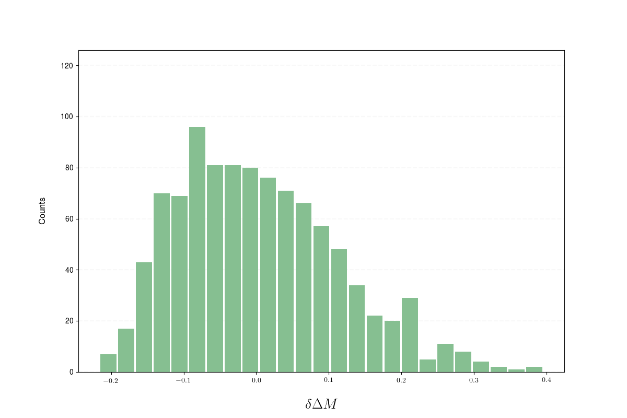

Figure 4: Estimator 3 normalized distribution in % for all the simulations.

Finally, the discrepancy for the mass of plutonium burned, variation goes form -20% to 40% (relative to the plutonium mass burned in the fixed fraction case) — see Figure 4.

This might impact strongly the total amount of plutonium present in simulation.

**Plutonium Composition**

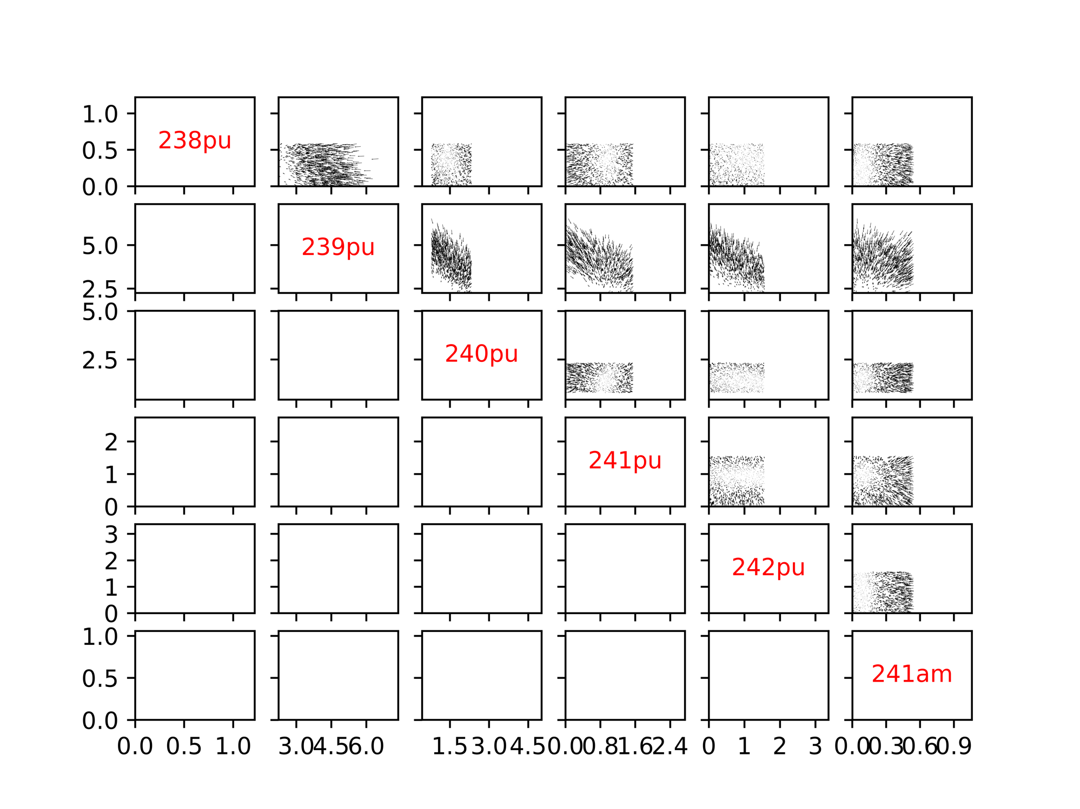

Figure 5:Fix fraction, Plutonium Isotopes fractions evolution (vector scale 1/10)

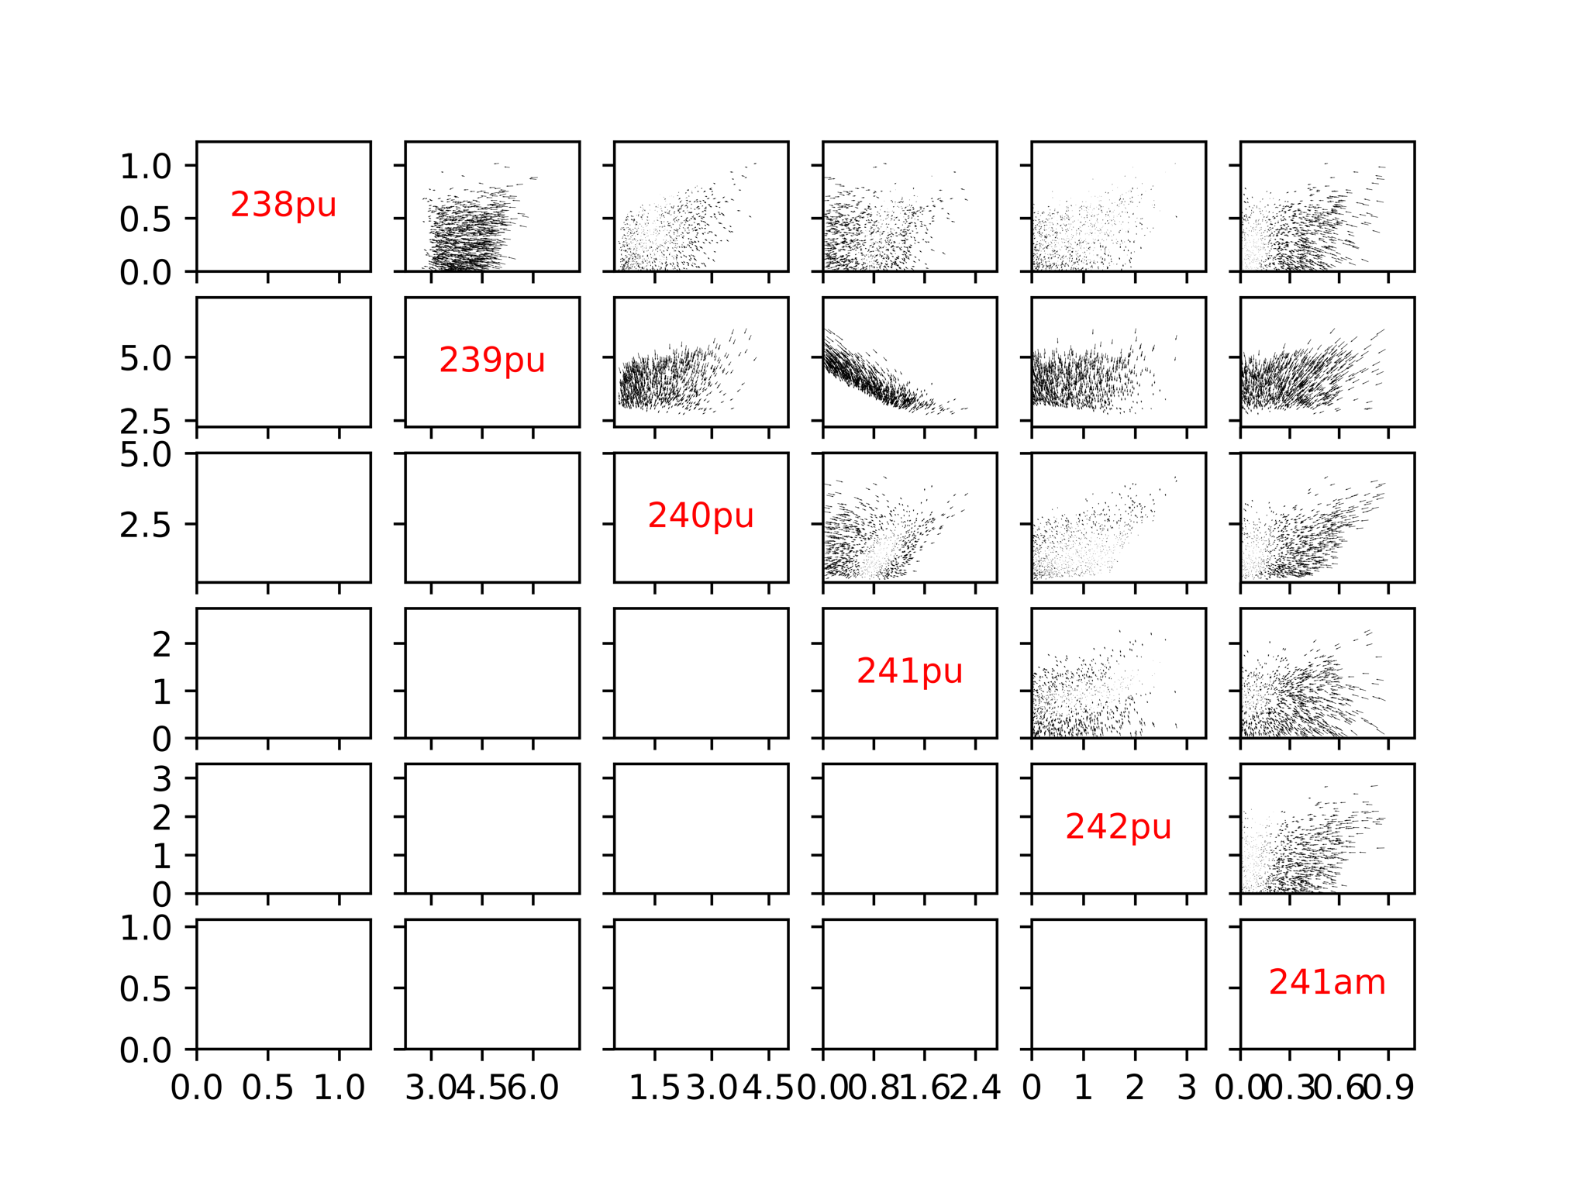

Figure 6:Pu-Equivalent Model, Plutonium Isotopes fractions evolution (vector scale 1/10)

Figure 5 and 6 can be found in hight resolution there:

Fig.5: https://github.com/bam241/fit_cyclus/raw/F01/F01/run_1/Variation_fix.png

Fig.6: https://github.com/bam241/fit_cyclus/raw/F01/F01/run_1/Variation_eq.png

Figures 5 and 6 confirm that the equilibrium composition of the plutonium in the considered reactor are the same, head toward to the same values regardless to the initial plutonium composition or fraction.

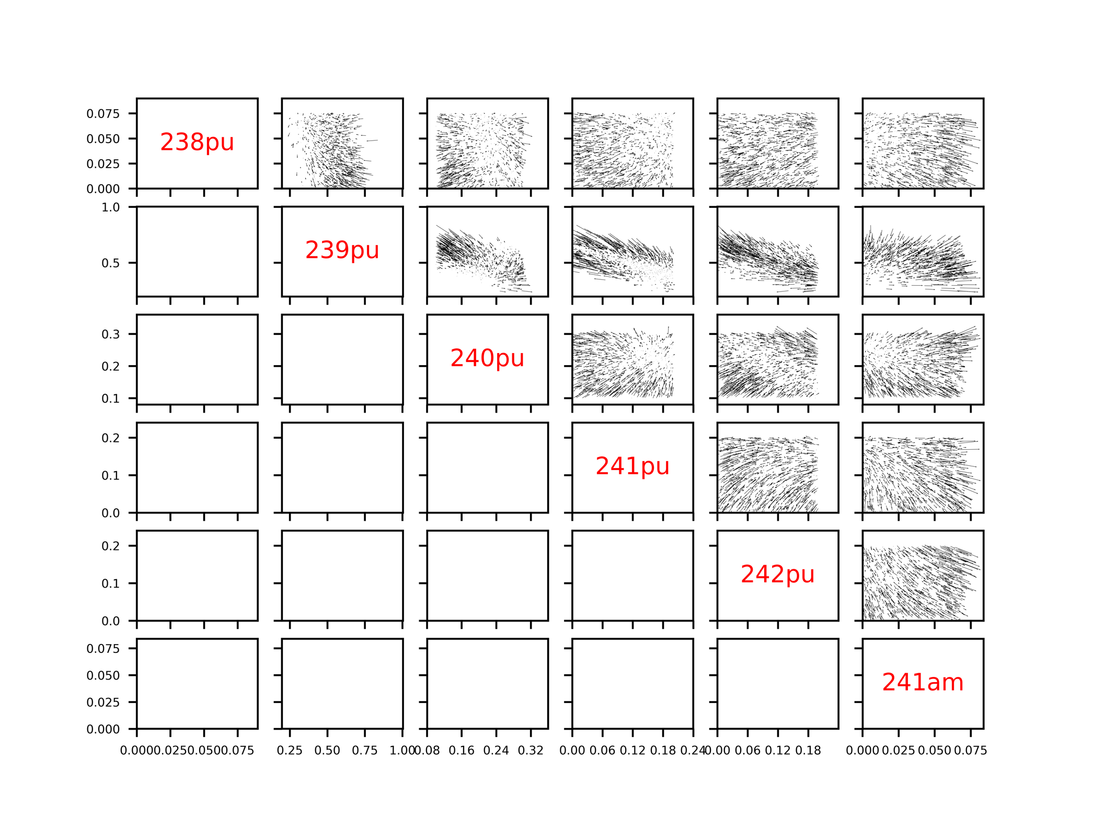

Figure 7: Plutonium Isotopes composition differences (FF – EqPu) as a function of the Pu initial composition

Fig.7 can be found in higher resolution here:

https://github.com/bam241/fit_cyclus/raw/F01/F01/run_1/Variation_pu_eoc.png

As shown on figure 7. using a fixed fraction instead of a fuel fabrication model, will have an impact on the plutonium composition at the end of the cycle. Depending of the scenario (reprocessing of the MOX spent fuel… ) using a fixed fraction might have a snowball effect on the rest of the simulation. One can observe up to 25% variation on the 238Pu isotopic fraction, 10% on the 239Pu, 15% on the 240Pu, 25% on the 241Pu, 84% on the 242Pu and 58% on the 241Am…