Electrical_Equipment

Bama Parthasarathy

November 17, 2016

Install FPP package

library("fpp")

## Warning: package 'fpp' was built under R version 3.3.2

## Loading required package: forecast

## Warning: package 'forecast' was built under R version 3.3.2

## Loading required package: zoo

##   
## Attaching package: 'zoo'

## The following objects are masked from 'package:base':  
##   
## as.Date, as.Date.numeric

## Loading required package: timeDate

## Warning: package 'timeDate' was built under R version 3.3.2

## This is forecast 7.3

## Loading required package: fma

## Warning: package 'fma' was built under R version 3.3.2

## Loading required package: tseries

## Warning: package 'tseries' was built under R version 3.3.2

## Loading required package: expsmooth

## Warning: package 'expsmooth' was built under R version 3.3.2

## Loading required package: lmtest

1. Plot the time series. Can you identify seasonal fluctuations and/or a trend?

data(hsales)  
hsales

## Jan Feb Mar Apr May Jun Jul Aug Sep Oct Nov Dec  
## 1973 55 60 68 63 65 61 54 52 46 42 37 30  
## 1974 37 44 55 53 58 50 48 45 41 34 30 24  
## 1975 29 34 44 54 57 51 51 53 46 46 46 39  
## 1976 41 53 55 62 55 56 57 59 58 55 49 47  
## 1977 57 68 84 81 78 74 64 74 71 63 55 51  
## 1978 57 63 75 85 80 77 68 72 68 70 53 50  
## 1979 53 58 73 72 68 63 64 68 60 54 41 35  
## 1980 43 44 44 36 44 50 55 61 50 46 39 33  
## 1981 37 40 49 44 45 38 36 34 28 29 27 29  
## 1982 28 29 36 32 36 34 31 36 39 40 39 33  
## 1983 44 46 57 59 64 59 51 50 48 51 45 48  
## 1984 52 58 63 61 59 58 52 48 53 55 42 38  
## 1985 48 55 67 60 65 65 63 61 54 52 51 47  
## 1986 55 59 89 84 75 66 57 52 60 54 48 49  
## 1987 53 59 73 72 62 58 55 56 52 52 43 37  
## 1988 43 55 68 68 64 65 57 59 54 57 43 42  
## 1989 52 51 58 60 61 58 62 61 49 51 47 40  
## 1990 45 50 58 52 50 50 46 46 38 37 34 29  
## 1991 30 40 46 46 47 47 43 46 37 41 39 36  
## 1992 48 55 56 53 52 53 52 56 51 48 42 42  
## 1993 44 50 60 66 58 59 55 57 57 56 53 51  
## 1994 45 58 74 65 65 55 52 59 54 57 45 40  
## 1995 47 47 60 58 63 64 64 63 55 54 44

plot(hsales)

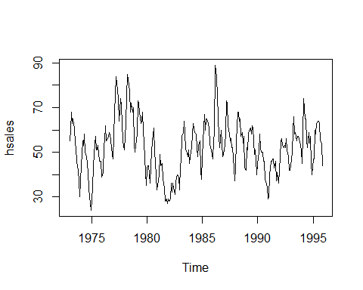 b) Use a classical decomposition to calculate the trend-cycle and seasonal indices.

fitd <- decompose(hsales)  
plot(fitd)

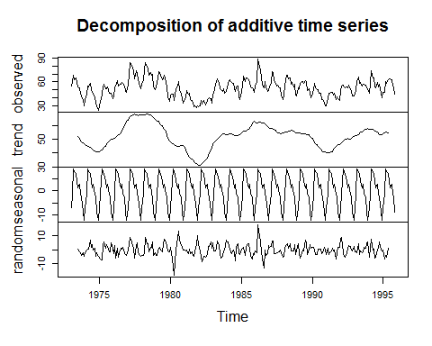

1. Do the results support the graphical interpretation from part (a)?

fit <- stl(hsales, s.window=5)  
plot(fit)

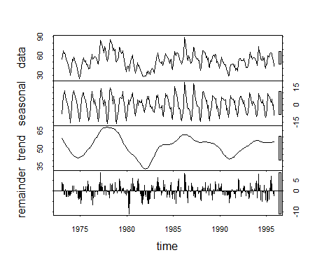 d) Compute and plot the seasonally adjusted data.

eeadj <- seasadj(fitd)  
plot(eeadj)

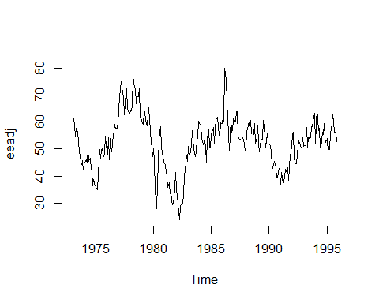

1. Change one observation to be an outlier (e.g., add 500 to one observation), and recompute the seasonally adjusted data. What is the effect of the outlier?

ee2 <- hsales  
 ee2[14] = ee2[14] + 500   
  
 fit2 <- decompose(ee2)   
ee2adj <- seasadj(fit2)   
 plot(ee2adj)

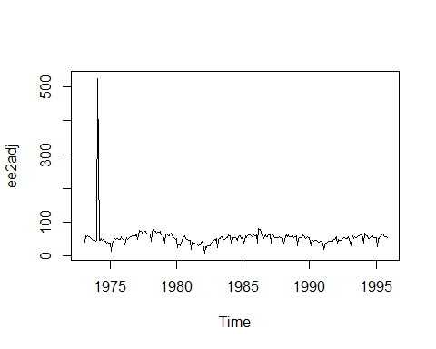 When we include the outlier to the data, the plot of the seasonal adjustment is so high for that one month in that year.

1. Does it make any difference if the outlier is near the end rather than in the middle of the time series?

ee3 <- hsales  
 ee3[21] = ee3[21] + 501   
  
 fit3 <- decompose(ee3)   
ee3adj <- seasadj(fit3)   
 plot(ee3adj)

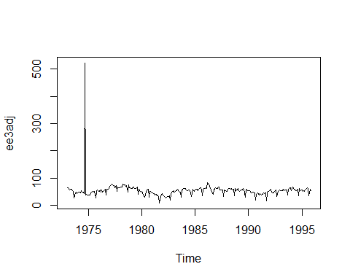 When we include the outlier to the data, the plot of the seasonal adjustment is so high for that one month in that year and it doesnt mateer where it occurs either .

1. Use STL to decompose the series.

fit4 <- stl(hsales,t.window=15,s.window="periodic")  
fit4

## Call:  
## stl(x = hsales, s.window = "periodic", t.window = 15)  
##   
## Components  
## seasonal trend remainder  
## Jan 1973 -7.097902 62.63332 -0.535422725  
## Feb 1973 -1.249071 60.86797 0.381103464  
## Mar 1973 9.078022 59.10261 -0.180632994  
## Apr 1973 7.990454 57.31929 -2.309749082  
## May 1973 7.381148 55.53598 2.082874106  
## Jun 1973 4.784276 53.76817 2.447554630  
## Jul 1973 1.578708 52.00036 0.420932011  
## Aug 1973 2.926674 50.37004 -1.296711754  
## Sep 1973 -1.377530 48.73971 -1.362183825  
## Oct 1973 -2.478505 47.55458 -3.076078050  
## Nov 1973 -9.101220 46.36945 -0.268231831  
## Dec 1973 -12.435055 45.94027 -3.505213074  
## Jan 1974 -7.097902 45.51108 -1.413182040  
## Feb 1974 -1.249071 45.51449 -0.265422148  
## Mar 1974 9.078022 45.51790 0.404075097  
## Apr 1974 7.990454 45.31727 -0.307720557  
## May 1974 7.381148 45.11663 5.502223065  
## Jun 1974 4.784276 44.41387 0.801854570  
## Jul 1974 1.578708 43.71111 2.710182931  
## Aug 1974 2.926674 42.54077 -0.467439559  
## Sep 1974 -1.377530 41.37042 1.007109645  
## Oct 1974 -2.478505 40.26518 -3.786677744  
## Nov 1974 -9.101220 39.15994 -0.058724687  
## Dec 1974 -12.435055 39.18622 -2.751165652  
## Jan 1975 -7.097902 39.21250 -3.114594339  
## Feb 1975 -1.249071 40.24396 -4.994887686  
## Mar 1975 9.078022 41.27542 -6.353443681  
## Apr 1975 7.990454 42.72376 3.285789199  
## May 1975 7.381148 44.17209 5.446761355  
## Jun 1975 4.784276 45.79265 0.423076478  
## Jul 1975 1.578708 47.41320 2.008088457  
## Aug 1975 2.926674 48.47106 1.602270011  
## Sep 1975 -1.377530 49.52891 -2.151376741  
## Oct 1975 -2.478505 49.86269 -1.384180380  
## Nov 1975 -9.101220 50.19646 4.904756427  
## Dec 1975 -12.435055 50.37691 1.058148566  
## Jan 1976 -7.097902 50.55735 -2.459447016  
## Feb 1976 -1.249071 50.85671 3.392364107  
## Mar 1976 9.078022 51.15607 -5.234087418  
## Apr 1976 7.990454 51.75709 2.252455526  
## May 1976 7.381148 52.35811 -4.739262253  
## Jun 1976 4.784276 53.30503 -2.089307001  
## Jul 1976 1.578708 54.25195 1.169345108  
## Aug 1976 2.926674 55.64851 0.424816914  
## Sep 1976 -1.377530 57.04507 2.332460413  
## Oct 1976 -2.478505 59.07822 -1.599714564  
## Nov 1976 -9.101220 61.11137 -3.010149097  
## Dec 1976 -12.435055 63.00403 -3.568979826  
## Jan 1977 -7.097902 64.89670 -0.798798277  
## Feb 1977 -1.249071 66.18458 3.064491173  
## Mar 1977 9.078022 67.47246 7.449517974  
## Apr 1977 7.990454 68.36148 4.648068971  
## May 1977 7.381148 69.25049 1.368359243  
## Jun 1977 4.784276 69.08915 0.126577377  
## Jul 1977 1.578708 68.92780 -6.506507632  
## Aug 1977 2.926674 68.05373 3.019595444  
## Sep 1977 -1.377530 67.17966 5.197870213  
## Oct 1977 -2.478505 66.84064 -1.362140208  
## Nov 1977 -9.101220 66.50163 -2.400410184  
## Dec 1977 -12.435055 66.86256 -3.427502257  
## Jan 1978 -7.097902 67.22348 -3.125582052  
## Feb 1978 -1.249071 67.64272 -3.393645649  
## Mar 1978 9.078022 68.06195 -2.139971894  
## Apr 1978 7.990454 68.66978 8.339766966  
## May 1978 7.381148 69.27761 3.341245103  
## Jun 1978 4.784276 69.41115 2.804568846  
## Jul 1978 1.578708 69.54470 -3.123410554  
## Aug 1978 2.926674 68.57771 0.495610701  
## Sep 1978 -1.377530 67.61073 1.766803649  
## Oct 1978 -2.478505 66.43613 6.042371816  
## Nov 1978 -9.101220 65.26154 -3.160319572  
## Dec 1978 -12.435055 64.35718 -1.922130355  
## Jan 1979 -7.097902 63.45283 -3.354928860  
## Feb 1979 -1.249071 62.70251 -3.453436857  
## Mar 1979 9.078022 61.95219 1.969792498  
## Apr 1979 7.990454 61.73115 2.278394678  
## May 1979 7.381148 61.51012 -0.891263867  
## Jun 1979 4.784276 60.80383 -2.588109008  
## Jul 1979 1.578708 60.09755 2.323742708  
## Aug 1979 2.926674 58.56141 6.511915165  
## Sep 1979 -1.377530 57.02527 4.352259316  
## Oct 1979 -2.478505 54.60118 1.877326588  
## Nov 1979 -9.101220 52.17709 -2.075865695  
## Dec 1979 -12.435055 49.18329 -1.748231374  
## Jan 1980 -7.097902 46.18949 3.908415224  
## Feb 1980 -1.249071 44.79711 0.451962692  
## Mar 1980 9.078022 43.40473 -8.482752489  
## Apr 1980 7.990454 43.70705 -15.697507937  
## May 1980 7.381148 44.00938 -7.390524110  
## Jun 1980 4.784276 44.86241 0.353311099  
## Jul 1980 1.578708 45.71545 7.705843164  
## Aug 1980 2.926674 46.77348 11.299849317  
## Sep 1980 -1.377530 47.83150 3.546027162  
## Oct 1980 -2.478505 47.53398 0.944520200  
## Nov 1980 -9.101220 47.23647 0.864753682  
## Dec 1980 -12.435055 45.46033 -0.025274989  
## Jan 1981 -7.097902 43.68419 0.413708618  
## Feb 1981 -1.249071 41.78221 -0.533140248  
## Mar 1981 9.078022 39.88023 0.041748238  
## Apr 1981 7.990454 38.18567 -2.176120217  
## May 1981 7.381148 36.49110 1.127750603  
## Jun 1981 4.784276 35.49635 -2.280630126  
## Jul 1981 1.578708 34.50161 -0.080313998  
## Aug 1981 2.926674 34.22366 -3.150337173  
## Sep 1981 -1.377530 33.94572 -4.568188654  
## Oct 1981 -2.478505 33.48086 -2.002352157  
## Nov 1981 -9.101220 33.01599 3.085224785  
## Dec 1981 -12.435055 32.44364 8.991413117  
## Jan 1982 -7.097902 31.87129 3.226613727  
## Feb 1982 -1.249071 31.40827 -1.159202997  
## Mar 1982 9.078022 30.94526 -4.023282368  
## Apr 1982 7.990454 30.89177 -6.882224420  
## May 1982 7.381148 30.83828 -2.219427196  
## Jun 1982 4.784276 32.18351 -2.967790852  
## Jul 1982 1.578708 33.52875 -4.107457652  
## Aug 1982 2.926674 35.95083 -2.877506535  
## Sep 1982 -1.377530 38.37291 2.004616275  
## Oct 1982 -2.478505 40.77777 1.700734147  
## Nov 1982 -9.101220 43.18263 4.918592465  
## Dec 1982 -12.435055 45.30106 0.133995178  
## Jan 1983 -7.097902 47.41949 3.678410170  
## Feb 1983 -1.249071 48.62187 -1.372797738  
## Mar 1983 9.078022 49.82425 -1.902268293  
## Apr 1983 7.990454 50.21903 0.790516791  
## May 1983 7.381148 50.61381 6.005041151  
## Jun 1983 4.784276 51.13236 3.083361555  
## Jul 1983 1.578708 51.65091 -2.229621185  
## Aug 1983 2.926674 52.42081 -5.347486796  
## Sep 1983 -1.377530 53.19071 -3.813180713  
## Oct 1983 -2.478505 53.74357 -0.265060734  
## Nov 1983 -9.101220 54.29642 -0.195200311  
## Dec 1983 -12.435055 54.72569 5.709363153  
## Jan 1984 -7.097902 55.15496 3.942938895  
## Feb 1984 -1.249071 54.98363 4.265445198  
## Mar 1984 9.078022 54.81229 -0.890311148  
## Apr 1984 7.990454 54.09304 -1.083497955  
## May 1984 7.381148 53.37380 -1.754945488  
## Jun 1984 4.784276 52.82397 0.391748941  
## Jul 1984 1.578708 52.27415 -1.852859774  
## Aug 1984 2.926674 52.23405 -7.160720127  
## Sep 1984 -1.377530 52.19394 2.183591214  
## Oct 1984 -2.478505 52.64665 4.831858272  
## Nov 1984 -9.101220 53.09935 -1.998134224  
## Dec 1984 -12.435055 53.76941 -3.334356585  
## Jan 1985 -7.097902 54.43947 0.658433333  
## Feb 1985 -1.249071 55.15216 1.096914394  
## Mar 1985 9.078022 55.86485 2.057132807  
## Apr 1985 7.990454 56.41502 -4.405475846  
## May 1985 7.381148 56.96520 0.653654777  
## Jun 1985 4.784276 57.26798 2.947746780  
## Jul 1985 1.578708 57.57076 3.850535640  
## Aug 1985 2.926674 58.03891 0.034416557  
## Sep 1985 -1.377530 58.50706 -3.129530832  
## Oct 1985 -2.478505 59.64373 -5.165226603  
## Nov 1985 -9.101220 60.78040 -0.679181929  
## Dec 1985 -12.435055 62.23626 -2.801206504  
## Jan 1986 -7.097902 63.69212 -1.594218801  
## Feb 1986 -1.249071 64.24098 -3.991906871  
## Mar 1986 9.078022 64.78984 15.132142411  
## Apr 1986 7.990454 64.32788 11.681661496  
## May 1986 7.381148 63.86593 3.752919856  
## Jun 1986 4.784276 62.77526 -1.559531405  
## Jul 1986 1.578708 61.68458 -6.263285811  
## Aug 1986 2.926674 60.32997 -11.256644666  
## Sep 1986 -1.377530 58.97536 2.402168173  
## Oct 1986 -2.478505 58.81863 -2.340124657  
## Nov 1986 -9.101220 58.66190 -1.560677041  
## Dec 1986 -12.435055 59.07383 2.361222111  
## Jan 1987 -7.097902 59.48577 0.612133540  
## Feb 1987 -1.249071 59.18674 1.062331775  
## Mar 1987 9.078022 58.88771 5.034267361  
## Apr 1987 7.990454 58.15163 5.857920210  
## May 1987 7.381148 57.41554 -2.796687665  
## Jun 1987 4.784276 56.37341 -3.157683427  
## Jul 1987 1.578708 55.33127 -1.909982333  
## Aug 1987 2.926674 54.33087 -1.257545151  
## Sep 1987 -1.377530 53.33047 0.047063724  
## Oct 1987 -2.478505 53.33889 1.139615614  
## Nov 1987 -9.101220 53.34731 -1.246092050  
## Dec 1987 -12.435055 53.93085 -4.495799865  
## Jan 1988 -7.097902 54.51440 -4.416495401  
## Feb 1988 -1.249071 55.09908 1.149991030  
## Mar 1988 9.078022 55.68376 3.238214814  
## Apr 1988 7.990454 56.24355 3.765992635  
## May 1988 7.381148 56.80334 -0.184490269  
## Jun 1988 4.784276 56.92746 3.288262507  
## Jul 1988 1.578708 57.05158 -1.630287861  
## Aug 1988 2.926674 56.68968 -0.616358325  
## Sep 1988 -1.377530 56.32779 -0.950257095  
## Oct 1988 -2.478505 55.74891 3.729598618  
## Nov 1988 -9.101220 55.17002 -3.068805225  
## Dec 1988 -12.435055 54.66440 -0.229350237  
## Jan 1989 -7.097902 54.15878 4.939117029  
## Feb 1989 -1.249071 54.08598 -1.836912183  
## Mar 1989 9.078022 54.01318 -5.091204042  
## Apr 1989 7.990454 54.05090 -2.041355102  
## May 1989 7.381148 54.08862 -0.469766886  
## Jun 1989 4.784276 54.14901 -0.933282883  
## Jul 1989 1.578708 54.20939 6.211897976  
## Aug 1989 2.926674 54.29231 3.781013508  
## Sep 1989 -1.377530 54.37523 -3.997699267  
## Oct 1989 -2.478505 53.77284 -0.294331583  
## Nov 1989 -9.101220 53.17044 2.930776546  
## Dec 1989 -12.435055 51.94237 0.492688731  
## Jan 1990 -7.097902 50.71429 1.383613195  
## Feb 1990 -1.249071 49.51397 1.735098746  
## Mar 1990 9.078022 48.31366 0.608321649  
## Apr 1990 7.990454 46.97148 -2.961930029  
## May 1990 7.381148 45.62929 -3.010442432  
## Jun 1990 4.784276 44.50697 0.708753546  
## Jul 1990 1.578708 43.38465 1.036646379  
## Aug 1990 2.926674 42.65579 0.417536344  
## Sep 1990 -1.377530 41.92693 -2.549401999  
## Oct 1990 -2.478505 41.31944 -1.840937415  
## Nov 1990 -9.101220 40.71195 2.389267613  
## Dec 1990 -12.435055 40.28996 1.145097490  
## Jan 1991 -7.097902 39.86796 -2.770060355  
## Feb 1991 -1.249071 39.86967 1.379397041  
## Mar 1991 9.078022 39.87139 -2.949408210  
## Apr 1991 7.990454 40.00196 -1.992413580  
## May 1991 7.381148 40.13253 -0.513679674  
## Jun 1991 4.784276 40.79270 1.423022878  
## Jul 1991 1.578708 41.45287 -0.031577714  
## Aug 1991 2.926674 42.81555 0.257772719  
## Sep 1991 -1.377530 44.17824 -5.800705155  
## Oct 1991 -2.478505 45.43031 -1.951800746  
## Nov 1991 -9.101220 46.68238 1.418844107  
## Dec 1991 -12.435055 47.37226 1.062793785  
## Jan 1992 -7.097902 48.06215 7.035755741  
## Feb 1992 -1.249071 48.60750 7.641575885  
## Mar 1992 9.078022 49.15284 -2.230866619  
## Apr 1992 7.990454 49.35556 -4.346009486  
## May 1992 7.381148 49.55827 -4.939413077  
## Jun 1992 4.784276 49.61658 -1.400856647  
## Jul 1992 1.578708 49.67490 0.746396639  
## Aug 1992 2.926674 50.20866 2.864666739  
## Sep 1992 -1.377530 50.74242 1.635108532  
## Oct 1992 -2.478505 51.27659 -0.798084109  
## Nov 1992 -9.101220 51.81076 -0.709536304  
## Dec 1992 -12.435055 52.07396 2.361096072  
## Jan 1993 -7.097902 52.33716 -1.239259273  
## Feb 1993 -1.249071 52.56421 -1.315133807  
## Mar 1993 9.078022 52.79125 -1.869270988  
## Apr 1993 7.990454 53.24912 4.760421626  
## May 1993 7.381148 53.70700 -3.088146484  
## Jun 1993 4.784276 54.56013 -0.344401925  
## Jul 1993 1.578708 55.41325 -1.991960509  
## Aug 1993 2.926674 56.14941 -2.076081192  
## Sep 1993 -1.377530 56.88556 1.491969819  
## Oct 1993 -2.478505 57.58867 0.889834744  
## Nov 1993 -9.101220 58.29178 3.809440115  
## Dec 1993 -12.435055 58.57592 4.859133500  
## Jan 1994 -7.097902 58.86006 -6.762160837  
## Feb 1994 -1.249071 58.25291 0.996156997  
## Mar 1994 9.078022 57.64577 7.276212184  
## Apr 1994 7.990454 57.01907 -0.009523089  
## May 1994 7.381148 56.39237 1.226480913  
## Jun 1994 4.784276 55.98646 -5.770731638  
## Jul 1994 1.578708 55.58054 -5.159247333  
## Aug 1994 2.926674 54.98379 1.089530954  
## Sep 1994 -1.377530 54.38705 0.990480935  
## Oct 1994 -2.478505 54.01866 5.459844715  
## Nov 1994 -9.101220 53.65027 0.450948940  
## Dec 1994 -12.435055 53.51443 -1.079373720  
## Jan 1995 -7.097902 53.37859 0.719315898  
## Feb 1995 -1.249071 53.65613 -5.407062040  
## Mar 1995 9.078022 53.93368 -3.011702625  
## Apr 1995 7.990454 54.53753 -4.527984096  
## May 1995 7.381148 55.14138 0.477473708  
## Jun 1995 4.784276 55.59793 3.617794779  
## Jul 1995 1.578708 56.05448 6.366812705  
## Aug 1995 2.926674 56.56281 3.510516640  
## Sep 1995 -1.377530 57.07114 -0.693607731  
## Oct 1995 -2.478505 57.51272 -1.034218921  
## Nov 1995 -9.101220 57.95431 -4.853089667