**Note:** The images below are captured from emails in the researcher’s inbox. The researcher explicitly selected these emails as examples of non-phishing emails with image attachments to create a simulated dataset. It is essential to clarify that these emails were legitimate and not associated with phishing or malicious activities.

Images Files with PNG extension:

Attachment Image-1

Attachment Image-2

Attachment Image-3

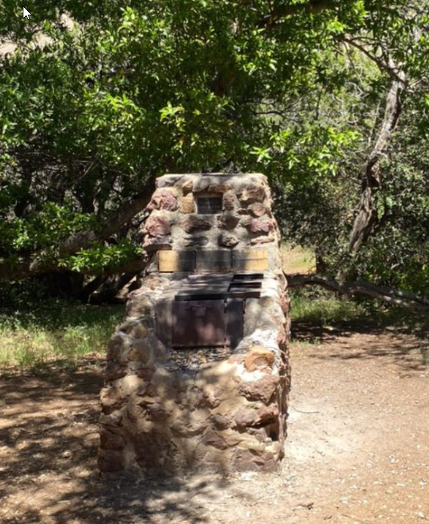

Attachment Image-4

Attachment Image-5

Attachment Image-6

(Verizon, 2023)

Image Files with JPG extension:

Attachment Image-7

Attachment Image-8

Attachment Image-9

Attachment Image-10

Reference

Verizon. (n.d.). *2023 data breach investigations report*. Verizon Business. https://www.verizon.com/business/resources/reports/dbir/