GY4051
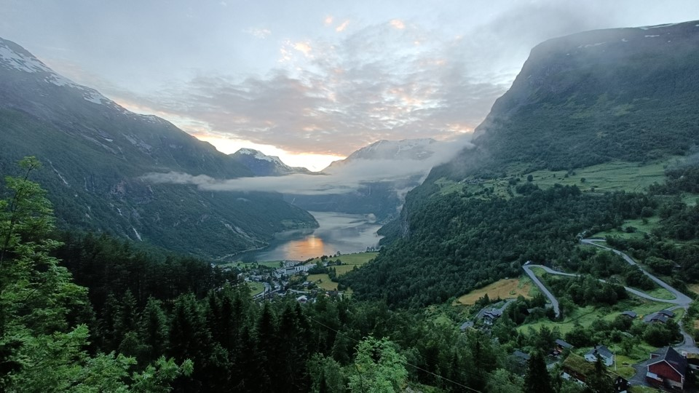
Earth Science and Society
Laboratory Workbook 2024/5 Tables and Questions

2 | 1 | E | D | C | B | A | Rock
 |  |  |  |  |  |  | Colour
 |  |  |  |  |  |  | Composition
 |  |  |  |  |  |  | Texture
 |  |  |  |  |  |  | Crystal shape
 |  |  |  |  |  |  | Style
 |  |  |  |  |  |  | Hazards
Questions
- Which is darker, the gabbro A or the granite C?

- Which is darker, the basalt B or the rhyolite D?

- Is the difference between gabbro A and the basalt B similar to the difference between the granite C and the rhyolite D?

- Which two rocks were formed from effusive eruptions?

- Which two rocks have the smallest crystal size?

- Which kind of rock do you think sediment 1 was eroded from?

- Which kind of rock do you think sediment 2 was eroded from?

3 | J | I | H | G | F | Rock
 |  |  |  |  |  | Colour
 |  |  |  |  |  | Texture
 |  |  |  |  |  | Crystal size
 |  |  |  |  |  | Permeability
 |  |  |  |  |  | Facies
 |  |  |  |  |  | Setting
 |  |  |  |  |  | Use?

Questions
- List rocks slate F, schist G, and gneiss H, in order of crystal size, from smallest to largest?

- List rocks slate F, schist G, and gneiss H, in order of layer thickness, from thinnest layers to thickest layers?

- List rocks slate F, schist G, and gneiss H, in order of metamorphic grade, from lowest metamorphic grade to highest metamorphic grade?

- Which of these rocks has the highest permeability?

- How does the permeability compare between rocks slate F, schist G, gneiss H, and quartzite I?

- Which of rocks slate F, schist G, gneiss H, and quartzite I could most easily be split into thin flat sheets?

- Which kind of rock do you think sediment 3 was eroded from?

GEOGRAPHY READING WEEK: Virtual Field Trip to Parys, Wales
There are too many students on this module to bring you all on an overseas field trip – so we’ll do the next best thing. This week’s virtual field trip to Parys, on the island of Anglesey in Wales, consists of a series of videos I recorded on site, along with some additional photos, all geolocated on an ArcGIS Story Map. You can go through the tour stop by stop, see the rocks around the area, and how it impacted society in the local region and beyond.
It should take around one hour to complete.
There’s also an independent exercise starting on the next page.

Reading Week Exercise: Stratigraphy and Geological Time

- Using the Principles of stratigraphy listed above, determine the sequence of geological events which have occurred in Figure 1. M and N are faults, J, K & L are igneous intrusions, and all other layers are sedimentary rocks.
Oldest |  |  |  |  |  |  | Youngest

- Which principle of stratigraphy did you apply to determine the relative ages of H and I?

- Which principle of stratigraphy did you apply to determine the relative ages of M and F?

- Explain the relationship between fault N and igneous intrusion J.

- For the recent past, carbon dating may be used – based on the decay of carbon-14 (¹⁴C). Knowing that the half life of ¹⁴C is 5730 years complete Table 1 by calculating the ‘percent of ¹⁴C remaining’ by years before present (B.P.).
Years B.P. | 0 | 5,730 | 11,460 | 17,190 | 22,920 | 28,650 | 34,380 | 40,110 | 45,840 | 51,570
% of ¹⁴C remaining
Table 1

Using the graph paper on the next page, construct a line graph from the data in Table 1. The result should be a smooth, curving line through all points. Use this graph of ¹⁴C decay to answer the following questions:
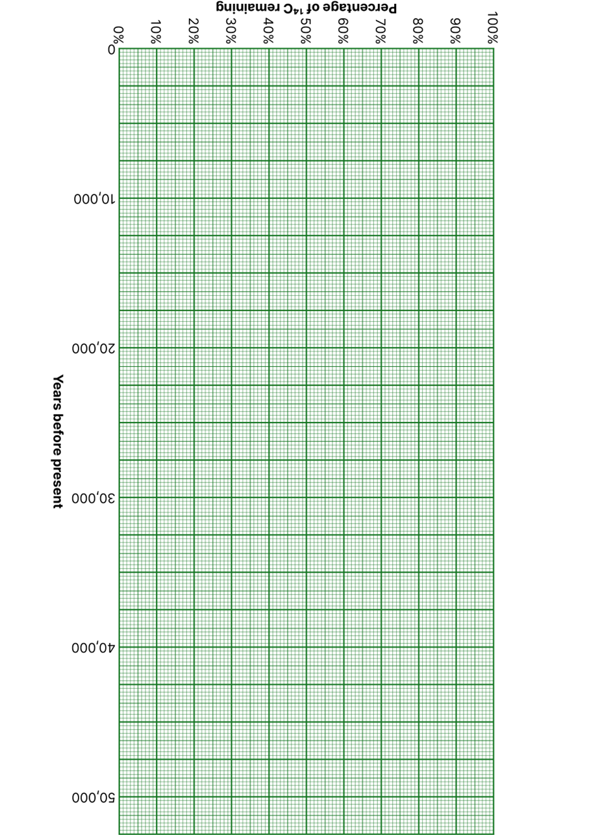
- In 1991, hikers in the Alps discovered an almost perfectly preserved body of a prehistoric man. Carbon dating of samples from the site established the death of the man to be approximately 5,300 years ago. What percentage of the original carbon-14 remained in the body?

- A 1998 study provided evidence that the tropics were much colder during the last glacial maximum than previously thought. Investigators retrieved two ice cores from the bottom of the ice cap at the summit of an extinct Bolivian volcano named Sajama. Trapped within the cores were insects and bark fragments from local trees. Carbon from organic material near the bottom of the cores dated to the coldest period of the last ice age. If those samples had 5.5 percent of their original carbon-14, approximately how many years ago did the glacier atop Sajama begin to form?

6 | 5 | 4 | O | N | M | L | K | Rock
 |  |  |  |  |  |  |  | Colour
 |  |  |  |  |  |  |  | Grain size
 |  |  |  |  |  |  |  | Sorting
 |  |  |  |  |  |  |  | Roundness/ sphericity
 |  |  |  |  |  |  |  | Porosity/ Matrix/Cement
 |  |  |  |  |  |  |  | Sedimentary structures
 |  |  |  |  |  |  |  | Oil & Gas systems

Questions
- How does the aeolian dune sandstone rock K compare to the aeolian dune sand sediment 4?

- How does the river sandstone rock L compare to the river sand sediment 5?

- How does the glacial diamictite rock M compare to the glacial till sediment 6?

- Is the difference between the aeolian dune sandstone rock K and the river sandstone rock L similar to the difference between the aeolian dune sand sediment 4 and the river sand sediment 5?

- Which rock is the most poorly sorted?

- Which rock is the most well sorted?

- Which rock has the most rounded grains?

- Which rock has the highest porosity?

9 |  |  |  | 8 |  |  |  | 7 |  |  |  | S |  |  |  | R |  |  |  | Q |  |  |  | P |  |  |  | Rock
 |  |  |  |  |  |  |  |  |  |  |  |  |  |  |  |  |  |  |  |  |  |  |  |  |  |  |  | Colour
Alteration | Sparite | Micrite | Allochems | Alteration | Sparite | Micrite | Allochems | Alteration | Sparite | Micrite | Allochems | Alteration | Sparite | Micrite | Allochems | Alteration | Sparite | Micrite | Allochems | Alteration | Sparite | Micrite | Allochems | Alteration | Sparite | Micrite | Allochems | Components
Peloids | Ooids | Intraclasts | Bioclasts | Peloids | Ooids | Intraclasts | Bioclasts | Peloids | Ooids | Intraclasts | Bioclasts | Peloids | Ooids | Intraclasts | Bioclasts | Peloids | Ooids | Intraclasts | Bioclasts | Peloids | Ooids | Intraclasts | Bioclasts | Peloids | Ooids | Intraclasts | Bioclasts | Allochems
 |  |  |  |  |  |  |  |  |  |  |  |  |  |  |  |  |  |  |  |  |  |  |  |  |  |  |  | Fossils
RL |  | RH |  | RL |  | RH |  | RL |  | RH |  | RL |  | RH |  | RL |  | RH |  | RL |  | RH |  | RL |  | RH |  | Sedimentation rate & energy
IL |  | IH |  | IL |  | IH |  | IL |  | IH |  | IL |  | IH |  | IL |  | IH |  | IL |  | IH |  | IL |  | IH
LL |  | LH |  | LL |  | LH |  | LL |  | LH |  | LL |  | LH |  | LL |  | LH |  | LL |  | LH |  | LL |  | LH
 |  |  |  |  |  |  |  |  |  |  |  | Grainstone | Packstone | Wackestone | Mudstone | Grainstone | Packstone | Wackestone | Mudstone | Grainstone | Packstone | Wackestone | Mudstone | Grainstone | Packstone | Wackestone | Mudstone | Dunham Classification
Questions
- Which of the four rocks shelf limestone P, mud mound limestone Q, calciturbidite R, and chalk S had the highest sedimentation rate?

- Which of the four rocks shelf limestone P, mud mound limestone Q, calciturbidite R, and chalk S has intraclast allochems?

- Which of the three rocks shelf limestone P, mud mound limestone Q, and calciturbidite R had the lowest energy environment?

- Which of the three rocks shelf limestone P, mud mound limestone Q, and calciturbidite R contains the most complete fossils?

- How does the permeability compare between the four rocks shelf limestone P, mud mound limestone Q, calciturbidite R, and chalk S?

- To which of the rocks is sediment 7 most similar?

- Do you think sediments 7, 8, and 9 were eroded from a limestone rock?

