Assignment 7: Phase 1

Concept 1:

Hierarchical representation of my idea of the web page. The lines represent relationships between the different pages on the website. I chose this representation because it is very clear how the webpage is organized and how to navigate through the website. It will include both lateral and vertical navigation. According to Rosenfeld et al. in the book “Information Architecture: For the Web and Beyond”, this type of mapping “provide a bird´s eye view of the information environment” (p.177), which was my main reason for this representation.

This webpage is structured around key facts and Alexander the Great´s timeline. I will use a global navigation bar, where there will be a logo up in the left corner that will link to the home page. The reason why I chose this navigation bar is because it allows for direct access to key areas and functions, no matter where the user is on the page. The navigation bar will stay the same and will not change depending on where you are on the webpage. This is a rough drawing of how it might look.

The navigation bar will remain the same throughout but will have an underlining beneath the word you are visiting, for example “Biography”. When there are different sub-categories, I will split it up into local navigation parts, such as a navigation bar on the left-hand side. There you will be able to select which category you would like to read about, for example his early life. The content will stay in the middle for everything.

The map category will be a map of Alexander the Great´s empire. I have yet not decided if the design will look like the drawing I have made or make a local navigation bar on the left-hand side again, where you can choose which year and see what his empire looked at your chosen time-period.

The timeline will look like this. You will get different important time-periods in Alexander the Great´s life, that will be split up into different segments. When you hover over the time-period you want to read about, the name of whatever important time-period will show, and some important facts will show underneath it.

The last part will consist of different quotes from Alexander the Great. I will split the quotes up into different boxes, as shown in the drawing. This will make it easier for users to identify and engage with the specific content.

Summary:

Global navigation bar:

* As discussed in the book, a global navigation bar is a crucial element in web design and is constantly evolving (p.184).
* The navigation bar is consistent, as recommended by Rosenfeld et al., ensuring that users can easily access different sections of the website (p.183).
* The underlining beneath the active category, like “Biography”, follows the principle of providing visual cues for the user´s current location within the website, enhancing navigation.

Local navigation bar:

* The use of local navigation on the left-hand side, as in the “Early life” section, offers a clear hierarchy and helps users select specific categories (Rosenfeld et al., p.186)

Content placement:

* Placing the content in the middle is a common and user-friendly approach, allowing users to focus on the primary information.

Map and timeline:

* Maps and timelines provide a visual representation of historical events, following the principles of providing multiple ways of understanding content.

Quotes:

* The use of boxes for quotes enhances visual organization, making it easier for users to identify and engage with specific content.

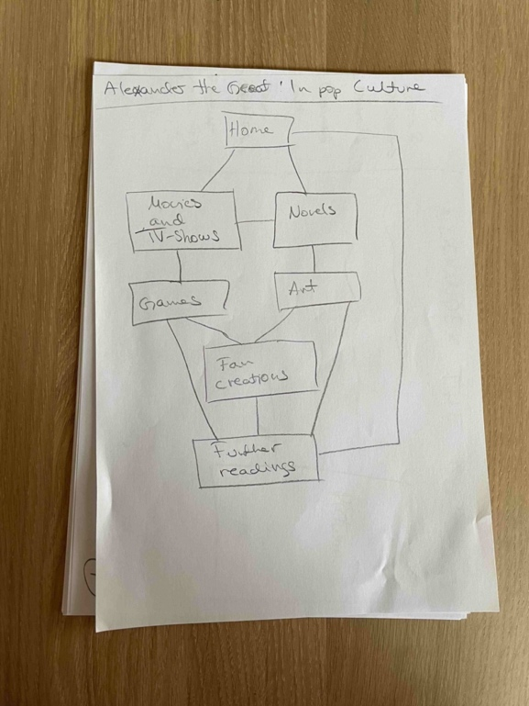Concept 2:

The concept also follows a hierarchical structure with a global navigation bar on the left-hand side, aligning with principles of information architecture discussed in the book. The wireframes illustrate how we have applied these principles to create web page focusing on Alexander the Great and a country he has conquered: Turkey.

Design wise, I went for the global navigation bar on the left-hand side. The main reason was space efficiency. I like this design for the same reasons I like the global navigation bar to be on top - it is easy to navigate through the content. When the bar is on the left-hand side, I feel like the content that you want to watch or read gets more attention. The bar on the left-hand side also establishes a clear hierarchy, with prime categories at the top and subcategories below, making it easier for users to understand the content structure.

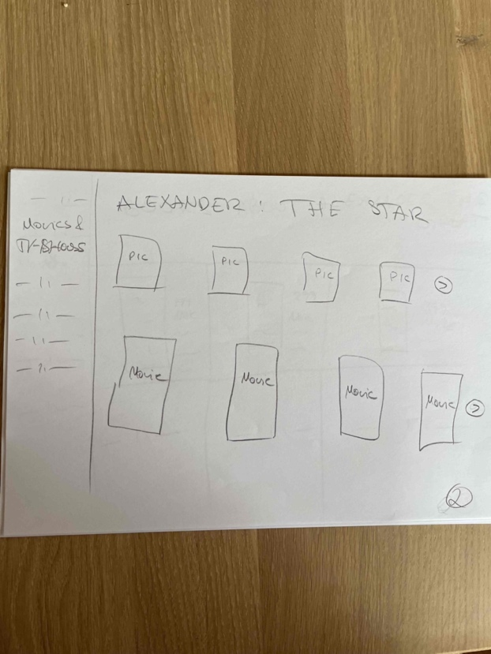In this category I took inspiration from Amazon´s personalized navigation. A picture can be found on page 203 in the book “Information Architecture: For the Web and Beyond”. There will be two slideshows for both TV-shows and movies, where you can navigate through them by using the arrow on the right-hand side. The use of slideshows provides a visually engaging way to present content, like how Amazon employs personal navigation (Rosenfeld et al., 203).

This part of the design is inspired by Ark´s webpage. It is in short, a list of books about Alexander the Great. It aims to offer a curated collection of recommended books on the subject, which involves a careful selection and organization of content to present users with the most relevant and valuable information. The practice of drawing inspiration from existing website and applying user-centered design principles is widely acknowledged in the field of web design and information architecture. In this case, the goal is to offer users a well-organized and valuable resource for further exploration of the topic at hand. For example, creating a “recommended books” section, which is a type of personalization. According to Rosenfeld et al. “personalization involves serving up information to the user based upon a model of behaviour, needs or preferences of that individual”.

Both designs incorporate principles of user-centered design, hierarchy, clear navigation, and visual organization, which are key aspects of effective information architecture as discussed in the book. “User. Content. Context. […]. They form the basis of our model for practicing effective information architecture design.” (Rosenfeld et al., 31)