Feature: Filter-based (Object) Enrolment
Field | Value
Product page
Components | FYNXT Cloud (CRM): Incentive Program wizard, Step 2 Enrollment Criteria.
Design | Wireframe Option B: https://claude.ai/artifact/VeagGXH62nuLdyJXq15vLR
Jira epic
Product owner
Needed by
Page status | Draft
Summary | A broker admin can decide who enrols in an incentive program using rules on CRM objects and their fields.

Why
The problem: Enrolment is decided only by fixed criteria: Country, Account Type, Account Status and Manual Enrollment.
Who asked:
What it costs today:
What good looks like: With FYNXT Cloud and the incentive program integrated, an admin can filter enrolment using objects and fields from the CRM.

Who is involved
Actor | Their part in this feature
Broker admin | Sets the enrolment rules on a program
CRM | Supplies objects, fields, values and participant records
Participant (client or IB) | Enrols only if they match the rules

User stories

US1 - Filter enrolment by CRM objects and fields (Must)
As a broker admin, I want to set enrolment rules on CRM objects and their fields, so that only matching participants enrol.
Independent test: With one rule, a matching participant enrols and a non-matching one does not.
Acceptance scenarios:
- Given the rule Account › Country is United Kingdom, when a participant from the United Kingdom enrols, then they are enrolled.
- Given the same rule, when a participant from Germany tries to enrol, then they are not enrolled.

US2 - Combine rules and groups (Must)
As a broker admin, I want to combine rules with All or Any, and group rules with their own All or Any, so that I can express conditions like A and B and (C or D).
Independent test: E1 and E2.
Acceptance scenarios:
- Given the setup in Examples, when a participant matches R1, R2 and R4, then they are enrolled.
- Given the same setup, when a participant matches R1 and R2 only, then they are not enrolled.

User journey
Broker admin CRM (FYNXT Cloud) Participant
|--1 open Step 2------>| |
|--2 add rules-------->| |
|--3 save program----->| |
| |<-4 tries to enrol----------|
| |--5 enrolled / not--------->|

- [UI] Broker admin opens Step 2 Enrollment Criteria in the program wizard (S1).
- [UI] Adds rules (Object, Field, Condition, Value), groups them if needed, and sets All or Any.
- [UI] Saves the program.
- [Backend] A participant tries to enrol; their CRM record is checked against the rules.
- [Backend] The participant is enrolled only if the rules are met.

Screens
ID | Screen | Figma frame link | Purpose | States to design
S1 | Incentive Program wizard: Step 2 Enrollment Criteria | Wireframe Option B (design link above) | Set enrolment rules | Empty, filled
S1 today: Step 2 Enrollment Criteria
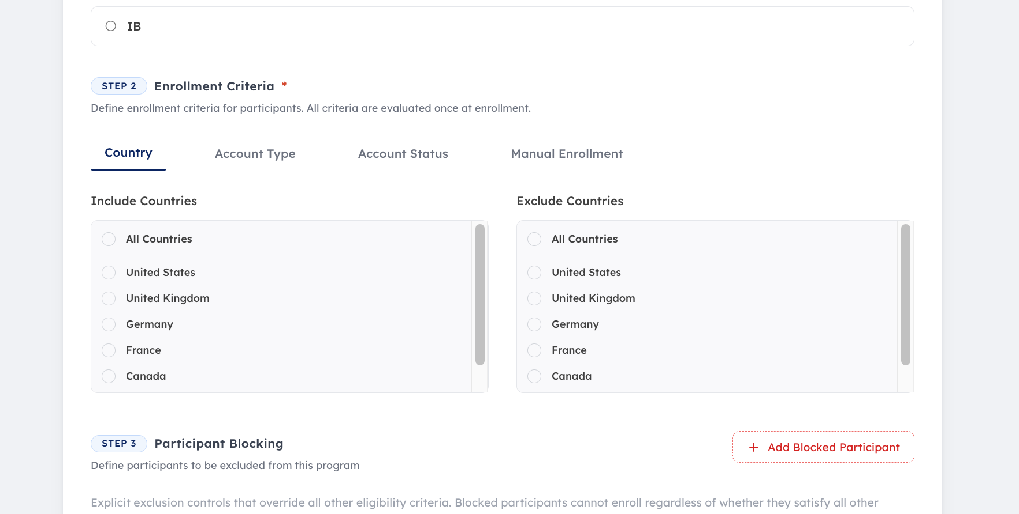

Rules

Front end
U1. In Step 2, the admin can add rules on CRM objects and their fields.
U2. A rule is Object, Field, Condition and Value. Only the chosen object's fields are offered; conditions and values depend on the field.
U3. The admin sets whether participants must match All or Any of the top-level rules and groups.
U4. The admin can group rules. Each group has its own All or Any, which applies only to the rules inside that group.
U5. A group holds rules only, not other groups.
U6. The admin can add and delete rules and groups, and clear all rules.

Back end
B1. Objects, fields and values come from the CRM.
B2. A participant enrols only if their CRM record meets the rules.
B3. The rules are checked once at enrolment, like the other criteria.
B4. Participant Blocking overrides all eligibility criteria, these rules included.

Examples
Setup: top level All. R1 Account › Country is United Kingdom. R2 Account › Account Status is Active. Group 1 (Any): R3 Account › Account Type is VIP; R4 Trading Account › Balance is greater than 1,000.
# | Rule | Input | Expected result
E1 | U3, U4, B2 | United Kingdom, Active, Standard, balance 2,500 | Enrolled (Group 1 met by R4)
E2 | U4, B2 | United Kingdom, Active, Standard, balance 500 | Not enrolled (Group 1 not met)
E3 | U3, B2 | Germany, Active, VIP | Not enrolled (R1 not met)
E4 | U3, B2 | Top level changed to Any. Germany, Active, Standard, balance 500 | Enrolled (R2 met)
E5 | B4 | Participant from E1 who is in Participant Blocking | Not enrolled

Edge cases and errors
Case | Side | Expected result
Participant's CRM field used in a rule is empty | Backend
A CRM field used in a rule is renamed or deleted | Backend

What must not change
- Country, Account Type, Account Status and Manual Enrollment can still be set.
- Participant Blocking overrides all eligibility criteria.
- All criteria are checked once at enrolment.

Out of scope
- Re-checking participants after they have enrolled.
- Groups inside groups.

Data and interfaces
Field | Screen | Direction | Type | Required | Allowed values and rules | Example
Object | S1 | In | List | Yes, per rule | From the CRM | Account
Field | S1 | In | List | Yes, per rule | The chosen object's fields, from the CRM | Country
Condition | S1 | In | List | Yes, per rule | Depends on the field type | Is
Value | S1 | In | Depends on field | Yes, per rule | From the CRM where a list exists | United Kingdom
Top-level match | S1 | In | List | Yes | All, Any | All
Group match | S1 | In | List | Yes, per group | All, Any | Any

Non-functional
Area | Requirement
Permissions
Speed
Audit

Success criteria
Measure | Target value

Integrations
System | Direction | Change | Owner agreed?
CRM | In | Objects, fields, values; participant records at enrolment

Definition of done
☐ Screen S1 matches its design, in every listed state
☐ Rules U1-U6 and B1-B4 are met
☐ Every question in Open questions and decisions has an answer
☐ Every acceptance scenario, example and edge case passes as an automated test
☐ Everything under What must not change still passes
☐ Product has signed off

Open questions and decisions
Question | Owner | Answer
How do top-level and group All / Any relate? | Product | Top level combines the rules and groups; a group's setting applies only inside that group
Can a group contain another group? | Product | No
When are the rules checked? | Product | Once at enrolment

Changes after Ready for build
None

Glossary
Term | Meaning
Object | A record type in the CRM, e.g. Account, Contact
Field | One attribute of an object, e.g. Country
Rule | Object, Field, Condition and Value
Group | A set of rules with its own All or Any

