《Object-Oriented Systems Analysis and Design》
Project Report
Project Name | University Assistant
Teammates | 萨沙， 乌拉德， 打你啦
My Name | Danila Ivlev

- Project description：

This project was realized as a program with three secondary parts. The part is a map that shows the user on the map the building he has chosen.

- Design Patterns: (including class diagrams, relative codes, screen shots and proper explanation)

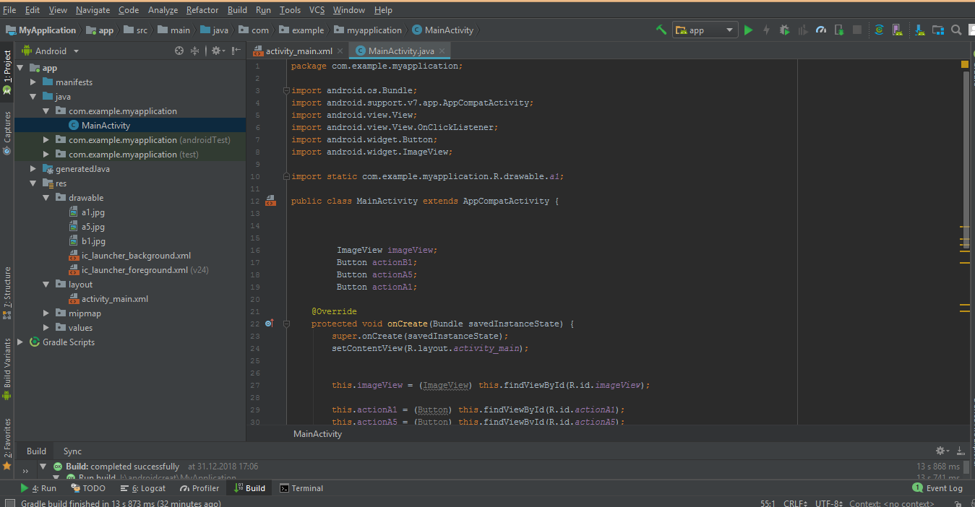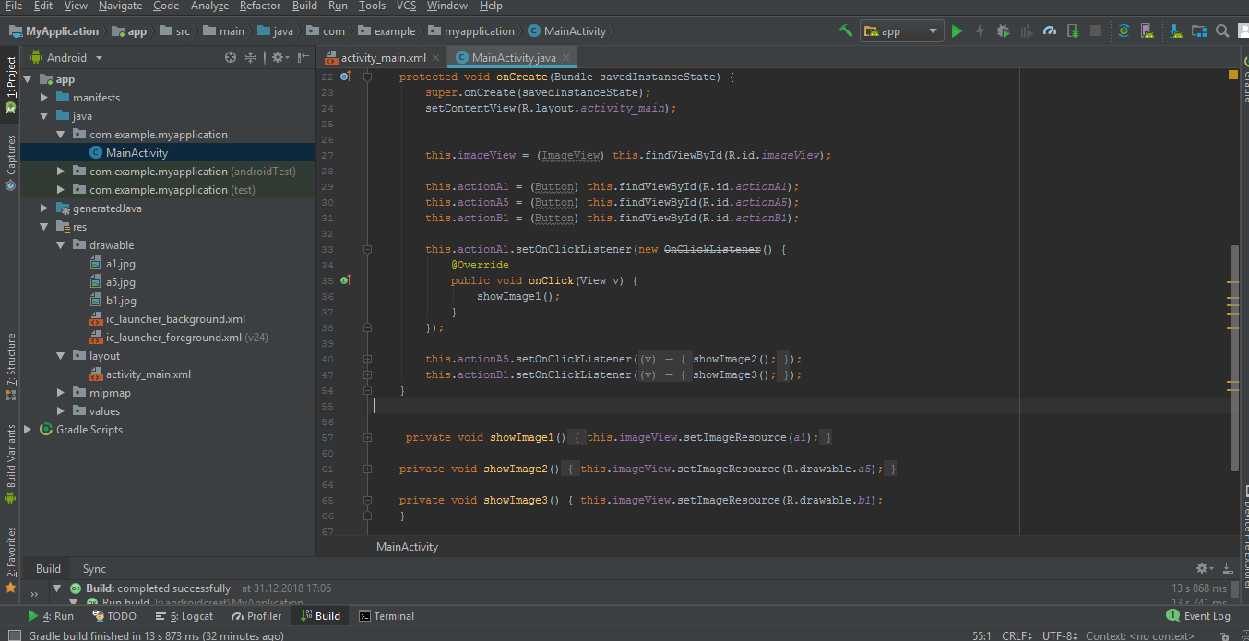
For my Part in this Project, I used Template pattern.

My main activity contains item ist only, but items are more important.




