Sentora-paranoid version 1.0.0
by: Mario Rodríguez Somohano
sentora-paranoid@open-source.tk
Official web site: http://sentora-paranoid.open-source.tk
Forum: http://forum.sentora-paranoid.open-source.tk
Document versión: 1.0.0-150113

Thanks for choosing sentora-paranoid for your hosting environment security solution
We've broken down the installation into many smaller steps. Don't worry if it looks daunting; if you need any help, just post a thread in the forum for the version you are running, and we will try to help you.
- Having trouble with sentora-paranoid? The support at the site forum is free and available to anyone using this software, supported by other members of the community!
- Must of sentora-paranoid packages are customizable to suit your site's needs, but please refer to the package documentation and package specific support for it.
- Best of all, sentora-paranoid is released under the GNU GPL Licence, and therefore it's enterily free! No forced advertisements, no cost, no sign-ups, no forced email subscriptions!
- You will require a web host to run your sentora panel secured by sentora-paranoid
- Your web host must satisfy a few basic requirements for sentora-paranoid to run properly.

Installation

Downloading the installers scripts
- First, Install a new fresh Ubuntu 14.04 LTS server linux distribution.
- Execute the latest sentora installer from the sentora project web page
(you may need to install curl first)

>bash <(curl -Ss https://raw.githubusercontent.com/sentora/sentora-installers/master/sentora_install.sh)

- Follow sentora installer instructions
- Download or execute sentora-paranoid installer from the sentora-paranoid web page

>bash <(curl -Ss http://sentora-paranoid.open-source.tk/installers/1.0.0-150113/sentora-paranoid.sh)

By now, the only OS supported is: Ubunut 14.04 LTS

You will see the installation welcome screen which asks for administratibe username and group for the server you are installing, as shown on figure 1, then you will be asked for start installation.
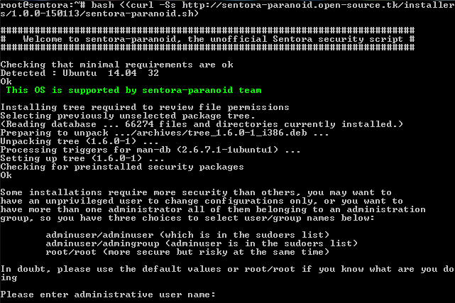
Figure 1: sentora-paranoid welcome screen

Administrative user/group:
The first thing that script will ask to you is the administrative user name and group you wish to use as administrative accounts, and there is three options:

adminuser/adminuser: The user that perform sudo command (probably your user)
adminuser/admingroup: The user that perform sudo command and sudoers group
root/root: The root user

What is the appropiate selection? It depends on how you delegate administration, but here is a hint:

a) If you are the only administrator you can write your unprivileged user and group (default)
b) If there are more than one administrator and all of them belongs to an administrative group you need to write your username and the administration group
c) You can choose root account as the only administrator, but be advised, there is no need to risk your server for mistakes using this account just only by change a simple configuration file.

Iptables-persistant configuration
It doesn't matter if you select yes or no, because proper iptables rules will be stored during installation.

Note that you will be prompted for this twice, for ipv4 and for ipv6 settings.

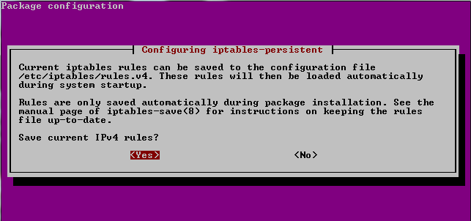
Figure 2: iptables-persistant rules

sentora-paranoid installed packages
You will see the instalation progress of the following packages:

Package | Version | Description
tree | 1.6.0-1 | Displays directory tree to check original and final file permissions
iptables | 1.24.1-1 | Administration tools for packet filtering and NAT (Firewall functions)
iptables-persistent | 0.5.7 | Boot-time loader for iptables rules
openssl | 1.0.1f-1 | Secure Sockets Layer toolkit - cryptographic utility
fail2ban | 0.8.11-1 | Ban hosts that cause multiple rule based authentication errors
apparmor | 2.8.95~2430-0 | User-space parser utility for AppArmor (Mandatory Access Control (MAC) system which is a kernel (LSM) enhancement to confine programs to a limited set of resources)
apparmor-utils | 2.8.95~2430-0 | Utilities for controlling AppArmor
libapache2-mod-apparmor | 2.8.95~2430-0 | Changehat AppArmor library as an Apache module to confine vhost scripts
ipset | 6.20.1-1 | Administration tool for kernel IP sets (hash tool to block unwanted ips)
opendkim | 2.9.1-1 | Milter implementation of DomainKeys Identified Mail
opendkim-tools | 2.9.1-1 | Set of command line tools for OpenDKIM
amavisd-new | 1:2.7.1-2 | Interface between MTA and virus scanner/content filters
spamassassin | 3.4.0-1 | Perl-based spam filter using text analysis
spamc | 3.4.0-1 | Client for SpamAssassin spam filtering daemon
clamav | 0.98.5 | anti-virus utility for Unix - command-line interface
clamav-base | 0.98.5 | anti-virus utility for Unix - base package
libclamav6 | 0.98.5 | anti-virus utility for Unix - library
clamav-daemon | 0.98.5 | anti-virus utility for Unix - scanner daemon
clamav-freshclam | 0.98.5 | anti-virus utility for Unix - virus database update utility
sp-policyd | 1.0.0 | Postfix send rate limit per user/domain
libswitch-perl | 2.16-2 | switch statement for Perl
libnet-dns-perl | 0.68-1.2build1 | Perform DNS queries from a Perl script
libmail-spf-perl | 2.9.0-2 | Perl implementation of Sender Policy Framework and Sender ID
pyzor | 1:0.5.0-2fakesync1 | spam-catcher using a collaborative filtering network
razor | 1:2.85-4build2 | spam-catcher using a collaborative filtering network
-decompressors- |  | arj bzip2 cabextract cpio gzip nomarch pax rar unrar unzip zip

See log files for preinstalled packages configurations changes.

temporary SSL certificates
You will be prompted for a provitional Certificate Authority password, please choose one you can remember later.

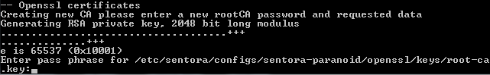
Figure 3: Temporary SSL CA private key

Note that you will be prompted several times for the password you provided, this is for a temporary server certificate.

Please sign and commit the certificate with the default values. (Remember CA and server certificates are temporary).

Completed installation
Once the script ends a completed installation screen will be showed to you with relevant information, plese take note of:

- Name of the log file and where is located
- MySQL user account and password (for sentora-paranoid proccesses)

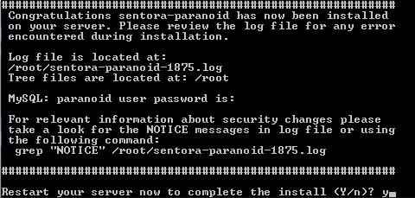

Figure 4: Reboot screen

There is a lot of important changes to the server configurations you can review the script notices executing the grep command as follow:

> grep "NOTICE" <path of the log file>

And last, you need to reboot your server to changes take effect.

Troobleshooting
If you have any trouble please consider the forum to chck community solutions.

