**Ensuring Repeatability: Creating Environments and Version Control**

We are going to explore using version control and containerization for accountability and function in the development of our bioinformatics pipelines, software, and collaborative efforts.

**Goals of this exercise**

1. Learn to interact with git and Github.
2. Use Singularity to create a container.

**Using Git and Github**

Git is a version control system that can be used locally or in conjunction with Github (a repository). As with any software, the best way to learn is to do and practice! I recommend you spend time interaction with these programs to explore their capacity and utility for your work.

Here are two links for documentation on using git and Github:

git: <https://git-scm.com/doc>

Github: <https://docs.github.com/en/get-started>

For today, let’s practice using git with a repository on my Github.

1. Use the following commands to clone the class repo to your computer.
   1. git clone <https://github.com/mrmckain/BSC695_Techniques_in_Practical_Bioinformatics.git>
2. You should see something like this:

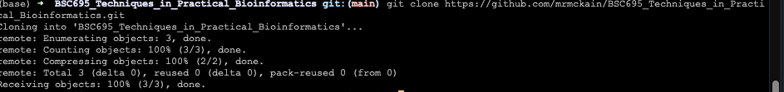

1. Move into the BSC695_Techniques_in_Practical_Bioinformatics directory that was created.
2. Create a file called yourname.txt.
   1. Fill the file with a statement about your favorite color and save the file.
3. Prepare to commit and push the file using this command.
   1. Git add yourname.txt
4. Commit the file with a message.
   1. git commit -m “Added yourname.txt file.”
5. Push the file to the repository on Github.
   1. git push
6. There may be some shenanigans with this, but we will troubleshoot in class!

**Using Singularity**

Singularity is a containerization software that allows you to package up an environment so your set up can function anywhere.

Let’s give it a go:

https://docs.sylabs.io/guides/latest/user-guide/