Episodic Structure in Psychotic Discourse: A Reproducible Workflow for Modeling Meta-Communication and Delusional Ontology in Schreber’s Memoirs
2026-05-23
Abstract
This study presents a reproducible computational workflow for analysing psychotic discourse through the interaction between meta-communication and delusional ontology. Building on pragmatic communication theory, these dimensions are operationalized as paragraph-level textual features and combined into a coupling index, enabling the examination of temporal organization in extended narrative material. Applied to Schreber’s Memoirs of My Nervous Illness, the analysis tests competing models of psychotic discourse, including cumulative escalation, temporal clustering, and reactive coupling. The results do not support a global escalation account. Instead, they reveal a non-uniform and temporally heterogeneous structure characterised by weak global association, limited serial persistence, and a small number of localized high-coupling segments. These peaks correspond to episodic configurations in which meta-communicative framing and delusional ontology become selectively aligned. The findings suggest that psychotic discourse is better understood as a sequence of transient discursive regimes rather than as a continuously intensifying system. Methodologically, the workflow provides a transparent and extensible framework for integrating qualitative theory with quantitative text analysis. Theoretically, it offers a preliminary formal framework for testing selected discourse-level implications of phenomenological models, particularly Sass’s concept of hyperreflexivity, in an empirically tractable form.

Introduction
The analysis of psychotic discourse has long occupied a complex position at the intersection of clinical description, theoretical interpretation, and linguistic observation. Classical approaches, particularly within psychoanalysis and phenomenology, have emphasized the meaningful and structured character of delusional experience, often treating it as a coherent, if unconventional, form of world-construction (Freud, 1911/1981; Sass, 1994a). At the same time, traditions emerging from communication theory, most notably the work of Bateson and the Palo Alto group, have foregrounded the relational and pragmatic dimensions of disturbed communication, highlighting how paradox, meta-communication, and breakdowns in contextual framing may contribute to the emergence and stabilization of psychotic patterns (Bateson, 1969/1987, 1987a, 1987b, 1987c, 1987d, 1987e; Watzlawick et al., 1967).
Despite their differences, these perspectives share a common assumption: that psychotic discourse exhibits an underlying form of organization, whether conceived as symbolic coherence, altered subjectivity, or disturbed communicative structure. Yet the nature of this organization, and in particular its temporal properties, has rarely been examined in a systematic and empirically grounded manner. Much of the existing literature relies on close reading, case-based interpretation, or theoretical reconstruction, leaving open the question of how discursive features unfold across extended narrative material and whether their relationships remain stable over time.
The present study addresses this gap by proposing a reproducible computational framework for the analysis of psychotic discourse, grounded in the interaction between two theoretically informed dimensions: meta-communication and delusional ontology. The notion of meta-communication, derived from Bateson’s work, refers to signals that frame, qualify, or comment upon the communicative act itself, thereby establishing the conditions under which meaning is to be interpreted. In the context of psychosis, disruptions or amplifications of such framing processes have been hypothesized to play a central role in the emergence of paradoxical or self-referential communication. Delusional ontology, by contrast, captures the explicit construction of an alternative reality, encompassing beliefs about external agents, metaphysical structures, and the nature of existence itself, as extensively documented in both psychoanalytic and phenomenological accounts (Freud, 1911/1981; Sass, 1994b).
While these dimensions have traditionally been treated qualitatively, the present approach operationalizes them as paragraph-level textual features, enabling their systematic measurement and temporal analysis. By combining these features into a coupling index, the study examines not only their co-occurrence but also their dynamic relationship across the progression of a narrative. This allows for the empirical evaluation of competing models of psychotic discourse, including the hypothesis of cumulative escalation, the possibility of temporally clustered intensification, and the alternative view that discursive organization may be locally contingent and episodic.
All analyses were conducted in R (R Core Team, 2024), using quanteda for text processing (Benoit et al., 2018) and quanteda.textstats for lexical-statistical measures (Benoit, 2024), with data manipulation implemented through dplyr ((Wickham et al., 2026) and visualization performed using ggplot2 (Wickham, 2026).
The empirical material for this investigation is Daniel Paul Schreber’s Memoirs of My Nervous Illness (Schreber, 1903/2000), a canonical text in the study of psychosis that has been extensively interpreted across multiple theoretical traditions. Unlike many previous analyses, the present study is based on a digitally reconstructed and manually curated version of the text, derived from OCR processing and subsequently reduced to the core narrative content. This procedure aimed to minimize editorial noise and peripheral material, thereby enhancing the validity of paragraph-level segmentation and feature extraction.
Situating this work within the broader field of computational psychiatry, the study contributes to ongoing efforts to bridge qualitative theory and quantitative analysis by transforming complex clinical constructs into empirically testable variables (Huys et al., 2016). At the same time, it remains closely aligned with the conceptual insights of earlier traditions, particularly those of Bateson and the Palo Alto school, whose emphasis on meta-communication and contextual framing finds here a formal and operational extension. In doing so, the study seeks not to replace interpretative approaches but to complement them with a methodological framework capable of revealing patterns that may otherwise remain implicit.
By examining the temporal organization of meta-communication and delusional ontology in Schreber’s text, this study advances a central question: whether psychotic discourse is best understood as a continuously structured system or as a dynamically shifting field characterised by localized moments of intensified organization. The answer to this question has implications not only for theoretical models of psychosis but also for the broader understanding of how meaning is constructed, disrupted, and reconfigured in extreme forms of human experience.

Methods

Corpus construction and source preparation
The corpus analysed in this study derives from Daniel Paul Schreber’s Memoirs of My Nervous Illness (Schreber, 1903/2000). The textual material was first digitized using optical character recognition (OCR) software applied to a printed edition of the work. Following this initial digitization step, a manual curation procedure was undertaken to reconstruct a clean textual corpus.
This manual intervention was not limited to superficial correction. The text was systematically reviewed and edited in order to isolate Schreber’s narrative voice and exclude non-authorial material, including editorial commentary, translator notes, bibliographic apparatus, page headers, running titles, and other paratextual elements. The resulting corpus therefore represents a deliberately reduced textual layer corresponding as closely as possible to the narrative core of Schreber’s memoir.
This dual-stage process, combining OCR-based digitization with manual textual curation, was designed to minimize the structural noise typically introduced by scanned editions while preserving the semantic integrity of the original narrative. The final corpus was stored as a UTF-8 encoded plain text file and used as the sole input for the computational pipeline.

Paragraph reconstruction and segmentation
The cleaned text was processed through a reproducible R-based pipeline designed to reconstruct paragraph-level segments. Raw text was first normalized by removing encoding artefacts, standardizing line breaks, and eliminating residual structural noise such as isolated page numbers and spaced uppercase headers.
Paragraph reconstruction was achieved by collapsing line-level text into continuous blocks and splitting segments based on paragraph boundaries defined by empty-line delimiters. Additional filtering steps removed segments below a minimum length threshold to avoid the inclusion of residual artefacts or structurally incomplete units.
The final segmentation yielded 235 paragraph-level units, each representing a contiguous discursive fragment of Schreber’s narrative. Segment-level metadata included a unique identifier (seg_id), sequential order (order), word count (words), and the raw textual content (text).

Operationalization of meta-communication and delusional ontology
Two theoretical constructs were operationalized at the segment level: meta-communication and delusional ontology. These constructs were translated into lexical indicators using theory-driven seed dictionaries.
The meta-communication lexicon targeted reflexive and higher-order discursive markers, including expressions related to explanation, meaning attribution, interpretation, justification, and communicative framing (e.g., ‘meaning’, ‘explain’, ‘interpret’, ‘in order to’, ‘it is necessary’). These markers were intended to approximate the pragmatic function of discourse about discourse.
The delusional ontology lexicon targeted content referring to supernatural agents, cosmological structures, divine entities, and metaphysical processes characteristic of Schreber’s system (e.g., ‘God’, ‘rays’, ‘souls’, ‘miracles’, ‘divine’, ‘creation’). These terms were selected to capture the ontological layer of the narrative.
For each segment, normalized scores were computed as the proportion of lexicon-matching tokens relative to total word count. This yielded two continuous variables: meta_score and delus_score.
The R packages quanteda (Benoit et al., 2018) and quanteda.textstats (Benoit, 2024) are available under the GNU General Public License and were used without modification. The dplyr (Wickham et al., 2026) and ggplot2 (Wickham, 2026) packages are similarly open-source and require no additional permissions for academic use.

Construction of the coupling index
To capture the co-occurrence of meta-communication and delusional ontology, a multiplicative coupling index (paranoid_meta) was defined as:
$$paranoid_meta=meta_score×delus_score$$
This formulation ensures that high values of the index emerge only when both dimensions are simultaneously elevated. Segments with high values in only one dimension do not produce high coupling scores. The index therefore operationalizes conjunctive intensity rather than additive contribution.

Statistical analyses
Three types of analyses were conducted.
First, global association between meta-communication and delusional ontology was assessed using Pearson’s product-moment correlation. This test evaluates whether the two dimensions co-vary across the corpus in a linear fashion.
Second, temporal structure was examined through autocorrelation analysis of the meta-communication score across segment order. The autocorrelation function (ACF) was used to assess whether meta-communicative activity exhibits persistence across adjacent segments.
Third, a simple lagged dependency model was tested by correlating the coupling index (paranoid_meta) with the one-step lag of delusional-ontology scores. This analysis evaluates whether increases in ontological intensity are followed by subsequent increases in discursive coupling.
In addition, peak segments were identified as those exceeding the 95th percentile of the coupling index. These segments were interpreted as localized regimes of intensified coupling. Lexical differentiation between peak and non-peak segments was assessed using log-likelihood keyness statistics (G²), enabling comparison of their respective lexical profiles.

Reproducibility
All preprocessing, segmentation, scoring, and statistical analyses were implemented in R (R Core Team, 2024) using a fully scripted workflow. The pipeline includes all steps from raw text ingestion to figure and table generation, ensuring full reproducibility of results given the same input corpus. Code and data are publicly available in a version-controlled repository (see ‘Data availability’ section).
No artificial intelligence tools were used in data analysis or in generating the results reported in this article. Every data analysis were made in the R ecosystem.

Results

Descriptive profile of the segmented corpus
The manually curated benchmark corpus was segmented into 235 paragraph-level units. Segment length ranged from 28 to 393 words, with a mean of 290.4 words and a median of 310.0 words. This distribution indicates that the corpus retained substantial paragraph-level variability while avoiding the fragmentation produced by OCR-based line segmentation.
The resulting dataset provided the basis for the computation of three paragraph-level variables: normalized meta-communication density (meta_score), normalized delusional-ontology density (delus_score), and their multiplicative coupling index (paranoid_meta).
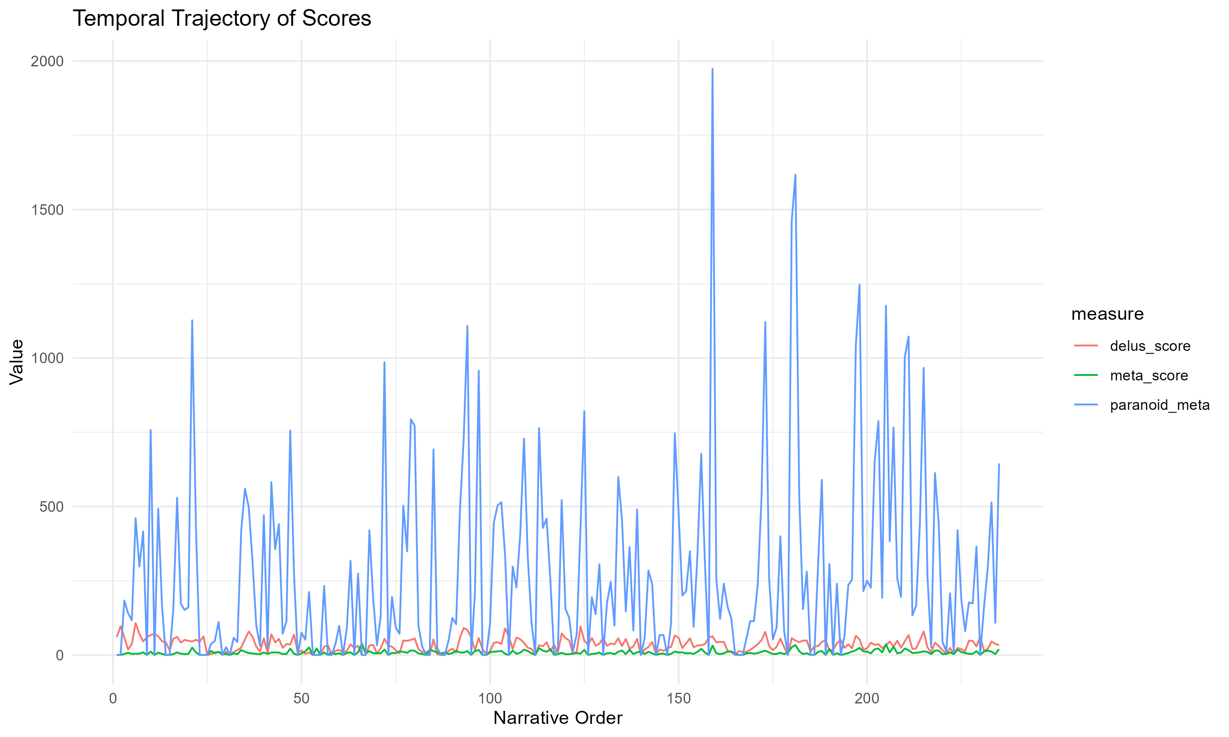
Figure 1: Fig. 1 Temporal trajectory of normalized meta-communication score, delusional-ontology score, and coupling index across segment order. Each point represents one of 235 paragraph-level segments. The coupling index (upper series) identifies localized peaks of conjunctive intensity.

Global association between meta-communication and delusional ontology
To test the monotonic escalation hypothesis, we estimated the Pearson correlation between normalized meta-communication scores and normalized delusional-ontology scores across all segments. The correlation was weak and non-significant, r = 0.041, 95% CI [−0.088, 0.168], p = 0.535.
This result does not support a global linear association between the two dimensions. Passages richer in delusional-ontological vocabulary were not systematically associated with higher levels of meta-communicative framing across the corpus as a whole.
f

Temporal clustering of meta-communicative activity
To assess whether meta-communicative framing exhibited temporal persistence across adjacent segments, we computed the autocorrelation function (ACF) of the meta-communication score. The first-lag autocorrelation was 0.052, and subsequent lags remained low in magnitude.
This pattern does not support the existence of robust temporal clustering in meta-communicative activity when considered in isolation. Meta-communicative signals therefore do not appear to organize into extended, self-sustaining stretches across narrative order.
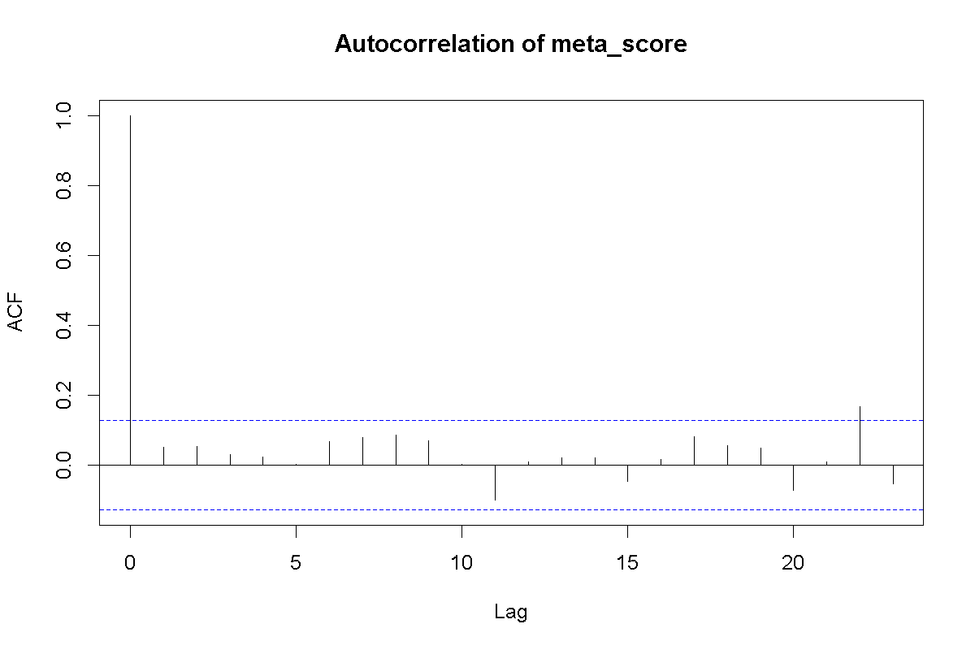
Figure 2: Fig. 2 Autocorrelation function of the normalized meta-communication score across narrative order. Dashed lines represent the 95% confidence interval for white noise. All lags fall within or near the confidence band, indicating absence of systematic temporal structure.

Lagged association and reactive coupling
To test a simple local reactive model, we examined the association between the coupling index (paranoid_meta) and the one-step lag of delusional-ontology scores. The resulting Pearson correlation was small but statistically significant, r = 0.161, 95% CI [0.033, 0.283], p = 0.014.
This finding suggests a limited local dependency: increases in delusional-ontological intensity may be followed by modest increases in discursive coupling in the immediately subsequent segment. However, the effect size remains small, indicating that coupling cannot be reduced to a strong or deterministic one-step reactive process.

Detection of peak regimes
Peak segments were defined as observations exceeding the 95th percentile of the coupling index. These segments represent passages in which meta-communicative framing and delusional ontology become simultaneously elevated relative to the rest of the corpus.
The peak structure remained episodic and sparse, indicating that the strongest forms of discursive coupling are concentrated in localized passages rather than diffusely distributed throughout the memoir.
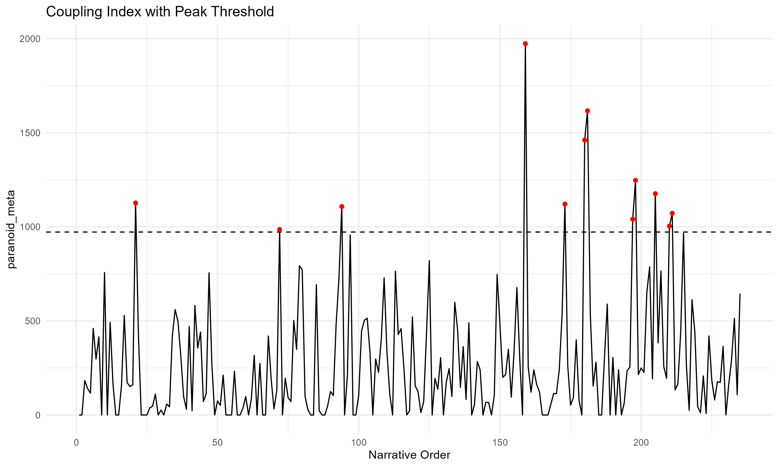
Figure 3: Fig. 3 Coupling index across segment order, with the 95th-percentile threshold (dashed line) and peak segments marked. Peak segments are sparsely and irregularly distributed, consistent with an episodic rather than cumulative structural model.

Lexical differentiation between peak and non-peak segments
To characterize the linguistic profile of high-coupling regimes, we compared peak and non-peak segments using log-likelihood keyness analysis (G²). This analysis identified the lexical features most strongly associated with peak passages and contrasted them with those characterizing the remainder of the corpus.

Table 1 Top peak-favoring terms from log-likelihood keyness analysis
Feature | G² | p | n target | n reference
nerves | 20.85 | < 0.001 | 32 | 241
divine | 17.89 | < 0.001 | 15 | 68
must | 15.97 | < 0.001 | 18 | 111
certain | 13.40 | < 0.001 | 15 | 92
plant | 12.51 | < 0.001 | 3 | 0
power | 12.32 | < 0.001 | 14 | 81
created | 10.72 | 0.001 | 10 | 48
remnants | 10.02 | 0.002 | 3 | 1
picture | 8.98 | 0.003 | 7 | 27
rays | 6.99 | 0.008 | 21 | 215
Note. G² = log-likelihood statistic. n target = frequency in peak segments; n reference = frequency in non-peak segments.

Table 2 Top non-peak-favoring terms from log-likelihood keyness analysis
Feature | G² | p | n target | n reference
first | 5.69 | 0.017 | 112 | 1
long | 2.72 | 0.099 | 55 | 0
since | 2.40 | 0.121 | 51 | 0
sleep | 2.32 | 0.127 | 50 | 0
possible | 1.86 | 0.173 | 44 | 0
time | 1.75 | 0.186 | 270 | 9
asylum | 1.42 | 0.234 | 111 | 3
flechsig | 1.37 | 0.242 | 69 | 1
Note. Non-peak terms show uniformly lower G² values and weaker lexical differentiation.
The keyness contrast indicates that peak and non-peak segments are not simply distinguished by raw intensity alone, but by differing lexical profiles. This supports the interpretation of peak passages as distinct discursive configurations rather than merely quantitatively stronger instances of surrounding narrative material.

Interim synthesis
Taken together, the results do not support a strong monotonic escalation account. Meta-communication and delusional ontology are not globally correlated in a statistically meaningful way, and meta-communicative activity does not display robust temporal clustering in isolation. At the same time, the lagged analysis suggests a modest local reactive dependency, and peak detection continues to identify sparse episodes of intensified coupling.
These findings favour a model of psychotic discourse that is weakly structured at the global level but punctuated by localized moments of heightened discursive coupling.

Discussion
The present analysis was designed to evaluate whether psychotic discourse is better understood as a continuously structured system or as a dynamically shifting field characterised by localized moments of intensified organization. The findings provide clear support for the latter interpretation. Across the corpus, the association between meta-communication and delusional ontology remained weak at a global level and showed limited temporal persistence, while a modest but significant lagged relationship suggested localized dependencies rather than sustained structural coupling. This pattern indicates that psychotic discourse, at least in this case, does not unfold as a cumulative or uniformly intensifying process but rather as a temporally heterogeneous sequence punctuated by episodic configurations of increased alignment.
From a phenomenological perspective, these results invite a reconsideration of accounts that emphasize the pervasive and enduring character of altered self-experience in schizophrenia. Within the classical phenomenological tradition, Minkowski (1927/2002) identified a pervasive "morbid rationalism" as a continuous structural condition, while Blankenburg and Mishara (2001) (1969/2001) described the loss of "natural self-evidence" as a stable background disturbance organising all social and practical experience. Kimura (2002) similarly characterised schizophrenic self-experience as a persistent splitting of subjectivity. Building on these foundations, Parnas and Sass (2001) formalised the ipseity-disturbance model, in which hyperreflexivity and diminished self-affection constitute a structurally continuous transformation of subjectivity, whereby patients simultaneously inhabit delusional and consensual realities (Sass, 1994a, 1994b; Sass & Byrom, 2015). The present findings do not contradict this framework at the descriptive level, but they suggest that its discursive manifestations may be more discontinuous than typically assumed. Rather than a stable background condition uniformly shaping discourse, hyperreflexive processes may become discursively salient only at specific moments, giving rise to transient peaks of alignment between meta-communicative framing and ontological elaboration. This does not invalidate the phenomenological model itself; rather, it suggests that, in the present operationalization and corpus, its discursive expression is episodic rather than uniformly distributed.
This interpretation resonates with phenomenological approaches that emphasize variability and situatedness in lived experience. Stanghellini (2001), for instance, describes schizophrenic experience as involving fluctuations in embodiment and self-affection, rather than a monolithic alteration. The present results extend this insight into the temporal organization of discourse, suggesting that the articulation of anomalous experience may itself be episodic, with moments of heightened structural coherence embedded within a more weakly organized narrative field.
At the same time, the findings complicate classical cognitive accounts of delusion formation. Maher (2005) proposed that delusions arise as rational explanations for anomalous experiences, implying a degree of internal coherence and sustained inferential structure. While this model captures important aspects of delusional reasoning, the weak global coupling observed here suggests that such coherence may not be consistently maintained across extended discourse. Instead, inferential integration appears to be locally achieved, emerging in short-lived configurations rather than as a stable organizing principle.
Contemporary models in computational psychiatry provide a useful framework for interpreting these dynamics. Approaches grounded in Bayesian inference have emphasized the role of aberrant priors and prediction error in shaping psychotic experience (Corlett et al., 2019), while broader frameworks highlight the need to bridge mechanistic models with clinically meaningful patterns (Huys et al., 2016). The present study contributes to this effort by operationalizing discursive features and examining their temporal organization, thereby translating qualitative constructs into empirically testable patterns. In this context, the observed episodic coupling may be understood as reflecting transient alignments between higher-order interpretive processes and anomalous experiential inputs, rather than a globally altered inferential regime.
Finally, the temporal heterogeneity identified in this study invites a reconsideration of psychotic narrative as a structured but non-uniform phenomenon. Rather than assuming a continuous transformation of meaning, psychotic discourse may be better conceptualized as a sequence of shifting regimes, in which different organizational principles become momentarily dominant. This view aligns with broader theories of narrative temporality that emphasize discontinuity and reconfiguration as fundamental features of meaning-making (Ricoeur, 1984/1985), and it suggests that the structure of psychotic discourse cannot be adequately captured by models that privilege global coherence over local dynamics.

Conclusion
This study presented a reproducible computational workflow for analysing psychotic discourse through the interaction between meta-communication and delusional ontology, operationalized as paragraph-level textual features and examined across extended narrative material. Applied to Schreber’s Memoirs of My Nervous Illness (1903/2000), the analysis did not support models of continuous escalation or stable structural coupling. Instead, it revealed a weakly organized global structure punctuated by localized peaks of intensified interaction, alongside limited temporal persistence and modest but significant lagged dependencies.
These findings have direct theoretical implications for the understanding of psychosis. In particular, they suggest not that phenomenological accounts of altered subjectivity are invalid, but that, at the level of discursive organization, their expression in the present operationalization and corpus appears episodic rather than uniformly distributed. The classical phenomenological tradition, from Minkowski's (1927/2002) morbid rationalism and Blankenburg's (2001) loss of natural self-evidence to Kimura's (2002) account of persistent self-splitting and Parnas and Sass's (2001) ipseity-disturbance model, consistently treats the schizophrenic alteration as a continuous structural condition rather than an intermittent state. While Sass’s (Sass, 1994a, 1994b; Sass & Byrom, 2015) concept of hyperreflexivity remains a powerful descriptive framework, the present results indicate that its observable manifestations in discourse may be episodic rather than uniformly distributed. Psychotic discourse, in this sense, appears less as a continuously transformed system and more as a temporally heterogeneous field in which moments of intensified coupling emerge against a background of relative structural looseness.
This does not invalidate phenomenological models; rather, it makes selected aspects of their discursive implications empirically tractable and open to specification. By translating constructs such as meta-communication and ontological elaboration into measurable features, the present approach enables a shift from purely interpretative accounts to models that can be systematically tested, compared, and refined. In doing so, it aligns with broader efforts in computational psychiatry, psychology and phenomenology to formalize complex psychological phenomena while preserving their clinical and experiential relevance (Huys et al., 2016).
More broadly, the findings support a view of psychotic discourse as a dynamic and non-uniform process, characterised by transient regimes of organization rather than stable global structures. This perspective challenges models that assume sustained coherence or continuous inferential integration and instead emphasizes variability, contingency, and temporal modulation as central features. In this respect, the study contributes to an emerging dialogue between phenomenology, cognitive theory, and computational modelling, demonstrating that even richly interpreted clinical texts can be re-examined as structured data without reducing their conceptual depth.
Future work may extend this approach by applying the workflow to additional corpora, refining the operationalization of discursive features, and integrating more formal computational models. In particular, the identification of episodic coupling patterns opens the possibility of developing explicitly dynamic models of psychosis, in which shifts between discursive regimes can be simulated and empirically evaluated. Such developments would not only deepen our understanding of psychotic phenomena but also help establish a common analytical language across traditionally distinct paradigms.
In this sense, the present study demonstrates that the episodic structure of psychotic discourse can be formally modelled through the dynamic interaction between meta-communication and delusional ontology, establishing a reproducible framework for analysing how meaning is intermittently organized in extreme forms of human experience.

Data availability
The code, derived data, and reproducibility materials supporting the findings of this study have been deposited in a public version-controlled repository and archived with a persistent identifier. Details of the repository location and identifier are withheld from this version of the manuscript to preserve double-blind peer review. Full repository information will be provided upon acceptance.
The repository includes the curated textual corpus derived from Schreber’s Memoirs of My Nervous Illness, the complete R-based computational pipeline for preprocessing, segmentation, scoring, and statistical analysis, Quarto manuscript files and analysis notebooks, and all figures and tables reported in the article. Due to the manual curation process applied to the source text, the corpus represents a processed derivative rather than a direct facsimile of any published edition. All transformations are documented within the repository.

References
Bateson, G. (1969/1987). Double bind (1969). In G. Bateson (Ed.), Steps to an Ecology of Mind - Collected essays in anthropology, psychiatry, evolution, and epistemology. Jason Aronson. (1972)
Bateson, G. (1987a). Epidemiology of a schizophrenia (1955). In G. Bateson (Ed.), Steps to an Ecology of Mind - Collected essays in anthropology, psychiatry, evolution, and epistemology. Jason Aronson. ((Orig: 1972))
Bateson, G. (1987b). The logical categories of learning and communication (1964). In G. Bateson (Ed.), Steps to an Ecology of Mind - Collected essays in anthropology, psychiatry, evolution, and epistemology. Jason Aronson. ((Orig: 1972))
Bateson, G. (1987c). Minimal requirements for a theory of schizophrenia (1959). In G. Bateson (Ed.), Steps to an Ecology of Mind - Collected essays in anthropology, psychiatry, evolution, and epistemology. Jason Aronson. ((Orig: 1972))
Bateson, G. (1987d). A theory of play and fantasy (1955). In G. Bateson (Ed.), Steps to an Ecology of Mind - Collected essays in anthropology, psychiatry, evolution, and epistemology. Jason Aronson. ((Orig: 1972))
Bateson, G. (1987e). Toward a theory of schizophrenia (1956). In G. Bateson (Ed.), Steps to an Ecology of Mind - Collected essays in anthropology, psychiatry, evolution, and epistemology. Jason Aronson. ((Orig: 1972))
Benoit, K. (2024). quanteda.textstats: Textual Statistics for the Quantitative Analysis of Textual Data (v.0.97.2, R (≥ 3.5.0)). Retrieved 30 from https://cran.r-project.org/web/packages/quanteda.textstats/index.html
Benoit, K., Watanabe, K., Wang, H., Nulty, P., Obeng, A., Müller, S., & Matsuo, A. (2018). quanteda: An R package for the quantitative analysis of textual data. Journal of Open Source Software, 3(30), 774-. https://doi.org/10.21105/joss.00774
Blankenburg, W., & Mishara, A. (2001). First Steps Toward a Psychopathology of "Common Sense". Philosophy, Psychiatry, & Psychology, 8, 303-315. https://doi.org/10.1353/ppp.2002.0014
Corlett, P. R., Horga, G., Fletcher, P. C., Alderson-Day, B., Schmack, K., & Powers, A. R., 3rd. (2019). Hallucinations and Strong Priors. Trends Cogn Sci, 23(2), 114-127. https://doi.org/10.1016/j.tics.2018.12.001
Freud, S. (1911/1981). Psycho-Analytic Notes on an Autobiographical Account of a Case of Paranoia (Dementia Paranoides) (J. Strachey, A. Freud, A. Strachey, & A. Tyson, Trans.). In S. Freud (Ed.), The Case of Schreber, Papers on Technique and Other Works (1911-1913) (Vol. S. E., 12, pp. 9-84). The Hogarth Press / Institute of Psychoanalysis. (1911-13)
Huys, Q. J. M., Maia, T. V., & Frank, M. J. (2016). Computational psychiatry as a bridge from neuroscience to clinical applications. Nature Neuroscience, 19, 404–413.
Kimura, B. (2002). Cogito and I: A Bio-logical Approach. Philosophy, Psychiatry, & Psychology, 8, 331-336. https://doi.org/10.1353/ppp.2002.0019
Maher, B. (2005). Delusional thinking and cognitive disorder. Integr Physiol Behav Sci, 40(3), 136-146. https://doi.org/10.1007/bf03159710
Minkowski, E. (1927/2002). La Schizophrénie. Psychopathologie des schizoides et des schizophrènes. Éditions Payot & Rivages. ((Orig.: 1927))
Parnas, J., & Sass, L. (2001). Self, Solipsism, and Schizophrenic Delusions. Philosophy, Psychiatry, & Psychology, 8, 101-120. https://doi.org/10.1353/ppp.2001.0014
R Core Team. (2024). R: A Language and Environment for Statistical Computing (Version 4.4.3) [Computer software]. In R Foundation for Statistical Computing. https://www.R-project.org/
Ricoeur, P. (1984/1985). Time and Narrative (Vol. 2). The University of Chicago.
Sass, L. (1994a). "My So-Called Delusions": Solipsism, Madness, and the Schreber Case. Journal of Phenomenological Psychology, 25, 70-103.
Sass, L. (1994b). The Paradoxes of Delusion: Wittgenstein, Schreber, and the Schizophrenic Mind. Cornell University Press.
Sass, L., & Byrom, G. (2015). Phenomenological and neurocognitive perspectives on delusions: A critical overview. World Psychiatry, 14(2), 164-173. https://doi.org/10.1002/wps.20205
Schreber, D. P. (1903/2000). Memoirs of my Nervous Illness (Ida Macalpine & Richard A. Hunter, Trans.). New York Review of Books. ((Orig.: Denkwurdigkeiten eines Nervenkranken, Leipzig, 1903; Memoirs of my Nervous Ilness, translated and edited by Ida Macalpine & Richard A. Hunter, London: W. Doson, 1955; first edition in german, 1903))
Stanghellini, G. (2001). Psychopathology of Common Sense. Philosophy, Psychiatry, & Psychology, 8(2/3). https://muse.jhu.edu/pub/1/article/28399
Watzlawick, P., Beavin, J. H., & Jackson, D. D. (1967). Pragmatics of Human Communication - A study of interactional patterns, pathologies and paradoxes. W. W. Norton & Company.
Wickham, H. (2026). ggplot2: Elegant graphics for data analysis. https://cran.r-project.org/web/packages/dplyr/index.html
Wickham, H., François, R., Henry, L., Müller, K., Vaughan, D., & Posit Software, P. (2026). dplyr: A Grammar of Data Manipulation. https://cran.r-project.org/web/packages/dplyr/index.html

