API INTEGRATION & JSON HANDLING
User Information Search & Filter Application
Name: Bammidi Rakesh
Roll Number: 23981A04Q9
Department: ECE
College: Raghu Engineering College
Date: 8 September 2026

1. Introduction
This project demonstrates Python communication with an external REST API, JSON parsing, search and filtering, and API error handling. The public JSONPlaceholder Users API is used for testing without an API key.

2. Objectives
- Fetch data using the Requests library.
- Parse JSON responses.
- Search users by name.
- Filter users by city.
- Refresh API data.
- Handle API errors gracefully.

3. Requirements Mapping
Requirement | Implementation
Fetch data using Requests | requests.get(API_URL, timeout=10)
Parse JSON | response.json()
Filtering/search | Name search and city filtering
Handle API errors | Timeout, HTTPError, RequestException and ValueError

4. Tools and Technologies
- Python 3
- Requests library
- JSON
- Visual Studio Code
- JSONPlaceholder REST API

5. API Endpoint
https://jsonplaceholder.typicode.com/users

6. Program Features
- Display all users
- Search user by name
- Filter users by city
- Refresh API data
- Exception handling
- Menu-driven interface

7. JSON Handling
The response.json() method converts the JSON response into Python objects. Nested fields such as user['address']['city'] are accessed for filtering and display.

8. Error Handling
The fetch_users() function catches timeout, HTTP, connection/request, and invalid JSON errors. The application reports the error and continues safely.

9. Program Flow
- Start the application.
- Send a GET request.
- Check the HTTP status.
- Parse JSON.
- Display the main menu.
- Perform display, search, filter, refresh, or exit.

10. Complete Source Code
import requests
# Public API URL
API_URL = "https://jsonplaceholder.typicode.com/users"
def fetch_users():
try:
response = requests.get(API_URL, timeout=10)
response.raise_for_status()
users = response.json()
print("\nAPI data fetched successfully!")
print("Total users:", len(users))
return users
except requests.exceptions.Timeout:
print("\nError: API request timed out.")
return []
except requests.exceptions.HTTPError as error:
print("\nHTTP Error:", error)
return []
except requests.exceptions.RequestException as error:
print("\nAPI Connection Error:", error)
return []
except ValueError:
print("\nError: Invalid JSON response.")
return []
def display_users(users):
if not users:
print("\nNo user data available.")
return
print("\n--------------- USER LIST ---------------")
for user in users:
print(f"ID: {user['id']} | Name: {user['name']} | Username: {user['username']} | City: {user['address']['city']}")
print("------------------------------------------")
def search_user(users):
search_name = input("\nEnter user name to search: ").strip().lower()
found = False
for user in users:
if search_name in user["name"].lower():
print("\nUser found!")
print("ID :", user["id"])
print("Name :", user["name"])
print("Username :", user["username"])
print("Email :", user["email"])
print("Phone :", user["phone"])
print("City :", user["address"]["city"])
found = True
if not found:
print("\nNo user found with that name.")
def filter_by_city(users):
city = input("\nEnter city to filter: ").strip().lower()
filtered_users = [u for u in users if city in u["address"]["city"].lower()]
if filtered_users:
print("\nUsers from", city.title(), ":")
for user in filtered_users:
print(f"ID: {user['id']} | Name: {user['name']} | City: {user['address']['city']}")
print("Total matching users:", len(filtered_users))
else:
print("\nNo users found in that city.")
print("=========================================")
print(" USER INFORMATION API")
print("=========================================")
users = fetch_users()
while True:
print("\n=========================================")
print(" MAIN MENU")
print("=========================================")
print("1. Display All Users")
print("2. Search User by Name")
print("3. Filter Users by City")
print("4. Refresh API Data")
print("5. Exit")
choice = input("\nEnter your choice: ")
if choice == "1":
display_users(users)
elif choice == "2":
search_user(users) if users else print("\nNo API data available.")
elif choice == "3":
filter_by_city(users) if users else print("\nNo API data available.")
elif choice == "4":
users = fetch_users()
elif choice == "5":
print("\nThank you for using User Information API.")
print("Program exited successfully.")
break
else:
print("\nInvalid choice. Please enter 1 to 5.")

11. Output Screenshots and Explanations

1. API Data Fetching
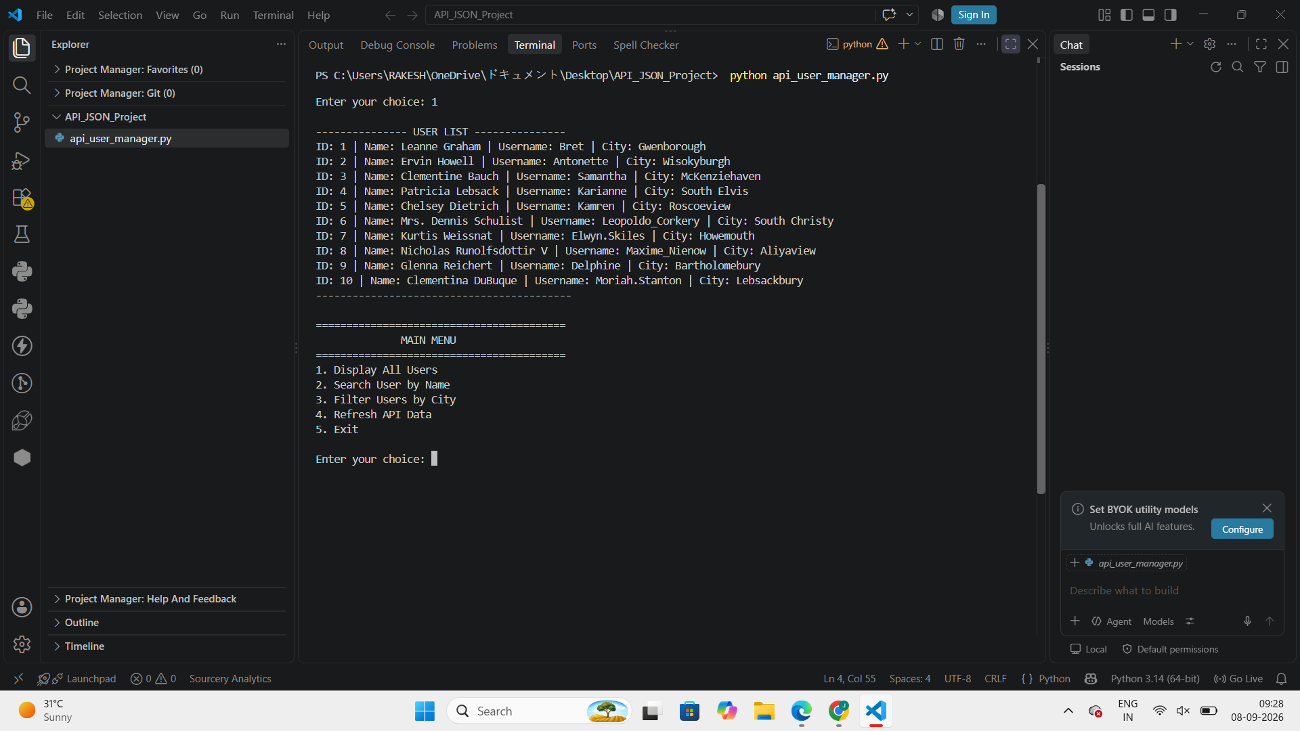
The application sends a GET request using Requests, parses the JSON response, and displays 10 user records.

2. Search User by Name
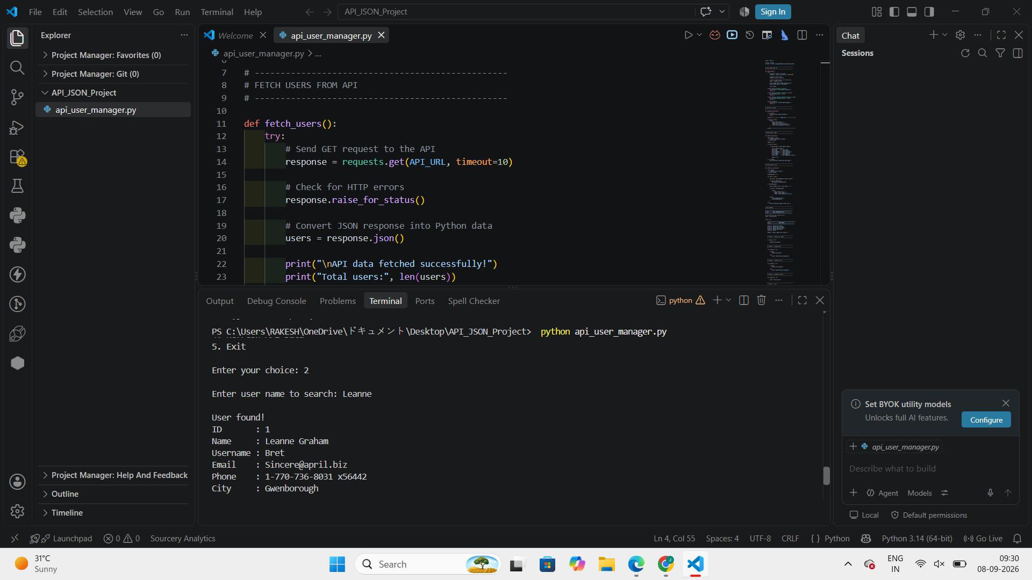
The program searches the parsed JSON data for a matching name and displays the selected user's details.

3. Filter Users by City
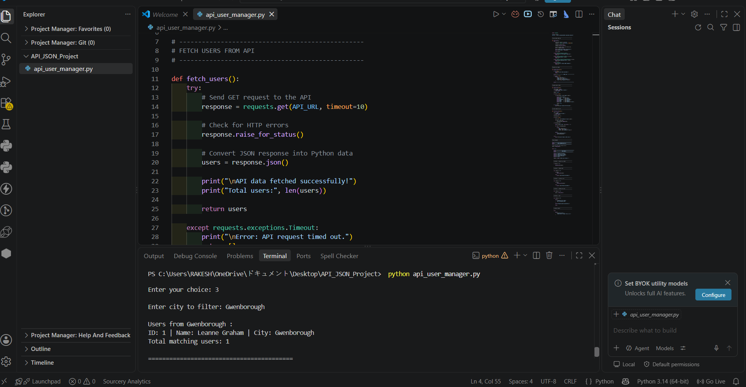
The program filters nested address-city data and displays the matching user records.

4. Refresh API Data
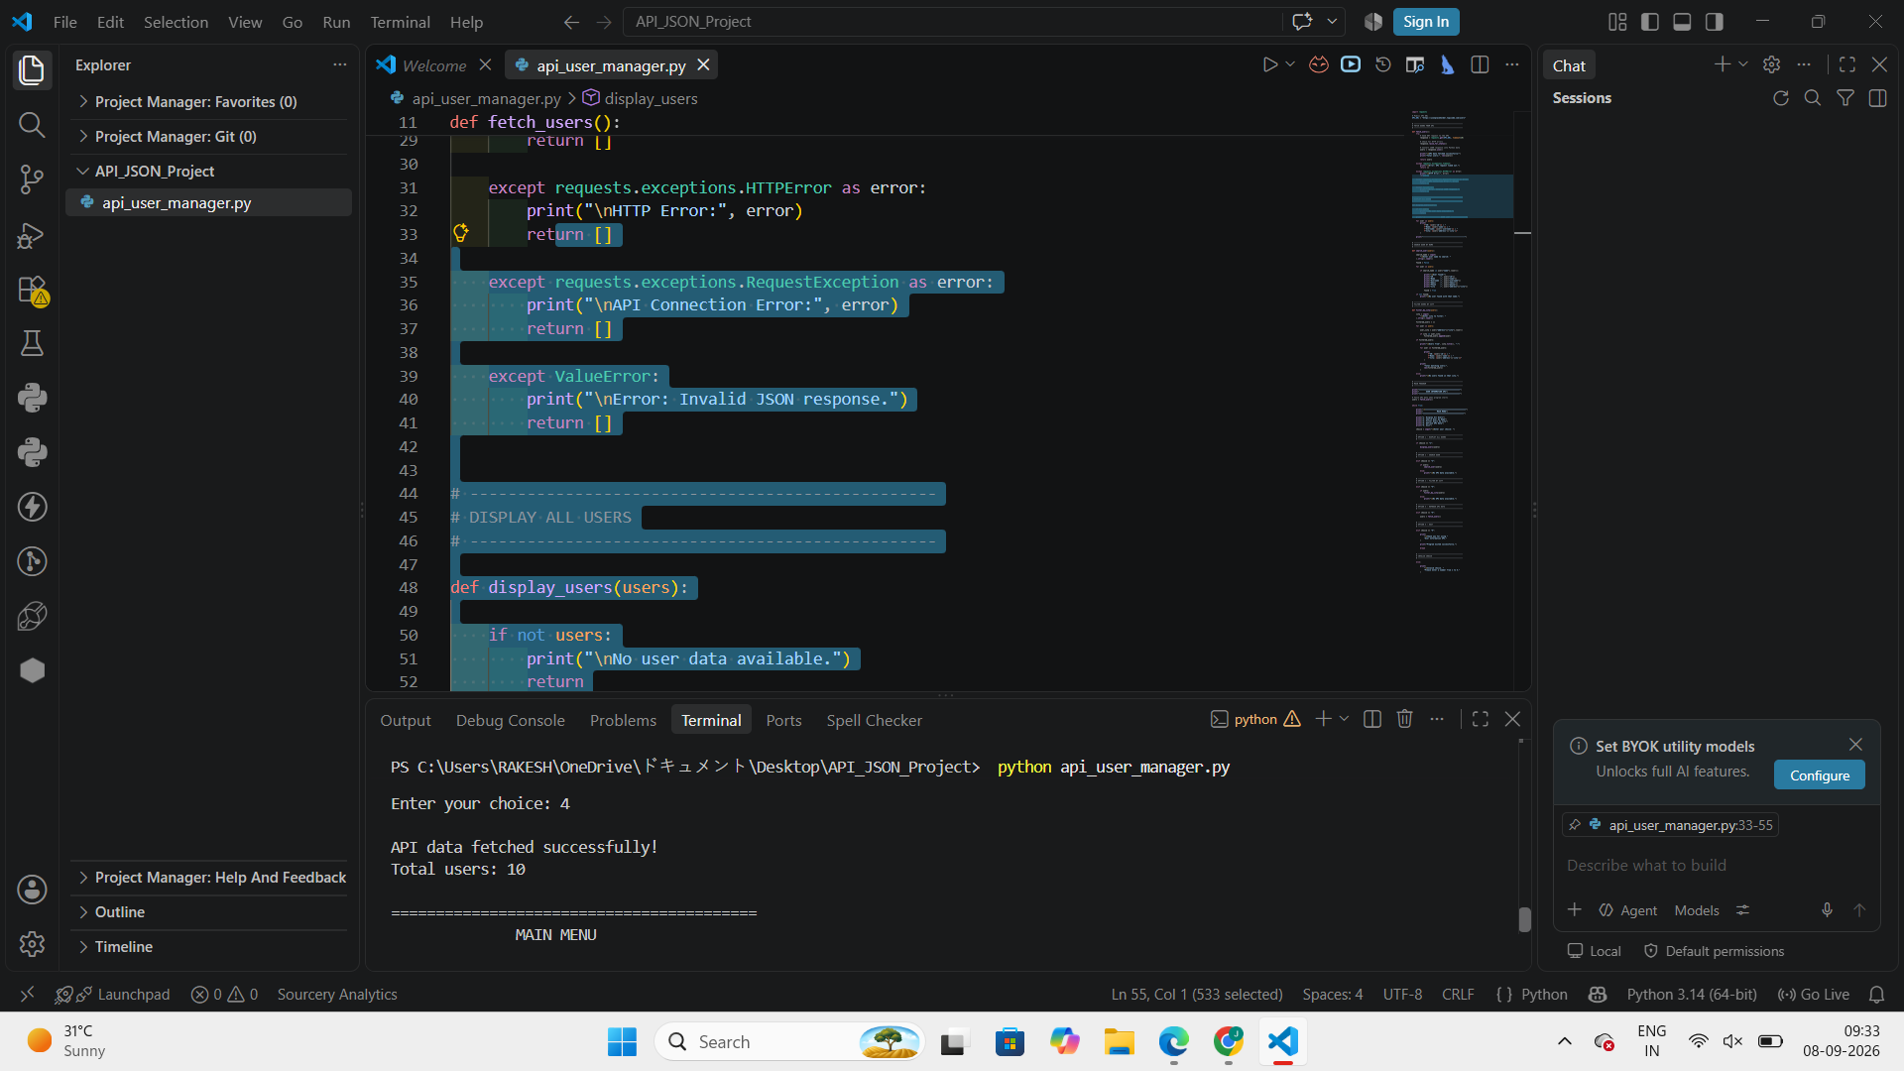
The refresh option performs another API request and successfully retrieves the JSON data.

5. API Error Handling
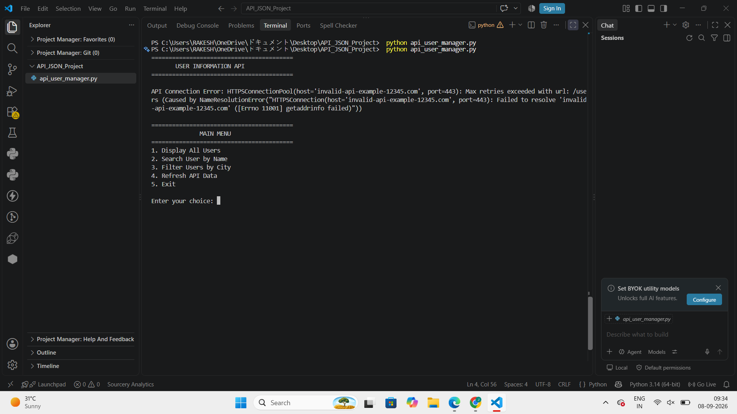
An invalid API address was used temporarily. The program caught the connection error and continued to the menu instead of crashing.

6. Program Exit
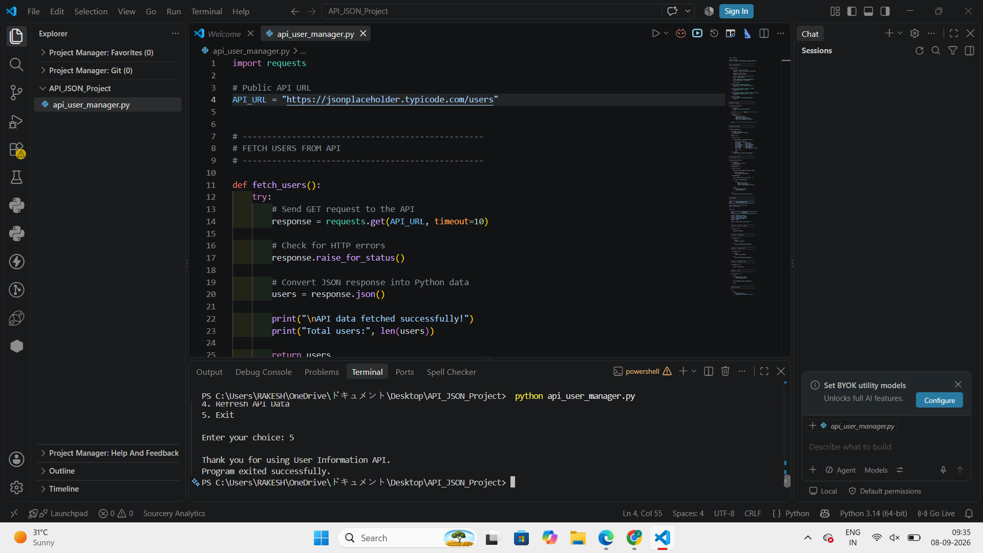
The application exits cleanly after option 5. The correct working API URL was restored before final use.

12. Advantages
- Simple menu-driven interface
- Real API communication
- Structured JSON processing
- Practical search and filtering
- Robust exception handling
- Easy to extend

13. Conclusion
The project successfully demonstrates API integration and JSON handling in Python. It retrieves external data with Requests, parses JSON, supports search and city filtering, refreshes data, and handles API failures without crashing.

14. Submission Link
https://github.com/bammidirakesh/Python-File-Automation

