FLASK MINI PROJECT REPORT
Student Management System
Student Name: Bammidi Rakesh
Roll Number: 23981A04Q9
Department: Electronics and Communication Engineering (ECE)
College: Raghu Engineering College
Project: Task 4 – Flask Mini Project

2. Requirements Mapping
- Flask routing and templates
- GET and POST form handling
- Basic CRUD and SQLite data storage
- Clean Bootstrap UI
- GitHub-ready project structure

1. Objective
Develop a web-based Student Management System using Flask, Jinja2 templates, SQLite, and Bootstrap. The application demonstrates routing, GET and POST form handling, and complete CRUD operations.

3. Technologies Used
Python, Flask, SQLite, HTML5, Jinja2 templating, Bootstrap 5.3.3, and VS Code.

4. Application Features
Add Student (Create), View Students (Read), Edit Student (Update), Delete Student (Delete), and a responsive Bootstrap interface.

6. Flask Routes
/ – displays all students. /add – GET displays the form and POST inserts a student. /edit/<student_id> – GET displays existing data and POST updates it. /delete/<student_id> – deletes a student and redirects to the list.

7. CRUD Flow
Create → POST → SQLite INSERT → list; Read → GET → SQLite SELECT → table; Update → POST → SQLite UPDATE → list; Delete → confirmation → SQLite DELETE → list.

5. Database Design
Column | Type | Constraint | Purpose
id | INTEGER | PRIMARY KEY, AUTOINCREMENT | Unique student ID
name | TEXT | NOT NULL | Student name
email | TEXT | NOT NULL | Email address
department | TEXT | NOT NULL | Department

8. Testing and Screenshots
Screenshot 1: Main student list showing records and CRUD action buttons.
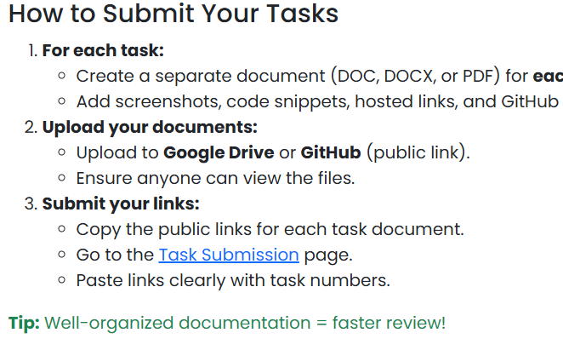
Screenshot 2: Add Student form demonstrating GET/POST form handling.
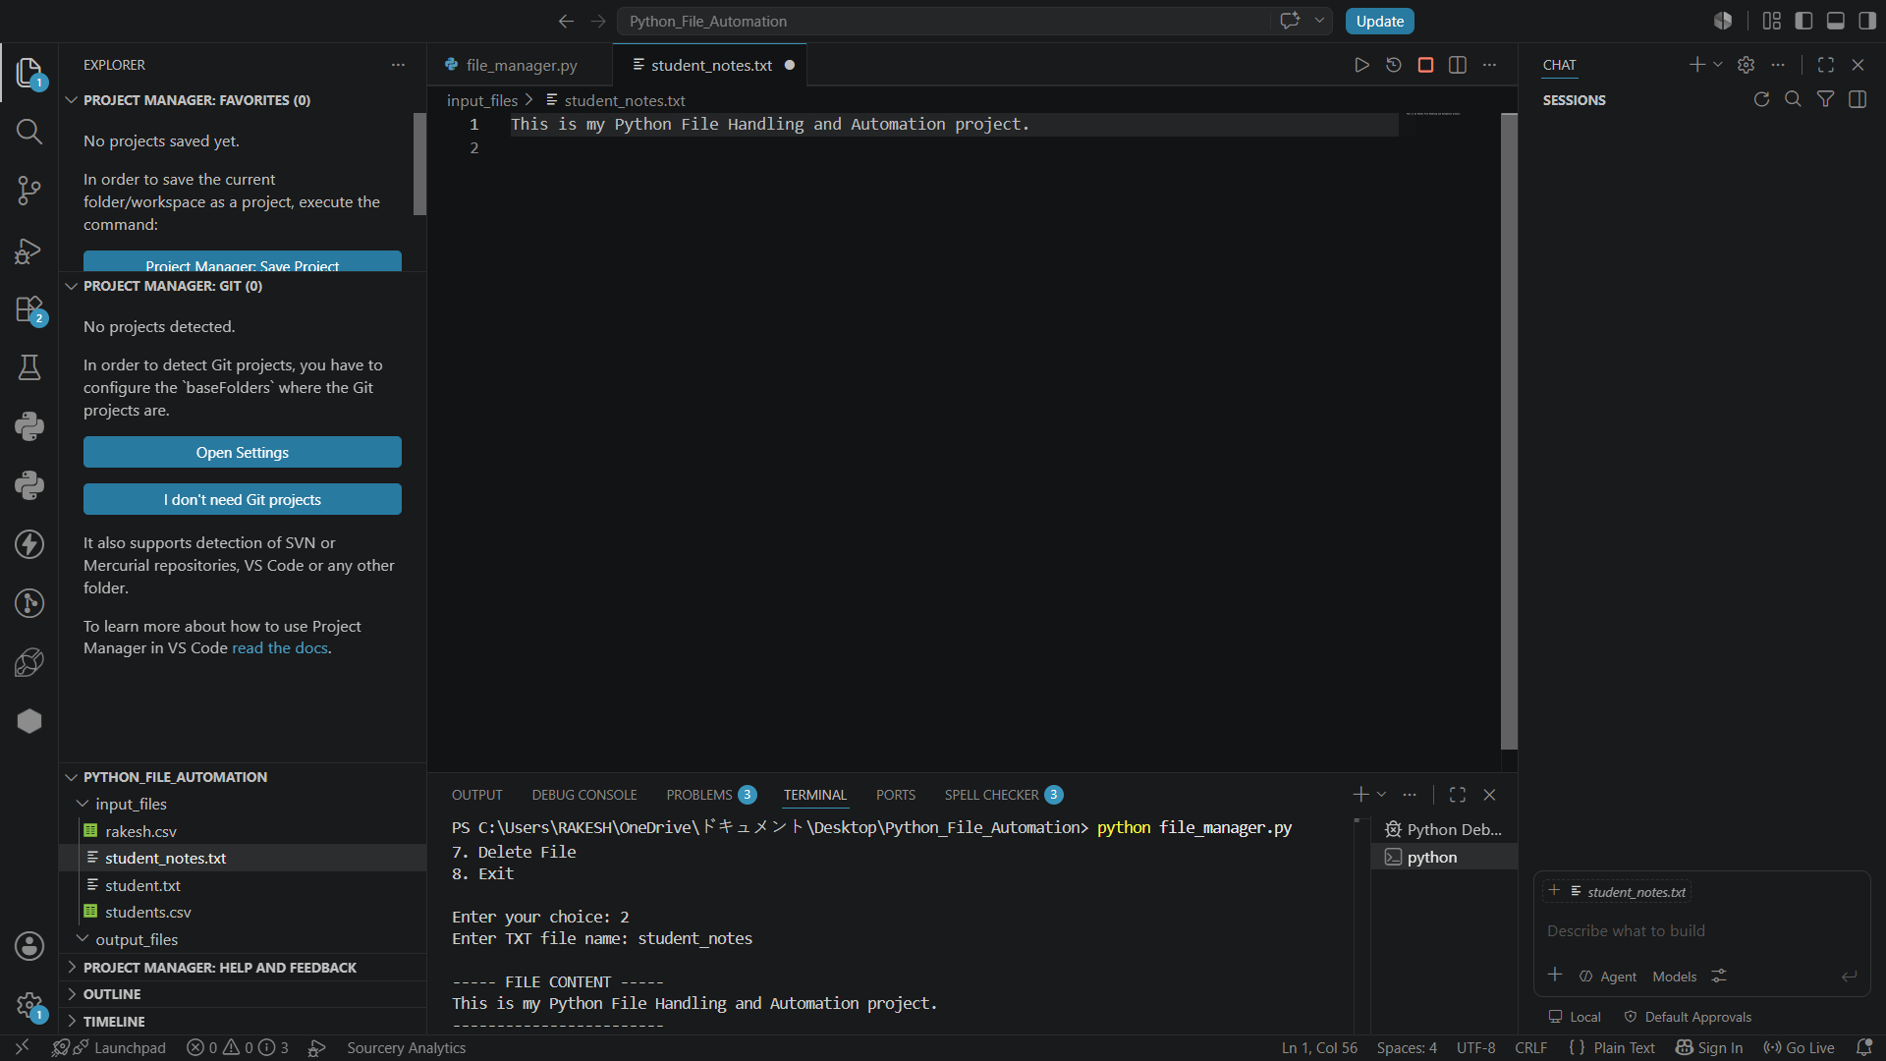
Screenshot 3: Edit Student form with existing values ready for update.

Screenshot 4: Delete confirmation demonstrating the delete workflow.
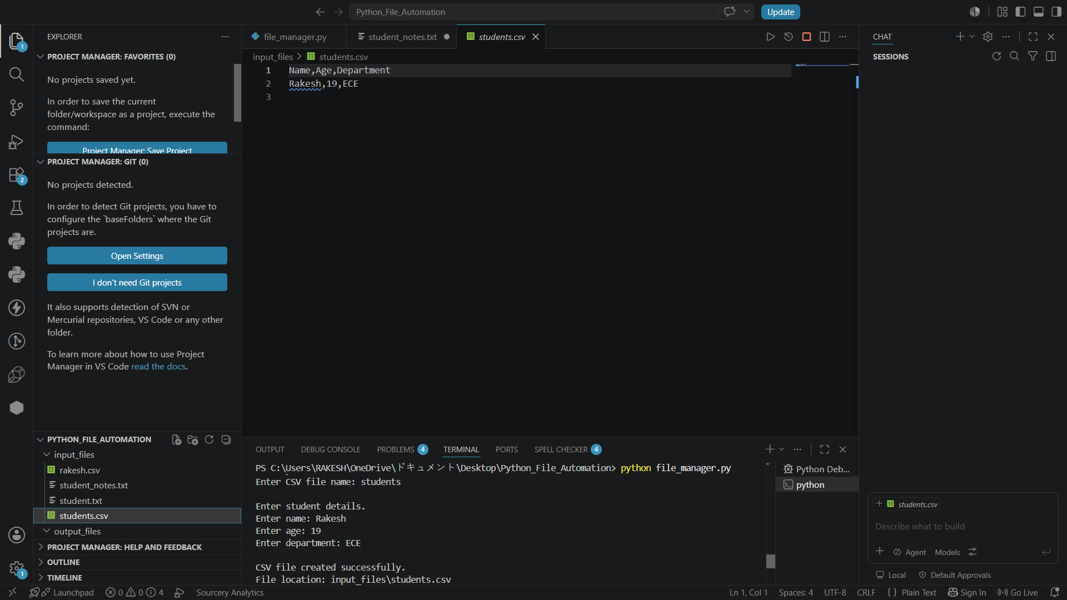

9. Source Code – app.py
from flask import Flask, render_template, request, redirect, url_for
import sqlite3

app = Flask(__name__)
DATABASE = "students.db"

def get_db_connection():
connection = sqlite3.connect(DATABASE)
connection.row_factory = sqlite3.Row
return connection

def create_table():
connection = get_db_connection()
connection.execute("""
CREATE TABLE IF NOT EXISTS students (
id INTEGER PRIMARY KEY AUTOINCREMENT,
name TEXT NOT NULL,
email TEXT NOT NULL,
department TEXT NOT NULL
)
""")
connection.commit()
connection.close()

@app.route("/")
def index():
connection = get_db_connection()
students = connection.execute(
"SELECT * FROM students ORDER BY id DESC"
).fetchall()
connection.close()
return render_template("index.html", students=students)

@app.route("/add", methods=["GET", "POST"])
def add_student():
if request.method == "POST":
name = request.form["name"]
email = request.form["email"]
department = request.form["department"]
connection = get_db_connection()
connection.execute(
"INSERT INTO students (name, email, department) VALUES (?, ?, ?)",
(name, email, department)
)
connection.commit()
connection.close()
return redirect(url_for("index"))
return render_template("add_student.html")

@app.route("/edit/<int:student_id>", methods=["GET", "POST"])
def edit_student(student_id):
connection = get_db_connection()
student = connection.execute(
"SELECT * FROM students WHERE id = ?", (student_id,)
).fetchone()
if request.method == "POST":
name = request.form["name"]
email = request.form["email"]
department = request.form["department"]
connection.execute(
"UPDATE students SET name = ?, email = ?, department = ? WHERE id = ?",
(name, email, department, student_id)
)
connection.commit()
connection.close()
return redirect(url_for("index"))
connection.close()
return render_template("edit_student.html", student=student)

@app.route("/delete/<int:student_id>")
def delete_student(student_id):
connection = get_db_connection()
connection.execute("DELETE FROM students WHERE id = ?", (student_id,))
connection.commit()
connection.close()
return redirect(url_for("index"))

if __name__ == "__main__":
create_table()
app.run(debug=True)

10. Conclusion
The project successfully demonstrates Flask routing, Jinja2 templates, GET and POST requests, SQLite persistence, and complete CRUD functionality with a clean Bootstrap interface.

11. Submission
GitHub repository: https://github.com/bammidirakesh/Flask-Student-Management-System

