IT Quality Assurance: Automated Defect Description Enhancer
Structured Project Report | AI-Assisted Defect Documentation and Developer Handoff

1. Executive Summary
This project proposes an AI-assisted system that converts natural-language QA defect descriptions into structured, complete, reviewable, and developer-ready defect reports. The system combines standardized core and category-specific templates, LLM-based information extraction, a human-in-the-loop clarification process, a second reasoning and enrichment stage, Markdown report generation, and email delivery.
The central objective is to reduce information loss between QA and engineering teams. By identifying missing details early, preserving tester-provided facts, clearly marking AI-generated annotations, and providing optional developer guidance, the proposed workflow aims to improve triage, reproducibility, and resolution efficiency.

2. Problem Statement
Poorly structured or incomplete defect reports create a bottleneck in the software development lifecycle. Vague reports increase triage uncertainty, cause developers to spend time attempting to reproduce issues, and create clarification loops between QA and development.
The defect lifecycle described in the source material is:
- Defect introduced: flawed code is written.
- Defect triggered: a user action or system state causes incorrect behavior.
- Failure observed: the QA engineer observes the failure and writes the defect report.
- Triage and assignment: severity and priority are evaluated from the report.
- Engineering reproduction: the developer attempts to reproduce the failure.
- Root cause analysis: the underlying defect is located.
- Resolution: the fix is applied, verified by QA, and closed.
The report is written at the failure-observation stage. Every downstream stage depends on the quality and fidelity of the information captured at that point.

3. Consequences of Lossy Defect Communication
- Speculative triage: incomplete information makes business impact, severity, and prioritization difficult to assess.
- Reproduction failures: developers spend time guessing missing steps, environment details, or system states.
- Delayed resolution: fix time increases because communication and clarification become the bottleneck rather than the code change itself.

4. Proposed Documentation Standard
The approach in the source material aligns its common fields with ISO/IEC/IEEE 29119-3:2021 and Mozilla's bug-writing guidance. The design uses a core template for fields common to all defects and category-specific extensions for specialized information.

Field | What it captures | Why it matters
Title | Specific one-line summary | Allows quick scanning and identification in a backlog.
Category | UI, API, Mobile, Backend, Security, Performance, etc. | Routes the issue to the appropriate team and template.
Severity | Impact if the defect remains unfixed | Separates technical impact from business urgency.
Priority | Urgency relative to other work | Supports scheduling and prioritization.
Environment | OS, browser/app version, device, server/region | Helps identify environment-specific behavior.
Steps to Reproduce | Exact, numbered, minimal actions | Makes the issue actionable and reproducible.
Expected Result | What should have happened | Defines the intended behavior.
Actual Result | Observed behavior, text, codes, or state | Captures the concrete symptom.
Frequency | Always, intermittent, rare, or attempt ratio | Helps identify deterministic or timing-related issues.
Evidence | Screenshots, logs, traces, payloads | Provides verifiable supporting material.

5. Category-Specific Extensions
Category | Additional fields
UI / Frontend | Browser and viewport, screenshot, affected page and component
API / Backend | Endpoint, HTTP method, request payload, response payload, status code, related service
Mobile | Device model, OS version, app build number, crash log or stack trace
Security | Vulnerability type, CVSS score, affected component, impact, proof of concept, disclosure sensitivity
Performance | Baseline versus observed metric, load conditions, resource utilization
Accessibility | WCAG criterion and assistive technology used
Localization | Locale/language and source string versus rendered string
Data Integrity | Query, before/after database state, affected record IDs

6. Proposed Functional Workflow

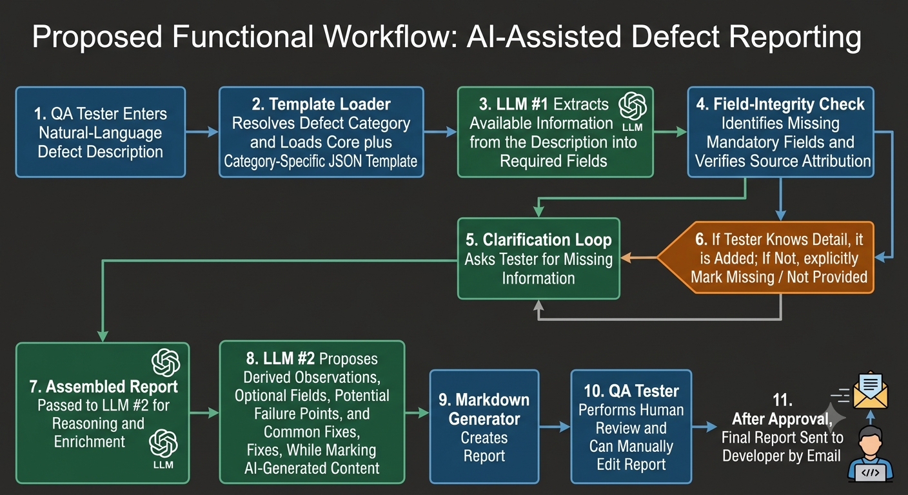

7. Two-LLM Design

7.1 LLM #1 — Extraction and Field Filling
- Classifies or works with the resolved defect category.
- Receives the raw description, core template, and category-specific template.
- Extracts only information supported by the tester's description.
- Marks missing mandatory fields instead of inventing values.
- Assigns source metadata such as tester_provided or partially_tester_provided.

7.2 LLM #2 — Reasoning and Enrichment
- Reviews the complete assembled report.
- Attempts to derive useful information from existing facts.
- Marks derived values and observations as AI Annotated.
- Generates optional developer-oriented descriptions and common fixes.
- Must not overwrite tester_provided values.
- Must distinguish hypotheses and diagnostic suggestions from confirmed root causes.

8. Example: Login Button Defect
Input summary:
The login button does not navigate from /login to /dashboard in the staging environment. The issue occurs on Chrome 118 and Windows 11 desktop in all 10 attempts. The button shows a pressed state, but no network request is generated and no JavaScript console errors are observed.
Field | Extracted value | Source
Title | Login button unresponsive | Tester-provided
Category | UI | Tester-provided
Severity | High | Tester-provided
Priority | P1 | Tester-provided
Environment | Chrome 118, Windows 11, desktop, staging | Tester-provided
Steps | Open /login; enter valid credentials; click Log In | Tester-provided
Expected | Redirect to /dashboard within 2 seconds | Tester-provided
Actual | Pressed visual state, no request, no navigation | Tester-provided
Frequency | Always, 10/10 attempts | Tester-provided
Evidence | DevTools screenshot referenced but not attached | Tester-provided
Viewport | Missing | Missing field
Suspected layer | Frontend/UI event-handling or submission layer | AI inference

8.1 AI-Enriched Diagnostic Observations
- The failure may occur before the HTTP request is constructed or dispatched.
- Potential failure points include an unregistered click handler, a blocked form submit handler, silent client-side validation, stale form state, event propagation issues, or a failed frontend state transition.
- Investigation should begin in the client-side click and form-submission path before the backend authentication endpoint.

8.2 Recommended Diagnostics
- Add a breakpoint inside the Log In click handler.
- Add a breakpoint inside the form submit handler.
- Confirm that the handler receives the entered credentials.
- Check whether client-side validation returns false.
- Inspect event.preventDefault() and event propagation behavior.
- Verify that the authentication API function is invoked.
- Enable Preserve log in the browser Network tab.
- Verify staging API configuration and environment variables.

9. Architecture.

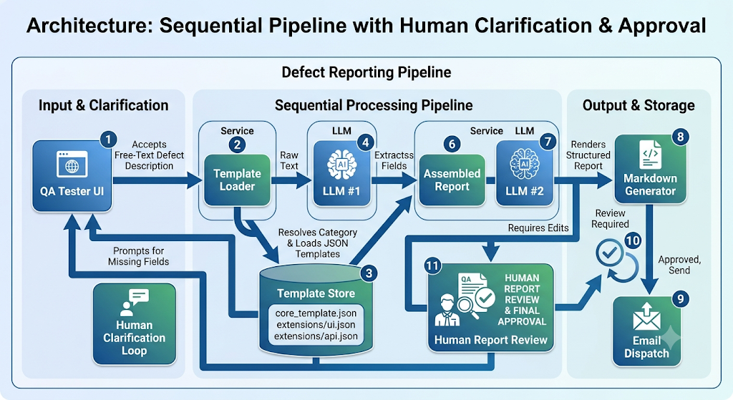

10. Recommended Technology Stack
Layer | Technology / Choice | Purpose
LLM access | LiteLLM | Single interface for LLM calls across providers.
Template storage | Flat JSON files | Simple storage for a small, fixed set of categories.
Category resolution | LLM classifier or Langraph | Resolve the defect category and resoning
Backend | FastAPI | Runs the pipeline and supports asynchronous clarification interactions.
Frontend | Streamlit or lightweight React | Provides raw input, missing-field prompts, and Markdown preview.
Field-integrity check | Plain Python functions | Validates required fields and prevents LLM #2 from modifying tester facts.
Markdown rendering | Python templates or Jinja2 | Pure formatting without an additional LLM call.
Delivery | smtplib | Sends the approved report through SMTP.
Testing | pytest and pytest-mock | Mocks LLM calls and validates field integrity.

11. Alternative Approaches

11.1 Approach 1 — Fixed Category and Markdown Templates
The LLM first classifies the defect into a predefined category. The system then selects a corresponding Markdown template, extracts the fields, fills the template, and sends the final report.
- Categories and templates are fixed.
- The LLM is primarily used for classification and information extraction.
- Markdown templates define the structure of the final report.
- This approach is comparatively simple and suitable for a small number of stable categories.

11.2 Approach 2 — RAG with PostgreSQL and a Vector Database
This approach adds historical defect information. PostgreSQL stores authoritative templates, while a vector database stores embeddings of past defect descriptions and related information.
- Convert the new defect description into an embedding.
- Search historical defect descriptions semantically.
- Retrieve relevant past defects as context.
- Retrieve the authoritative category template from PostgreSQL.
- Provide the current description, historical context, and relevant template to the LLM.
- Generate the structured defect report.
Historical defects are used as contextual support and not as the source of truth for the current defect.

12. Data Integrity and Governance Requirements
- Tester-provided values must be immutable during the reasoning stage unless the tester explicitly edits them.
- Every field should carry source metadata such as tester_provided, ai_inference, ai_reasoning, or missing.
- AI-generated suggestions must not be represented as confirmed root causes.
- Missing information should be explicitly labeled rather than guessed.
- Evidence references should distinguish between referenced-but-not-attached and actually attached artifacts.
- The final email dispatch should occur only after human review and approval.

13. Testing Strategy
- Unit-test template loading and category resolution.
- Test extraction against complete, incomplete, ambiguous, and multi-category descriptions.
- Verify that missing mandatory fields are detected correctly.
- Verify the clarification loop updates only the intended fields.
- Assert that tester_provided values remain byte-identical before and after LLM #2.
- Test Markdown rendering with filled, missing, and AI-annotated fields.
- Test email dispatch with mocked SMTP services.
- Include regression tests for malformed LLM output and invalid JSON.

14. Future Enhancements

- Support both text and image evidence, with image context extraction.
- Use external diagnostic tools during the reasoning stage to collect additional information.
- Maintain a separate database of solved defects and their resolutions.
- Use RAG over solved defects to suggest historically relevant diagnostic paths and fixes.
- Add confidence scores and an explicit human approval gate for high-impact or security-related defects.

15. Conclusion
The proposed Automated Defect Description Enhancer combines structured documentation standards with LLM-based extraction and reasoning. Its strongest design principle is the separation between tester-provided facts, missing information, and AI-generated annotations. A clarification loop improves completeness, while a second reasoning stage adds developer-oriented context without replacing the original evidence. The final human review step maintains accountability before the report is delivered to engineering.

16. References Mentioned in the Source Material
- ISO/IEC/IEEE 29119-3:2021 — Software Testing: Test Documentation.
- Mozilla Bug Writing Guidelines.
- Mozilla Bug Report Template.
- MDN — How to File Browser Bugs.
- Automated Bug Report Classification Using BERT (IEEE QRS 2025).

Prepared from the

