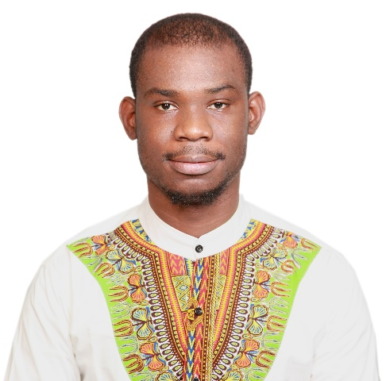

English, French, Chinese

LANGUAGE

Cooking, Reading, Vlogging

HOBBIES

Taipei/Taiwan

+886 976-728-721

[bamounidominique@gmail.com](mailto:bamounidominique@gmail.com)

bamouni.dominique

Born : 1988-RCI

CONTACT

REFERRER

Available on request

BAMOUNI DOMINIQUE





Profile



Master's degree in Electrical Engineering and Computer Science (EECS). An accomplished professional in the telecommunication industry and customer services for over 10+ years with Europe, Asia, and American companies. All the time has been spent on pre-sales, product development, technical issues solving, project management and customer services with a bias towards post-sales services. My extensive background in many of the areas as telecommunication technical knowledge, service/product solution sales in sub-region, project delivery/management, and people management will be beneficial supporting new challenges as required position.

CAREER

Consultant in computer network field

[Read More…](https://bamounidominique.github.io/resume/)

TOOLS

Python, JavaScript

Network Analyzer: Burpsuite, Colasoft, Wireshark, iperf, Penetration test tools in kali Linux

SKILLS

**5G Packet Core (5GC)**

Experience with various vendors 5GC including Nokia CMU, Athonet, Ataya, Saviah, Druid

**Mobile Edge Computing (MEC)**

Familiar with Deep Packet Inspection (DPI) and 3GPP Compliance MEC. Shared core + MECs on customers site

PUBLICATION

**Computer Network CCNP level**

Switching, Routing and firewalls. Prior experience with Cisco, D-Link and Nokia network equipment’s. Network automation and scripting with Python.

“Time Series Data Compression”

NCS 2017, Bamouni Dominique,

Sheau-Ling Hsieh; Shyan-Ming Yuan

**Network Business**

A clear picture of the telecom business. Experience working with OEM, ODM, SI.

**Testing & Troubleshooting**

Build automated test cases/lab. Excellent problem-solving skills.

**Access Point (AP)**

5G Fixed Wireless AP(FWA), xDSL, xPON, Wi-Fi Routers, Mesh.

Work History

**2022-Now**

**Vertex System ~ Taiwan**

**5G SA/NSA Packet Core Engineer**

* Performed Integration and Deployment of 5G (SA and NSA) Core Networks, Installation, commissioning, and maintenance
* Mobile Edge Computing (MEC) with various vendors such as Nokia, PacketX , ITRI
* Troubleshoot of existing 5G private networks devices including Nokia 5G SA/NSA Core, Routers, VPN, RAN, UEs
* Developing Automation Portal for Shared Core

[Read More…](https://bamounidominique.github.io/resume/)

**2017-2022**

**D-Link Corporation ~ Taiwan**

**Network Consultant/Presales**

* Analyze and handle product inquiries from overseas business unit (ISPs) and provide solutions to troubleshooting.
* Support product planner and QA department for product validation, interoperability testing and benchmark testing.
* Provide consultation for pre-sales questions and design problems.
* Create and maintain testing laboratory environment for wireless broadband product verification.
* Periodical technical training for internal engineers regarding essential networking knowledge, installation, operation, maintenance and troubleshooting of products.
* **Projects:** DSL-224(Comteco/TATA); DIR-825(Telefornica); DIR-819(Claro); DSL-5300(Australia); DSL-385(TalkTalk); AVSystem; Canal+; retail projects and many more.

**Purview Service ~ UK**

**Network Engineer Freelancer**

* Replacing, installing new L3 switch/chassis on customers network
* User Acceptance Testing (UAT) for VoIP phones, servers, printers, internet.

**2019-2020**

**2015-2017**

**NATIONAL Chiao Tung University ~ Taiwan**

**CCNA Teacher Assistant**

* Responsible for teaching Computer Network and Application CCNA Lab using real Cisco Routers and Switches to graduate students. Introduce cutting edge LAN/WAN/WLAN/VLAN/VPN networking technologies in depth, including integrated Wireless/Wired infrastructure design, configurations, security enhancements, QoS as well as hands-on experience and skills on Cisco products.

**Physics Teacher ~ BURKINA**

**Network Engineer Freelancer**

* Course & Exam delivery for grade 9-12 students.

**2011-2014**

Education

**MASTER’S DEGREE ~ Electrical and Computer Science EECS**

National Chao Tung University, Hsinchu, Taiwan

**2015-2017**

**MASTER’S DEGREE ~ Applied Physics (Energy)**

Ouagadougou University, Ouagadougou, Burkina Faso

Languages

English (advanced), Chinese (advanced), French (Native), Bambara (Native), Gourounsi (Native)

**2010-2011**