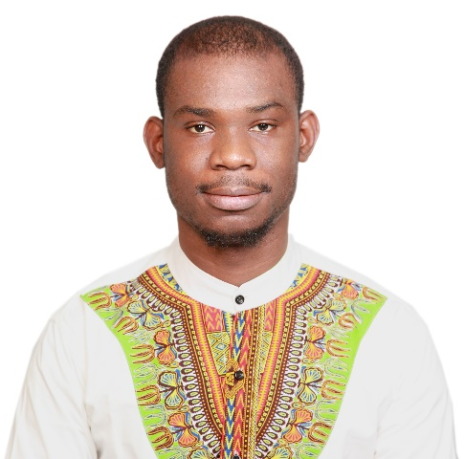

**NATIONAL Chiao Tung University ~ Taiwan**

**CCNA Teacher Assistant**

* Responsible for teaching Computer Network and Application CCNA Lab using real Cisco Routers and Switches to graduate students. Introduce cutting edge LAN/WAN/WLAN/VLAN/VPN networking technologies in depth, including integrated Wireless/Wired infrastructure design, configurations, security enhancements, QoS as well as hands-on experience and skills on Cisco products.

Experience

**2017-now**

**D-Link Corporation ~ Taiwan**

**Network Consultant/Presales**

* Analyze and handle product inquiries from overseas business unit (ISPs) and provide solutions to troubleshooting.
* Support product planner and QA department for product validation, interoperability testing and benchmark testing.
* Provide consultation for pre-sales questions and design problems.
* Create and maintain testing laboratory environment for wireless broadband product verification.
* Periodical technical training for internal engineers regarding essential networking knowledge, installation, operation, maintenance and troubleshooting of products.
* **Projects:** DSL-224(Comteco/TATA); DIR-825(Telefornica); DIR-819(Claro); DSL-5300(Australia); DSL-385(TalkTalk); AVSystem; Canal+; retail projects and many more.

**2015-2017**

Consultant in computer network field

CAREER

“Time Series Data Compression”

NCS 2017, Bamouni Dominique,

Sheau-Ling Hsieh; Shyan-Ming Yuan

Network Analyzer: Burpsuite, Colasoft, Wireshark, iperf, Penetration test tools in kali Linux

TOOLS

PUBLICATION

English, French, Chinese

LANGUAGE

Cooking, Reading, Vlogging

HOBBIES

Taipei/Taiwan

[www.linkedin.com/in/dominique-bamouni-5b1bb385](http://www.linkedin.com/in/dominique-bamouni-5b1bb385/)

+886 976-728-721

[bamounidominique@gmail.com](mailto:bamounidominique@gmail.com)

bamouni.dominique

Born : 08/10/1988-RCI

CONTACT

REFERRER

Available on request

Profile

Master’s degree in Electrical Engineering and Computer Science (EECS). I am dedicated Hardworking and proactive network Engineer well capable with design, implementation, configuration, deployment and troubleshooting IP networks. I’m currently looking for an opportunity to utilize my technical skills in a challenging working environment and become an asset to the organization that I work for.

**2010-2012**

BAMOUNI DOMINIQUE

**MASTER’S DEGREE ~ Applied Physics (Energy)**

Ouagadougou University, Ouagadougou, Burkina Faso

**MASTER’S DEGREE ~ EECS**

National Chao Tung University, Hsinchu, Taiwan

Education