

Slama Finance Project Proposal
This document Generated By AI
Any resemblance to actual persons, living or dead, or actual events is purely coincidental .
Finance document management system
Prepared for | Hamza Fidadi
Prepared by | Mohamed Yassine Bassim
Proposal reference | SF 2026 001
Issue date | 23 September 2026

This proposal presents the scope, design direction, delivery schedule, project price, commercial terms, and post-launch support for the Slama Finance web application.

Decision requested
Confirm the functional scope, project price, delivery schedule, and payment terms.

1 Solution overview and deliverables
The delivered solution is a responsive, private company dashboard for managing products, clients, commercial documents, collections, delivery notes, staff access, reporting and notifications.
Business area | Included functionality
Catalog and clients | Product, service and client lists with search, detail, creation, update and archive states.
Sales documents | Estimates, invoices, optional VAT, searchable products, conversion and PDF generation.
Collections and delivery | Installment payments, payment methods, outstanding balances and bons de livraison.
Administration | Staff accounts, dynamic roles, permissions, document design and client notifications.
Reporting | Financial summaries and configurable daily, weekly or monthly scheduled reports.
Deployment | Production deployment using the selected hosting option, initial setup and handover.

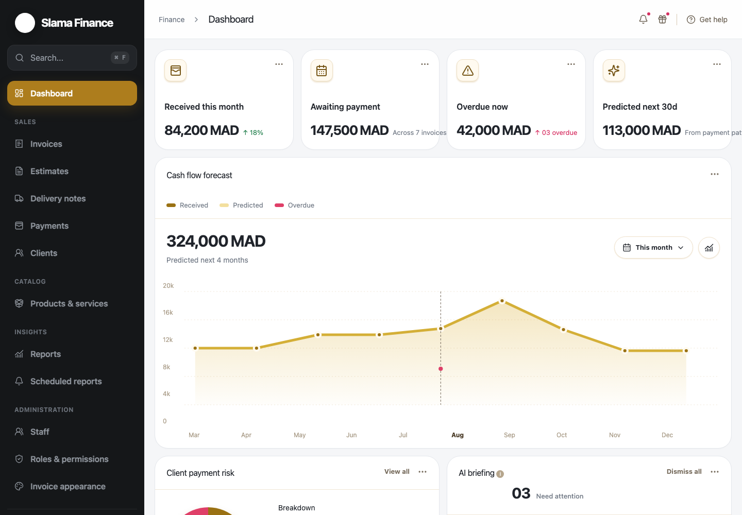

2.1 Product and service catalog
The catalog centralizes reusable products and services so users can select consistent names and prices when creating documents.
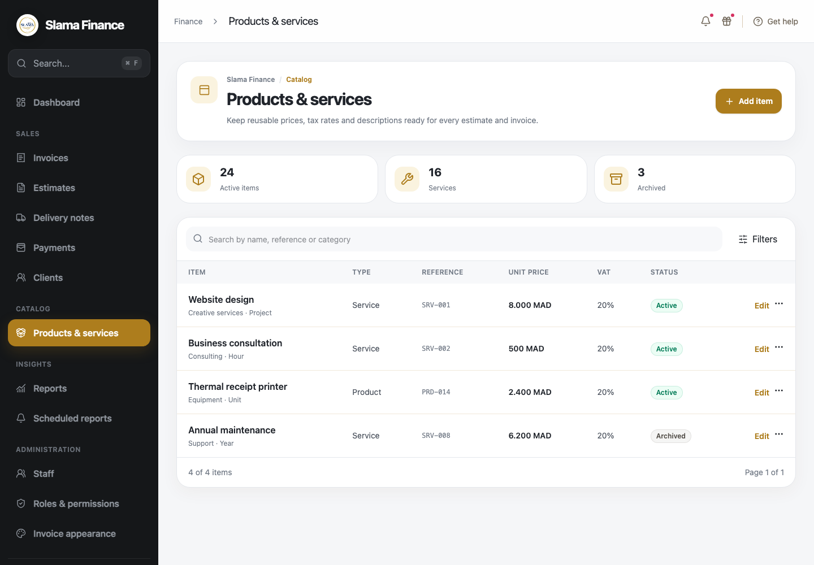  Searchable product and service list | 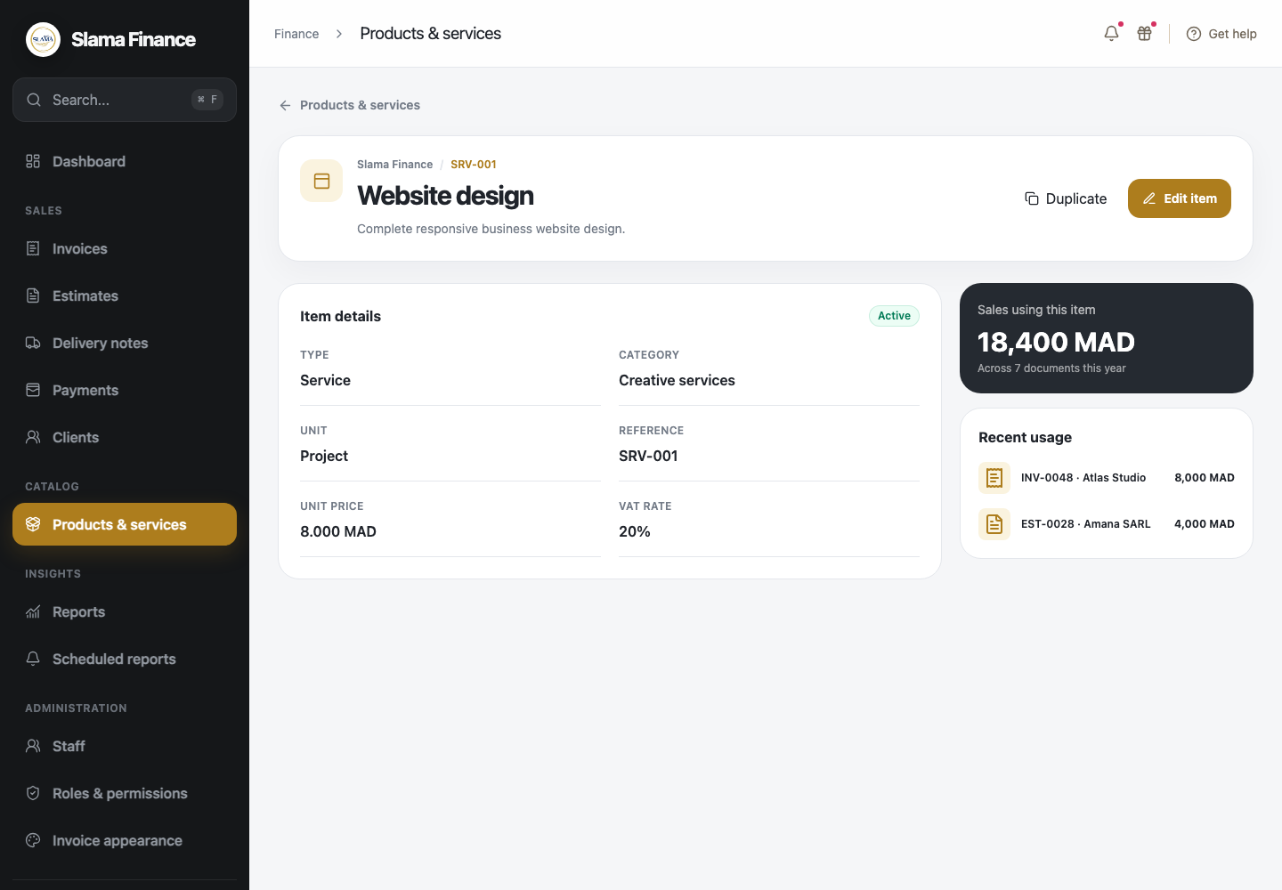  Item detail with recent usage
- Search and filter active or archived catalog items.
- Review price, unit, reference, VAT and recent document usage.

2.2 Product creation and editing
The same structured editor supports both new items and controlled updates to existing catalog records.
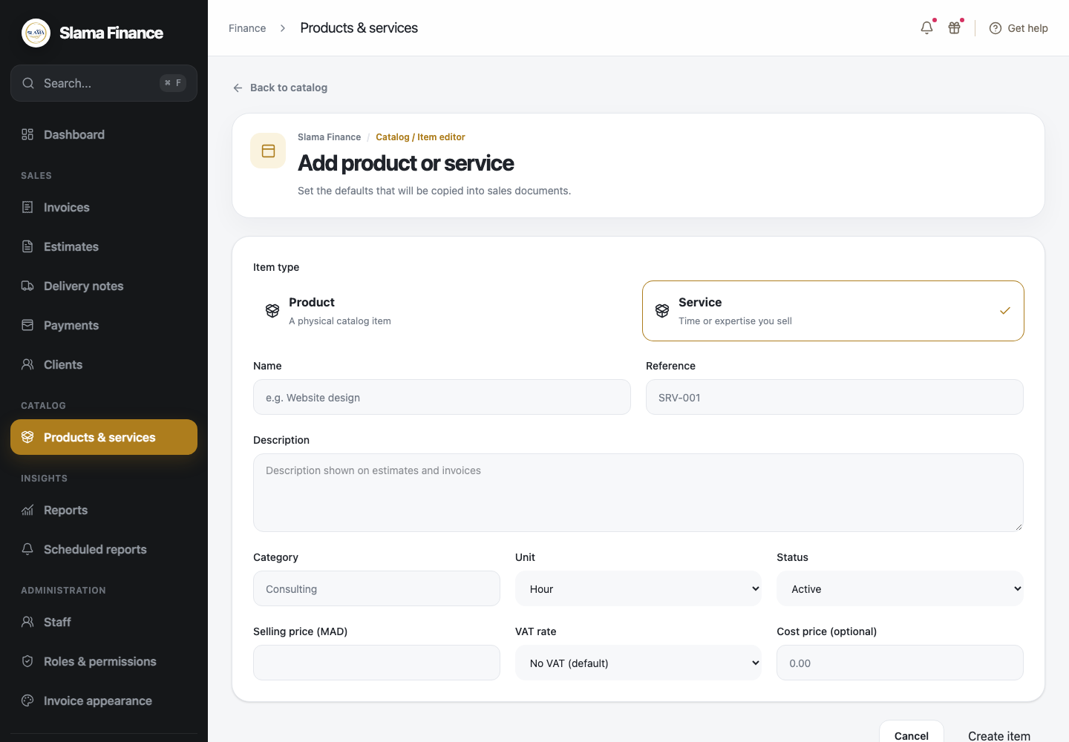  Create a product or service | 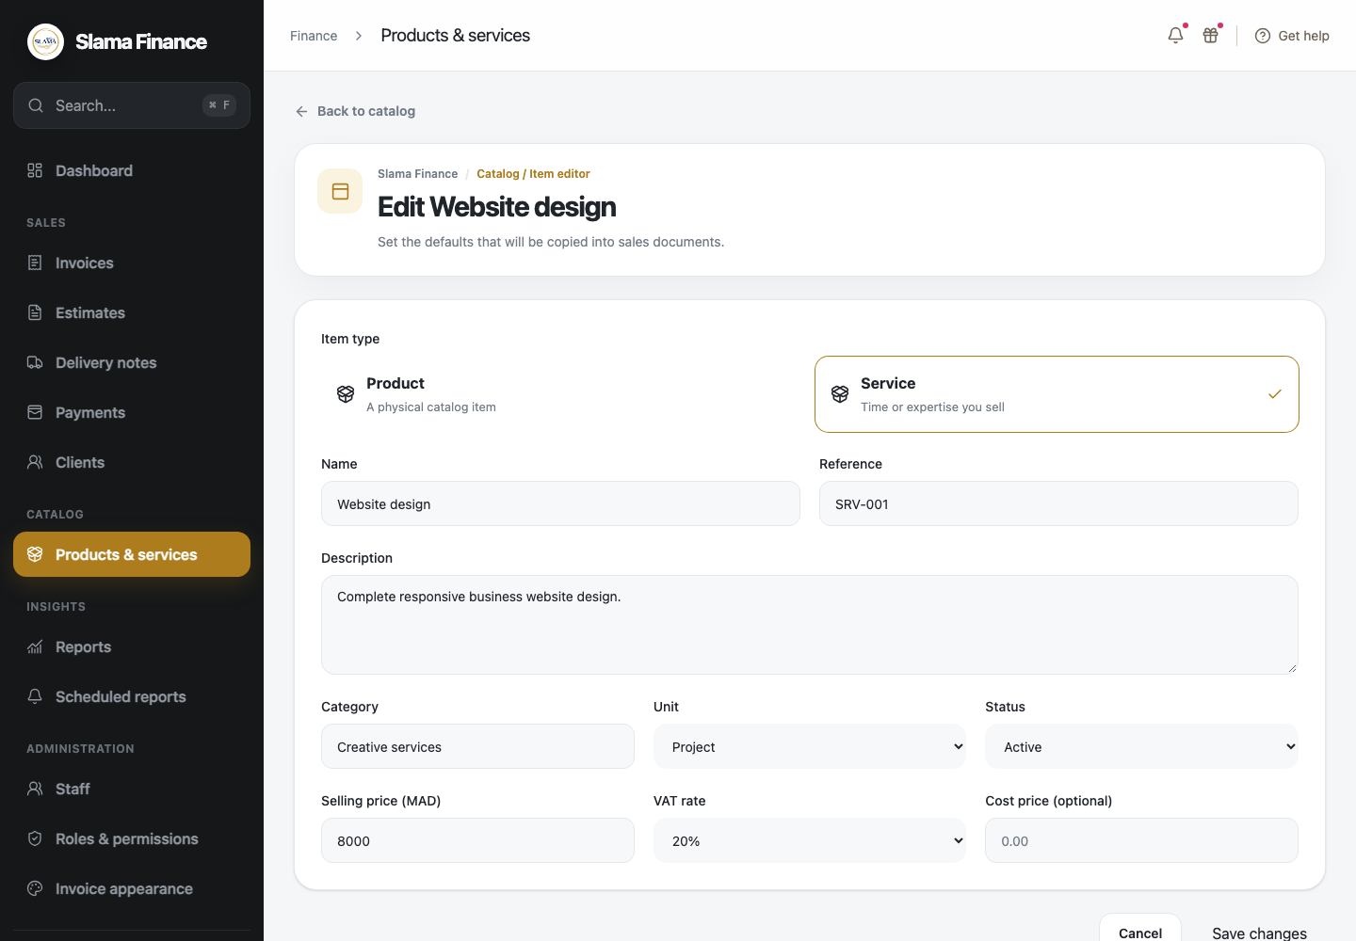  Edit an existing catalog item
- Configure item type, name, reference, description, category, unit, price and status.
- VAT remains optional and defaults to no VAT for newly created items.

3.1 Client management
Client records combine identification, contact details, balances, document history and communication preferences.
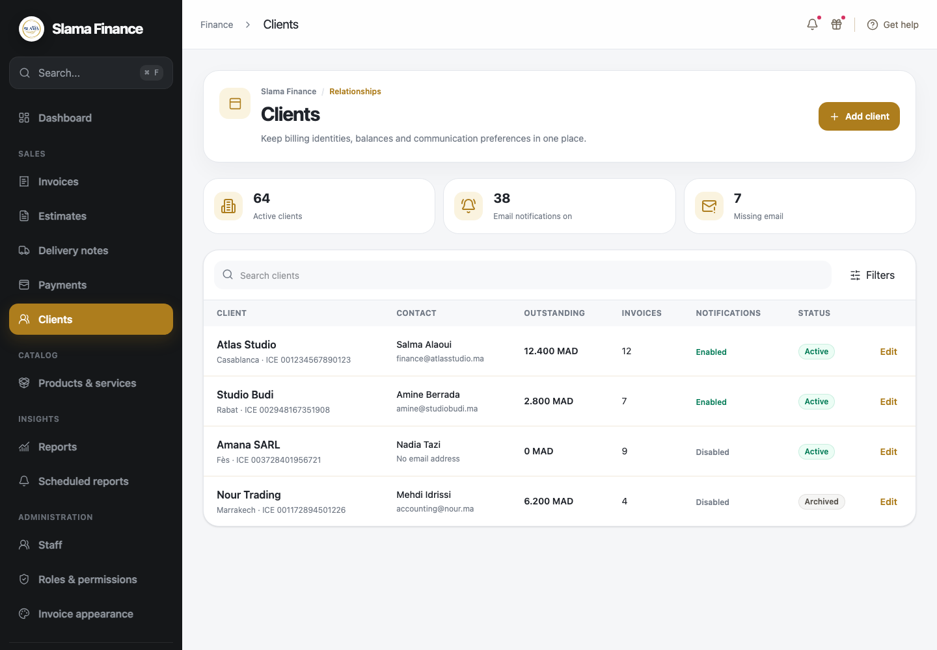  Client list with balances and notification state | 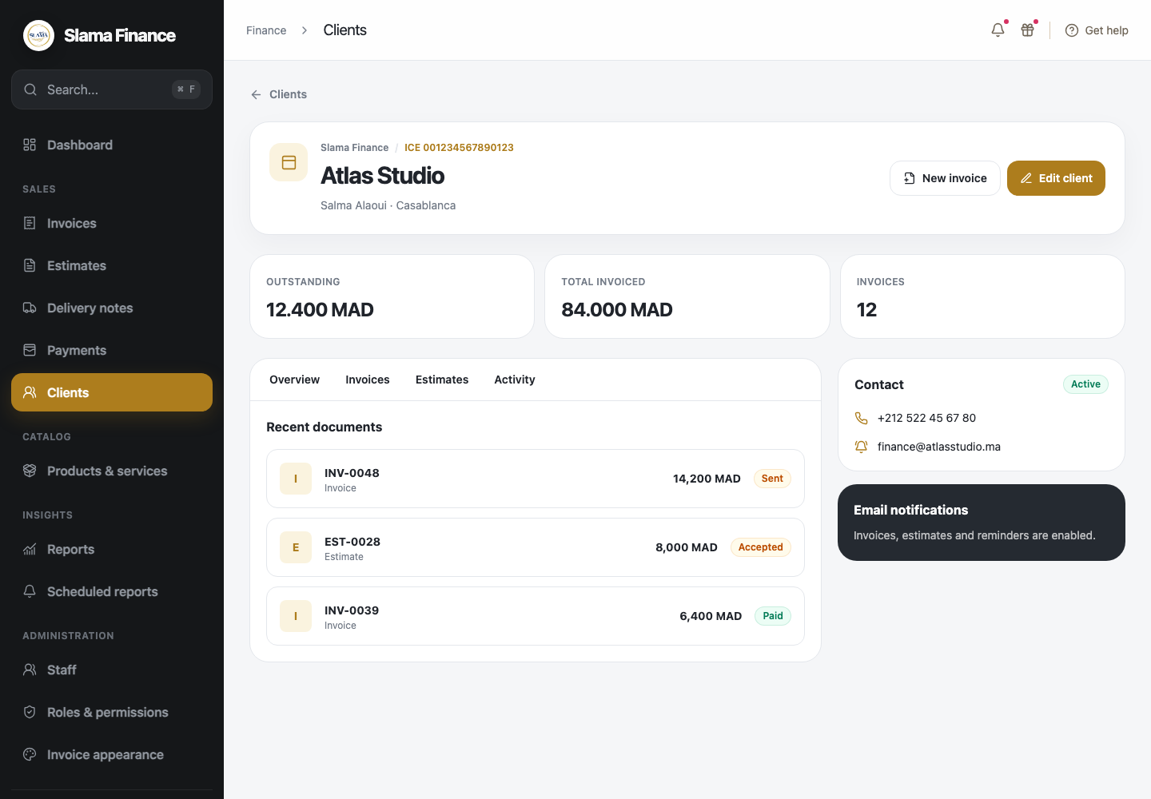  Client profile and related documents
- Search clients and review outstanding balances at a glance.
- Open a client profile to review invoices, estimates and contact information.

3.2 Client creation and editing
The client form keeps legal, contact and communication information together.
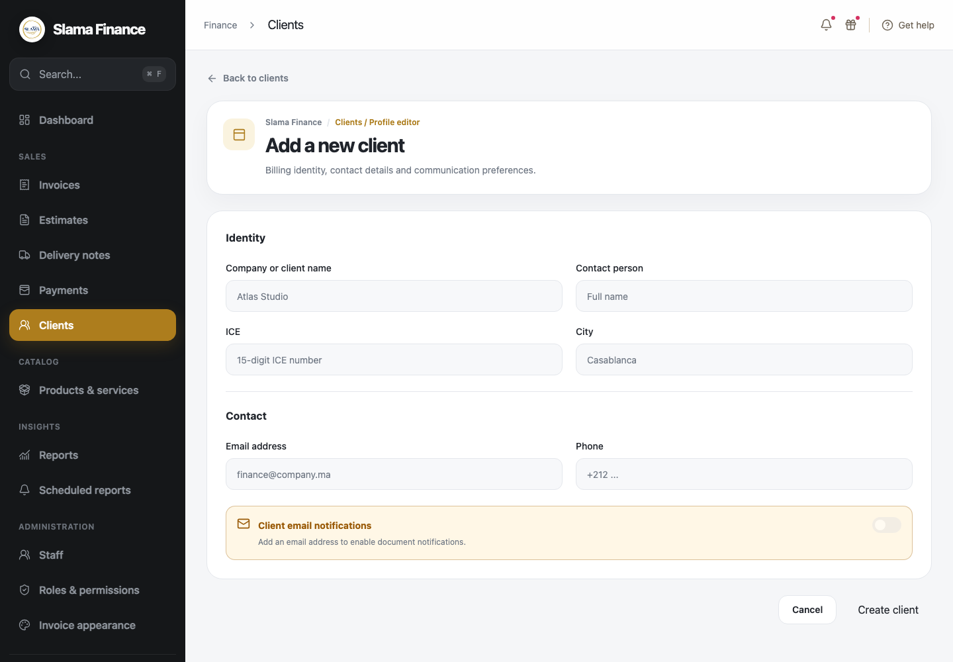  Create a client | 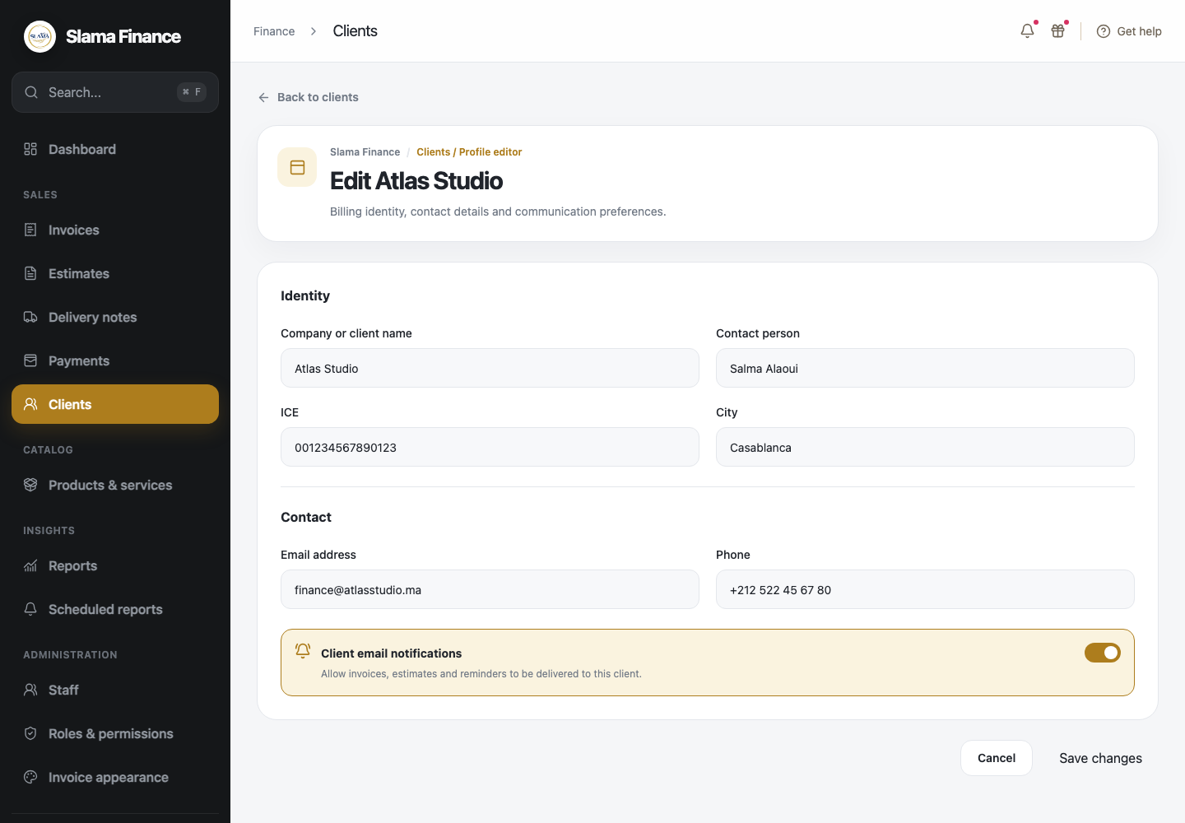  Update client information
- Store company name, contact person, ICE, city, email and telephone.
- Enable optional client notifications only when a valid email address exists.

4.1 Invoice management
Invoices can be searched and followed from draft through collection, with payment progress visible from the list.
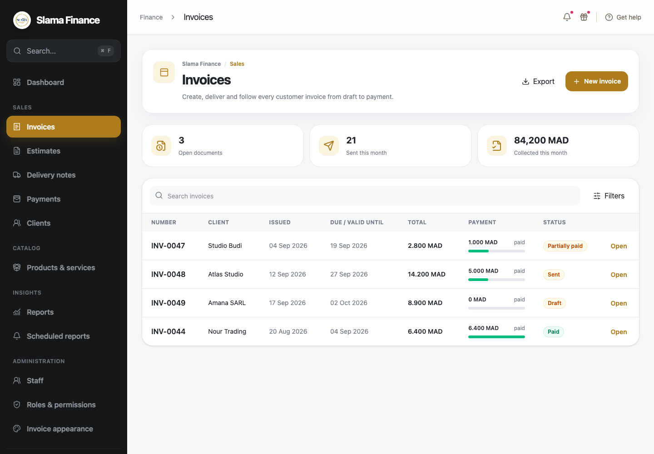  Invoice list and payment progress | 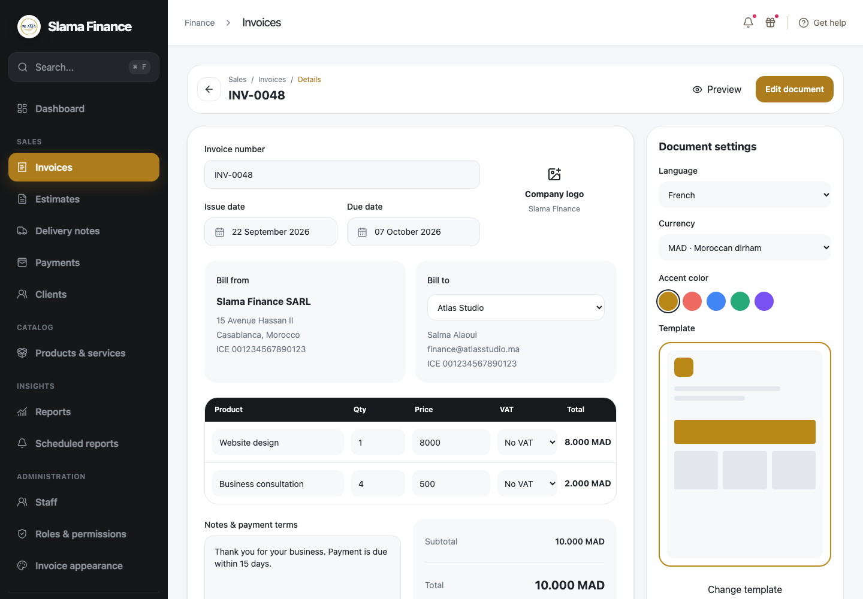  Invoice detail and document settings
- Track invoice status, total amount, amount paid and remaining balance.
- Preview the final document and review recorded installments from the invoice detail.

4.2 Invoice creation and editing
The invoice editor combines client selection, searchable catalog products, totals, terms and visual settings.
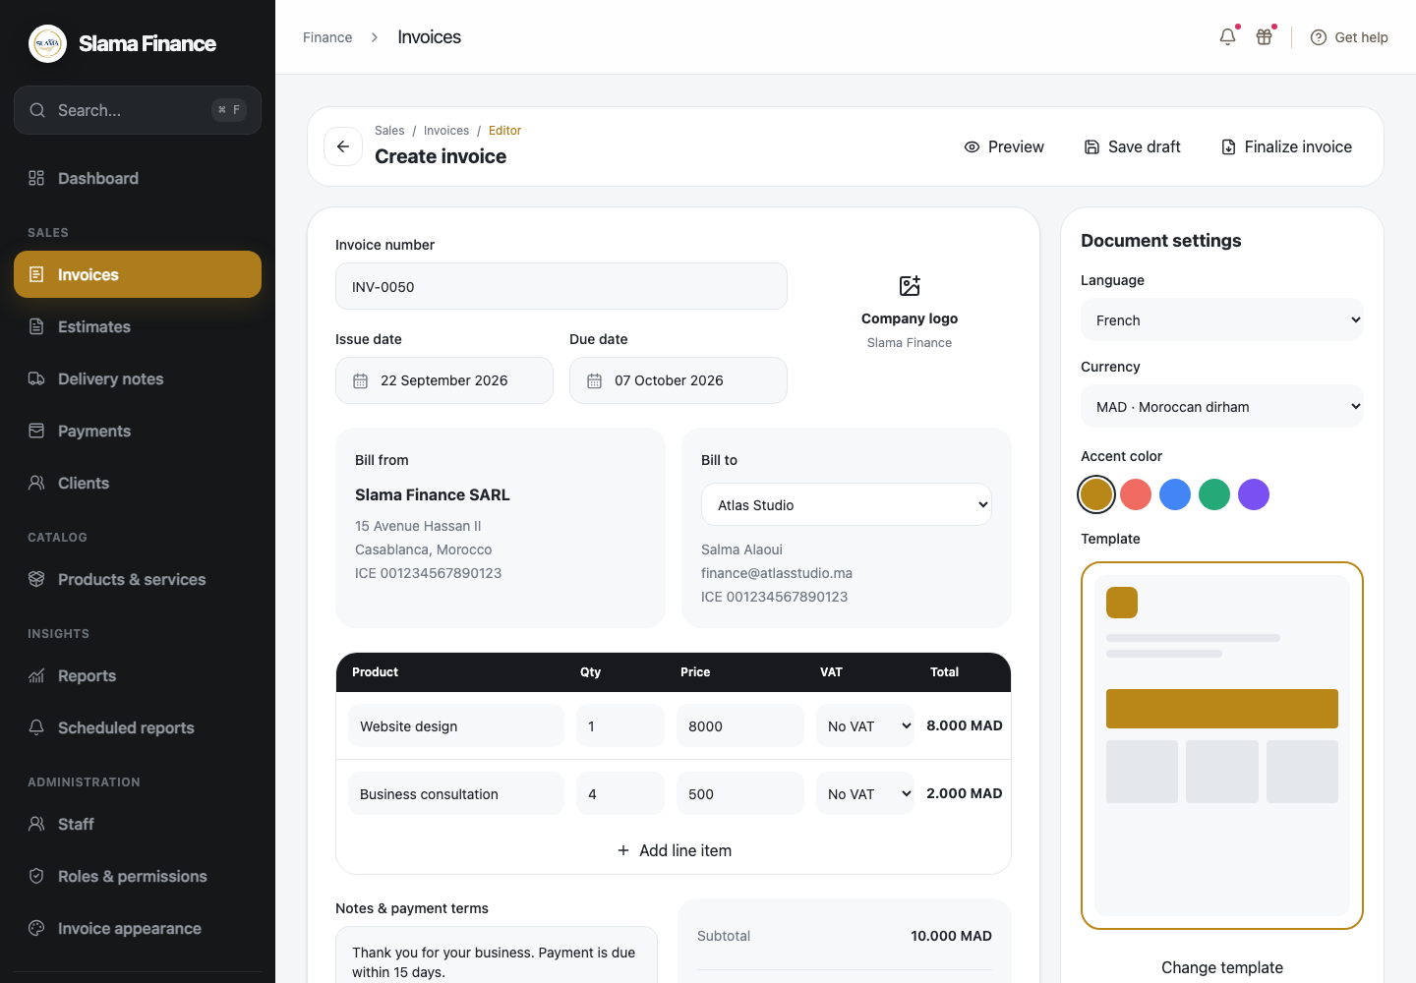  Create a new invoice | 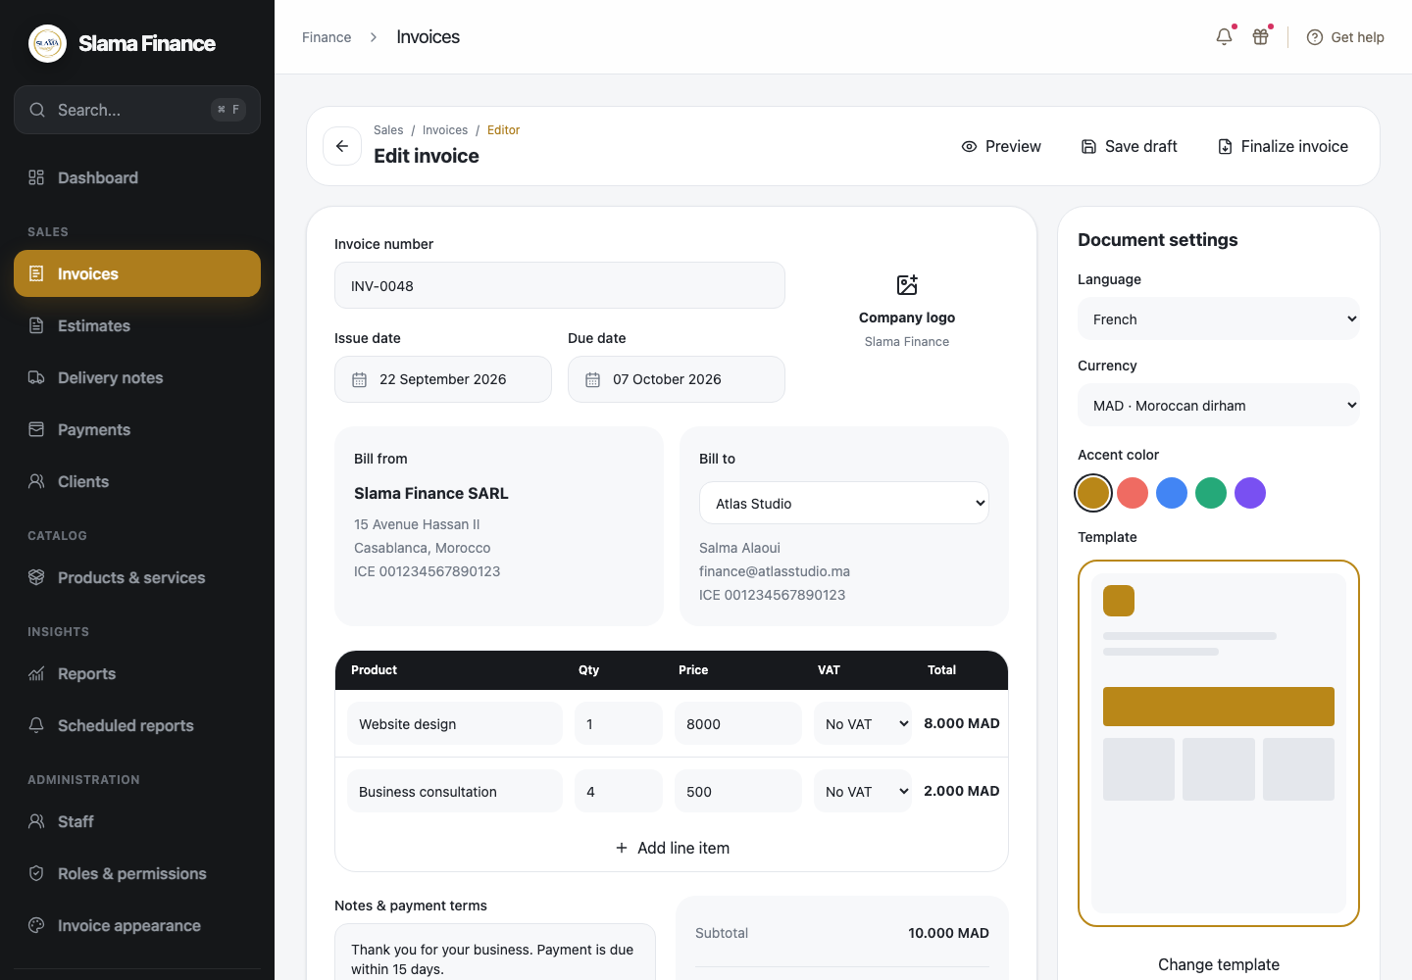  Edit an existing invoice
- Search products by name or reference and automatically fill the product name and price.
- VAT is not added unless the user explicitly selects a VAT rate for a line.
- Save drafts, preview documents and finalize invoices.

5.1 Estimate management
Estimates use the same familiar document workflow while supporting acceptance and conversion into an invoice.
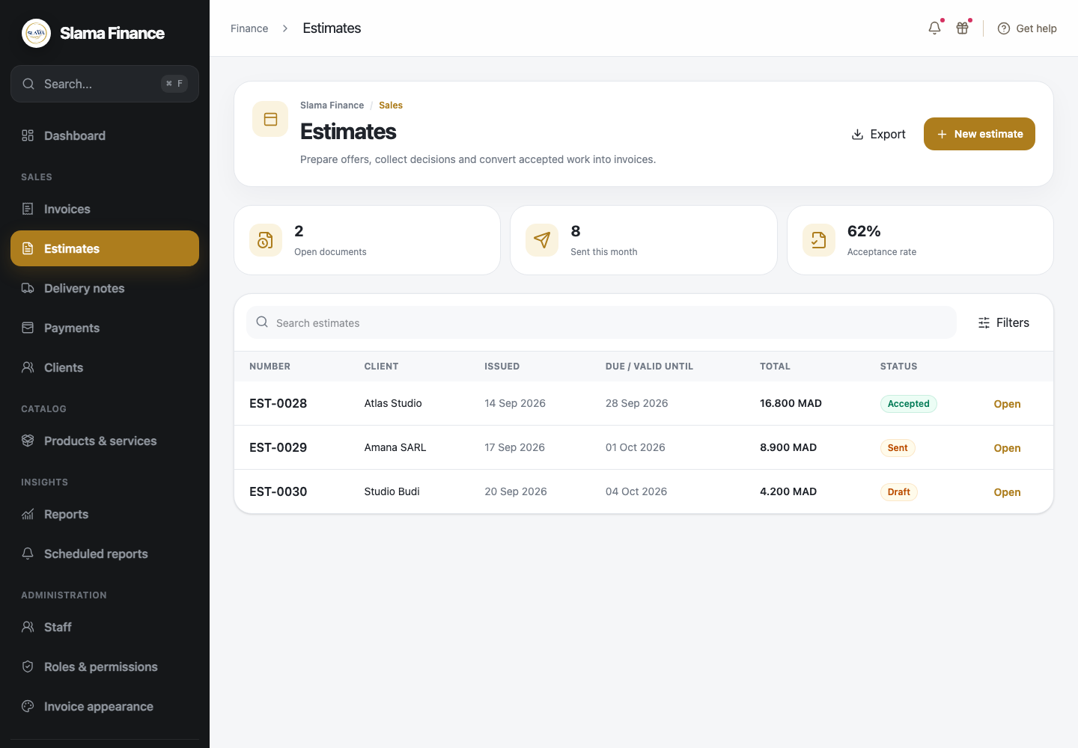  Estimate list with acceptance status | 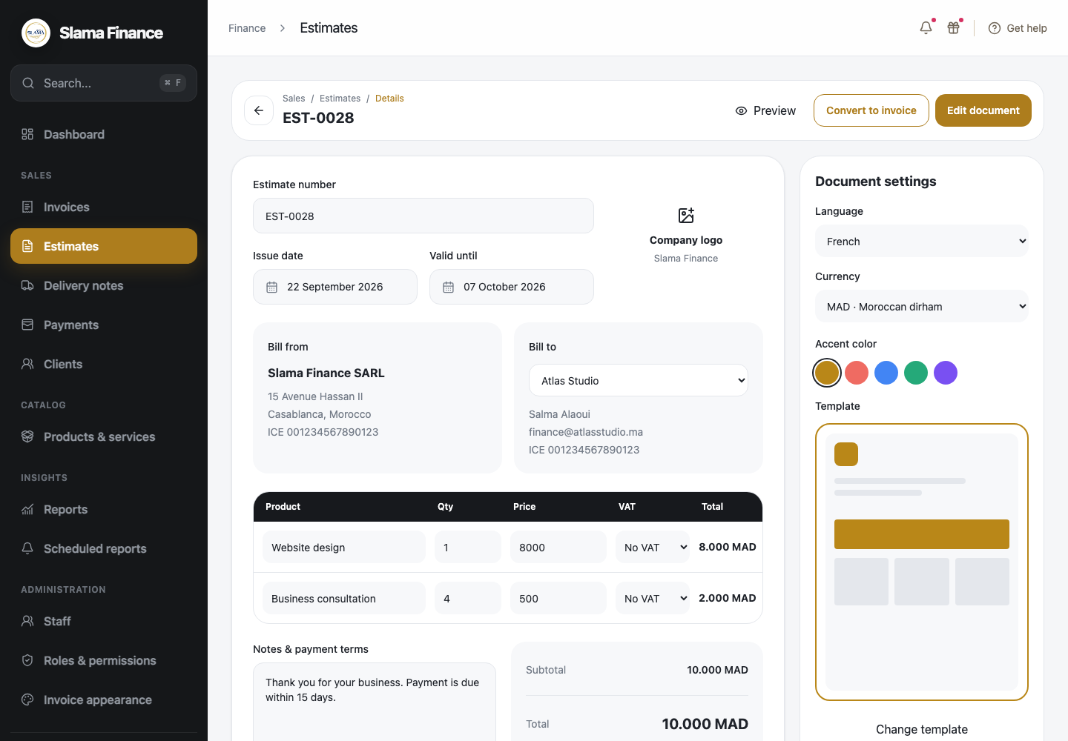  Estimate detail and conversion action
- Search estimates and follow draft, sent and accepted states.
- Convert an accepted estimate into an invoice without re-entering its products.

5.2 Estimate creation and editing
Users can prepare and adjust offers before sending them to the client.
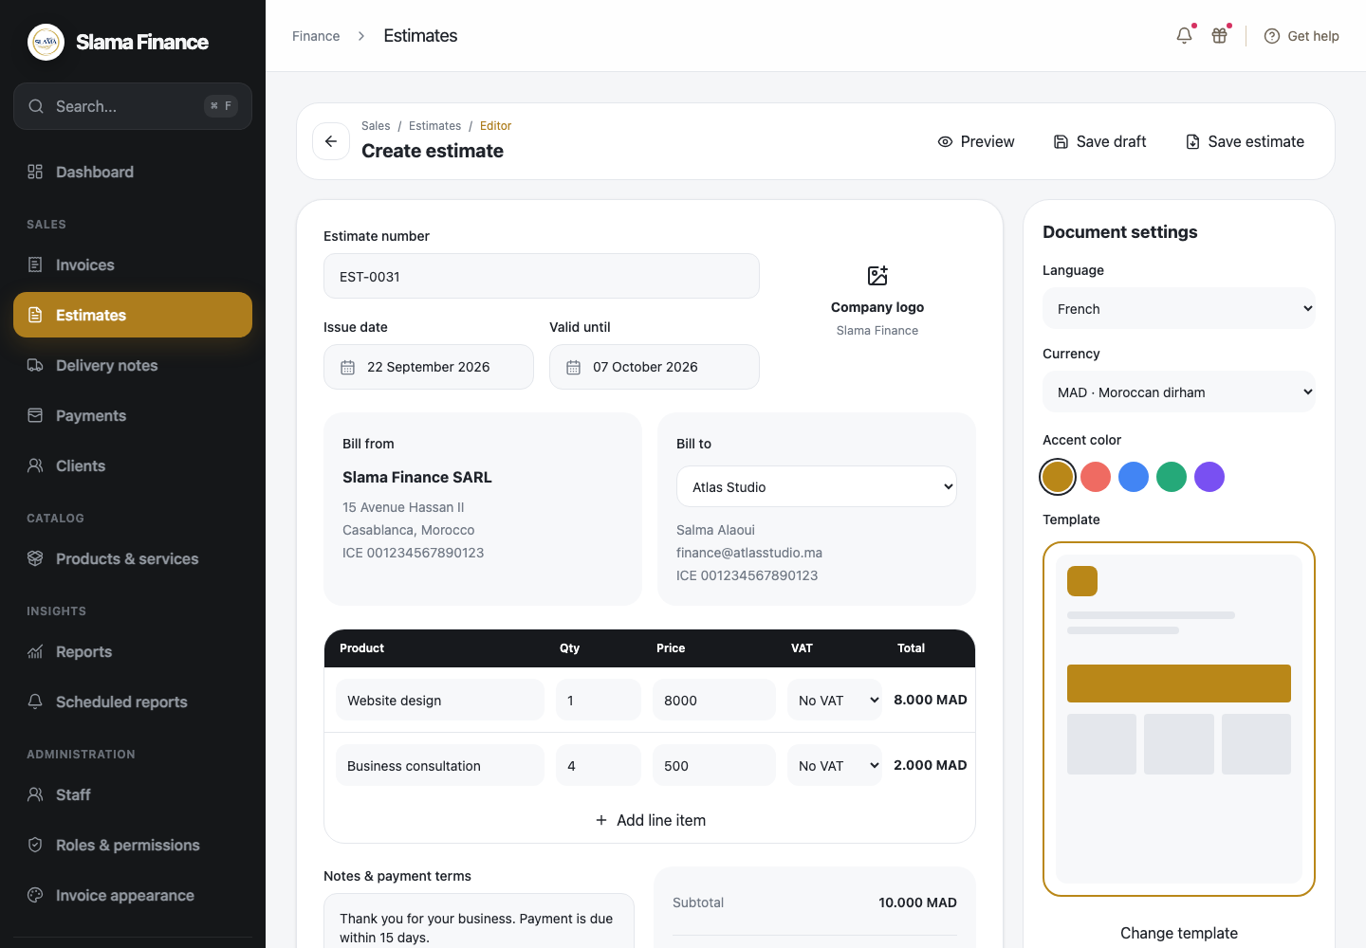  Create an estimate | 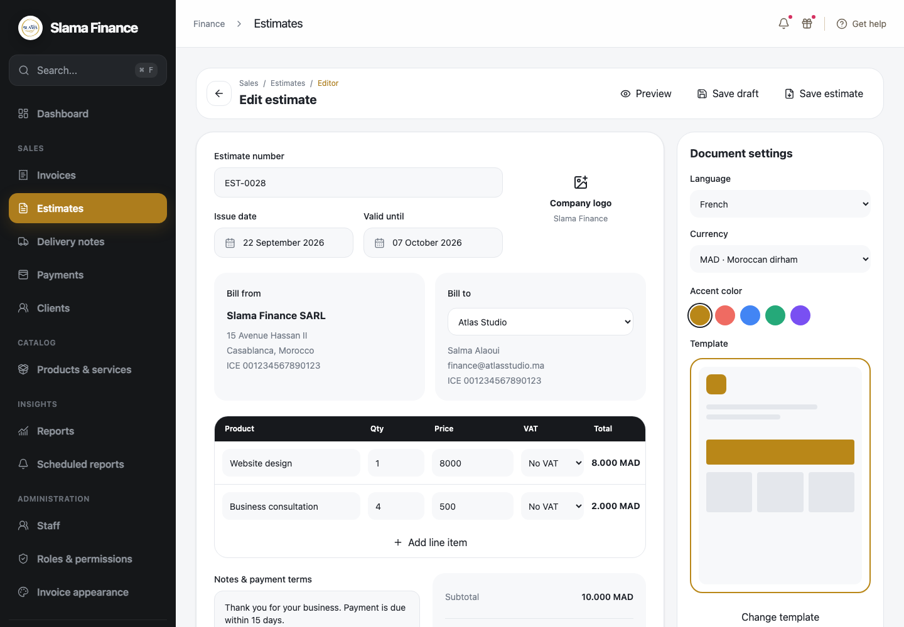  Edit an estimate
- Use searchable products, quantities, prices and optional VAT.
- Configure validity dates, notes, language, currency and document appearance.

6.1 Delivery note management
Bons de livraison document delivered products and quantities without exposing prices.
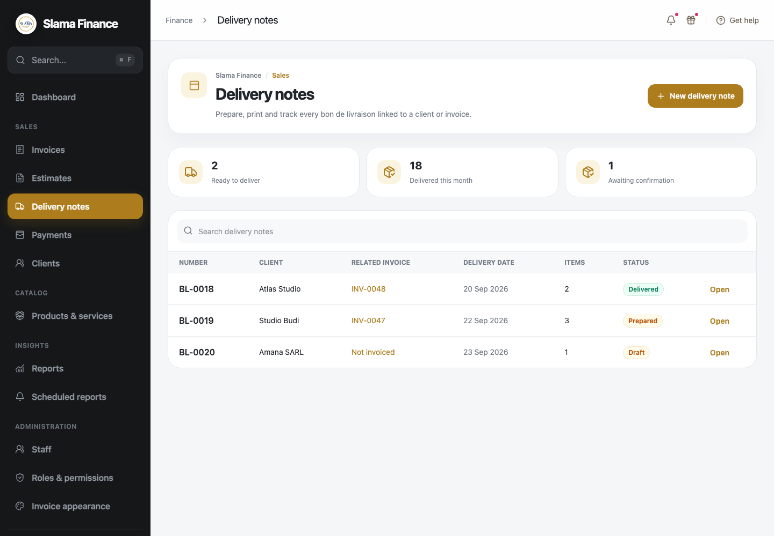  Delivery-note list and statuses | 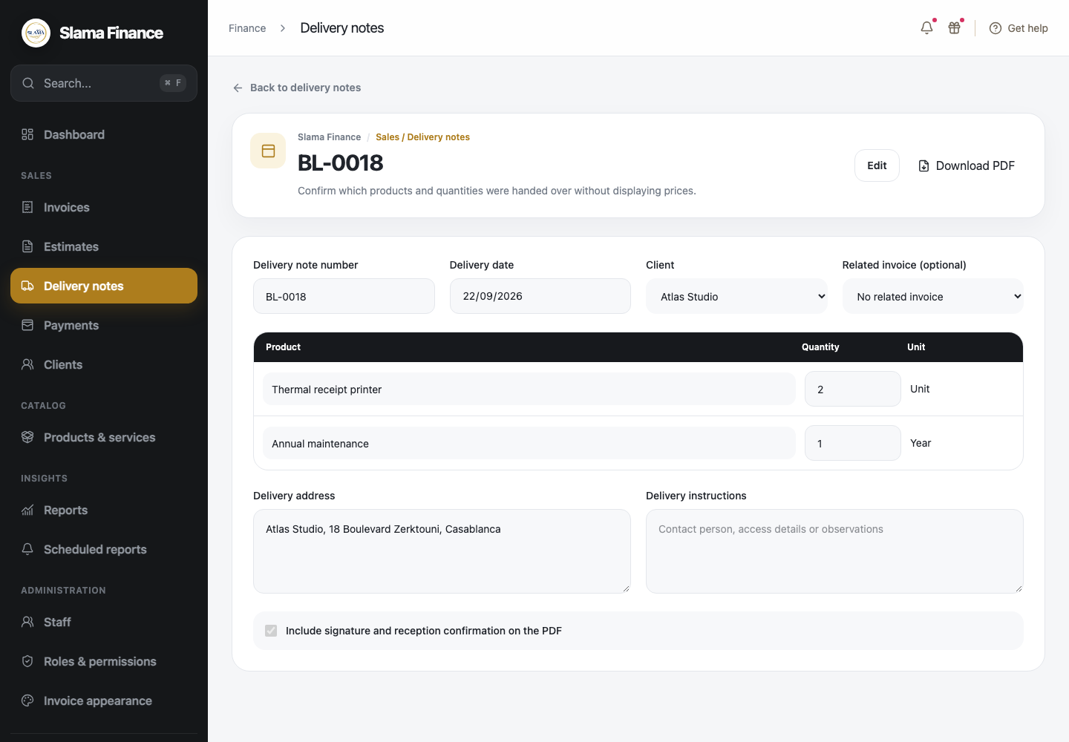  Delivery-note detail and PDF action
- Track draft, prepared, delivered and acknowledged delivery notes.
- Link a delivery note to an invoice when required.

6.2 Delivery note creation and editing
Delivery notes record the operational handover and can include reception confirmation.
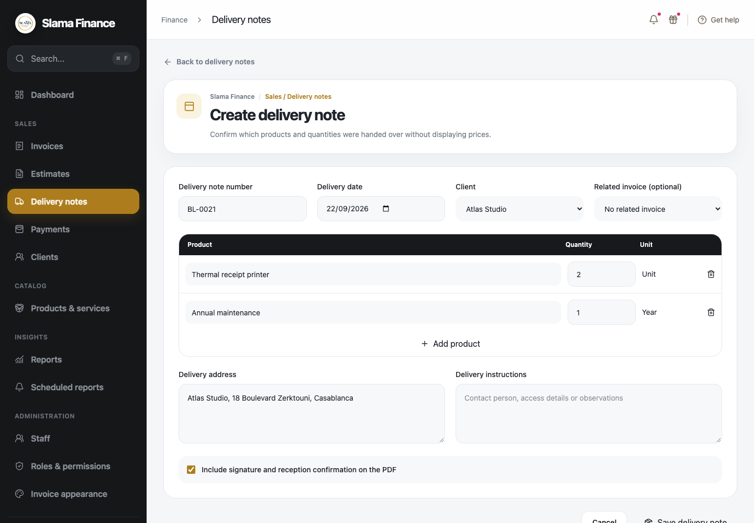  Create a delivery note | 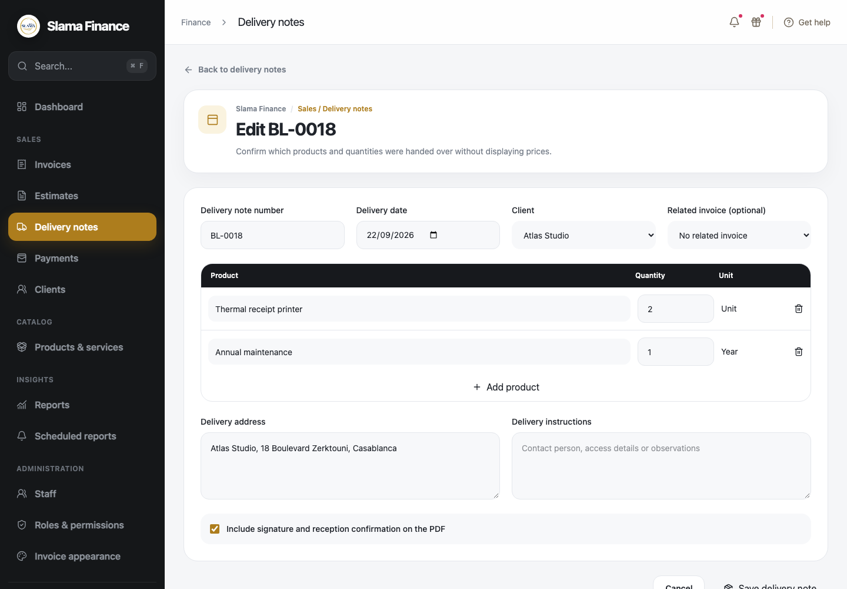  Edit delivery information
- Search products and enter delivered quantities and units.
- Add the address, instructions and optional signature or reception confirmation.
- Generate a printable PDF without product prices or invoice totals.

7 Payment and installment tracking
The payment ledger connects every receipt to an invoice and preserves the selected payment method and reference.
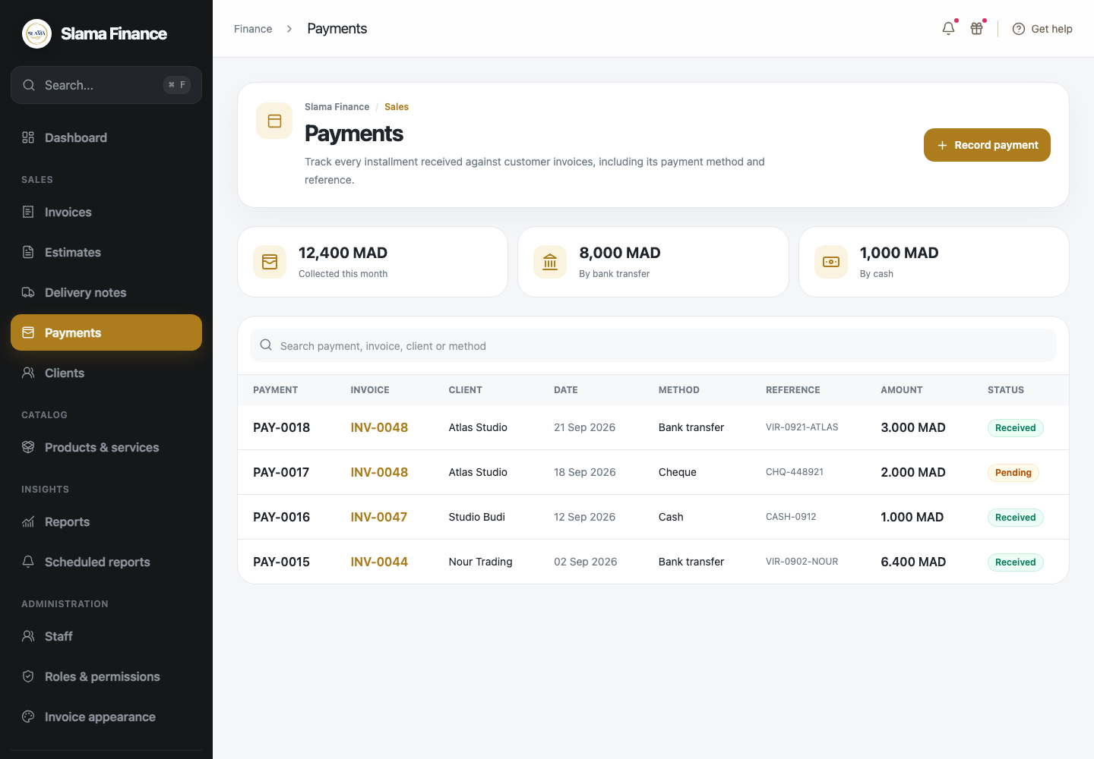  Payment ledger | 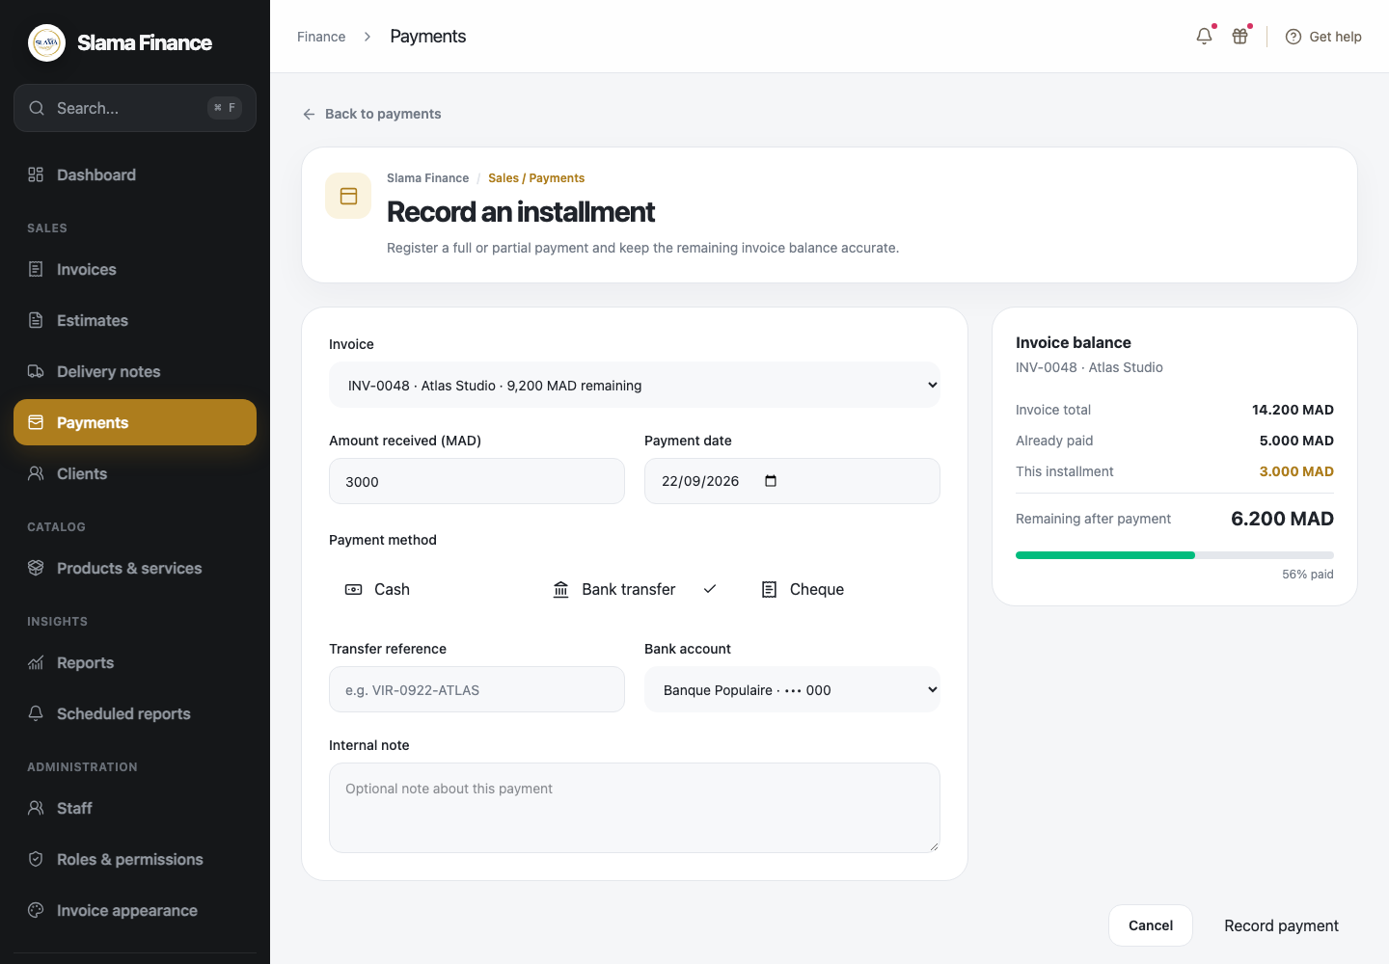  Record a partial payment
- Record full payments or multiple installments by cash, bank transfer or cheque.
- Store transaction references, cheque information, payment dates, notes and status.
- Calculate the remaining invoice balance immediately after each installment.

8.1 Financial reporting
Reports provide a concise view of revenue, collections, unpaid amounts, overdue invoices and client performance.
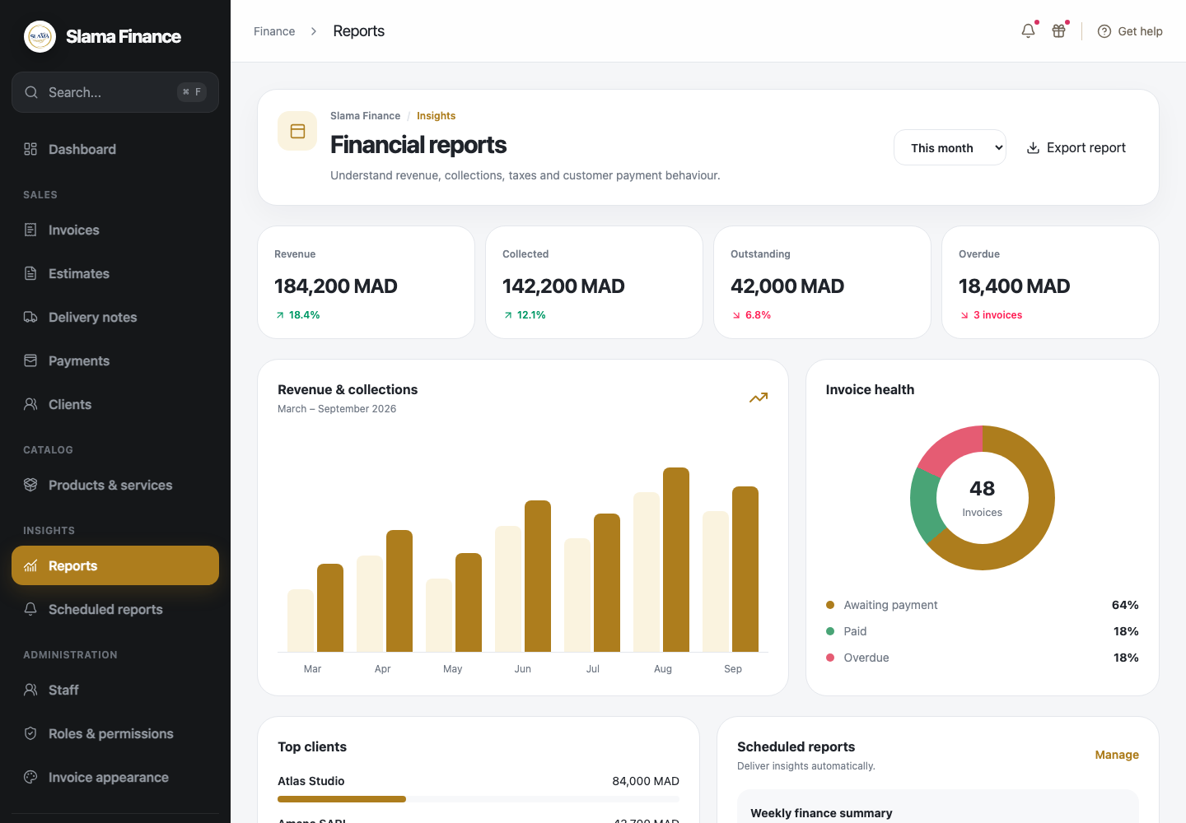  Financial report overview | 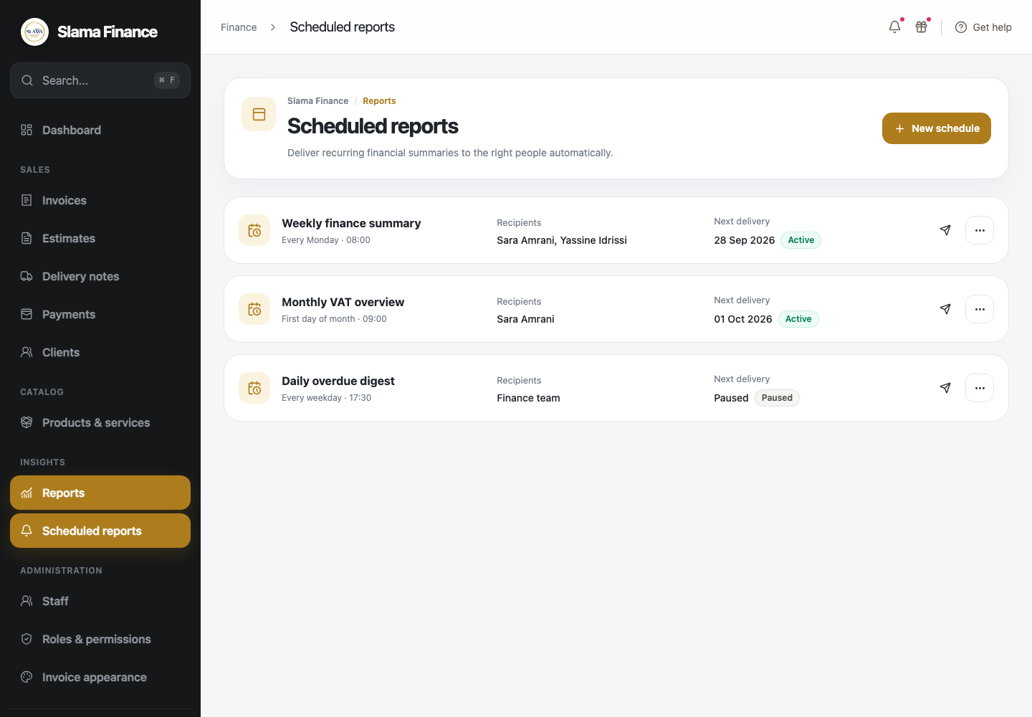  Recurring report schedules
- Review financial indicators and invoice health.
- Deliver reports automatically on a daily, weekly or monthly schedule.

8.2 Scheduled report configuration
Each schedule defines its timing, recipients, status and report contents.
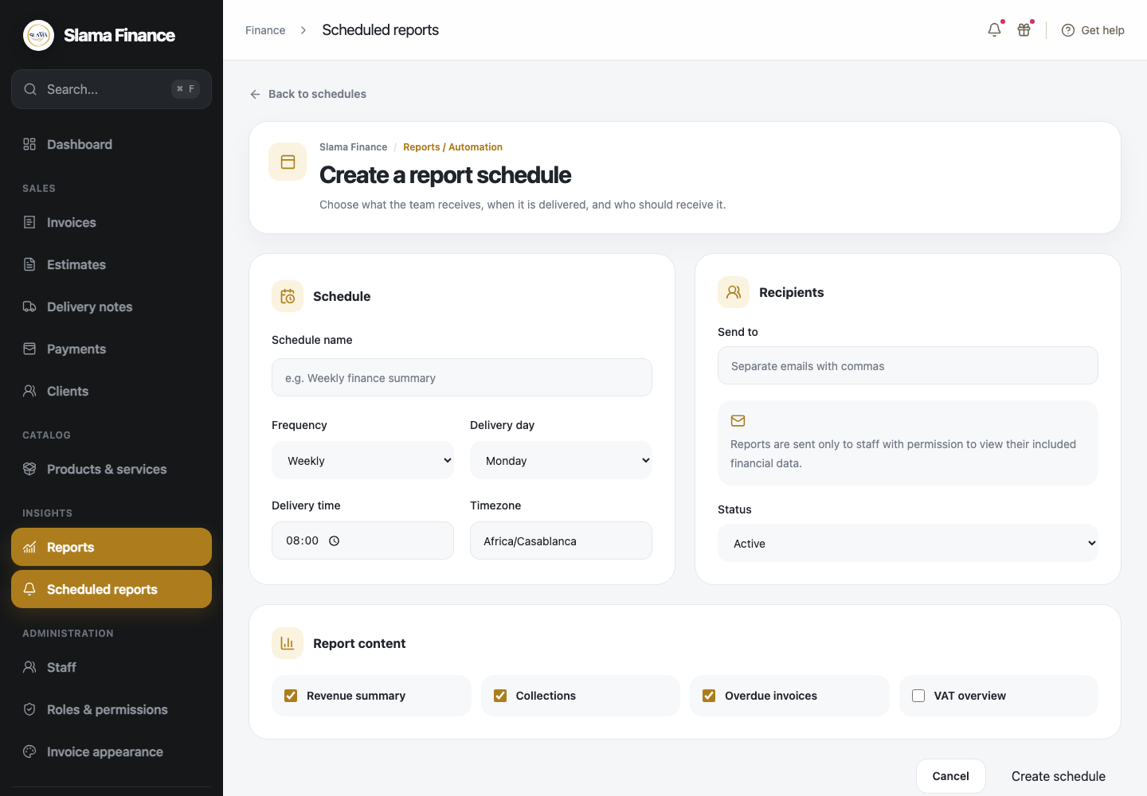  Create a report schedule | 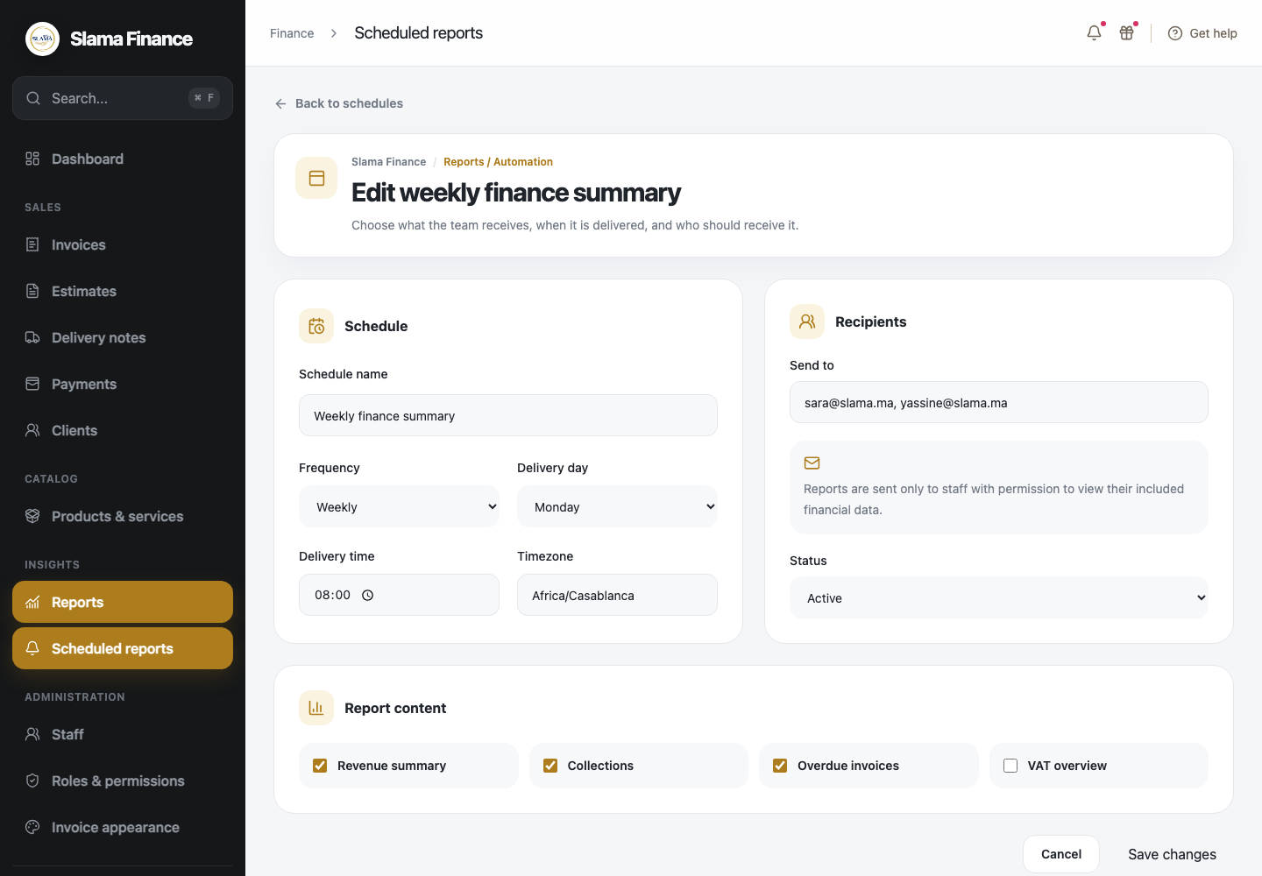  Edit a report schedule
- Configure frequency, delivery day, delivery time and timezone.
- Choose recipients and include revenue, collections, overdue invoices or VAT summaries.

9.1 Staff management
Only administrators can create staff accounts; there is no public registration.
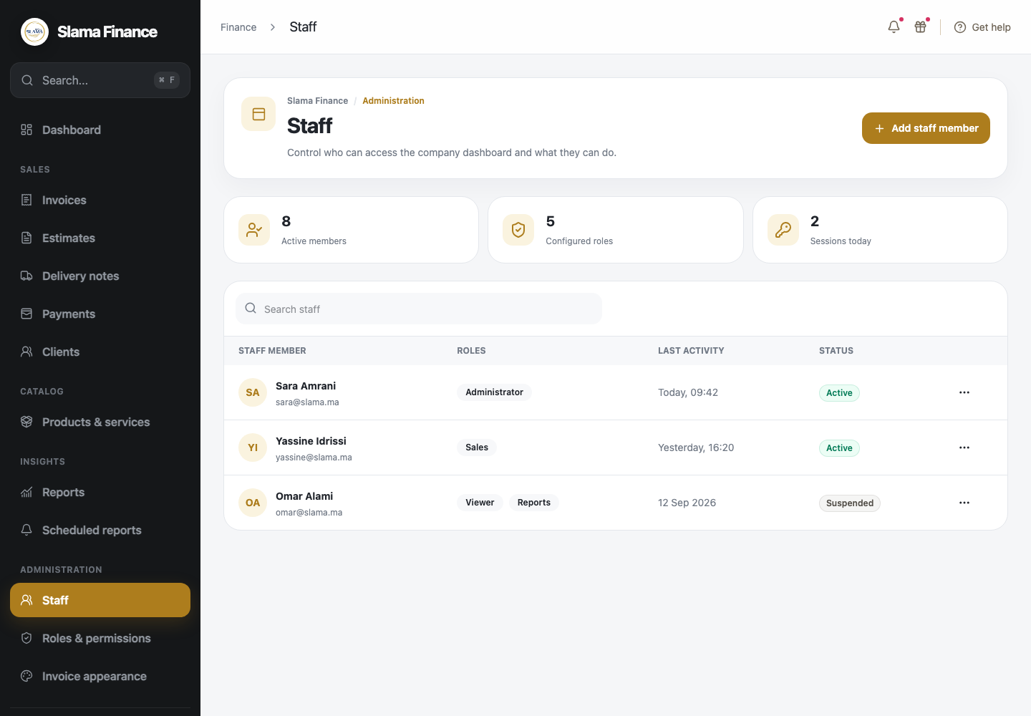  Staff list, activity and status | 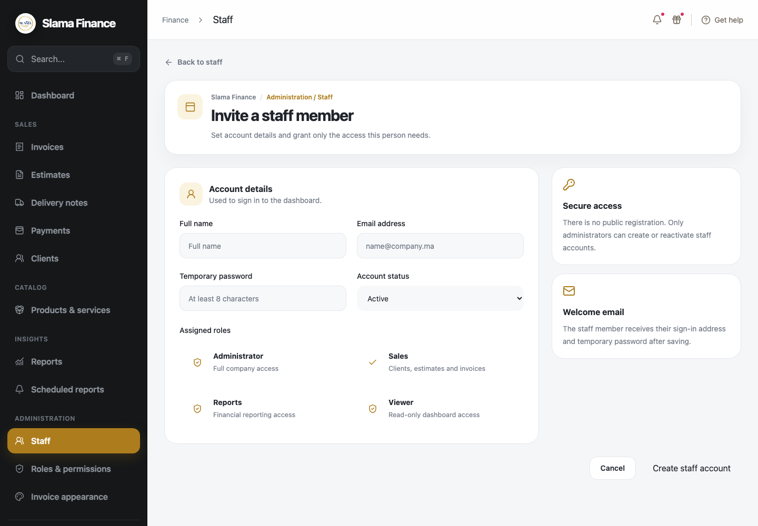  Create a staff account and assign roles
- Create, activate, suspend and update staff members.
- Assign one or more roles when creating a staff account.

9.2 Staff editing and access review
Administrators can revise account status and assigned responsibilities as the team changes.
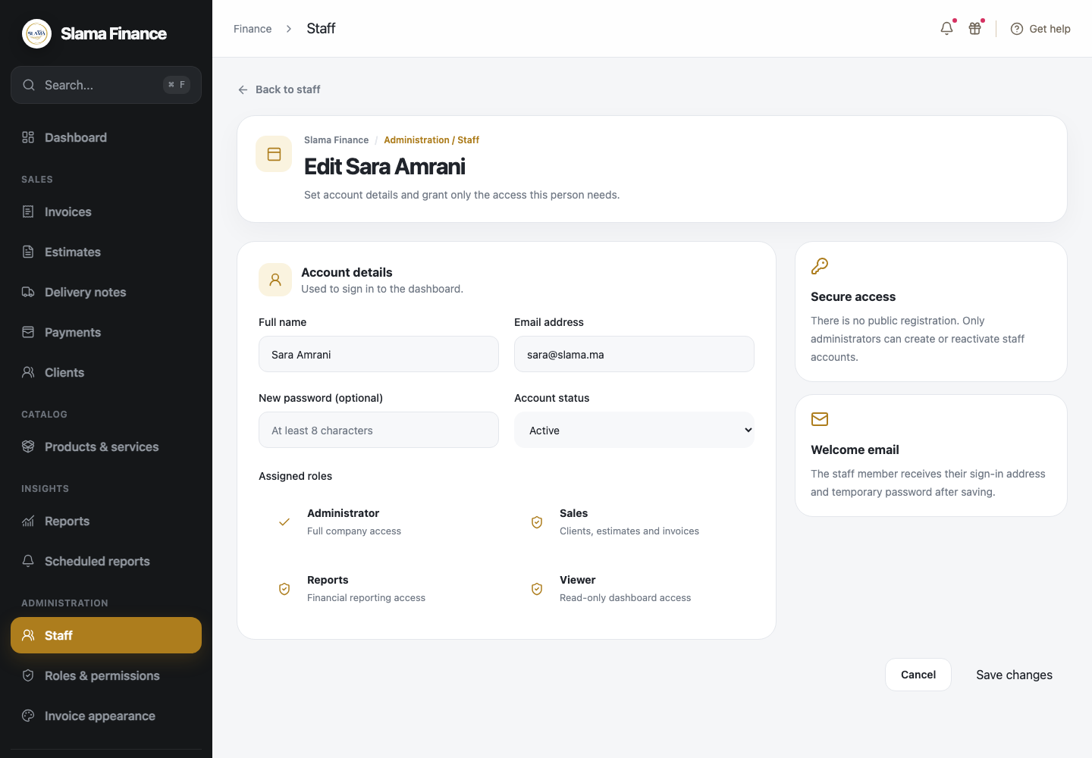
Edit staff details and roles
- Update staff identity, email, password, status and assigned roles.
- Keep sensitive actions limited to authorized staff.

9.3 Dynamic RBAC configuration
Roles are configurable so the administrator can define precisely what each team member may view or change.
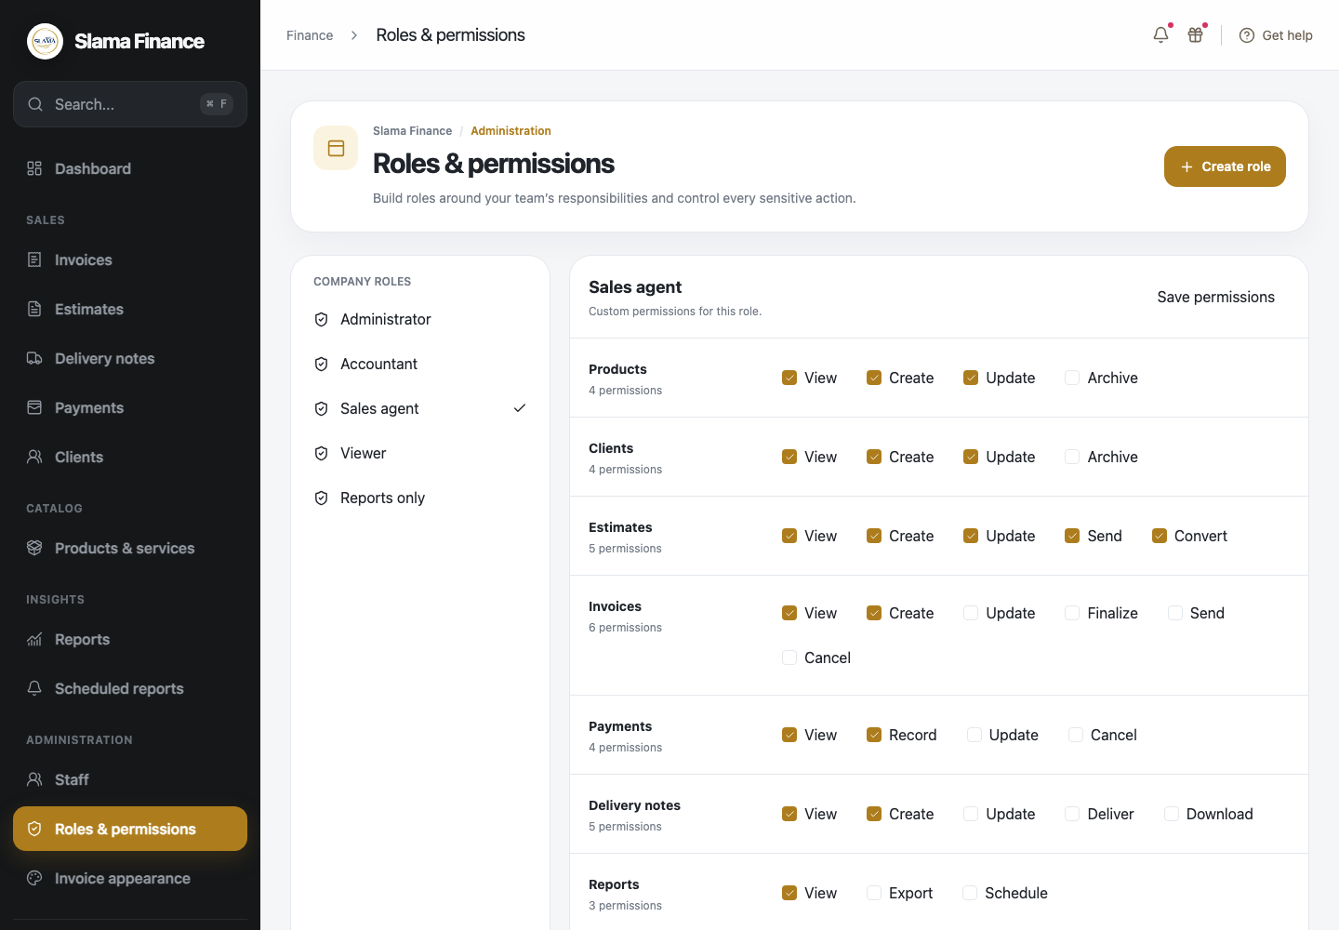  Existing roles and permission matrix | 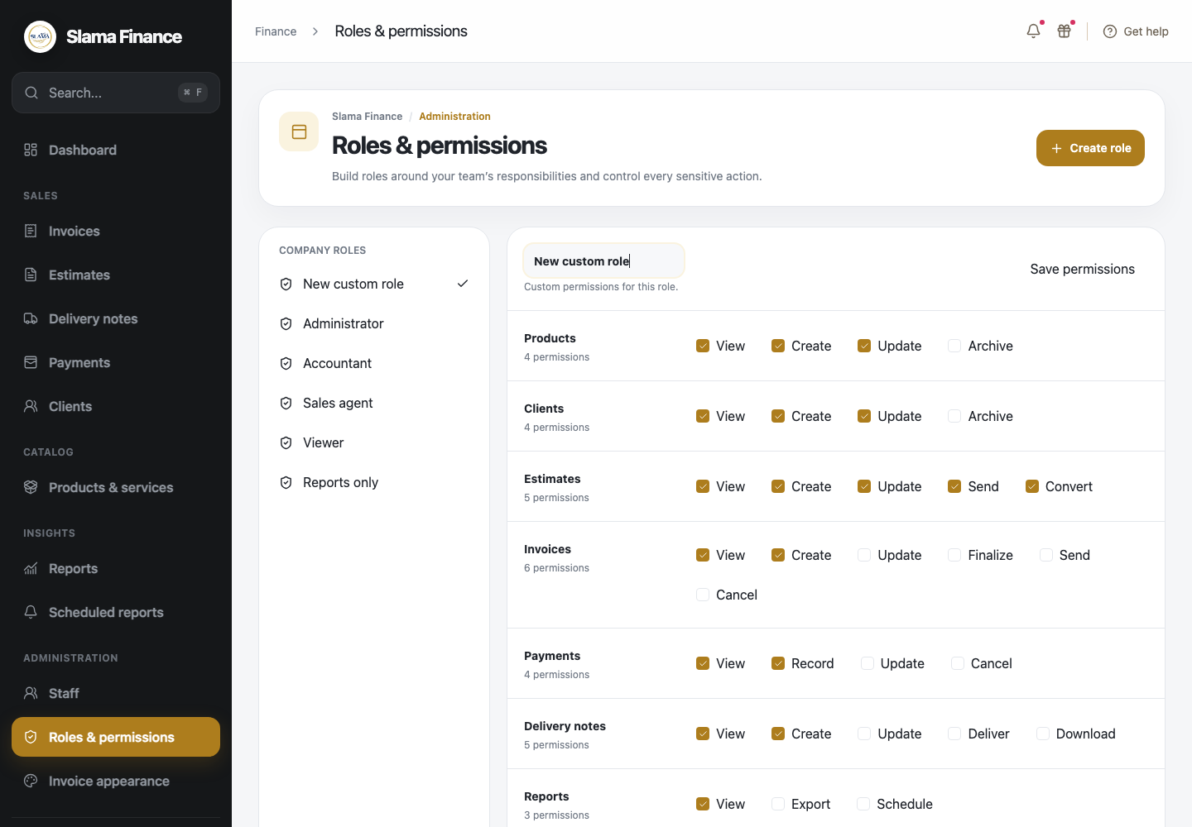  Create a custom role
- Control permissions for products, clients, estimates, invoices, payments, delivery notes, reports, staff and settings.
- Create custom roles instead of relying only on fixed system profiles.

10.1 Invoice and estimate appearance
The document designer provides a live preview so the company can approve its printable identity before use.
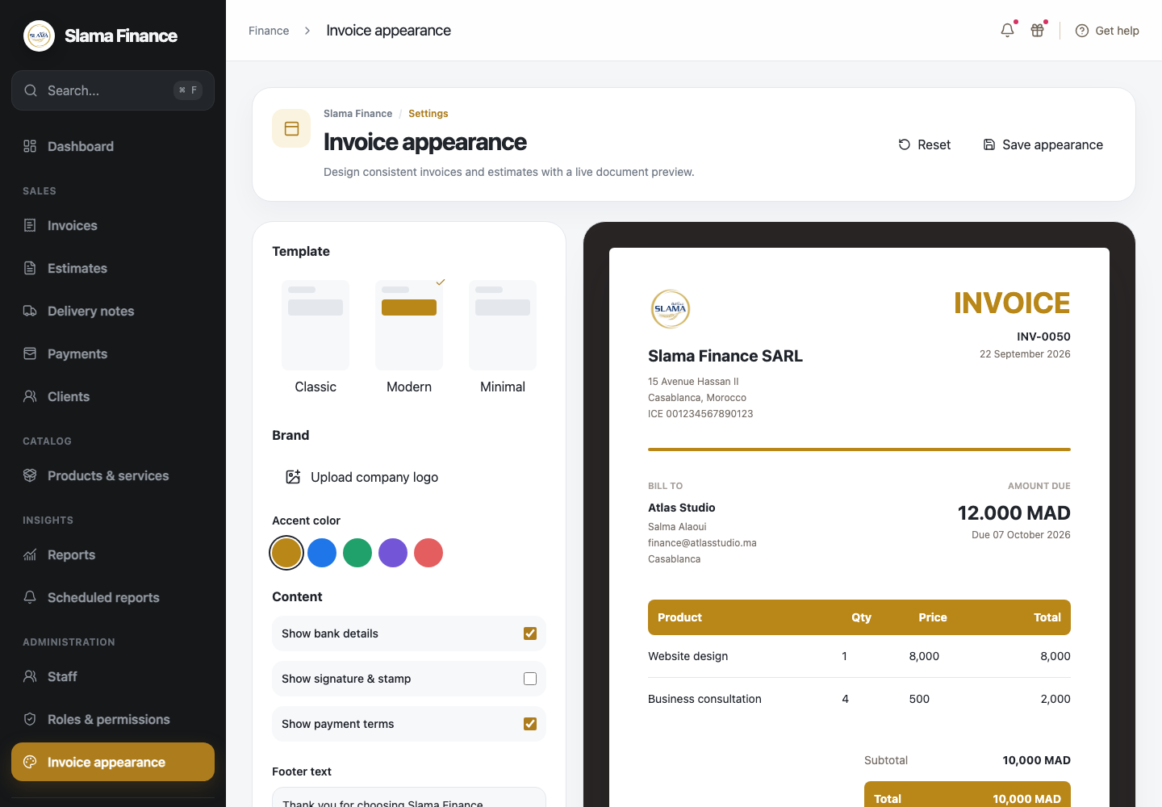  Template, logo, color and content controls | Selected appearance applied to an invoice
- Choose the template and accent color and upload the company logo.
- Configure bank information, payment terms, signature, stamp and footer text.
- Print product names rather than internal product descriptions.

10.2 Client notification settings
Email communication is optional and controlled through company defaults and client contact availability.
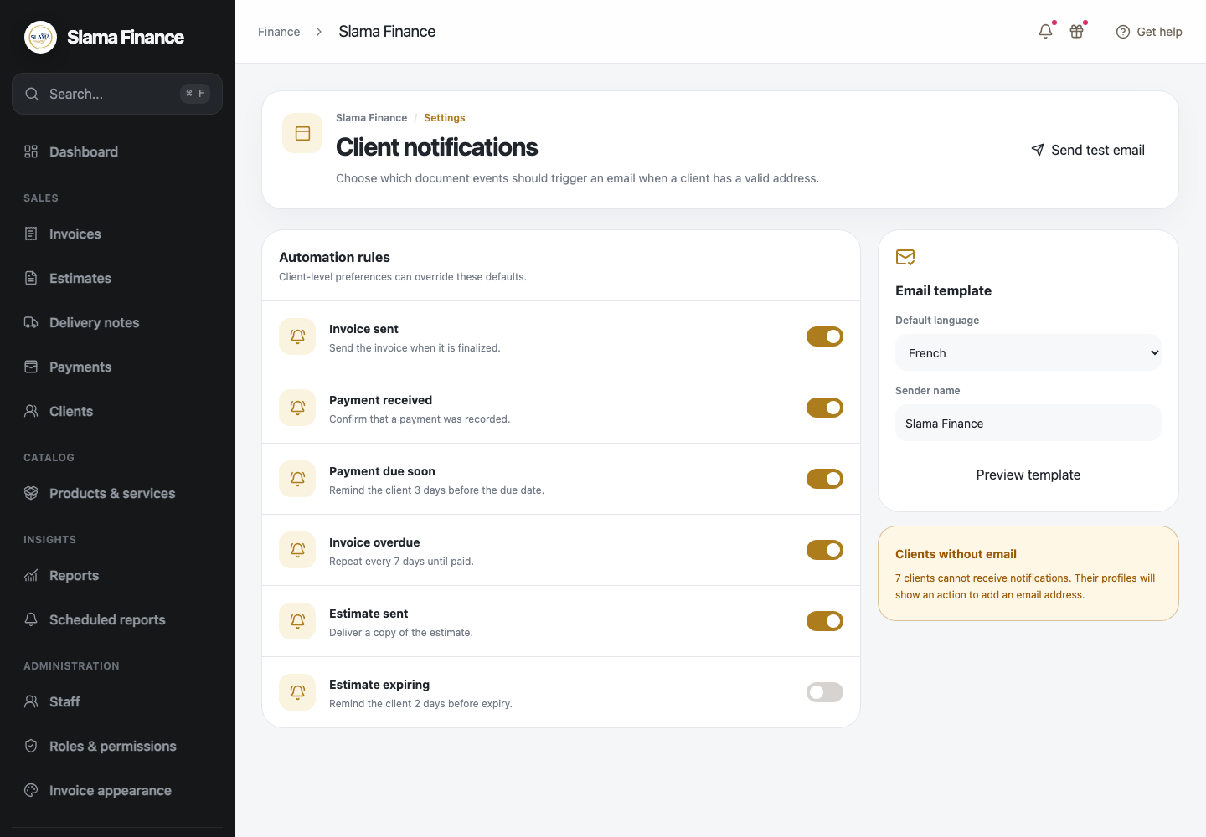  Notification rules and email-template settings | Client notification state in the client list
- Configure invoice, payment, overdue and estimate messages.
- Select sender identity, language and template content.
- Disable client notifications automatically when no valid email address is available.

11 Project price and OCI deployment
The project will be deployed on an OCI Always Free eligible environment. This deployment is included in the agreed project price and is suitable for the expected initial workload.
Project price. 5,000 DH including application delivery, initial OCI deployment, configuration, and handover.
Included capacity. Up to 2 OCPUs and 12 GB memory across eligible Ampere instances, 200 GB of block storage, and 20 GB of object storage, subject to OCI eligibility and availability.
Annual hosting cost. 0 DH while the account and resources remain eligible for OCI Always Free limits. Domain, email services, optional paid backups, and any usage beyond the free allowance remain separate client costs.

Completion schedule
The estimated completion time is 3 to 4 weeks from project confirmation, receipt of the initial payment, and delivery of the required company information and branding materials. The schedule assumes timely client review and approval at each milestone.
Stage | Expected period
Scope and design confirmation | Week 1
Core application development | Weeks 2
Reports, documents and deployment | Weeks 3
Client acceptance and launch | Week 4

12 Commercial terms

What is excluded
Unless added through a separate written estimate, this proposal excludes mobile applications, a public client portal, online payment gateways, full accounting or bookkeeping, inventory and warehouse management, bank synchronization, multi-company support, integrations with third-party systems.

How additional requests are handled
Minor corrections needed to match the approved scope are included. New features, major workflow changes, additional integrations or material design changes are reviewed first and require a separate written estimate and schedule before work begins.

Who pays recurring infrastructure costs
The client owns and pays all hosting, domain, email and other third-party service renewals or usage charges after launch. OCI may remain free only while the account and usage are eligible for the provider’s free-tier limits. Any provider price change, paid upgrade or excess usage is paid directly by the client.

Support after launch
The proposal includes 3 months of corrective support after production launch. This covers defects where the delivered application does not behave according to the approved scope. Training questions, new functionality, provider incidents, content entry, ongoing monitoring and long-term maintenance are not included and may be covered by a separate support agreement.

Client confirmation
By signing below, the client confirms the project scope, price, schedule, payment terms, deployments, exclusions and support conditions described in this proposal.
Approved project | Slama Finance — 5,000 DH
Client name and company
Signature and date
Provider signature and date

