**Getting Started**

**Introduction**

This project requires you to build out a travel app that, at a minimum, obtains a desired trip location & date from the user, and displays weather and an image of the location using information obtained from external APIs. Given that this is the Capstone project, it's highly encouraged for you to go above and beyond, adding additional functionality and customization to truly stand out with a project you are proud to have at the top of your portfolio!

**Project Rubric**

Your project will be evaluated by a Udacity code reviewer according to the Travel Planner App [project rubric](https://review.udacity.com/#!/rubrics/2669/view). Please review for detailed project requirements.

**Get the Starter Code**

If you'd like to start from scratch without any files, you are encouraged to do so! You learn the most by developing on your own! But, it can be a bit challenging having to start from scratch. There’s not the standard starter code you’re used to. If you would like to start with starter code, duplicate your code from project 3 and start there. Here is just one possibility for the visual of this project. Of course, you can style it how you choose, and extending the project will dictate the final appearance.

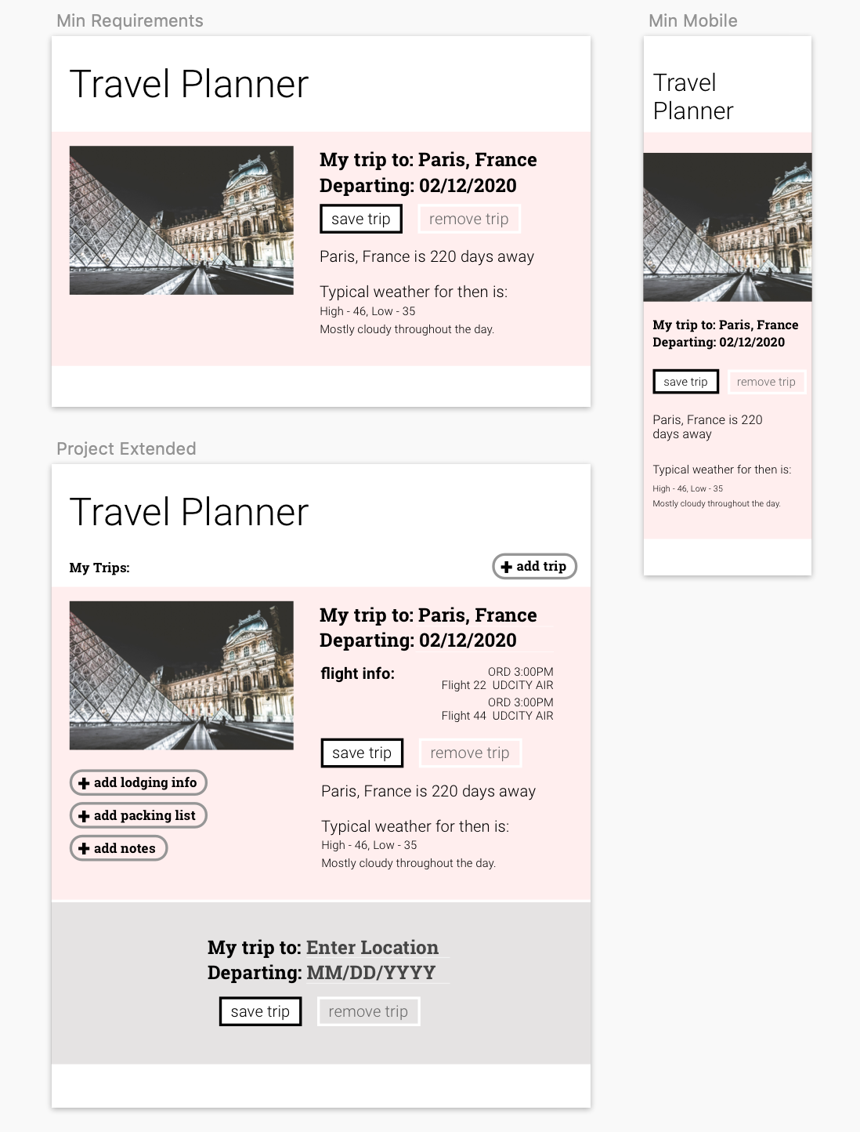

An example Travel App, both at minimum and with additional functionality

**Before you begin...**

Before moving forward, reacquaint yourself with project 3 & 4. After, ask yourself:

* What is the [Document](https://developer.mozilla.org/en-US/docs/Web/API/Document)?
* What are [events](https://developer.mozilla.org/en-US/docs/Web/API/Event)?
  + How do we [listen for them](https://developer.mozilla.org/en-US/docs/Web/API/EventTarget/addEventListener)?
* How can we [access elements](https://www.w3schools.com/js/js_htmldom_elements.asp) within the DOM?
* We can also access elements with [getElementsByClassName()](https://developer.mozilla.org/en-US/docs/Web/API/Document/getElementsByClassName" \t "_blank). What does this method return, and how do you use it?
* Every element has an [innerHTML](https://developer.mozilla.org/en-US/docs/Web/API/Element/innerHTML" \t "_blank) property that represents the markup of the element's content. How can you leverage this property to get and set content?
* What is the [Fetch API](https://developer.mozilla.org/en-US/docs/Web/API/Fetch_API) and how can we use it to get data?
* What are [callback functions](https://developer.mozilla.org/en-US/docs/Glossary/Callback_function" \t "_blank) and how do we use them appropriately?
* What is [asynchronous javascript](https://developers.google.com/web/fundamentals/primers/async-functions)?
* How/Why do we use [Express](https://expressjs.com/)?
* How/Why do we use [Webpack](https://webpack.js.org/)?
* How/Why do we use [service workers](https://developer.mozilla.org/en-US/docs/Web/API/Service_Worker_API)?

NEXT

;