Description: Beskrivning: hd_vertikal_farg WORD.wmf

Thesis report

Master thesis in Microdata Analysis

Business Intelligence Program

School for Technology and Business Studies

Dalarna University

Description: StreckTiteln

All for one one for All

Author: Bamshad Shirmohammadi

Supervisor: Professor Arend Hintze

Examiner:

Dalarna University

791 88 Falun

Sweden

Tel 023-77 80 00

Subject:

Course code: MI4002

Points: 15/30hp

Date of the examination: 20XX-XX-XX

**Abstract**

Text (max 300 words)…

**Contents**

[Introduction 6](#_Toc57146440)

[Background 6](#_Toc57146441)

[Purpose 6](#_Toc57146442)

[Literature review 7](#_Toc57146443)

[Material and Methods 7](#_Toc57146444)

[Experiments 7](#_Toc57146445)

[Data description 9](#_Toc57146446)

[LOD.csv 9](#_Toc57146447)

[Movement.csv 10](#_Toc57146448)

[Methods 10](#_Toc57146449)

[Results 11](#_Toc57146450)

[Discussion 15](#_Toc57146451)

[Conclusions 15](#_Toc57146452)

[References 16](#_Toc57146453)

# Introduction

## Background

The people’s collaboration in the societies can be considered as one of the main aspects of the development in terms of economy, health, education and so on. For example, in a country the citizens would have a better health care system, if all of them pay their taxes. However, it is always possible that some of people can bypass the rules and stop paying it. There are different approaches to address this issue for example, a government can deprive those who do not pay their taxes from welfare system benefits or another way can be educating people in a way that it works based on trust.

In this regard, there are some practices to simulate the real societies using small group of men and women and test their way of collaboration. For instance, one of these experimental economics is “public goods game”. In this game the participants are given equal amount of money and there is a public pot that they can put some or all their money. When they put their tokens in the pot, it will be multiplied by a factor and then, it will be divided in the players. So, if a player is careful about the society benefits, he/she will put more money and those who are selfish and only consider their personal benefits will not put anything. The scenario that individuals only think about their personal gain is called “Tragedy of the Commons”.

This problem or tragedy can be discussed in the field of artificial intelligence as well. For example, if we make fisher robots and reward them based on the number of fishes they can bring, they will do it as much as possible and eventually the ecosystem will be damaged. So, maybe we should change their rewarding schema in a way that they must also consider the community benefits and do not ruin the ecosystem. In this study, we are going to work in this problem and check the possibility of forcing artificial agents to cooperate based on their common welfare and not only their individual interest.

## Purpose

This research seeks to improve the way we train groups of AI controllers (agents) to perform better individually and in teams at the same time. While this is a basic research question in optimization of neural networks using genetic algorithms, it has direct applications to robotics and other autonomous AI decision making systems that need to work in groups.

## Literature review

# Material and Methods

This research will use the MABE (C++ Modular Agent Based Evolution Framework [1]) to implement virtual test environments. Agents are controlled using Markov Brains [2] which are a particular evolvable type of neural network. After replicating evolutionary experiments are completed, data will be analyzed and visualized.

## Experiments

Simple example:

|  |  |  |  |  |  |  |  |  |  |  |  |  |  |  |  |  |  |  |  |  |  |  |  |  |  |  |  |  |  |  |  |  |  |  |  |  |  |  |  |  |  |  |  |  |  |  |  |  |  |  |  |  |  |  |  |  |  |  |  |  |  |  |  |  |  |  |  |  |  |  |  |  |  |  |  |  |  |  |  |  |  |  |  |  |  |  |  |  |  |  |  |  |  |  |  |  |  |  |  |  |  |  |  |  |  |  |  |  |  |  |  |  |  |  |  |  |  |  |  |  |  |  |  |  |  |  |  |  |  |  |  |  |  |  |  |  |  |  |  |  |  |  |  |  |  |  |  |  |  |  |  |  |  |  |  |  |  |  |  |  |  |  |  |  |  |  |  |  |  |  |  |  |  |  |  |  |  |  |  |  |  |  |  |  |  |  |  |  |  |  |  |  |  |  |  |  |  |  |  |  |  |  |  |  |  |  |  |  |  |  |  |  |  |  |  |  |  |  |
| --- | --- | --- | --- | --- | --- | --- | --- | --- | --- | --- | --- | --- | --- | --- | --- | --- | --- | --- | --- | --- | --- | --- | --- | --- | --- | --- | --- | --- | --- | --- | --- | --- | --- | --- | --- | --- | --- | --- | --- | --- | --- | --- | --- | --- | --- | --- | --- | --- | --- | --- | --- | --- | --- | --- | --- | --- | --- | --- | --- | --- | --- | --- | --- | --- | --- | --- | --- | --- | --- | --- | --- | --- | --- | --- | --- | --- | --- | --- | --- | --- | --- | --- | --- | --- | --- | --- | --- | --- | --- | --- | --- | --- | --- | --- | --- | --- | --- | --- | --- | --- | --- | --- | --- | --- | --- | --- | --- | --- | --- | --- | --- | --- | --- | --- | --- | --- | --- | --- | --- | --- | --- | --- | --- | --- | --- | --- | --- | --- | --- | --- | --- | --- | --- | --- | --- | --- | --- | --- | --- | --- | --- | --- | --- | --- | --- | --- | --- | --- | --- | --- | --- | --- | --- | --- | --- | --- | --- | --- | --- | --- | --- | --- | --- | --- | --- | --- | --- | --- | --- | --- | --- | --- | --- | --- | --- | --- | --- | --- | --- | --- | --- | --- | --- | --- | --- | --- | --- | --- | --- | --- | --- | --- | --- | --- | --- | --- | --- | --- | --- | --- | --- | --- | --- | --- | --- | --- | --- | --- | --- | --- | --- | --- | --- | --- | --- | --- | --- | --- |
| |  |  |  |  |  |  |  |  |  | | --- | --- | --- | --- | --- | --- | --- | --- | --- | |  |  |  | |  |  |  |  |  | |  |  |  | |  |  |  |  |  | |  |  |  | |  |  |  |  |  | |  |  |  | |  |  |  |  |  | |  |  |  | |  |  |  |  |  | |  |  |  | |  |  |  |  |  | | Turn 1 Scores | | | | | | | | | | A1 0 | | | A2  0 | | A3  0 | | A4  0 | | | |  |  |  |  |  |  |  |  |  | | --- | --- | --- | --- | --- | --- | --- | --- | --- | |  |  |  | |  |  |  |  |  | |  |  |  | |  |  |  |  |  | |  |  |  | |  |  |  |  |  | |  |  |  | |  |  |  |  |  | |  |  |  | |  |  |  |  |  | |  |  |  | |  |  |  |  |  | | Turn 2 Scores | | | | | | | | | | A1  1 | | | A2  0 | | A3  1 | | A4  0 | | | |  |  |  |  |  |  |  |  |  | | --- | --- | --- | --- | --- | --- | --- | --- | --- | |  |  |  | |  |  |  |  |  | |  |  |  | |  |  |  |  |  | |  |  |  | |  |  |  |  |  | |  |  |  | |  |  |  |  |  | |  |  |  | |  |  |  |  |  | |  |  |  | |  |  |  |  |  | | Turn 3 Scores | | | | | | | | | | A1  1 | | | A2  0 | | A3  2 | | A4  0 | |   First generation’s genetics: A1: G1 A2: G2 A3: G3 A4: G4  IDs: A1: 1 A2: 2 A3: 3 A4: 4 |
| |  |  |  |  |  |  |  |  |  | | --- | --- | --- | --- | --- | --- | --- | --- | --- | |  |  |  | |  |  |  |  |  | |  |  |  | |  |  |  |  |  | |  |  |  | |  |  |  |  |  | |  |  |  | |  |  |  |  |  | |  |  |  | |  |  |  |  |  | |  |  |  | |  |  |  |  |  | | Turn 1 Scores | | | | | | | | | | A1 0 | | | A2  0 | | A3  0 | | A4  0 | | | |  |  |  |  |  |  |  |  |  | | --- | --- | --- | --- | --- | --- | --- | --- | --- | |  |  |  | |  |  |  |  |  | |  |  |  | |  |  |  |  |  | |  |  |  | |  |  |  |  |  | |  |  |  | |  |  |  |  |  | |  |  |  | |  |  |  |  |  | |  |  |  | |  |  |  |  |  | | Turn 2 Scores | | | | | | | | | | A1 0 | | | A2  1 | | A3  0 | | A4  1 | |   Second generation’s genetics: A1: G1\*V1 A2: G3\*V2 A3: G3\*V3 A4: G3\*V4  IDs: A1: 5 A2: 6 A3: 7 A4: 8 | |  |  |  |  |  |  |  |  |  | | --- | --- | --- | --- | --- | --- | --- | --- | --- | |  |  |  | |  |  |  |  |  | |  |  |  | |  |  |  |  |  | |  |  |  | |  |  |  |  |  | |  |  |  | |  |  |  |  |  | |  |  |  | |  |  |  |  |  | |  |  |  | |  |  |  |  |  | | Turn 3 Scores | | | | | | | | | | A1 0 | | | A2  1 | | A3  0 | | A4  2 | | |
| |  |  |  |  |  |  |  |  |  | | --- | --- | --- | --- | --- | --- | --- | --- | --- | |  |  |  | |  |  |  |  |  | |  |  |  | |  |  |  |  |  | |  |  |  | |  |  |  |  |  | |  |  |  | |  |  |  |  |  | |  |  |  | |  |  |  |  |  | |  |  |  | |  |  |  |  |  | | Turn 1 Scores | | | | | | | | | | A1 0 | | | A2  0 | | A3  0 | | A4  0 | | | |  |  |  |  |  |  |  |  |  | | --- | --- | --- | --- | --- | --- | --- | --- | --- | |  |  |  | |  |  |  |  |  | |  |  |  | |  |  |  |  |  | |  |  |  | |  |  |  |  |  | |  |  |  | |  |  |  |  |  | |  |  |  | |  |  |  |  |  | |  |  |  | |  |  |  |  |  | | Turn 2 Scores | | | | | | | | | | A1 1 | | | A2  1 | | A3  1 | | A4  1 | |   Third generation’s genetics: A1: G3\*V2 \*V5 A2: G3\*V4\*V6 A3: G3\*V4\*V7 A4: G3\*V4\*V8  IDs: A1: 9 A2: 10 A3: 11 A4: 12 | |  |  |  |  |  |  |  |  |  | | --- | --- | --- | --- | --- | --- | --- | --- | --- | |  |  |  | |  |  |  |  |  | |  |  |  | |  |  |  |  |  | |  |  |  | |  |  |  |  |  | |  |  |  | |  |  |  |  |  | |  |  |  | |  |  |  |  |  | |  |  |  | |  |  |  |  |  | | Turn 3 Scores | | | | | | | | | | A1 1 | | | A2  2 | | A3  1 | | A4  1 | | |

**Game settings:**

Variable settings:

|  |  |
| --- | --- |
| Reward mode | Meaning |
| 0 | Individual reward |
| 1 | Mean score (What they got on average) |
| 2 | Maximum score (What their best performer received) |
| 3 | Minimum score (What their worst performer received) |

|  |  |
| --- | --- |
| Group mode | Meaning |
| 0 | Clone |
| 1 | Four different organisms |

Constant parameters:

Other 11 points such as field’s dimension, …

## Data description

### LOD.csv

|  |  |
| --- | --- |
| Column name | Explanation |
| Generation | Generation number |
| ID | ID of each agent |
| Score | This field based on rewarding scheme value has the following meanings:   |  |  | | --- | --- | | Reward mode | Score Meaning | | 0 | Individual score | | 1 | Mean score of the four agents | | 2 | Max score of the four agents | | 3 | Minimum score of the four agents | |
| rawScores | Scores of all the group members |
| ownScore | The own score of the agent which is selected in the line of decent |

### Movement.csv

|  |  |  |
| --- | --- | --- |
| Column name | Explanation | |
| t | Turn number | |
| x | Position in X axis | |
| y | Position in Y axis | |
| d | Direction | Meaning |
| 0 | Up |
| 1 | Right |
| 2 | Bottom |
| 3 | left |
| e | Number of grasses that the agent gathered. It can be named as energy as well. | |
| a | Action type | Meaning |
| 0 | Do nothing |
| 1 | Turn left |
| 2 | Turn right |
| 3 | Move forward |
| 4,5,6,7 | giving grasses to an agent or putting it on a tile. |
| b | Beep (yes or no) | Meaning |
| 0 | No |
| Any other number | Beep |

## Methods

# Results

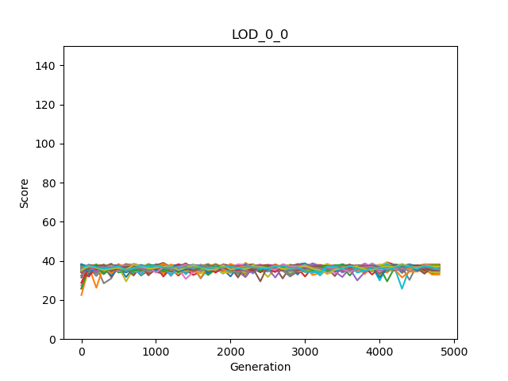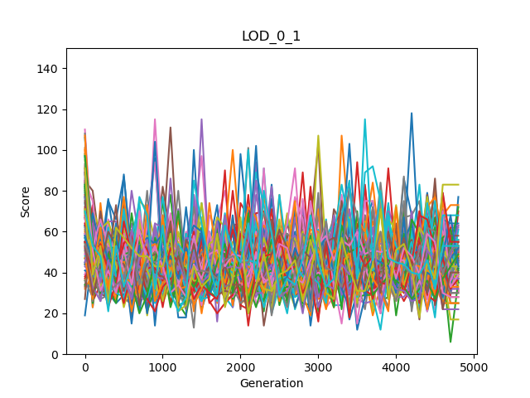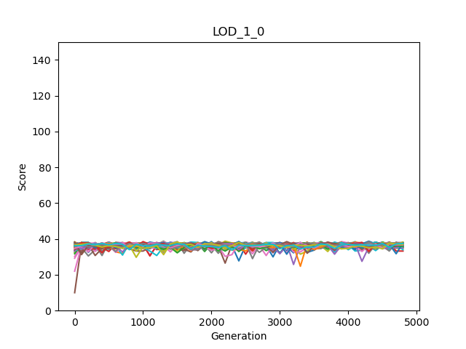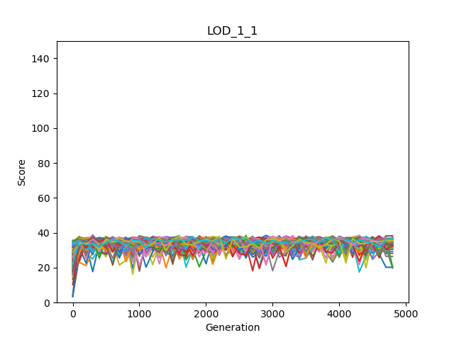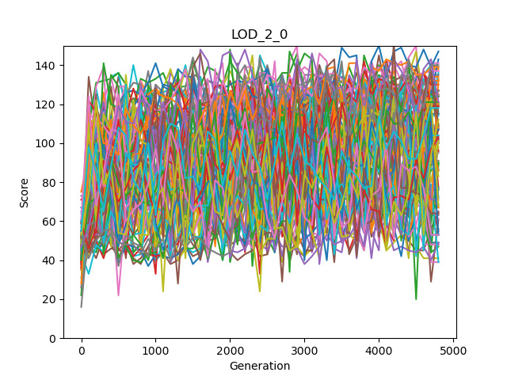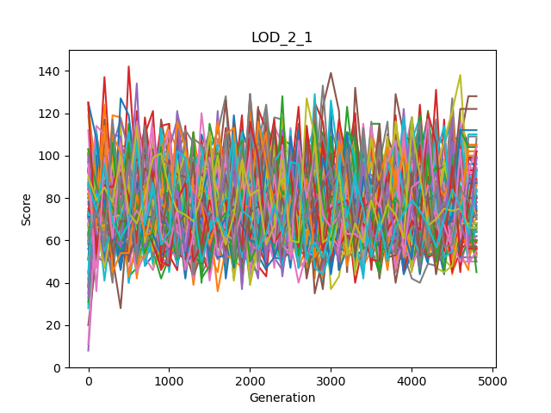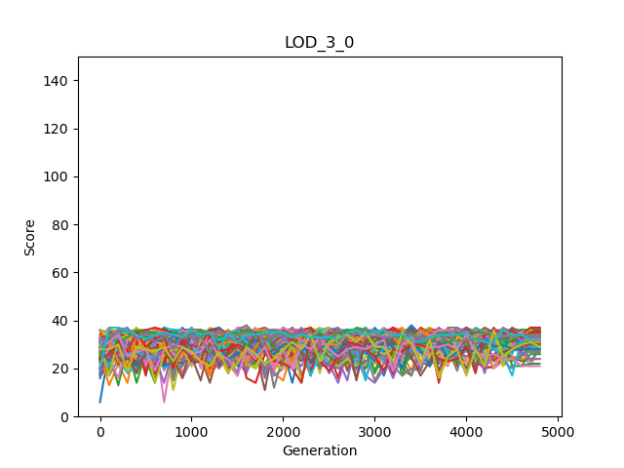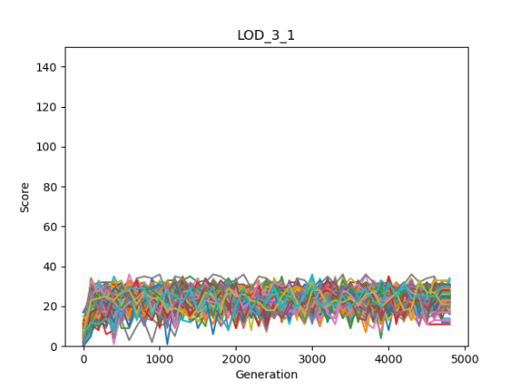

Individual | Clone

Individual | Group

Mean | Clone

Mean | Group

Maximum | Clone

Maximum | Group

Minimum | Clone

Minimum | Group

|  |  |  |  |  |  |
| --- | --- | --- | --- | --- | --- |
| rewardGroupModes | Mean  OwnScores | Mean  Minimums | Mean  Maximums | Mean  Averages | Mean  Sums |
| LOD\_0\_0  Group mode: Clone  Reward mode: Individual | 36.4275510 | A picture containing shape  Description automatically generated26.0175510 | 47.4516326 | 36.4275510 | 145.710204 |
| LOD\_0\_1  Group mode: Not Clone  Reward mode: Individual | 44.7497959 | 20.1351020 | 52.0906122 | Logo  Description automatically generated36.5244898 | Logo  Description automatically generated146.097959 |
| LOD\_1\_0  Group mode: Clone  Reward mode: Average | 36.4372959 | Logo  Description automatically generated25.8336734 | 47.5702040 | A picture containing shape  Description automatically generated36.4372959 | A picture containing shape  Description automatically generated145.749183 |
| LOD\_1\_1  Group mode: Not clone  Reward mode: Average |  | 11.6457142 | Logo  Description automatically generated56.7748979 | 33.9260204 | 135.704081 |
| LOD\_2\_0  Group mode: Clone  Reward mode: Maximum |  | 2.70897959 | Logo  Description automatically generated91.9987755 | 30.8365306 | 123.346122 |
| LOD\_2\_1  Group mode: Not clone  Reward mode: Maximum |  | 1.56244898 | A picture containing shape  Description automatically generated75.5930612 | 31.0185204 | 124.074081 |
| LOD\_3\_0  Group mode: Clone  Reward mode: Minimum | 30.7763265 | Logo  Description automatically generated30.7763265 | 42.3973469 | Logo  Description automatically generated36.4311734 | Logo  Description automatically generated145.724693 |
| LOD\_3\_1  Group mode: Not clone  Reward mode: Minimum | 34.1008163 | 23.0051020 | 44.5406122 | 33.0433673 | 132.173469 |

Always the minimum scores are higher in clone mode in relative to different individuals. So, if we are interested to have good minimum scores, we should use clone mode.

Except maximum rewarding scheme, the maximum score is higher when the agents are not clone. Therefore, if we do not consider setting the rewarding scheme, different agents are better than clones.

Except maximum rewarding scheme, the own score is higher when the agents are not clone. Therefore, if we do not consider setting the rewarding scheme, different agents are better than clones.

There is no clear pattern however, when clone modes have bigger averages the differences are bigger. So, we can say that for average also the clones are better.

Again, there is no clear pattern and when clone modes have bigger sum, the differences are bigger. Like the average for total sum also clones are slightly better.

# Discussion

# Conclusions

# References

|  |  |
| --- | --- |
| [1] | B. Clifford and H. Arend, "Mabe (modular agent based evolver): A framework for digital evolution research," in *Artificial Life Conference Proceedings*, 2017. |
| [2] | H. Arend, A. E. Jeffrey, S. O. Randal, B. K. David, S. Jory, A. Larissa, T. S. Ali, K. Peter, S. e. Leigh och G. Heather, ”Markov brains: A technical introduction”. |