# Selection

## Human selection



First Generation

Second Generation

Third Generation



Tick: they are selected to be allowed to have offspring

Cross: they are NOT selected to be allowed to have offspring

## Natural selection

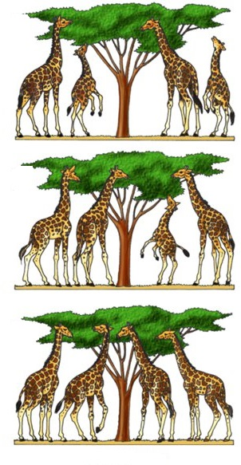

First Generation

Second Generation



Third Generation

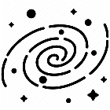

|  |  |
| --- | --- |
| Term | Definition |
| Fitness (w) | An individual ability to survive and reproduce. mean number of viable offspring |
| Altruistic behavior | A behavior that decrease an individual fitness in benefit of other individual fitness in the population. |
| Offspring | Children |
| Inclusive Fitness | Like fitness but, it includes actions that are considered to increasing the chance of survive and reproduction of relatives. For example, it can happen among siblings. when the fitness is not only dependent on your own, but it depends on the fitness of others. Predator Prey relations |
| Kin selection | Is a type of natural selection that individuals with common genes favors altruism to increase the chance of reproduction among them. Only some of the members will reproduce. |
| Group selection | When natural selections work in the level of a group. For example, a survival of a group of wolves which some of them may sacrifice their self in benefit of others.  For group selection to happen, replication has to happen as a group. |
| Evolution (Darwin)  NOT Lamark | Evolution is a mechanism composed of inheritance, variation (random), and selection. It leads to an adaptation of organisms that fit their environment better. variation = random mutation |

|  |  |
| --- | --- |
| Term | Implementation in the experiments |
| Fitness | Score |
| Altruistic behavior | If you give food to others (we do not have it in clone mode) |
| Offspring | Next generation |
| Inclusive Fitness | We have average and minimum scores of the groups which present inclusive fitness (only for NOT clone mode). |
| Kin selection | It can happen in group of individuals. We should not mention it here |
| Group selection | Clone mode |
| Individual selection | NOT clone mode |
| Evulsion | All the agents have their own special genetic and they can produce offspring. Those who are more successful are only allowed to reproduce and therefore, the best genetics are selected from each generation to create next generation. So, by repetition of this process the agents get better and better through the generations. |