**Tools Used:**

Aws S3, DynamoDB, Python, Lambda functions , Cloud Trail.

**Why DynamoDB ?**

Amazon DynamoDB is a key-value and document database that delivers single-digit millisecond performance at any scale. It's a fully managed, multiregion, multimaster, durable database with built-in security, backup and restore, and in-memory caching for internet-scale applications. DynamoDB supports some of the world’s largest scale applications by providing consistent, single-digit millisecond response times at any scale. DynamoDB is serverless with no servers to provision, patch, or manage and no software to install, maintain, or operate. DynamoDB supports ACID transactions to enable you to build business-critical applications at scale.

**Technical overview:**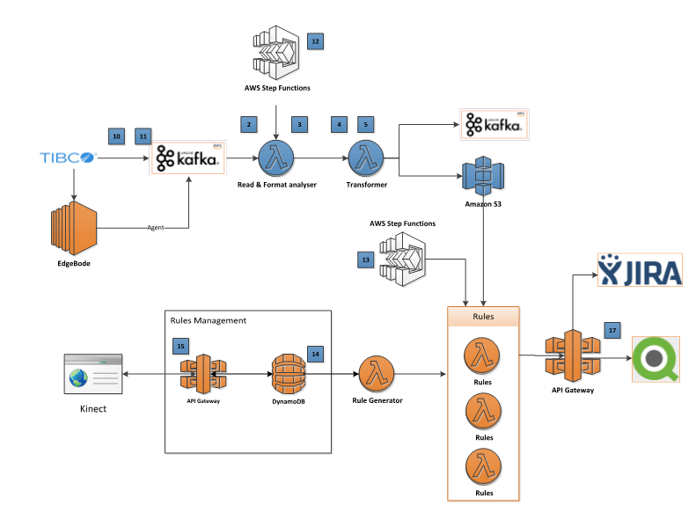

1. Received TLINK & ANTARES files from TIBCO.
2. Json files will be pushed into storage (s3) layer using lambda functions.
3. Transformations done using AWS lambda functions and stored data in Dynamo DB.
4. Built Rest API using AWS API gateway with Dynamo DB.

**Use case:**

To perform bath quantity check against each file receiving between 2005 and 1250 systems.

Alert users if we didn’t receive TLINK file within 15 mins 2005 and 1250 systems.

**Process Flow:**

Input files -> S3 Storage -> AWS Lambda transformations -> DynamoDB Storage -> Output to BI Tools

Stored input files received from client in s3 buckets and processed the files using AWS Lambda function. Finally stored the output in DynamoDB for visualization.

Received TLINK & ANTARES json files from TIBCO frequently and it will store the received files in S3 buckets.

Rules will be configured in DynamoDB table to process every json file using AWS lambda functions.

Scheduled AWS lambda functions in cloud Trail to retrieve rules from dynamo DB.

Rule1 will perform DynamoDB write operation for the json file with Batch Id & Status on ANTARES file.

Rule2 will perform DynamoDB read operation quantity check for the TLINK file with Batch Id column.

**Lessons Learned:**

Learnt how to perform scan operations for the entire table with minimal time.

Learnt how to query against single column value in the table.