
31-DEC-2025
Letter Of Internship
Mr. Priyanshu Yadav
TCS – Chennai

Dear Mr. Priyanshu,
This is to certify that Priyanshu Yadav has completed internship in Engineering – Backend Development team at TCS Chennai form 01-DEC-2025 to 31-DEC-2025.
During this tenure, he worked as Backend Developer Intern and we have found him to be extremely hard-working, diligent, and result-oriented.
It was a pleasure having him and we would like to take the is opportunity to thank him for all the sincere efforts he has put into his work and wish him all luck in the future endeavours.
Your Associate number is 1593844.
Yours sincerely,
For TATA Consultancy Services Limited.
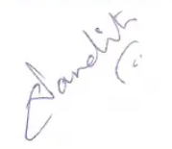
GIRISH V NANDIMATH
Head Talent Acquisition - India

