Internship project report
Supervisors: Dr BENHADDOU Driss, NACER Khalil
Student: EL MAAKOUL Imane

Department of Technology
University of Houston
Houston, TX, 77204, USA
http:// www.uh.edu/technology/
September 15, 2014
Keywords: WSN, CSMA-CA, ZIGBEE, reliability, Ultrasonic sensors, Arduino.
Abstract
In the following report I will describe the work done to improve the reliability of the WSN, and the program of room occupancy sensors
Improving reliability in Wireless Sensor Network
Imane EL MAAKOUL
Abstract
The existing WSN is composed of nodes that are themselves composed of microcontrollers linked to temperature, humidity and CO2 sensors. Those sensors give real time measurement of the environment which is the laboratory, and send them using ZIGBEE IEEE 802.15.4 standard to send packets to a gateway where the data is going to be processed, stored in the MANGO database, and finally the Raspberry Pi is calculating the value of the dampers’ angle that the environment stay within the defined context. The problem is that the sent packets are usually corrupted due to collisions, and packet lost. That is the reason why we used ZIGBEE API which is a free Java software that will enable using CSMA-CA Collision Avoidance while communication.

RELIABILITY IN WSN:
- CSMA-CA

Carrier Sense Multiple Access with Collision Avoidance is a network multiple access method in which carrier sensing is used, but nodes attempt to avoid collisions by transmitting only when the channel is sensed to be “idle” When they do transmit, nodes transmit their packet data in its entirety.
It is particularly important for wireless networks, where the collision detection of the CSMA-CD is unreliable due to the hidden node problem in wireless networking. CSMA-CA is a protocol that operates in the Data Link Layer (Layer2) of the OSI model and is therefore suitable for the low-level nodes in the WSN.
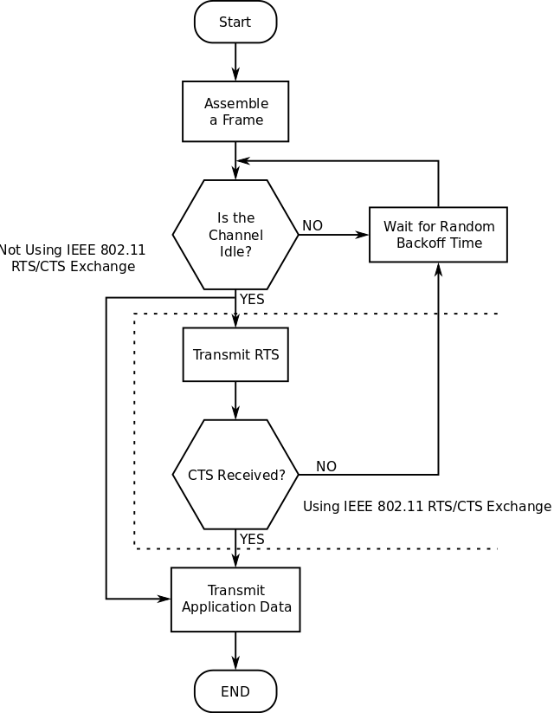
Figure1: CSMA-CA algorithm

As shown in figure1 each node that has a pending frame checks if the channel is “idle” if not wait for a random period of the time before re checking the availability of the channel. If the Channel is available and the RTS/CTS is enabled the node sends a RTS Request To Send packet which is a short control packet, and waits for CTS Clear To Send packet, once the CTS packet is received the sender node starts data transmission. The goal of enabling RTS/CTS is avoiding long collisions since we don’t have collision detection in wireless networks. If RTS/CTS is not enable the node will wait until the channel is available and afterward starts sending data.

Implementing this protocol will dramatically help improving reliability by reducing the amount of collisions. The free software ZIGBEE API enables CSMA-CA in the network, the technical steps to do so are described in the next paragraph.

First the ZIGBEE chip had to be configured using XCTU Configuration and Test Utility software so that all nodes have the same CHANNEL ID in this case C, different PAN ID for each ZIGBEE chip on the network, and all the devices are end devices with API 2 mode enabled.

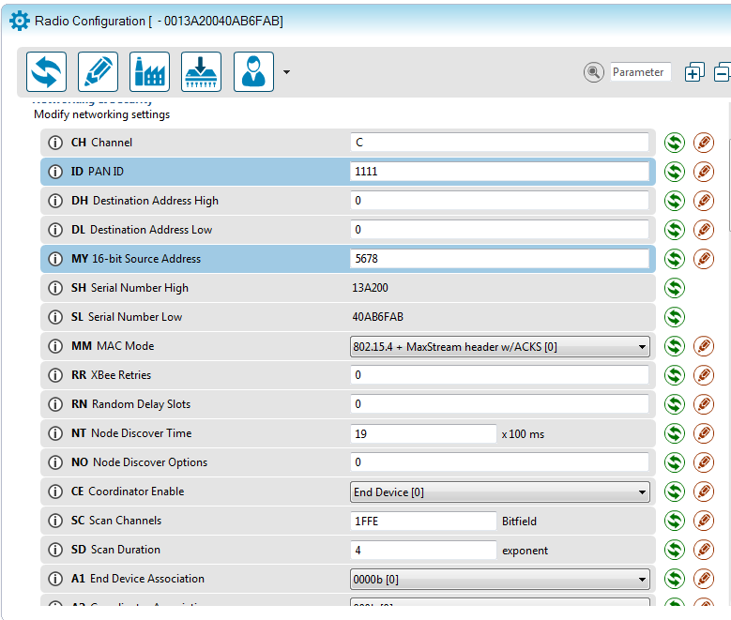
Figure2: Raspberry Pi ZIGBEE chip configuration

All microcontrollers whose type is Arduino Uno using the ZIGBEE chip starts sending packets after 10 seconds from being powered on, using CSMA –CA layer 2 protocol for communication with the Raspberry Pi. Each microcontroller sense the channel and make sure it is empty before start sending packets, Each packet contains real time measurements of Temperature, Co2, Humidity in the laboratory. The maximum length of data that can be sent in a packet is one BYTE. If the packet is larger than that, then we proceed to packet’s fragmentation: dividing the packet into a multiple one Byte length packets.
The Raspberry Pi receives packets from the microcontrollers and stores them into MANGO database using Java API for communication between XBees series 1 (802.15.4) in the Network.

- CONTIKI OS

CONTIKI OS is a lightweight open source operating system developed by Adam Dunkels. It is used in embedded systems and wireless sensor networks and it is designed for micro-controllers like MSP430, AVR and ARM.
Its main features are:
- Multitasking kernel
- Protothreads
- TCP/IP networking including IPv6
- Communication: uIP and RIME
- Programming model
- Power profiling to measure consumption at network scale
CONTIKI is programmed in C and it is the state of art among the different operating systems used for wireless sensor networking. The usage of this operating system would have helped to implement not only a reliable communication protocol in the second layer of the OSI model, but also a reliable communication protocol in the network layer using the uIP stack available in CONTIKI to use TCP/IP or UDP/IP communication. Yet the problem faced during operating CONTKI on Arduino uno board used in the network which has ATmega324p processor, is the size of the code that goes beyond the size of the flash memory of Arduino. As for example the sample code for exchanging UDP packets, even after optimizing code compilation in order to generate smaller .hex files, is still roughly 2KB larger than the maximum code size that can be ported to Arduino which is 32 KB. This hardware constraint has obliged the team to look for another solution to look for another alternative which is either changing the network hardware or getting more efficient one with larger flash memory, and more performing processors such as AVR ATmega128RFA1, or motes; or implementing CSMA-CA in the existing network. The team chosen the second option which is described.

ROOM OCCUPANCY SENSORS:
- HARDWARE:

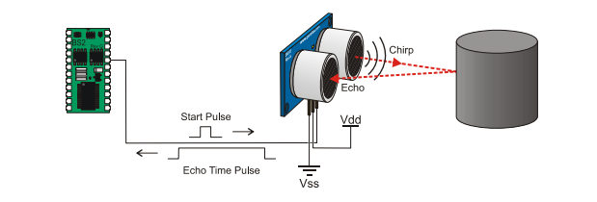
The hardware used is two Ping))) ultrasonic distance sensors. Each one of those sensors detect the distance of the closest object in front of them (from 2 cm up to 3 cm). It works by sending periodically a burst of ultrasound (almost 40 KHz) and listening for the echo when it bounces back off of an object. The necessary time for sending the burst and getting back the echo is used by Arduino Uno to calculate the distance that separates an object from the ultrasonic sensor.
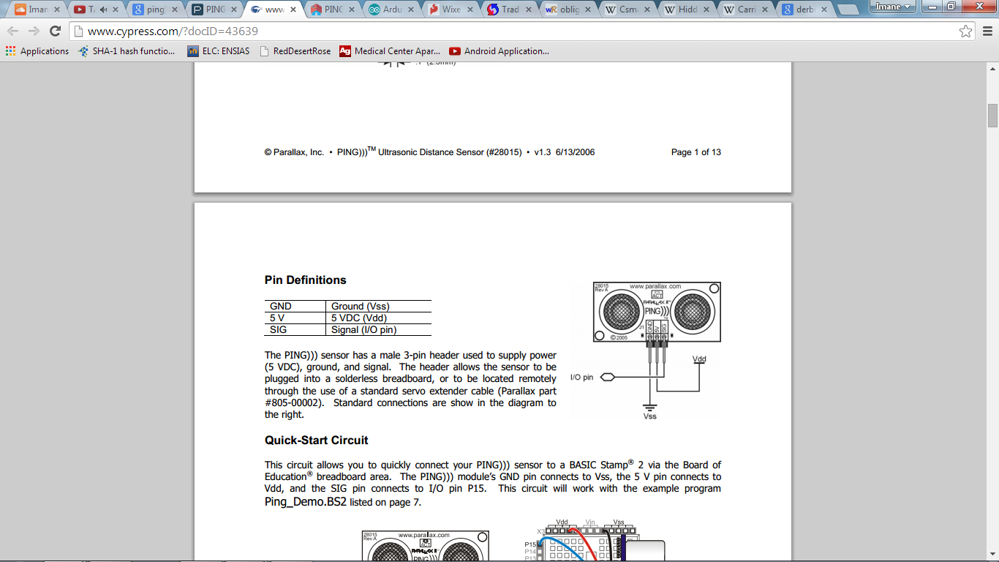

Figure3: Ping))) Ultrasonic distance sensor pins

The PING))) sensor has a male 3-pin header used to supply power (5 VDC), ground, and signal. The header allows the sensor to be plugged into a solderless breadboard, or to be located remotely through the use of a standard servo extender cable.

Figure4: Ultrasonic sensor pins definition

The GND and 5V power pins of the sensor are connected to the correspondent pins of ARDUINO, the SIG pin (as shown in the figure4) is connected to one of the 13 ARDUINO. This pin used for two-way communication with the ARDUINO, the ARDUINO sends a pulse through SIG pin to the sensor which sends the ultrasonic burst afterwards and when it gets back the echo signal, the sensor measures the time required for the echo return, and returns this value to the microcontroller as a variable-width pulse via the same I/O pin.

- ALGORITHM

In order to count the number of the entrances and exits to a room, both ultrasonic sensors are used on a single breadboard, when they first start and when no obstacle is detected they both send a duration that is ~ roughly equivalent to 3 cm. The idea is getting information from both of the sensors and once one of them sends when the calculated distance for one of the sensors is within a range we then see if the other sensor also detects an object, if so then there is a person passage, which sensor has detected the object first is what will enable the program from deciding if it is an entrance or an exit.

- PROBLEMS ENCOUNTERED

The issues that were faced are mainly related to some of the hardware limitations and/or issues:

- Crosstalk or beam interference:
This happens when the two sensors are too physically too close from each other, then one of the sensors may take the echo of the other sensor as his own and their for it would be an entrance rather than exit and vice versa.
- Precise sensor alignment with the object:
The object should be angled in no more than 3 degrees in order for the echo to be captured by the ultrasonic sensor as explained in the following figure.

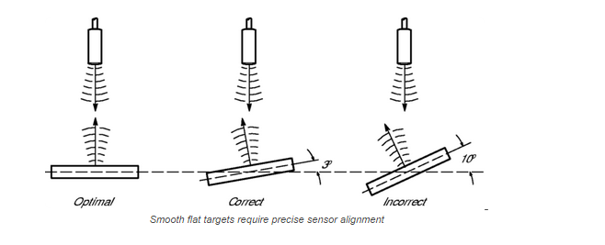
Figure5: different object Ultrasonic sensor alignment

If the angle is more than a certain value the sensor may not catch the refracted burst and causes lowering accuracy.
Other problems that may affect the overall accuracy of the sensors are due to human behavior at the door of a room:

- A person may stand at the door entrance before deciding to move on.
- A person may stand at the door for a while and moves back on the opposite direction.
- The duration that takes each person to enter or exit a room should be taken into consideration.

- MOUNTING:

The mounting part is very important in order to get a higher accuracy, in fact the sensors shouldn’t be mounted next to HVAC, or in an environment containing material that could absorb the ultrasonic burst, also an environment causing multiple refractions of the ultrasonic burst. These problems leads us to carefully choose the mounting location that respects the following mounting requirements:

- The optimal Ultrasonic sensor installation is 1/3 the distance from the side wall
- The sound path should be perpendicular to the monitored surface
- Avoid mounting the ultrasonic sensor power cable in proximity to high voltage or current wiring

The tests that have been done in the laboratory have shown that the most accurate location to mount the sensor are either in the wall side or upon the door.
For the upon door sensor mounting, experiments have shown that the optimal place to mount the sensors is the 2 place shown in figure6.

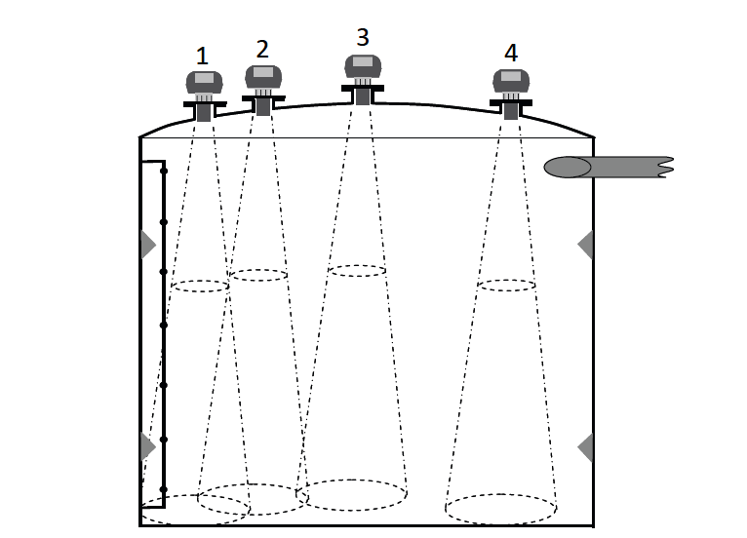

Figure6: Optimal Ultrasonic sensor position upon the door

Webography

