TEST DOCUMENT

In the following pages I am going to describe the testing conditions that were performed in order to get an estimation of the accuracy of the Ultrasonic sensors. All the tests were performed under the common condition described below

* Common condition to all of the performed tests:

The sensors are mounted on the side wall next to the door, the door swinging doesn’t get in the way of the sensors beams.

1. Performed tests:
2. Normal walking speed. Person is moving in a straight line

10 entrances

|  |  |  |  |  |  |  |  |  |  |  |
| --- | --- | --- | --- | --- | --- | --- | --- | --- | --- | --- |
| Entrance N: | 1 | 2 | 3 | 4 | 5 | 6 | 7 | 8 | 9 | 10 |
| True/False | T | T | T | T | T | T | T | T | T | T |

Error rate 0%

10 exits

|  |  |  |  |  |  |  |  |  |  |  |
| --- | --- | --- | --- | --- | --- | --- | --- | --- | --- | --- |
| Entrance N: | 1 | 2 | 3 | 4 | 5 | 6 | 7 | 8 | 9 | 10 |
| True/False | T | T | T | F | T | F | T | T | T | T |

Error rate 20%

1. Fast walking speed. Person is moving in a straight line

10 entrances

|  |  |  |  |  |  |  |  |  |  |  |
| --- | --- | --- | --- | --- | --- | --- | --- | --- | --- | --- |
| Entrance N: | 1 | 2 | 3 | 4 | 5 | 6 | 7 | 8 | 9 | 10 |
| True/False | T | T | F | T | T | T | F | T | T | T |

Error rate 20%

10 exits

|  |  |  |  |  |  |  |  |  |  |  |
| --- | --- | --- | --- | --- | --- | --- | --- | --- | --- | --- |
| Entrance N: | 1 | 2 | 3 | 4 | 5 | 6 | 7 | 8 | 9 | 10 |
| True/False | T | T | F | T | T | T | F | T | T | T |

Error rate 20%

1. Slow walking speed. Person is moving in a straight line

10 entrances

|  |  |  |  |  |  |  |  |  |  |  |
| --- | --- | --- | --- | --- | --- | --- | --- | --- | --- | --- |
| Entrance N: | 1 | 2 | 3 | 4 | 5 | 6 | 7 | 8 | 9 | 10 |
| True/False | F | T | T | T | T | T |  | T | T | T |

Error rate 10%

10 exits

|  |  |  |  |  |  |  |  |  |  |  |
| --- | --- | --- | --- | --- | --- | --- | --- | --- | --- | --- |
| Entrance N: | 1 | 2 | 3 | 4 | 5 | 6 | 7 | 8 | 9 | 10 |
| True/False | F | T | F | F | T | T | T | T | T | T |

Error rate 30%

|  |
| --- |
| Error rate is about **16,67 %**  Accuracy is **80 %** |

* Common condition to all of the performed tests:

The sensors are mounted upon the door, 1/3 from the door lockset as mentioned in the technical report, except the test number a, the door is widely open.

1. Performed tests
2. The door is closed

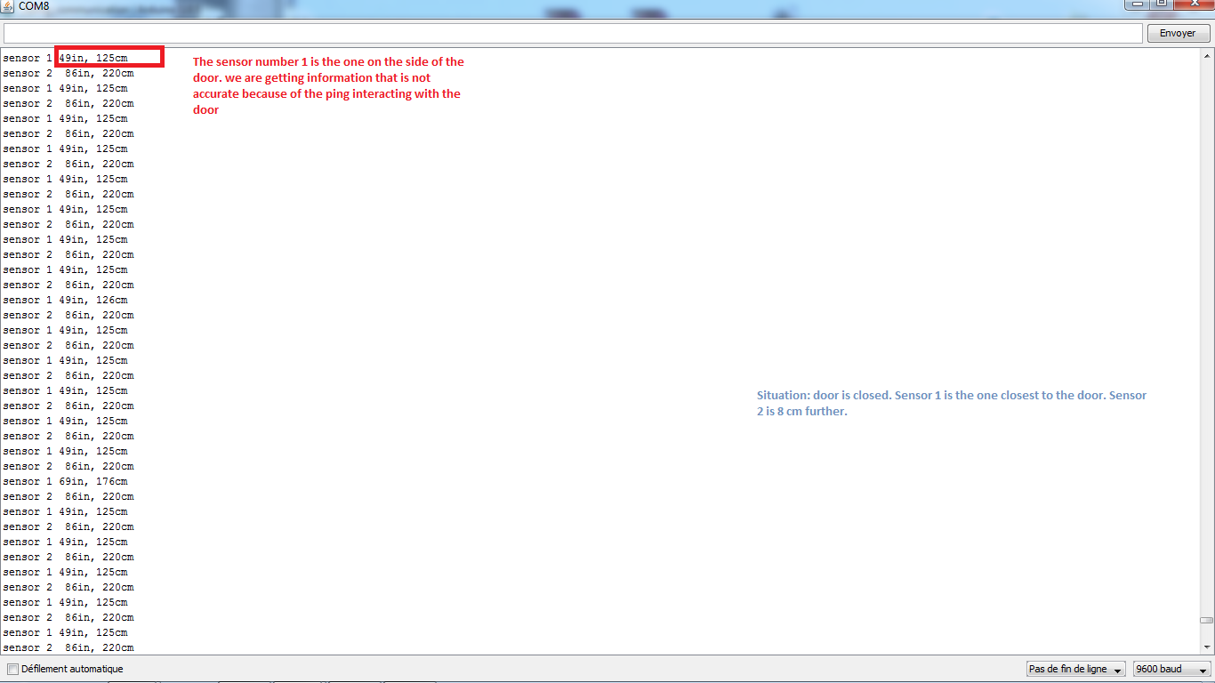

1. The door is open: no one is entering or going out of the room

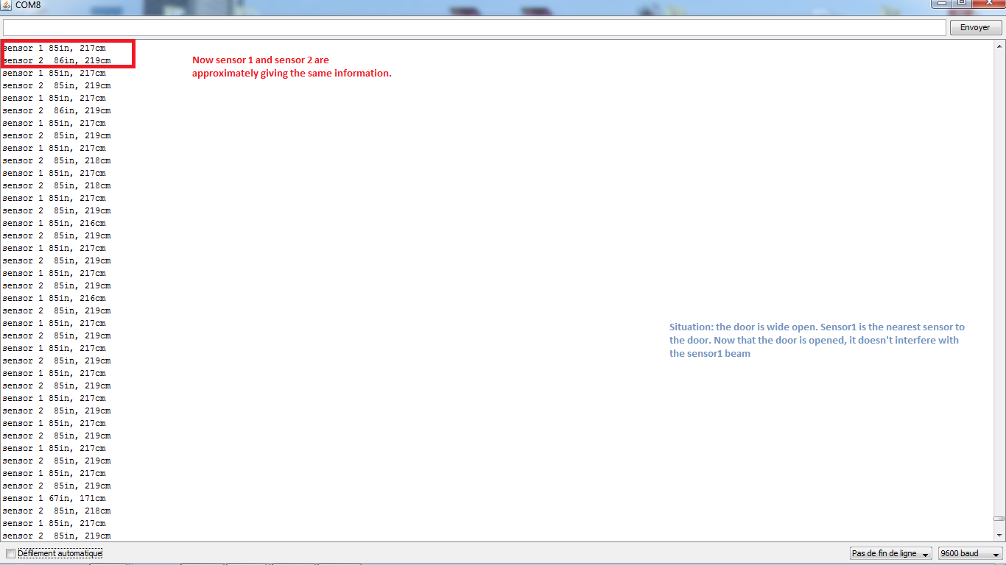

1. Normal walking speed. Person is moving in a straight line under the sensors.

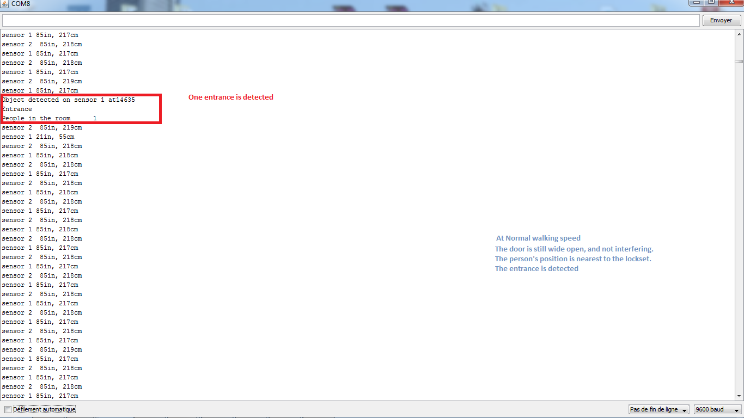

Out of 10 entrances, the error rate is 20 %

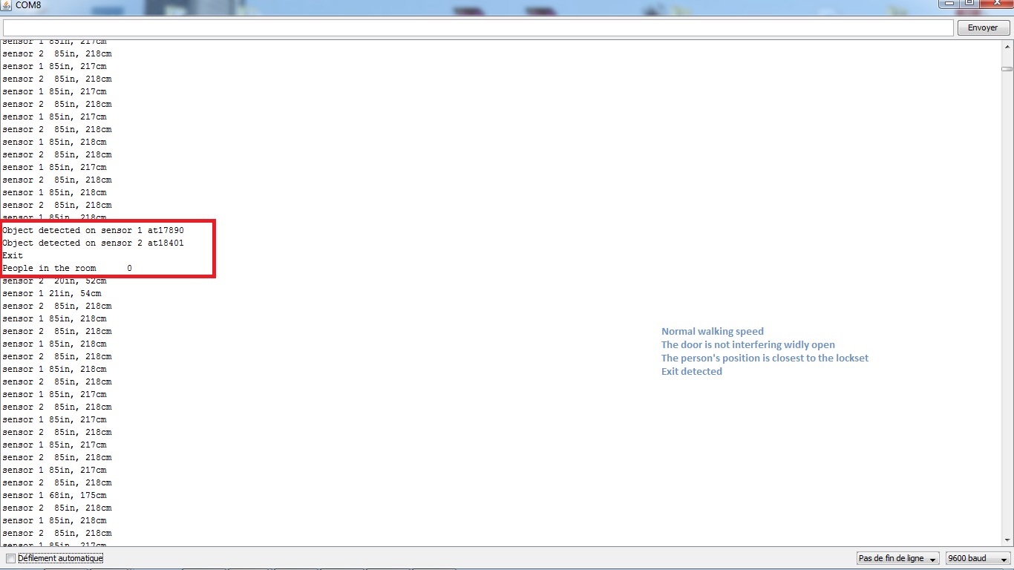

Out of 10 exits, the error rate is 10%

Conclusion:

A first analyze of the errors that have occurred during the tests process, we can say that one of the sensors does not detect the person moving in front of them, while the other one detects the movement of the person. This is due to the echo signal not going back to the sensor, so the sensor keep waiting for the object to cross its beam in vain. There many hypothesis on why the refracted signal doesn’t go back to the sensor, one of them could be that the object meaning the person is not properly aligned with the sensor, as mentioned in the technical report, the inclination of the sensed object shouldn’t exceed a certain value in order to the echo to refract correctly to the sensor. Another hypothesis could be: the person’s way of moving in front of the sensors: the person may be swinging his arms while walking and that probably causes the echo signal not to go back to the sensor. Also the experimentation has shown that the best locations for mounting the sensors as far as accuracy is concerned are either upon the door, or on the side wall. It has also shown that accuracy drops dramatically if the sensors are mounted on the ceiling.

As conclusion, we know that the choosing the right location of the sensors is extremely important for better accuracy. More tests should be performed for each room in order to find the parameters that infer the accuracy of the sensors measurement.