Join Table

Worksheet 4

Nama : Bana Khusnan

SOAL 4.1

Tampilkan data berikut menggunakan join table:

|  |  |  |  |  |  |  |
| --- | --- | --- | --- | --- | --- | --- |
| **Pesanan** | | | **Pelanggan** | | **Kartu** | |
| id | tanggal | total | kode | nama | nama kartu | diskon |

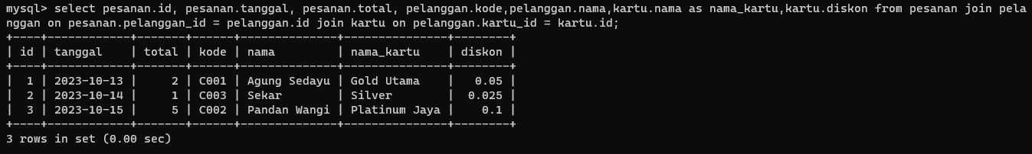

|  |  |  |  |  |  |  |  |
| --- | --- | --- | --- | --- | --- | --- | --- |
| **Pembelian** | | | | | **Produk** | **Vendor** | |
| id | tanggal | nomor | jumlah | harga | nama | nama | kontak |

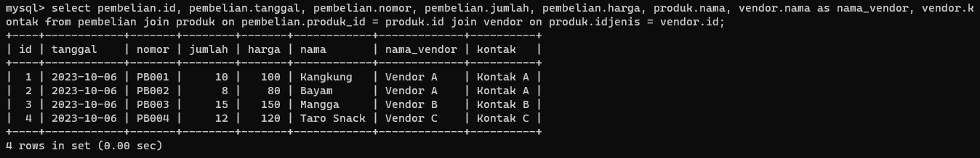

|  |  |  |  |  |  |  |  |  |
| --- | --- | --- | --- | --- | --- | --- | --- | --- |
| **Pesanan** | | | **Pelanggan** | **Produk** | | **Jenis produk** | **Pesanan items** | |
| id | tanggal | total | nama | kode | nama | nama | qty | harga_jual |

