LAB ACTION PLAN FOR WEEK 4

Objective:
To enable students to:
- Understand the structure and lifecycle of a Maven project.
- Build and package Java and Web applications using Maven.
- Add dependencies using pom.xml, compile and test using plugins.
- Resolve errors and conflicts arising from dependency mismatches.
- Work with parent and multi-module Maven projects.
- Generate executable JARs and deployable WARs using Maven.
Students must document observations, include screenshots of executions, and answer scenario-based questions after completing the tasks.

Understanding Maven Project Structure
Maven standardizes the project structure for both Java and web-based applications. src/
├── main/
│ ├── java/ → Application source code
│ └── resources/ → Configuration files like config.properties
└── test/
├── java/ → Unit test source code
└── resources/ → Test resources
The compiled files and reports are generated in the target/ directory after a successful build.

Steps to Perform Maven Build and Testing
----mvn clean install
- clean: Deletes the previous build (target/ folder)
- install: Builds, tests, and installs the package to local .m2 repository
After execution:
- target/ folder contains compiled .class files and the final .jar or .war
- Artifact is stored in:
~/.m2/repository/groupId/artifactId/version/
Add a Dependency (e.g., Gson):
In pom.xml:
<dependency>
<groupId>com.google.code.gson</groupId>
<artifactId>gson</artifactId>
<version>2.10</version>
</dependency>
After running:
mvn clean install
Check:
- Gson JAR is downloaded to .m2/repository/com/google/code/gson/gson/
- If version is wrong or not found → BUILD FAILURE with dependency resolution error.
Creation of Maven Java Project
Step 1. Open Eclipse IDE
└── 1.1. Launch Eclipse workspace
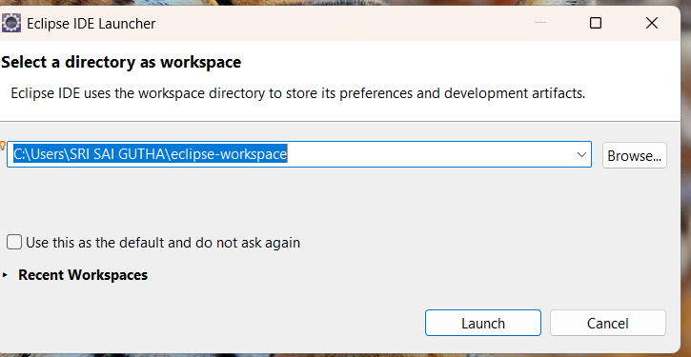
Step 2. Install Maven Plugin (if not installed)
└── 2.1. Go to "Help" in the top menu
└── 2.1.1. Click "Eclipse Marketplace"
└── 2.1.2. Search for "Maven Integration for Eclipse"
└── 2.1.3. Install the plugin if not already installed
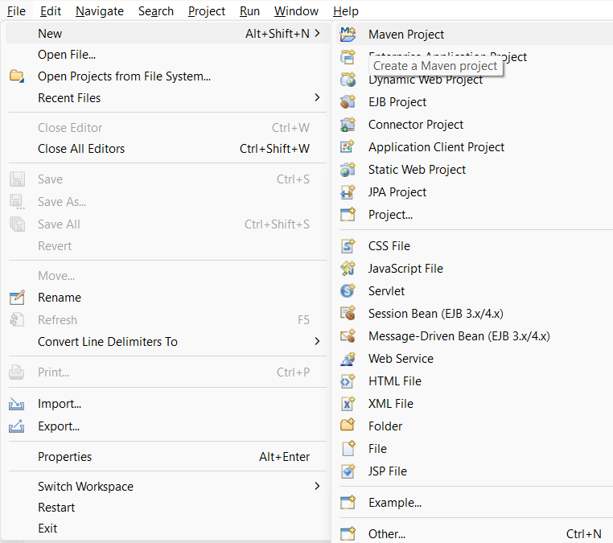
Step 3. Create a New Maven Project
└── 3.1. File -> New -> Project...
└── 3.1.1. Expand "Maven"
└── 3.1.2. Select "Maven Project" and click "Next"
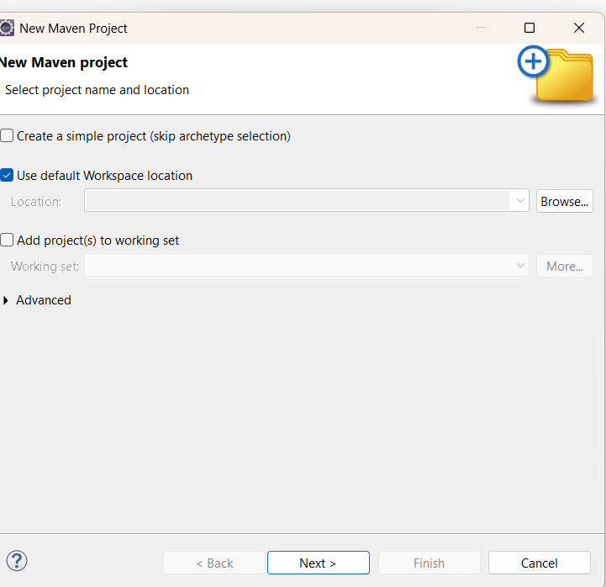
Step 4. Set Project Configuration
└── 4.1. Select workspace location (default or custom)
└── 4.2. Click "Next"

Step 5. Choose Maven Archetype
└── 5.1. Select an archetype(e.g "org.apache.maven.archetypes -> maven-archetype-quickstart 1.4 ")
└── 5.2. Click "Next"
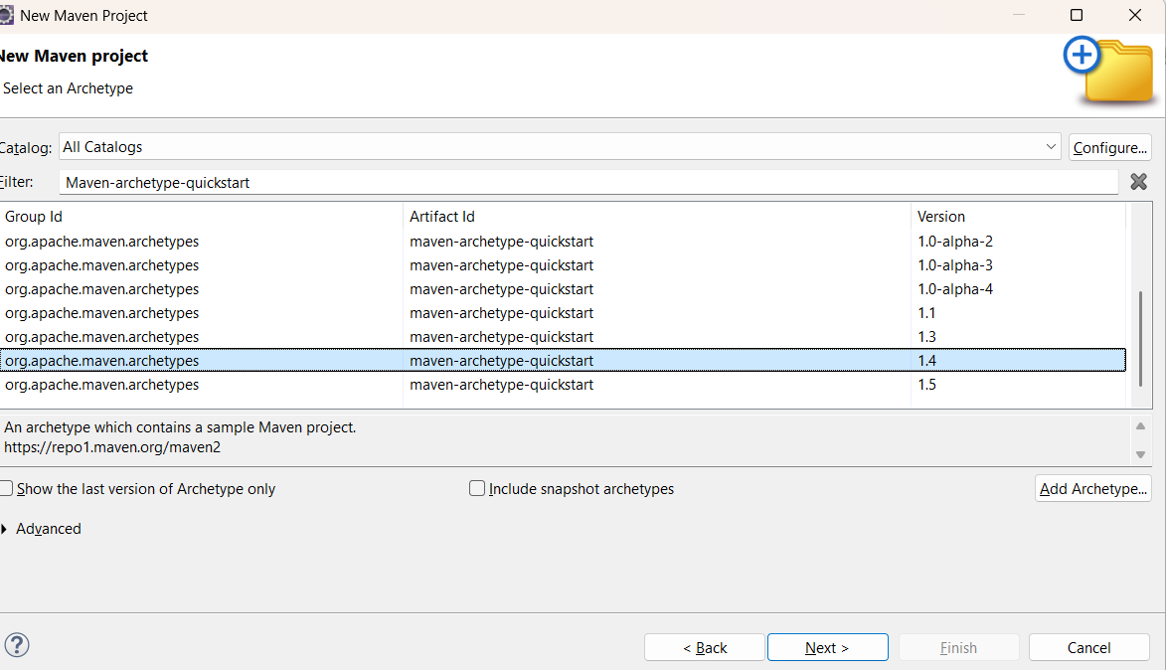
Step 6. Define Project Metadata
└── 6.1. Group ID: (e.g., com.example)
└── 6.2. Artifact ID: (e.g., my-maven-project)
└── 6.3. Version: (default is usually fine)
└── 6.4. Click "Finish"
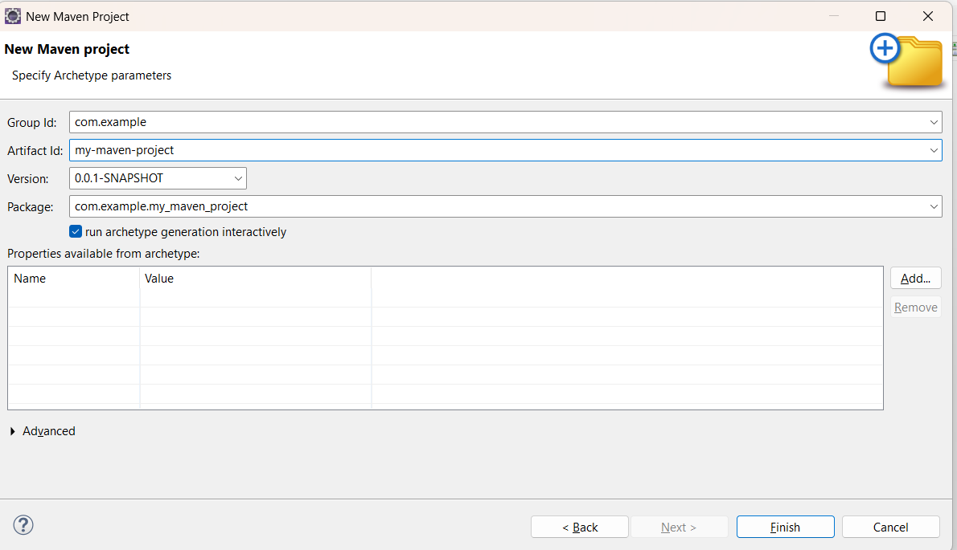
In Console, artifacts are grouped. When prompted with Y/N, type 'Y'.
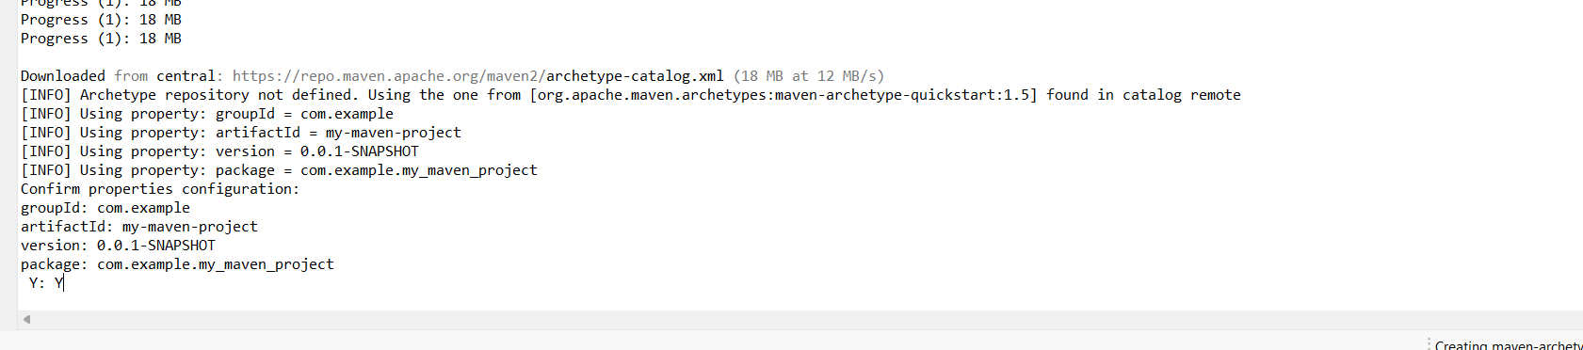
Step 7. Maven Project Created
└── 7.1. Project structure is generated with a standard Maven layout
└── 7.2. Includes:
└── src/main/java (for Java source code)
└── src/test/java (for test code)
└── pom.xml (Maven configuration file)
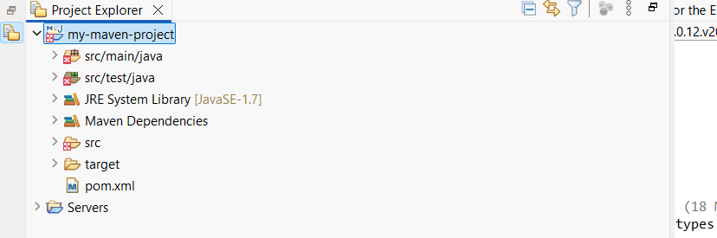
Step 8. Update Project Settings (if needed)
└── 8.1. Right-click on the project -> Maven -> Update Project...
└── 8.2. Ensure dependencies are up to date
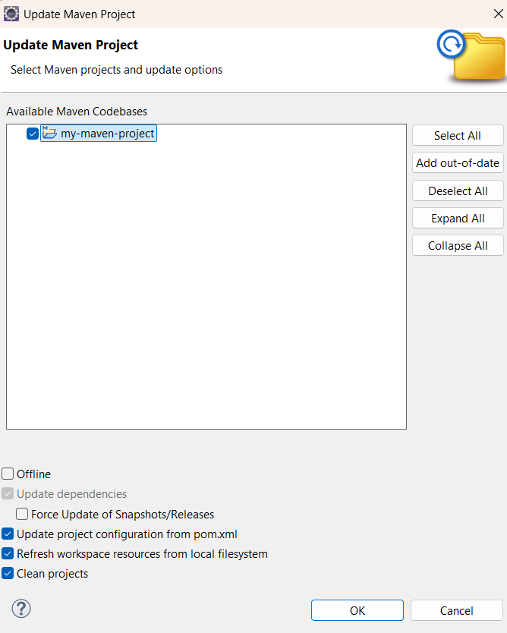
Step 9. Build and Run Maven Project
└── 9.1. Right-click on App.java -> Run As -> Maven Clean
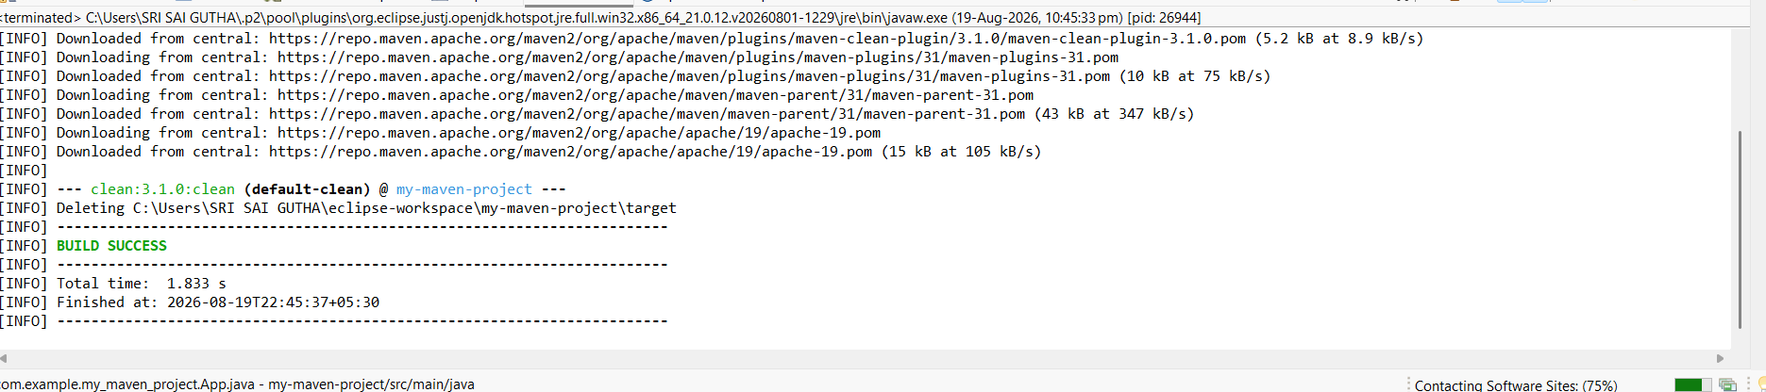
└── 9.1.1. Right-click on App.java -> Run As -> Maven Install
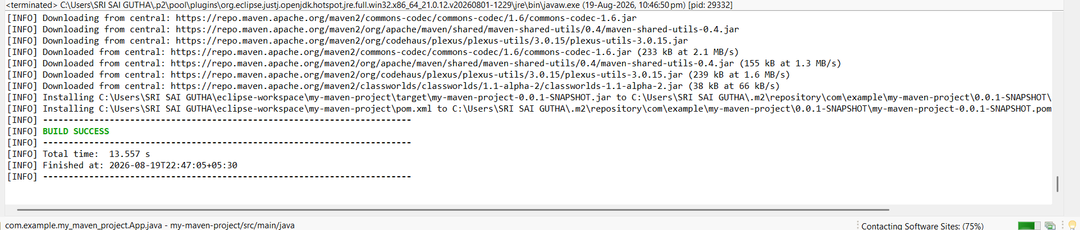
└── 9.1.2. Right-click on App.java -> Run As -> Maven Test
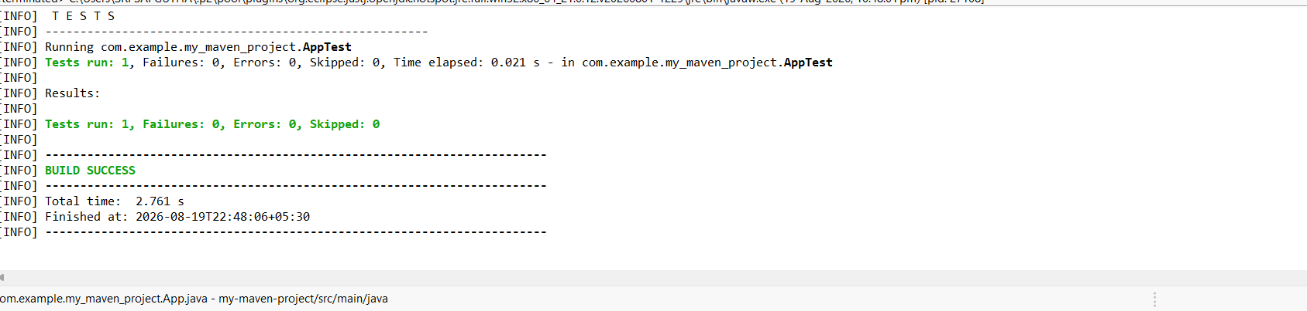
└── 9.1.3. Right-click on App.java -> Run As -> Maven Build
Step 10. In the Maven Build dialog:
└── Enter Goals: clean install test
└── Click on Apply -> Click on Run
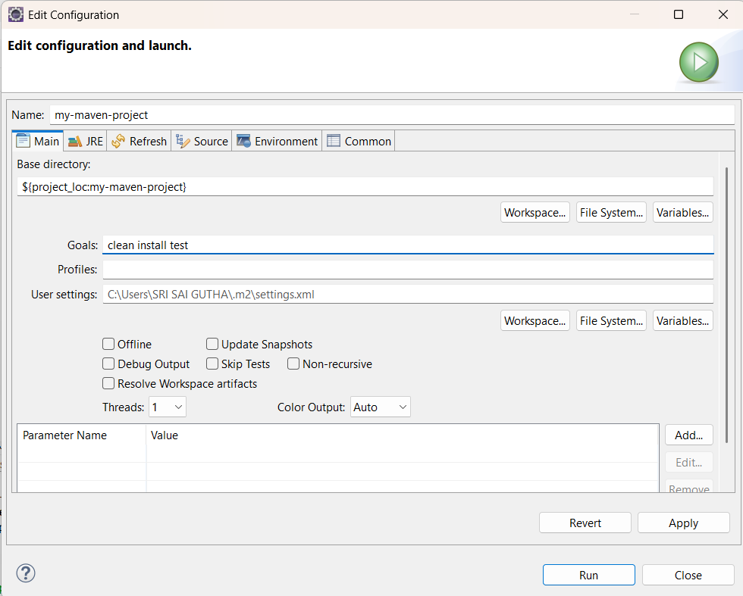

Step 11. Check console for BUILD SUCCESS message.
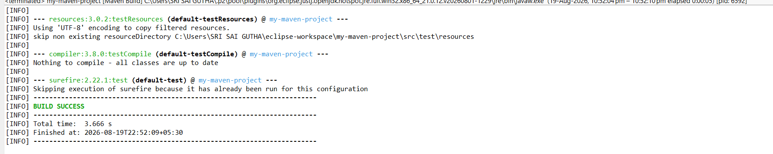
Step 12. Run the application:
└── Right-click on App.java -> Run As -> Java Application
└── Output: "Hello World" displayed.
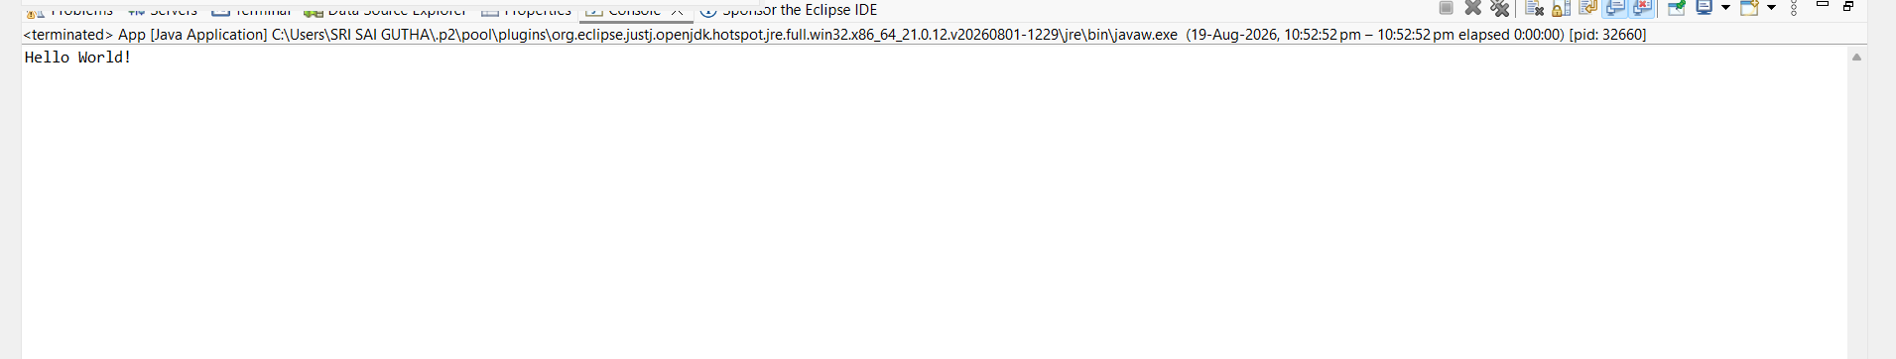
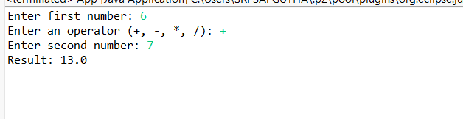
GITHUB PUSH:
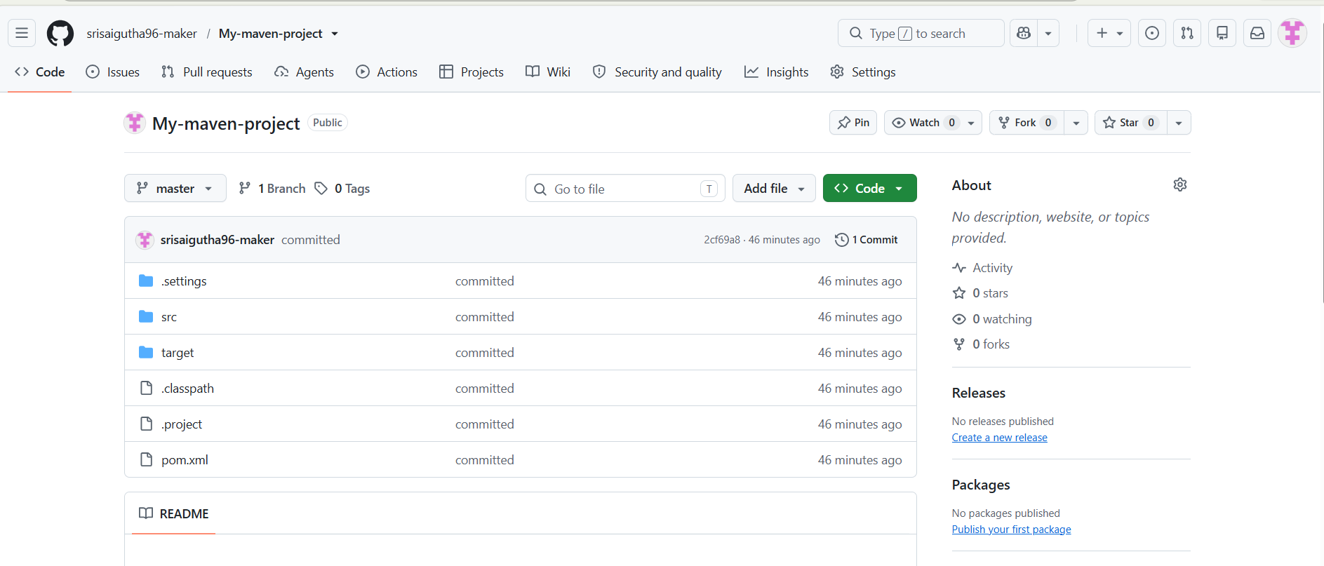
Creation of Maven web Java Project
Step 1: Open Eclipse
└── 1.1 Launch Eclipse IDE.
└── 1.2 Select or create a workspace.
Step 2: Create a New Maven Project
└── 2.1. File -> New -> Project...
└── 2.1.1. Expand "Maven"
└── 2.1.2. Select "Maven Project" and click "Next"
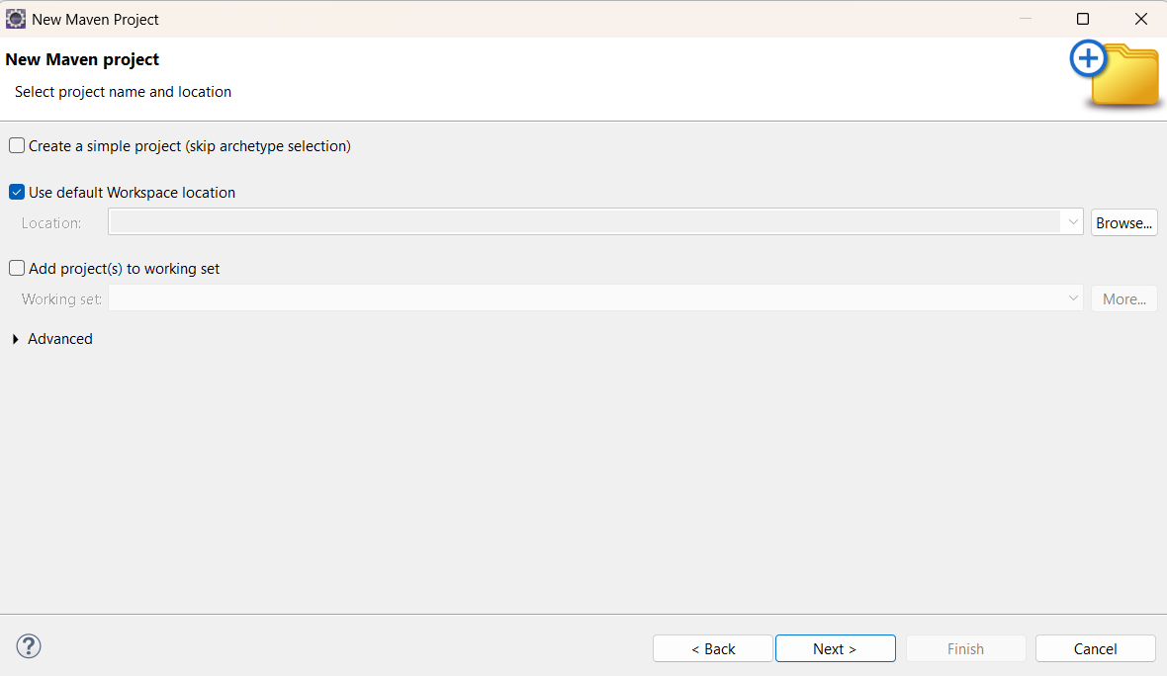
Step 3: Choose Maven Archetype
└── 3.1. Select an archetype(e.g "'org.apache.maven.archetypes' -> 'maven-archetype-webapp' 1.4 ")
└── 3.2. Click "Next"
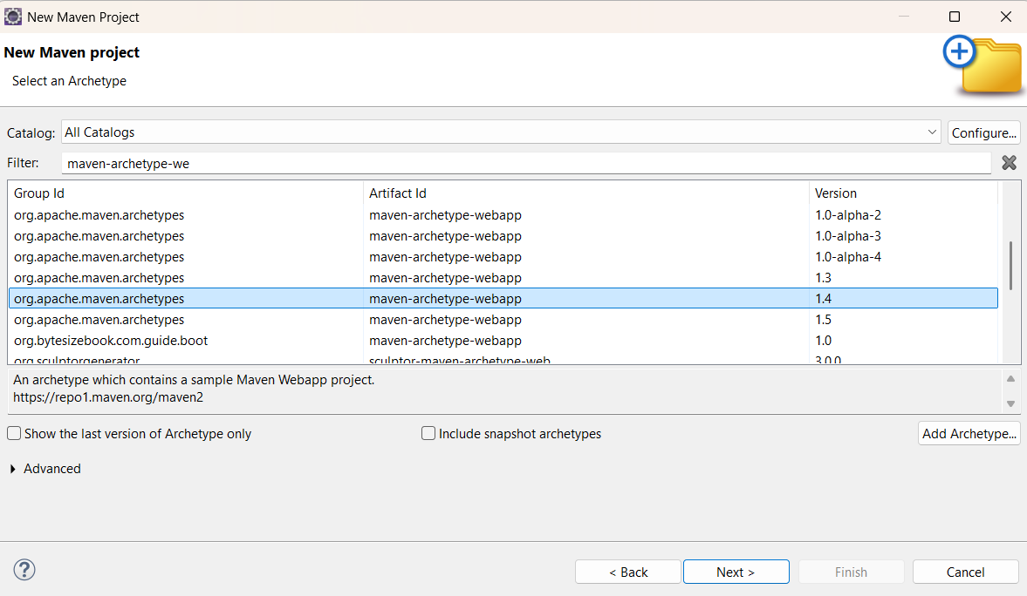
Step 4: Configure the Maven Project
└── 4.1 Group Id: Enter a group ID (e.g., com.example).
└── 4.2 Artifact Id: Enter an artifact ID (e.g., my-web-app).
└── 4.3 Click **Finish** to create the project.
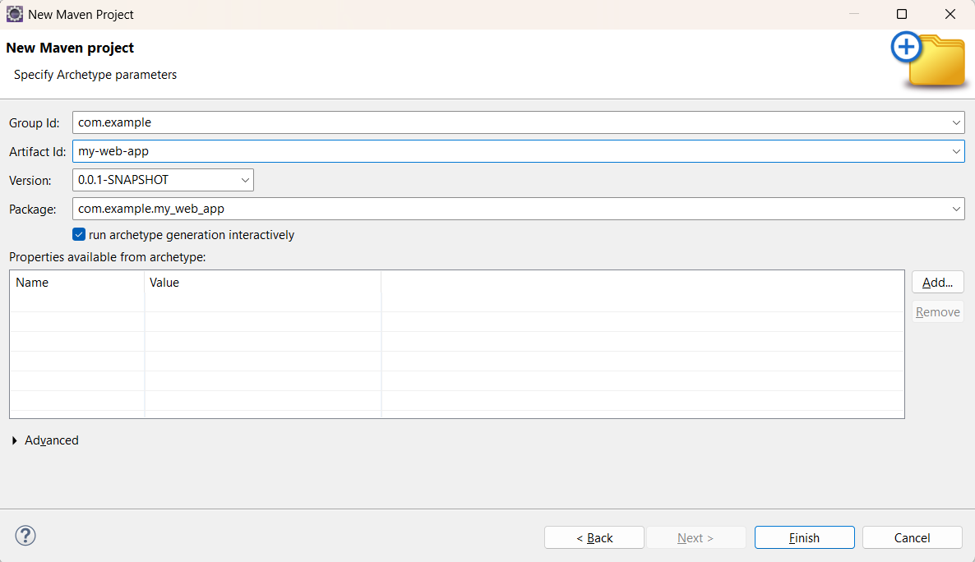
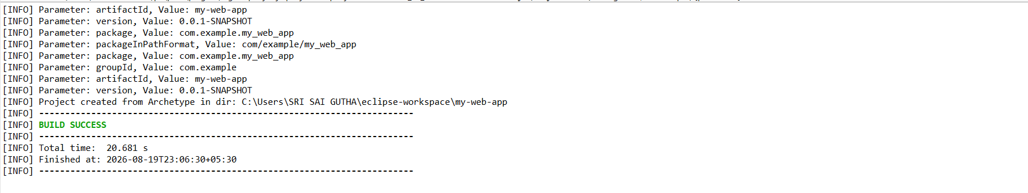
Step 5: Add Maven Dependencies
└── 5.1 Open the **pom.xml** file in the Maven project.
└── 5.2 Add the necessary dependencies for your web project (e.g., Servlet, JSP):
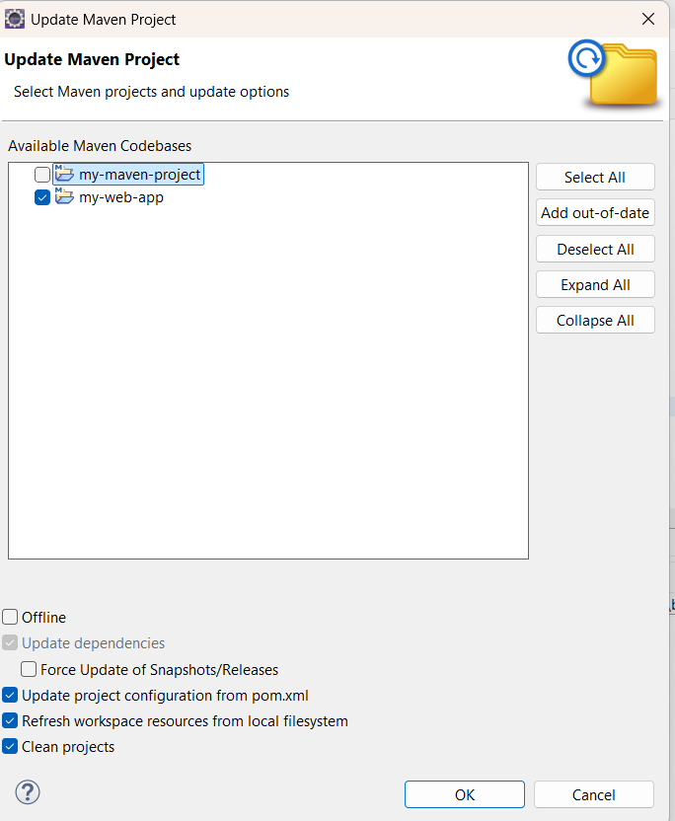
Go to browser -> Open mvnrepository.com
Search for 'Java Servlet API' -> Select the latest version.
Copy the dependency code -> Paste it in MavenWeb’s pom.xml under the target folder
└── Example:
```xml
<dependency>
<groupId>javax.servlet</groupId>
<artifactId>javax.servlet-api</artifactId>
<version>4.0.1</version>
<scope>provided</scope>
</dependency>
```
Step 6:-. Configure server:
└── Window -> Show View -> Servers
└── Add server -> Select Tomcat v9.0 server -> Click Next
└── Configure server options (e.g., ports, server location).

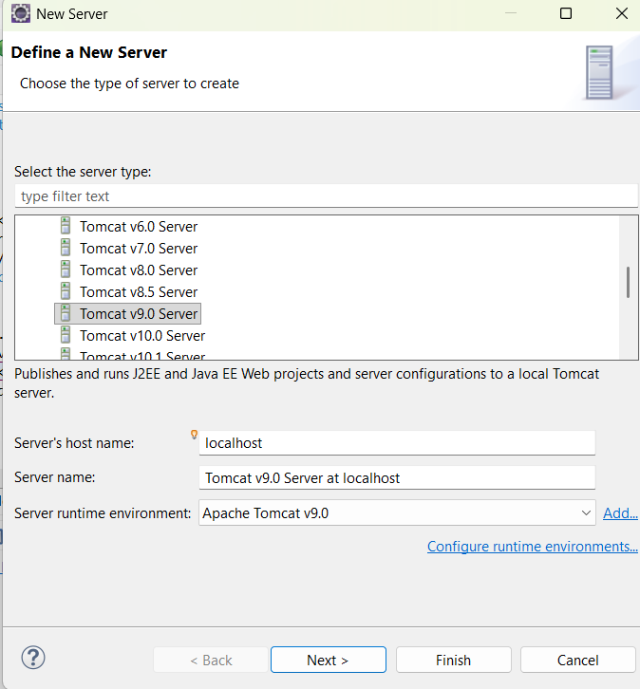
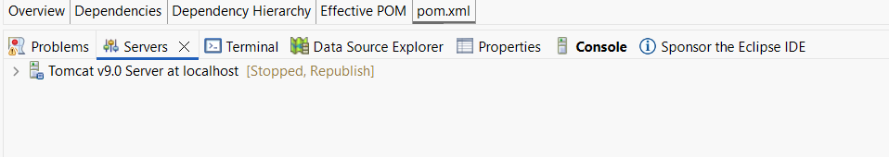
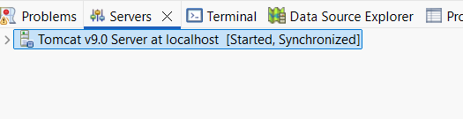
Step 7:-. Modify 'tomcat-users.xml':
└── Add role and user details under <tomcat-users> tag.
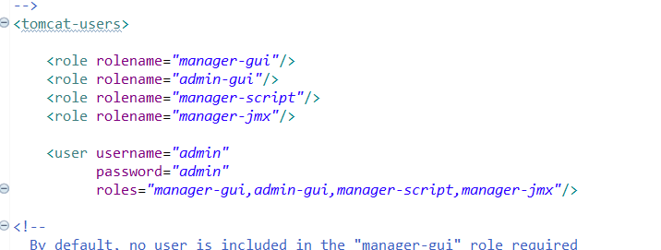
Step 8:. Build the project:
└── Right-click on index.jsp -> Run As -> Maven Clean
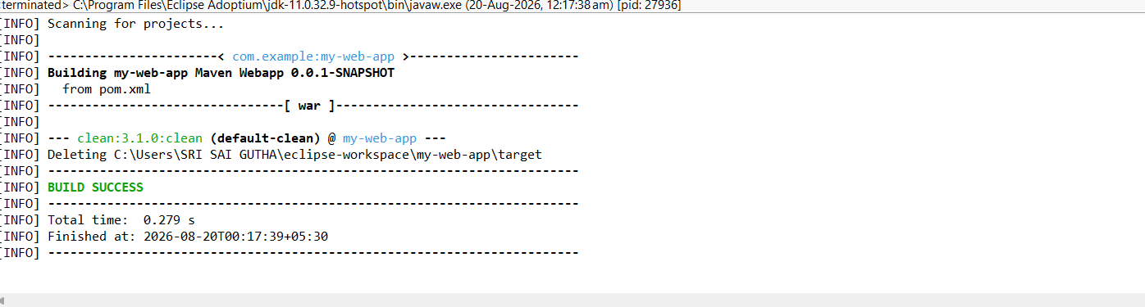
└── Right-click on index.jsp -> Run As -> Maven Install
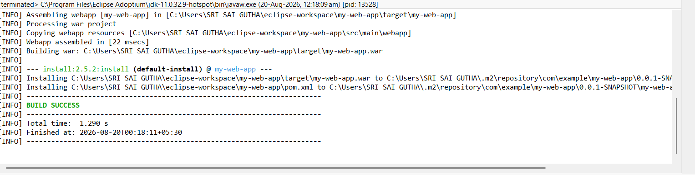
└── Right-click on index.jsp -> Run As -> Maven Test
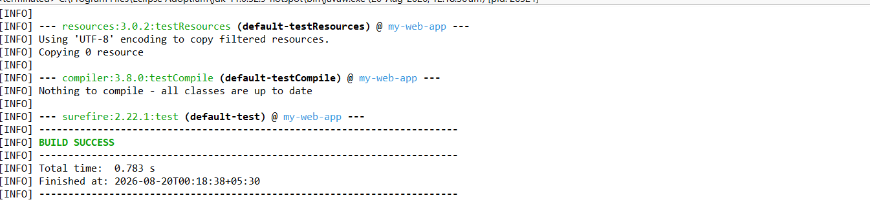
└── Right-click on index.jsp -> Run As -> Maven Build

Step 9. In the Maven Build dialog:
└── Enter Goals: clean install test
└── Click on Apply -> Click on Run
Step 10. Check console for BUILD SUCCESS message.
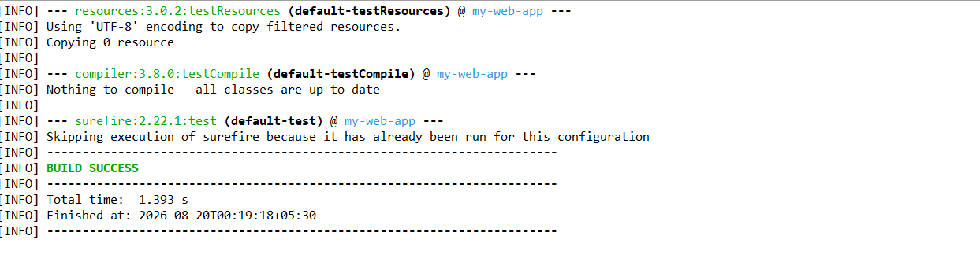
Step 11. Run the application:
└── Right-click on index.jsp -> Run As -> Run on Server
└── Select the Tomcat server -> Click on Finish
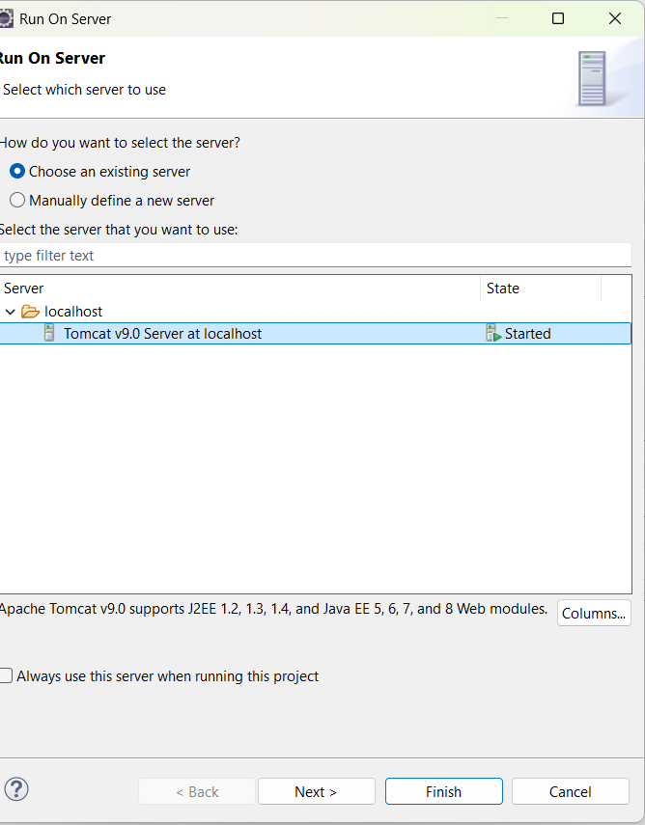
Step 12. Output: "Hello World" webpage displayed.
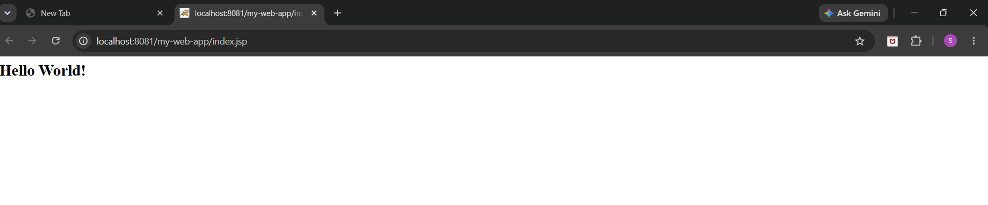


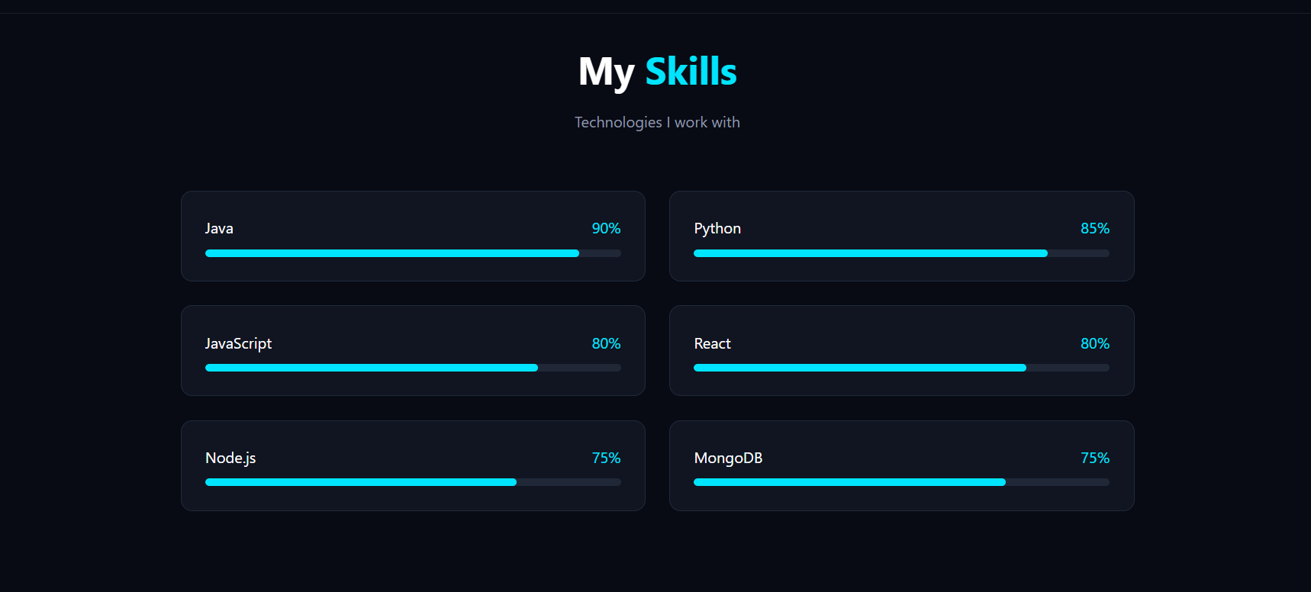
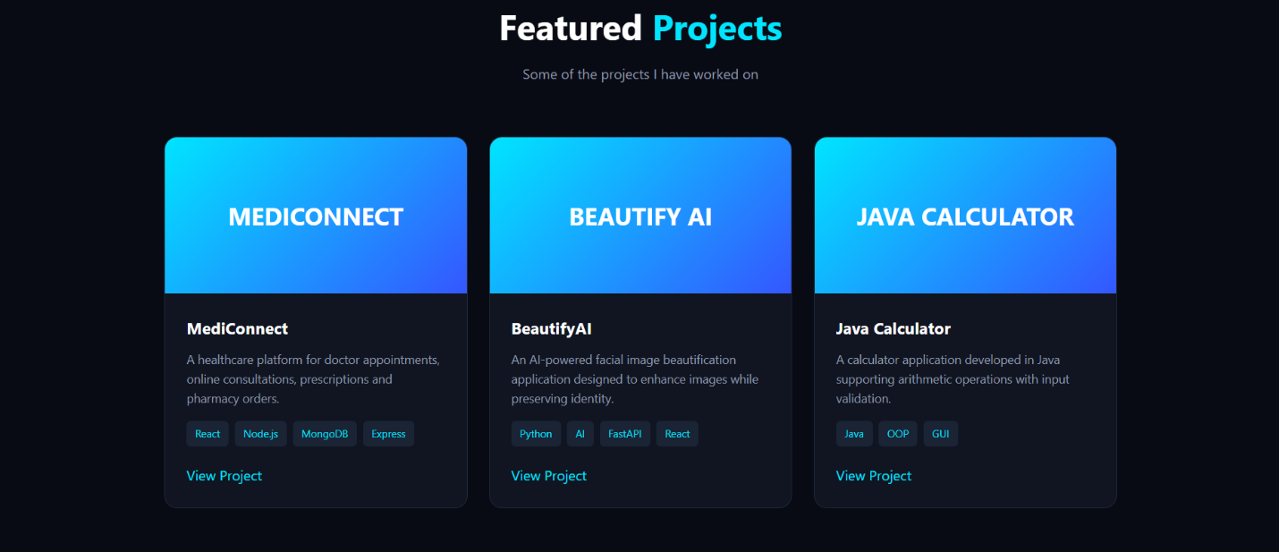
Note:-Now push yours Maven java project and Maven Web Project into your github
GITHUB PUSH:

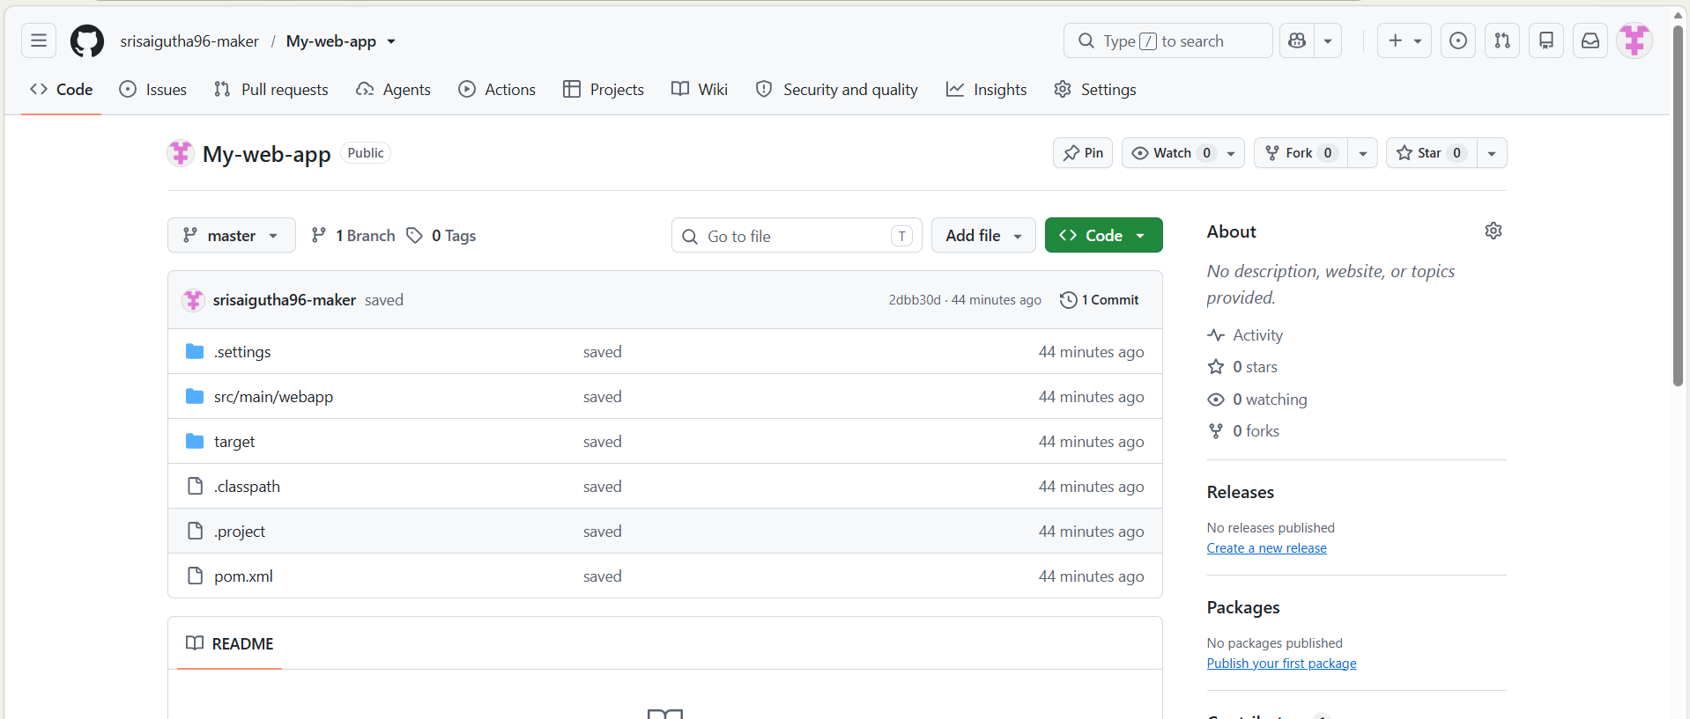
- Configure Java Version via Compiler Plugin
In pom.xml:
<plugin>
<groupId>org.apache.maven.plugins</groupId>
<artifactId>maven-compiler-plugin</artifactId>
<version>3.11.0</version>
<configuration>
<source>17</source>
<target>17</target>
</configuration> </plugin>
Check:
- Run mvn package
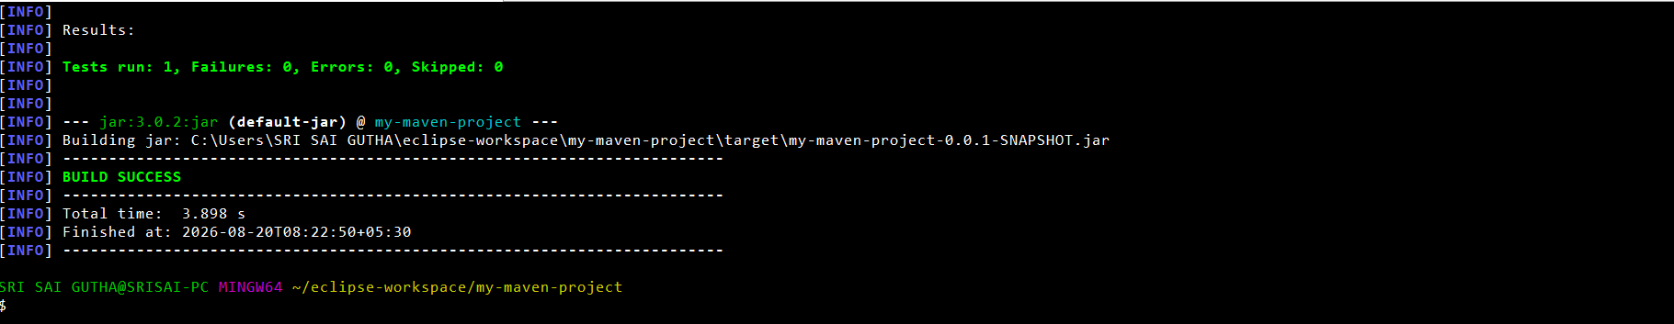
- Inspect generated JAR: jar tf target/myapp.jar
- 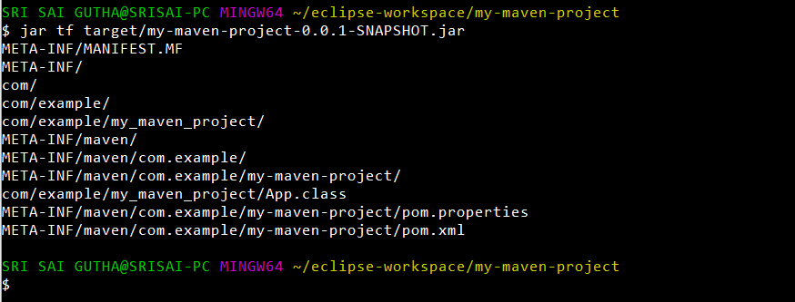
- JUnit Testing and Reports
Place test files in src/test/java. Example:
public class AppTest {
@Test
public void testSum() {
assertEquals(5, 2 + 3);
}
}
Run:
mvn test
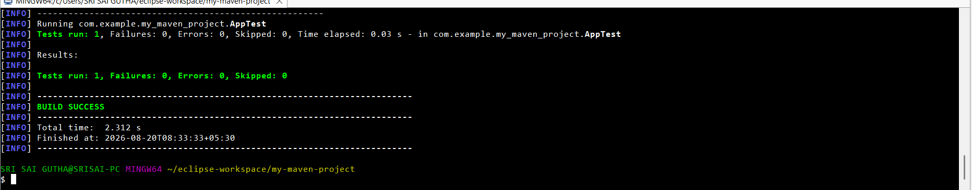
Check:
- target/test-classes/ → compiled test .class files

- target/surefire-reports/ → .txt or .xml test results
If test fails → corresponding log and failure trace shown

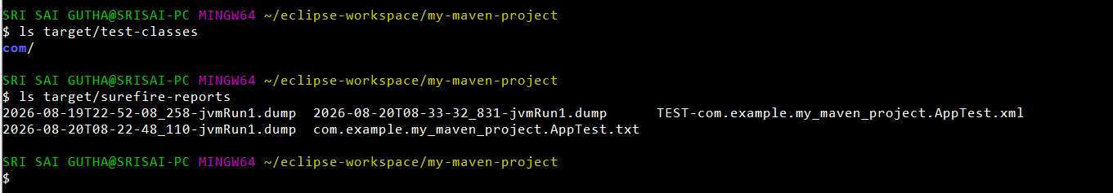
- Handling Errors in pom.xml
- Typos in version numbers or missing repositories cause BUILD FAILURE
- Maven shows precise error in console
- Fix the dependency tag → re-run mvn clean install
- 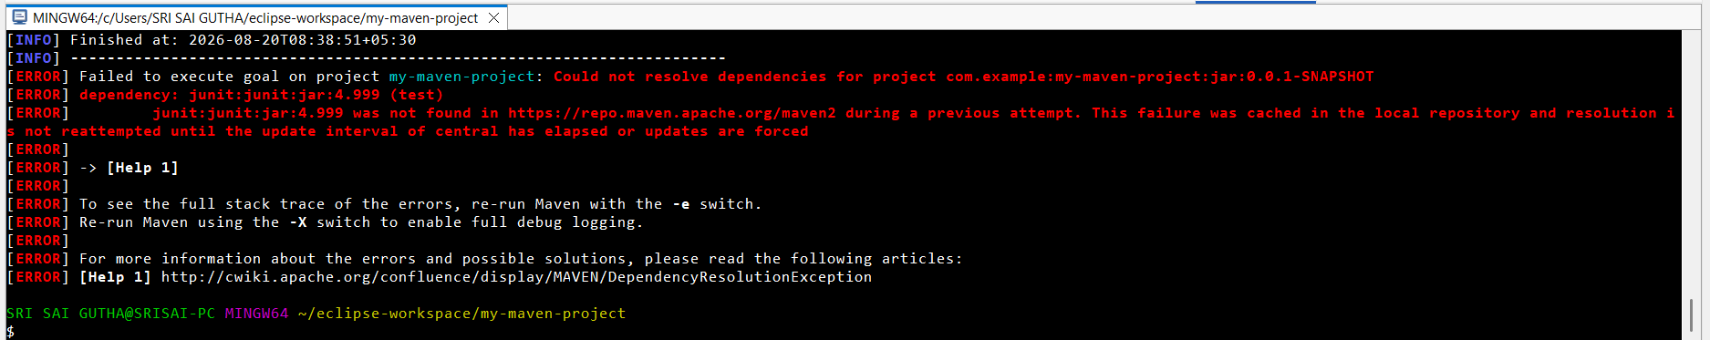
- 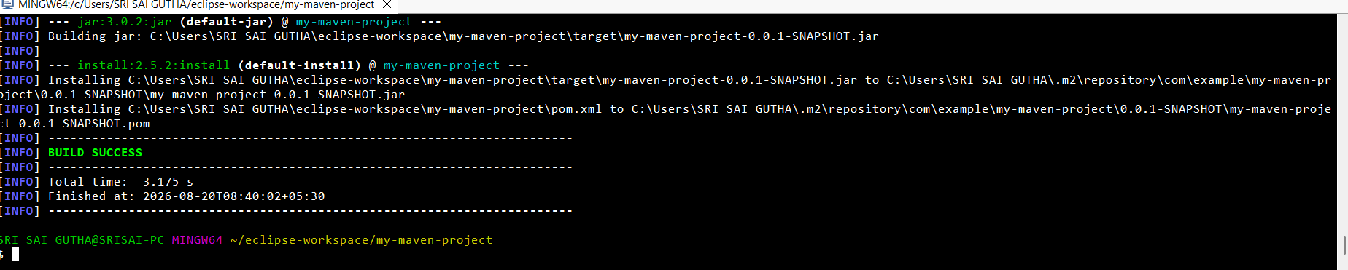

- Adding Resource Files
Put config.properties inside:
src/main/resources/config.properties
To read:
InputStream input = getClass().getClassLoader().getResourceAsStream("config.properties");
After build, check target/classes/ → file should exist there.
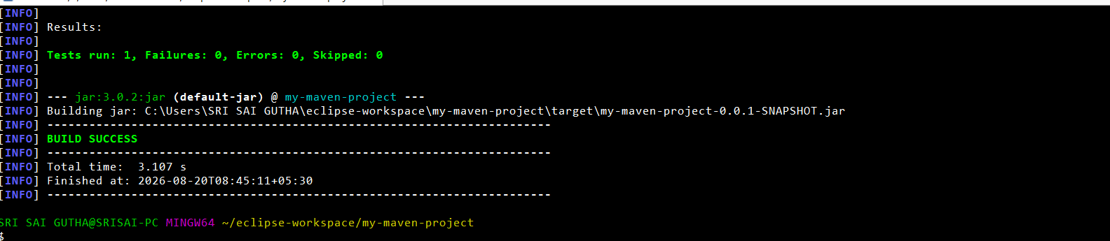
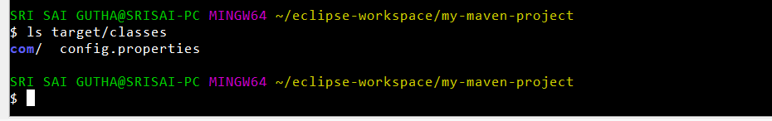

- Multi-Module and Parent Projects
Structure:
parent/
├── pom.xml (packaging: pom)
├── core/
| └── pom.xml
└── web/
└── pom.xml
- Parent pom.xml defines <modules> and common dependencies
- Each submodule builds independently ins to its target/ directory
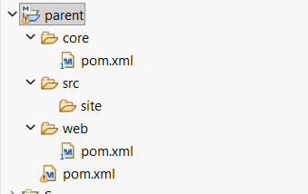

- Executable JARs

Add to pom.xml:

<build>
<plugins>
<plugin>
<groupId>org.apache.maven.plugins</groupId>
<artifactId>maven-jar-plugin</artifactId>
<configuration>
<archive>
<manifest>
<mainClass>com.example.Main</mainClass>
</manifest>
</archive>
</configuration>
</plugin>
</plugins>
</build>
Run:
mvn package
java -jar target/myapp.jar
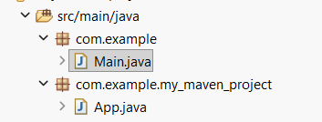.
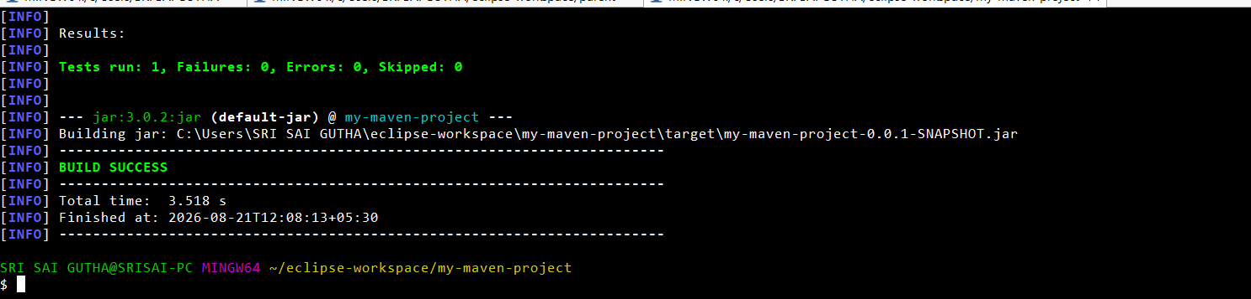

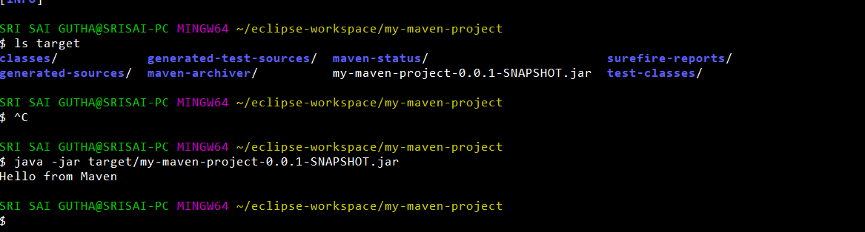

- Building a WAR File
Create a Maven web project with structure:
src/main/webapp/
└── WEB-INF/web.xml

Add:
<packaging>war</packaging>
Command:
mvn package
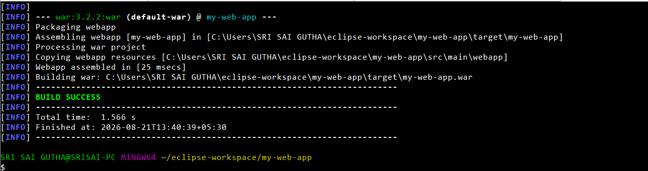
Generates target/mywebapp.war → deploy on Tomcat server.
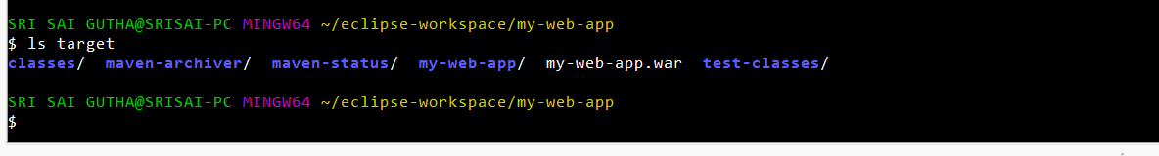
- Scenario-Based Questions:
- If my error is about:
Failed to execute goal org.apache.maven.plugins:maven-compiler-plugin:3.8.1:compile
[ERROR] -> [Help 1]
[ERROR] To see the full stack trace of the errors, re-run Maven with the -X switch.
How can I resolve it using maven terminal?
1. Maven Compiler Error
- Run mvn clean compile.
- If error continues, run mvn clean compile -e.
- For detailed debugging, use mvn clean compile -X.
- Check java -version and mvn -version.
- Check the Maven Compiler Plugin in pom.xml.

- A dependency you added is not recognized by the compiler. What steps would you take to confirm it is available in .m2 and listed in dependency tree?
2. Dependency Not Recognized
- Check the dependency in .m2/repository.
- Run mvn dependency:tree.
- Check the dependency version and scope.
- Use mvn dependency:tree -Dincludes=groupId:artifactId.

- A teammate sends a .patch file for a bug fix. How would you apply it and include it in your Maven build?
3. Apply .patch File
- Open the project directory.
- Run git apply bug-fix.patch.
- Check changes using git diff.
- Build using mvn clean install.

- You have multiple JUnit test failures and want to rerun only failed tests. How would you approach this?
4. Rerun Failed JUnit Tests
- Run mvn test.
- Check failures in target/surefire-reports/.
- Run only the failed test:
mvn -Dtest=TestClassName test.

- Your Maven build fails due to “Unsupported class version error.” What plugin and configuration would you review?
5. Unsupported Class Version
- Check java -version.
- Check mvn -version.
- Review the Maven Compiler Plugin.
- Check <source> and <target> Java versions in pom.xml.
- Make sure the Java versions are compatible.

- You need to change your Java application from a WAR to a standalone JAR. What pom.xml changes are needed?
6. Change WAR to JAR
- Open pom.xml.
- Change <packaging>war</packaging> to <packaging>jar</packaging>.
- Remove unnecessary WAR/web configuration.
- Run mvn clean package.

- You are required to change the default build output directory from target/ to build_output/. How would you configure it?
7. Change target/ to build_output/
- Add the following to pom.xml:
<directory>${project.basedir}/build_output</directory>
- Run mvn clean install.
- Build files will be generated in build_output/.

- You want to skip tests during the Maven build. What command would you use?
8. Skip Tests
- Use:
mvn clean install -DskipTests
- This skips test execution.

- How would you generate a site report (with test coverage, dependency analysis) for a Maven project?
9. Generate Site Report
- Run mvn site.
- Reports are generated in target/site/.
- For dependency analysis, use mvn dependency:analyze

- How do you build a Java project using Maven, and what files are generated in the target/ folder after running mvn clean install?
10. Build Java Project
- Open terminal in the folder containing pom.xml.
- Run mvn clean install.
- Maven compiles, tests, packages, and installs the project.
- Output is generated in target/.
- It may contain classes, test-classes, surefire-reports, and JAR/WAR files.

- How does Maven resolve dependency conflicts when two libraries use different versions of the same dependency, and how can you view and manage the dependency tree?
11. Dependency Conflicts
- Maven uses dependency mediation to select a dependency version.
- Usually, the nearest dependency in the tree is selected.
- View dependencies using mvn dependency:tree.
- Manage versions using <dependencyManagement>.

- How do you write and run a JUnit test in a Maven project, and where are the compiled test classes and reports stored after running mvn test?
12. JUnit Test
- Create the test inside src/test/java/.
- Add the @Test annotation.
- Run using mvn test.
- Compiled test classes are in target/test-classes/.
- Test reports are in target/surefire-reports/.

- How can you create an executable JAR with a main method using Maven, and which plugin helps configure this behavior?
13. Executable JAR
- Use the Maven JAR Plugin.
- Configure the mainClass in pom.xml.
- The main class must contain public static void main().
- Run mvn clean package.
- Execute using java -jar application.jar.

- How do you install and use a custom third-party JAR file in your Maven project, and how can you confirm it’s included in the build and classpath?
14. Custom Third-Party JAR
- Install the JAR using mvn install:install-file.
- Add the JAR as a dependency in pom.xml.
- Run mvn dependency:tree.
- Run mvn clean package to confirm it is included.

- How do you create a Maven web project that packages into a WAR file, and what is the standard folder structure for such a project?
15. Maven Web Project
- Set <packaging>war</packaging> in pom.xml.
- Use src/main/java/ for Java code.
- Use src/main/webapp/ for web files.
- Use WEB-INF/ for web configuration.
- Run mvn clean package.

- What command do you use to build a WAR file in Maven, where is it generated, and how can you deploy it to a server like Apache Tomcat?
16. Build and Deploy WAR
- Run mvn clean package.
- WAR is generated inside target/.
- Copy the WAR file to Tomcat's webapps/ folder.
- Start Tomcat.
- Tomcat automatically deploys the WAR.

- How do you add JSTL and servlet-api dependencies in a Maven web project, and why should the servlet API use provided scope instead of compile?
17. JSTL and Servlet API
- Add JSTL dependency to pom.xml.
- Add Servlet API dependency.
- Use <scope>provided</scope> for Servlet API.
- Tomcat already provides the Servlet API at runtime.
- Therefore, it does not need to be packaged inside the WAR.

- How do you set up a multi-module Maven web project with separate modules for core logic and web interface, and how are these modules built and connected?
18. Multi-Module Maven Project
- Create a parent Maven project.
- Create core and web modules.
- core contains business logic and produces a JAR.
- web contains the web interface and produces a WAR.
- Add core as a dependency of web.
- Build all modules using mvn clean install.

- How do you configure a Maven web project, and how does its packaging and execution differ from a traditional WAR-based application?
19. Maven Web Project vs WAR Application
- Configure the project with <packaging>war</packaging>.
- Web files are placed in src/main/webapp/.
- Build using mvn clean package.
- WAR runs inside a server such as Tomcat.
- A standalone JAR can run directly using java -jar application.jar.

Conclusion
Mastering Maven empowers students to structure projects efficiently, manage complex dependencies, and automate testing and packaging. By practicing real-world scenarios—such as resolving build errors, handling resource files, applying patches, and deploying to servers—students gain valuable hands-on experience aligned with professional software development workflows. Maven not only streamlines builds but also enforces standardization and reusability across projects. Through Maven, students learn efficient project management, dependency control, multi-module integration, and reproducible builds. Understanding Maven’s lifecycle, plugin system, and error handling prepares students for professional DevOps and CI/CD workflows. This lab equips students with hands-on experience in packaging, testing, resolving conflicts, and deploying real-world Java and Web applications.

