Sprint 2 — AWS Infrastructure Provisioning with Terraform
ShopNow CI/CD Capstone · Infrastructure workstream · Susmitha
AWS account 095355901688 · Region ap-south-1 · Cluster shopnow-eks-dev

This document records how the AWS infrastructure for the ShopNow project was provisioned with Terraform, in the order the work was actually carried out. Each step includes the command that was run, a screenshot of the result, and a short note on what to look for in the output.
Everything here was created from code in the terraform-Sushmita/ folder of the project repository. No AWS resource was created by hand in the console — which is the point of Infrastructure as Code, and what allows the whole environment to be destroyed and rebuilt on demand.

What was provisioned
VPC with two public and two private subnets across two Availability Zones, an Internet Gateway, a NAT Gateway, route tables and security groups. Three ECR repositories. IAM roles for the EKS control plane, the worker nodes and Jenkins. An EKS cluster with a two-node managed node group and five add-ons. Terraform state stored remotely in S3 with versioning, encryption and locking.

1. Configure the AWS CLI
The team agreed to work in a single shared AWS account so that ECR images, the cluster and the Terraform state are all in one place. Cross-account access would have added complexity for no benefit at this stage.
An IAM user was created in that account and its access key configured as a named CLI profile. A named profile was used rather than the default so that other AWS access on the same machine is left untouched.
aws configure --profile shared
Figure 1 — Starting the CLI configuration for the shared account profile.
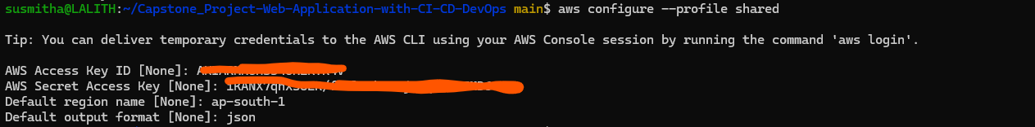
Figure 2 — Entering the access key, secret, default region (ap-south-1) and output format.
Note The secret access key is only displayed once, at the moment the key is created in the IAM console. If it is lost, the key has to be deleted and a new one generated.

Confirming the identity
Before running any Terraform it is worth confirming exactly which account and which identity the CLI is using. Terraform contains no account ID anywhere in its code — it builds resources in whichever account the calling credentials belong to, so this one command determines where everything will be created.
export AWS_PROFILE=shared
aws sts get-caller-identity
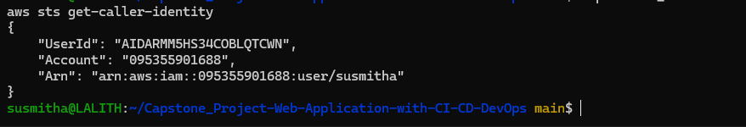
Figure 3 — Confirming the CLI is authenticated as an IAM user in account 095355901688.

2. Check what already exists in the account
Another team member had already pushed Docker images, which means the ECR repositories were created ahead of the Terraform run. Checking for them first avoids an avoidable failure part-way through an apply.
aws ecr describe-repositories --region ap-south-1 \
--query 'repositories[].repositoryName'
Figure 4 — Three repositories already present, matching the names the Terraform configuration expects.
Why this matters Terraform refuses to create a resource that already exists, so these three repositories would have caused the apply to fail. They were imported into Terraform state instead — covered in section 5.

3. Create the remote state backend
Terraform records everything it creates in a state file. Keeping that file on one laptop would mean nobody else on the team could run Terraform, and losing the laptop would leave AWS resources that nothing could account for.
The state is therefore stored in an S3 bucket with versioning enabled (so a corrupted state can be rolled back), server-side encryption (the file contains resource identifiers), and a DynamoDB table for locking (so two people applying at the same moment cannot overwrite each other).
This lives in its own small stack, run once. It has to, because the S3 backend cannot store the state of the very bucket that is the backend — a chicken-and-egg problem. This stack keeps its own state in a local file for exactly that reason.
cd terraform-Sushmita/bootstrap
terraform init
terraform apply
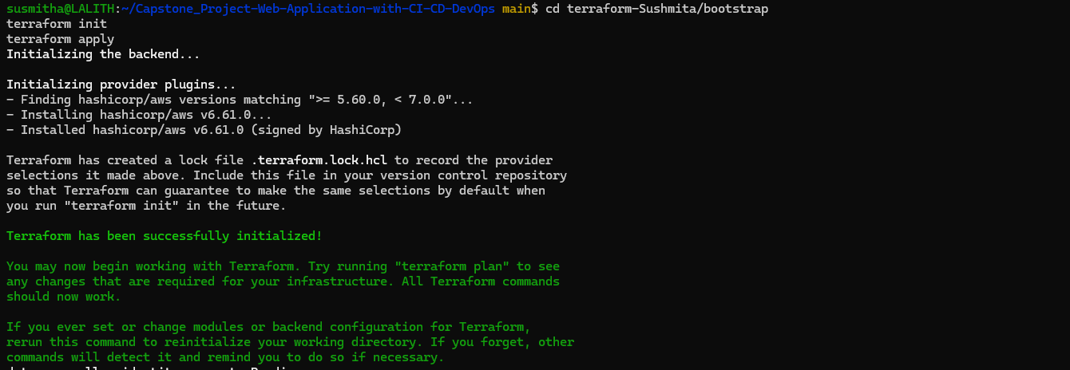
Figure 5 — Initialising the bootstrap stack and downloading the AWS provider.
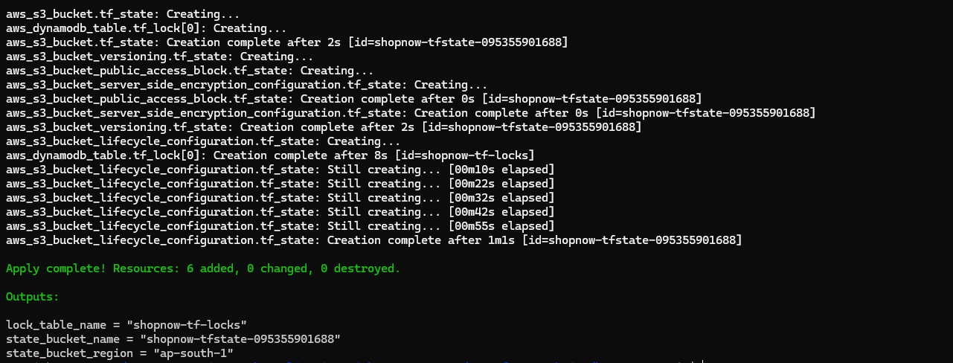
Figure 6 — Six resources created: the bucket, its versioning, encryption, public-access-block and lifecycle settings, plus the DynamoDB lock table.
Note The bucket name is derived from the account ID, giving shopnow-tfstate-095355901688. S3 bucket names are globally unique across all AWS customers, so appending the account ID guarantees no collision.

4. Point the environment at the remote state
The bucket name produced by the bootstrap stack was written into two files: backend.hcl, which tells Terraform where the state lives, and terraform.tfvars, which supplies the same value to the IAM policy that grants Jenkins access to it.
The backend block in the code is deliberately left empty and its values passed in at initialisation time. Backend configuration cannot use variables — Terraform must locate the state file before it can evaluate anything else — so a separate file is the standard way around that limitation. It also means a future production environment can point at a different bucket without any code change.
cd ../envs/dev
terraform init -backend-config=backend.hcl
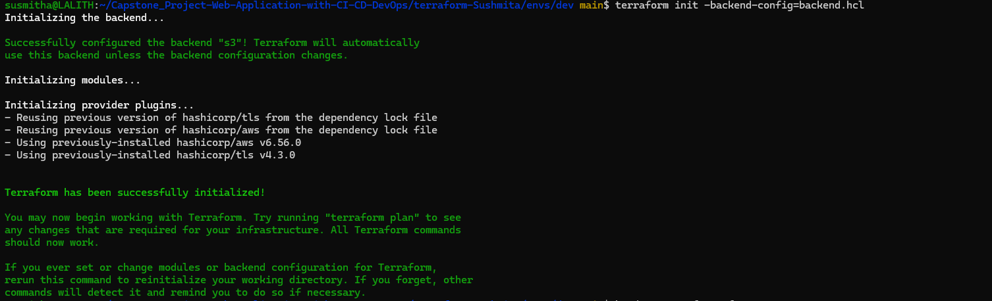
Figure 7 — "Successfully configured the backend s3". From this point the state is shared, not local.

5. Import the existing ECR repositories
Rather than excluding the three pre-existing repositories from the configuration, they were imported into Terraform state. Importing means Terraform now manages them properly — the lifecycle policies and scan-on-push settings defined in the module get applied, and the repositories become part of the infrastructure-as-code description rather than something created by hand.
Each repository is imported individually, matching the key Terraform uses for it internally.

Frontend
terraform import \
'module.ecr[0].aws_ecr_repository.this["avinash-shopnow/frontend"]' \
avinash-shopnow/frontend
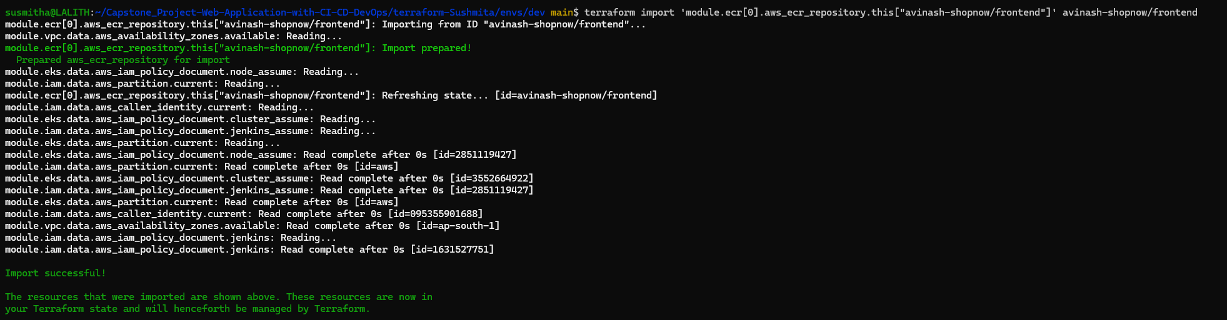
Figure 8 — Frontend repository imported successfully.

Admin
terraform import \
'module.ecr[0].aws_ecr_repository.this["avinash-shopnow/admin"]' \
avinash-shopnow/admin
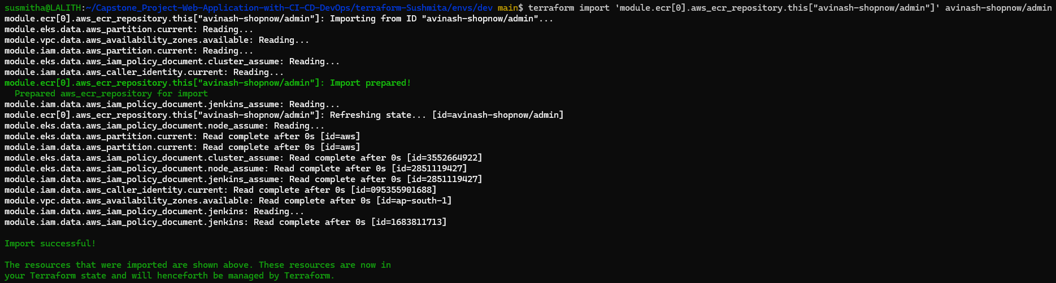
Figure 9 — Admin repository imported successfully.

Backend
terraform import \
'module.ecr[0].aws_ecr_repository.this["avinash-shopnow/backend"]' \
avinash-shopnow/backend
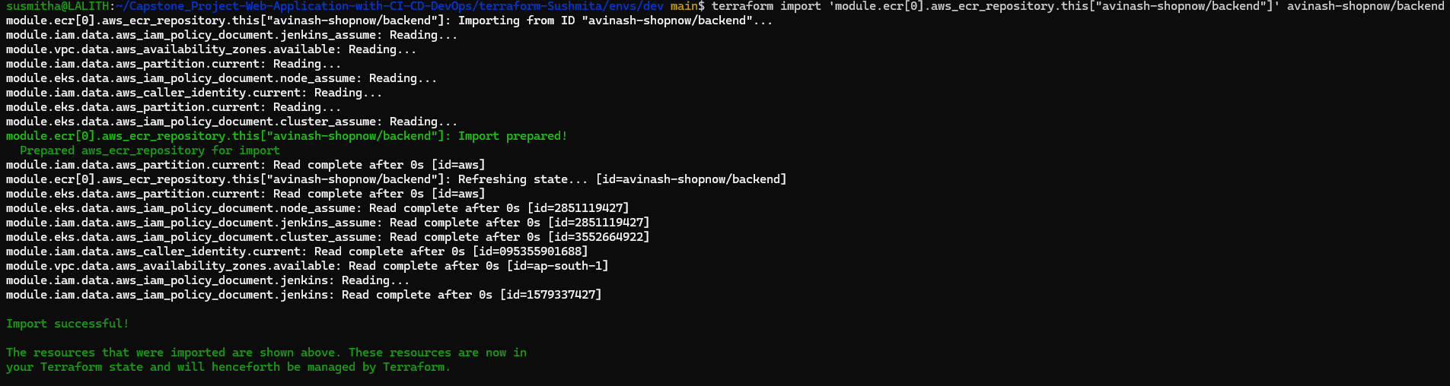
Figure 10 — Backend repository imported successfully. All three are now under Terraform management.

6. Plan the infrastructure
A plan compares the code against the real state of AWS and reports exactly what it would change. It creates nothing and costs nothing, so it can be run as often as needed. Saving the plan to a file and applying that file — rather than running a bare apply — guarantees that what gets built is precisely what was reviewed, with no chance of something changing in between. This is also how the Jenkins pipeline will run it in a later sprint.
terraform plan -out=tfplan
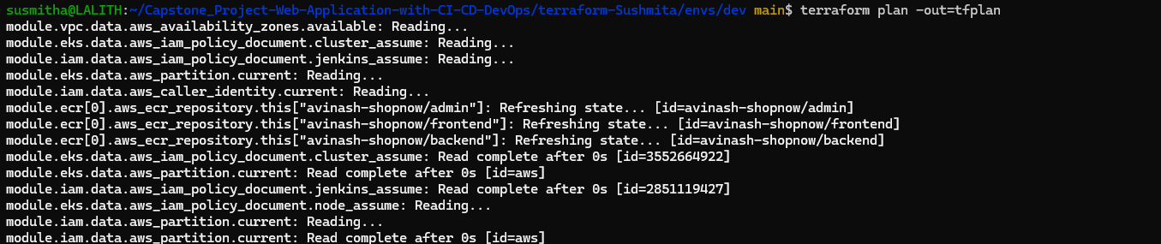
Figure 11 — Terraform refreshing the state of the imported ECR repositories before calculating the plan.
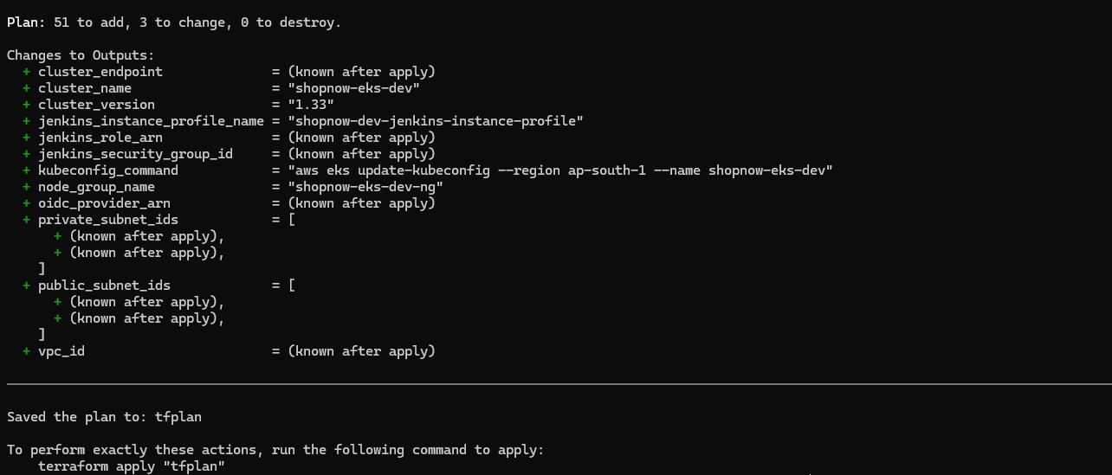
Figure 12 — Plan summary: 51 to add, 3 to change, 0 to destroy.
Reading this output The 3 changes are the imported ECR repositories receiving their lifecycle policies and scan-on-push configuration. "0 to destroy" is the number to check most carefully — at this stage nothing should be being deleted.

7. Apply
The apply builds the VPC and its subnets, the security groups, the IAM roles, the EKS control plane, the managed node group and the cluster add-ons. Terraform works out the ordering itself from the references between resources, and builds independent branches in parallel.
terraform apply tfplan
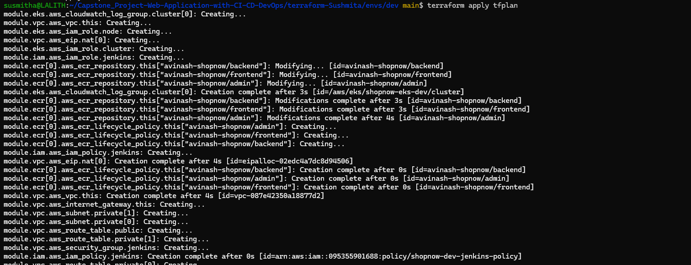
Figure 13 — Apply complete. The outputs below the summary are the values the rest of the team needs.
The outputs are the interface between this layer and the other three workstreams. Rather than sharing screenshots or messages, each teammate reads the value they need directly:
Jenkins / CI-CD — jenkins_instance_profile_name, jenkins_security_group_id, public_subnet_ids
Docker / Kubernetes — ecr_repository_urls, cluster_name, docker_build_args, app_ingress_paths
Ansible / Monitoring — private_subnet_ids, node_group_name
Important These identifiers are regenerated every time the environment is destroyed and rebuilt. Teammates should read them from terraform output rather than saving them.

8. Verify the cluster
With the infrastructure applied, kubectl was pointed at the new cluster and its health checked. This is the confirmation that the cluster is not just created but actually usable.
aws eks update-kubeconfig --region ap-south-1 --name shopnow-eks-dev
kubectl get nodes
kubectl top nodes
kubectl apply -f ../../extras/storageclass-gp3.yaml
kubectl get pods -n kube-system
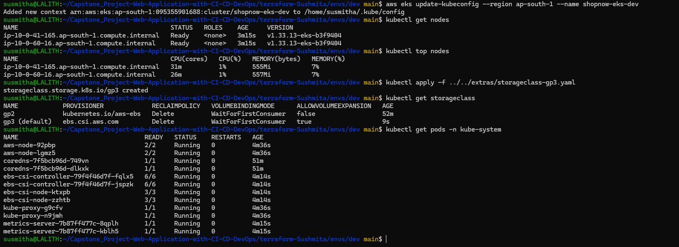
Figure 14 — Two nodes Ready, metrics reporting, gp3 set as the default StorageClass, and every system pod Running with zero restarts.

What each check confirms
Two nodes in Ready state means the node group joined the control plane successfully — the most common failure point in an EKS build, and almost always a networking or IAM problem when it goes wrong.
kubectl top returning figures confirms the metrics-server add-on is working, which the Horizontal Pod Autoscaler will depend on in a later sprint.
The gp3 StorageClass is what allows MongoDB to claim persistent storage. EKS ships no default StorageClass, so without this a storage request would stay pending indefinitely. The EBS CSI driver that fulfils those requests is installed by Terraform with its own scoped IAM role.
All add-on pods Running with zero restarts — CoreDNS for name resolution, aws-node for pod networking, kube-proxy, the EBS CSI controller and node agents, and metrics-server.

Problems encountered
Two failures came up during this sprint. Both are recorded here because the diagnosis is more useful than the fix.

Terraform could not resolve a for_each at plan time
The EKS module grants kubectl access to a set of IAM principals using EKS Access Entries, looping over the list with for_each. One entry in that list is the Jenkins role ARN, which does not exist until the apply creates it — and for_each requires its keys to be known before the apply begins.
The fix was to change the input from a list to a map with fixed labels as keys. Terraform can then build the loop at plan time, because the keys are known even though one of the values is not. The same correction was needed in the policy association resource, which had been looping over the access-entry resource itself.

The AWS Free Plan restricts which instance types can launch
The node group was originally configured with t3.medium Spot instances — the conventional choice for an EKS worker node. AWS accepted the node group request, then failed to launch the underlying EC2 instances, reporting that the instance type was not eligible for the Free Tier. Because a managed node group launches instances asynchronously, this took around 33 minutes to surface as CREATE_FAILED.
Querying the account for permitted types showed which were available:
aws ec2 describe-instance-types \
--filters Name=free-tier-eligible,Values=true \
--query 'InstanceTypes[].InstanceType' --region ap-south-1
The configuration was changed to m7i-flex.large, which is eligible in ap-south-1 and offers 2 vCPU and 8 GiB — more memory than the original choice. Capacity type was switched from Spot to on-demand at the same time, since the error referenced Spot specifically and Spot is separately restricted on the Free Plan.
Worth noting A successful terraform plan does not guarantee a successful apply. Plan validates syntax and references; it does not ask AWS whether the account is permitted to launch a given instance type. Some constraints only surface at the API.

Cost management
The running environment costs roughly $0.30 per hour, or about $7 per day if left up. Several decisions in the configuration were made specifically to keep that figure down:
A single shared NAT Gateway rather than one per Availability Zone. A NAT Gateway costs around $32 per month before data charges, and the common default of one per AZ triples that for no benefit in a development environment.
ECR lifecycle policies that expire untagged image layers after three days and retain only the ten most recent images per repository. Without them, every pipeline build would add several hundred megabytes that nothing ever removes.
Control plane logging limited to the api and authenticator log types with seven-day retention, rather than the full set with indefinite retention.
Twenty-gibibyte root volumes on the worker nodes instead of the fifty-gibibyte default, and non-current Terraform state versions expiring after thirty days.
Beyond configuration, the environment is torn down between working sessions. The full stack rebuilds from a single command in about fifteen minutes, so there is no reason to leave it running when nobody is using it.
terraform destroy
Before destroying Any Kubernetes Service of type LoadBalancer creates a real AWS load balancer that Terraform does not track. Delete those first with kubectl delete svc --all --all-namespaces, or the VPC deletion will hang and the load balancer will keep billing.

Sprint 2 outcome
Terraform scripts written for the VPC, subnets, Internet Gateway, NAT Gateway, route tables, security groups, ECR repositories, IAM roles and the EKS cluster — complete.
Terraform state stored securely in S3 with versioning, encryption and locking, giving all four team members consistent access — complete.
Provisioning tested and proven reproducible: applied successfully, verified with kubectl, and destroyed cleanly — complete.
The remaining Sprint 2 task, a Jenkins job that runs the Terraform provisioning, depends on the Jenkins server from Sprint 1 and sits with the CI/CD workstream. The Terraform side is ready for it: setting allow_jenkins_to_run_terraform to true and re-applying grants the Jenkins role the permissions that job will need, and the Jenkins EC2 instance can use an IAM instance profile rather than stored access keys.

