Hero Vired | DevOps Skill Test 3
Deploy a Multi-Service Node.js E-commerce Application Using Terraform and Docker
Implementation documentation with screenshots
Submitted by | Banala Susmitha
GitHub repository | https://github.com/banalasusmitha/ecommerce-terraform-docker
Docker Hub images | https://hub.docker.com/u/sunilstark007
AWS region | ap-south-1 (Asia Pacific, Mumbai)
Date | 27 September 2026

1. Objective and result
The goal of this assignment is to containerise a Node.js e-commerce application that has four backend services (user, products, orders and cart) and one frontend, publish the images on Docker Hub, and use Terraform to provision the AWS infrastructure the containers run on: a VPC with a public subnet, a security group and an EC2 instance. The frontend must be reachable from the internet and Terraform must print its public address.
Result: a single terraform apply created 8 AWS resources in ap-south-1. At first boot, the EC2 instance's user-data script installed Docker, pulled the five images from Docker Hub and started them. The frontend was reachable at http://13.127.98.111 and reported all four backend services as running (Figure 25).
Source code:
https://github.com/banalasusmitha/ecommerce-terraform-docker

2. Architecture
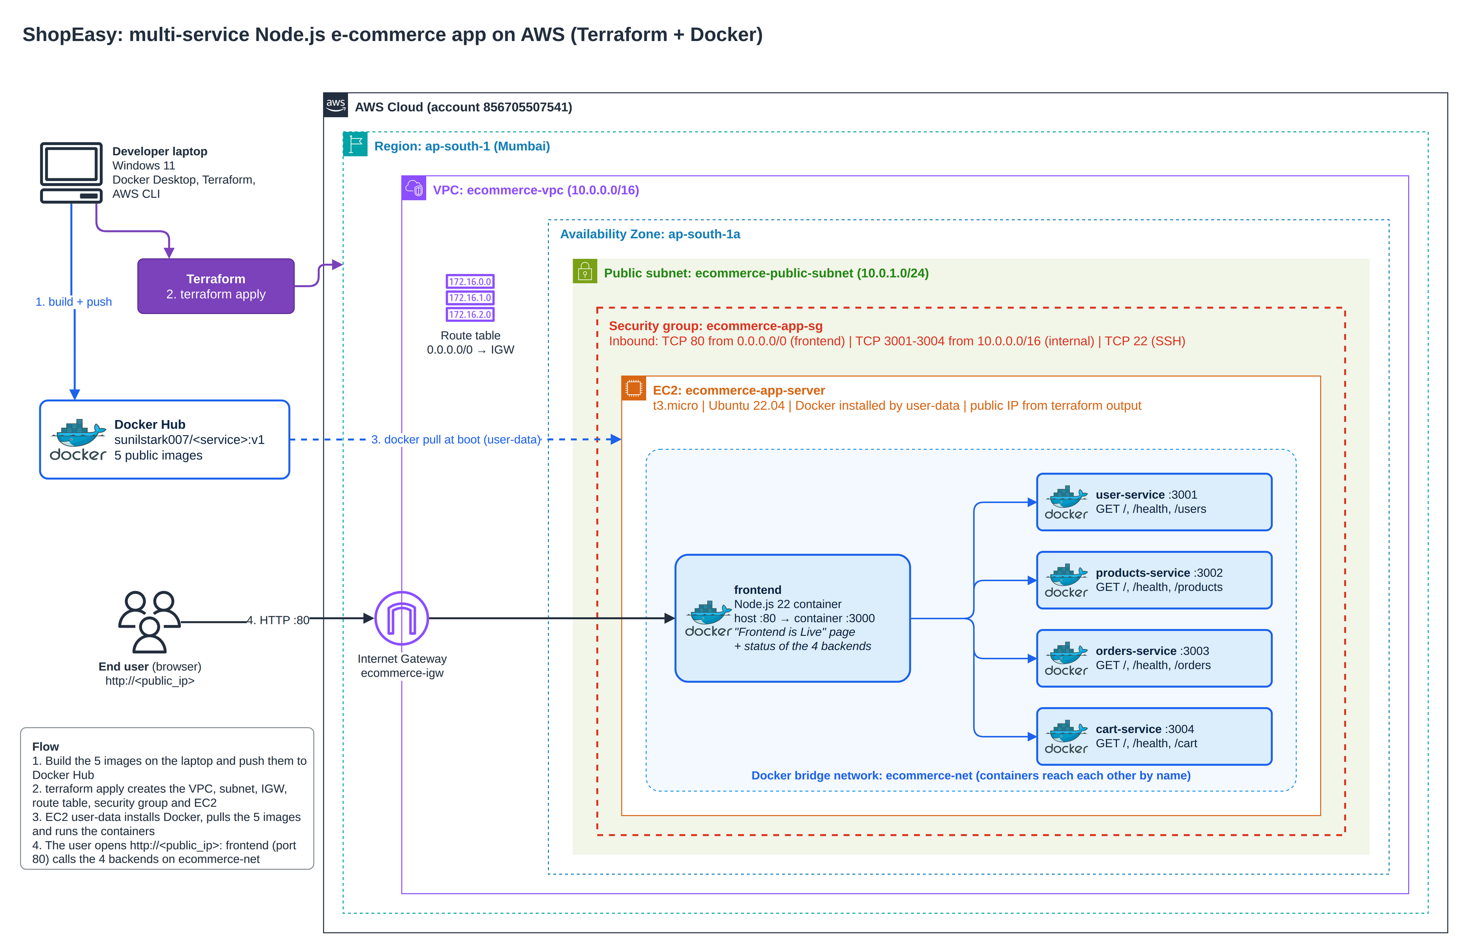
Figure 1: Solution architecture. Drawn in draw.io; the editable source is docs/architecture.drawio in the repository. The numbers on the arrows match the four stages of the deployment.

Request path: the browser connects to the instance's public IP on port 80 through the internet gateway. The security group allows port 80 from anywhere, so the request reaches the frontend container, which Docker publishes on host port 80 (container port 3000). The frontend calls the four backend containers by name (for example http://user-service:3001) over the private Docker network ecommerce-net. The backend ports 3001-3004 are open in the security group only to the VPC range 10.0.0.0/16, so they are not reachable from the internet.

2.1 Services
Service | Docker image | Container port | Host port on EC2 | Endpoints
frontend | sunilstark007/frontend:v1 | 3000 | 80 (public) | /, /health, /api/users, /api/products, /api/orders, /api/cart
user-service | sunilstark007/user-service:v1 | 3001 | 3001 (VPC only) | /, /health, /users
products-service | sunilstark007/products-service:v1 | 3002 | 3002 (VPC only) | /, /health, /products
orders-service | sunilstark007/orders-service:v1 | 3003 | 3003 (VPC only) | /, /health, /orders
cart-service | sunilstark007/cart-service:v1 | 3004 | 3004 (VPC only) | /, /health, /cart

2.2 AWS resources created by Terraform (8 in total)
Terraform resource | Name tag | Configuration
aws_vpc.main | ecommerce-vpc | 10.0.0.0/16, DNS support and DNS hostnames enabled
aws_internet_gateway.igw | ecommerce-igw | Gives the VPC access to the internet
aws_subnet.public | ecommerce-public-subnet | 10.0.1.0/24 in ap-south-1a, public IP assigned at launch
aws_route_table.public | ecommerce-public-rt | Route 0.0.0.0/0 to the internet gateway
aws_route_table_association.public | - | Attaches the route table to the subnet, which makes it public
aws_security_group.app | ecommerce-app-sg | Inbound: 80 from 0.0.0.0/0; 3001-3004 from 10.0.0.0/16; 22 from 0.0.0.0/0. Outbound: all
aws_key_pair.app | ecommerce-key | Public SSH key used to log in for verification
aws_instance.app | ecommerce-app-server | t3.micro, latest Canonical Ubuntu 22.04 AMI, 10 GB gp3, user-data script

About the "Default VPC" wording in the evaluation criteria
The requirements ask for a VPC with at least one public subnet provisioned with Terraform, so this project creates its own VPC (ecommerce-vpc) instead of using the account's default VPC. Because the whole network is defined in code, terraform apply recreates it identically in any account. The account's default VPC (172.31.0.0/16), visible in Figures 31 and 32, was not used or changed.

3. Tools and versions
Tool | Version | Used for
Windows 11 + PowerShell | - | Local workstation
Docker Desktop | Docker 28.5.1 | Building, testing and pushing the images
AWS CLI | 2.35.7 | Authentication through IAM Identity Center (aws sso login)
Terraform | 1.16.2, hashicorp/aws provider 5.100.0 | Provisioning the AWS infrastructure
Node.js | 22 (node:22-alpine base image) | Runtime of all five services
Ubuntu | 22.04.5 LTS on EC2 | Docker host
Git / GitHub | - | Source code repository

4. Project structure
ecommerce-terraform-docker/
|-- frontend/ Dockerfile, server.js, package.json
|-- user-service/ Dockerfile, server.js, package.json
|-- products-service/ Dockerfile, server.js, package.json
|-- orders-service/ Dockerfile, server.js, package.json
|-- cart-service/ Dockerfile, server.js, package.json
|-- terraform/
| |-- provider.tf Terraform and AWS provider settings
| |-- variables.tf Input variables
| |-- terraform.tfvars Values used for this deployment
| |-- network.tf VPC, internet gateway, subnet, route table
| |-- security_group.tf Firewall rules
| |-- ec2.tf AMI lookup, key pair, EC2 instance
| |-- user_data.sh.tpl Boot script: install Docker, pull and run images
| `-- outputs.tf Public IP, DNS and URLs
|-- docs/ architecture.drawio, architecture.png, this document
|-- screenshots/ Evidence for every step
|-- build-and-push.sh Optional helper to build and push all images
`-- README.md

5. Implementation steps

5.1 Environment setup
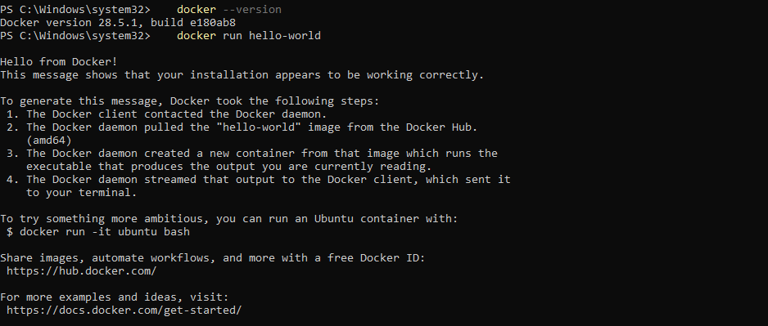
Figure 2: Docker check. Docker 28.5.1 is installed and the Docker Desktop engine is running: the hello-world container runs successfully on amd64.
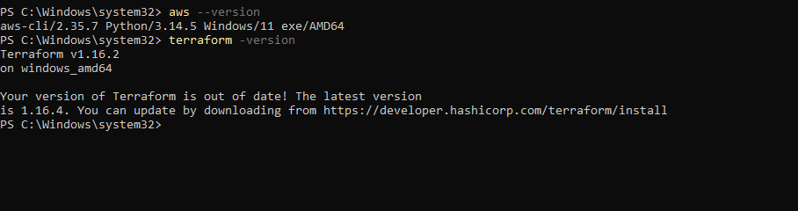
Figure 3: AWS CLI and Terraform check. AWS CLI 2.35.7 and Terraform 1.16.2 are installed and available in PowerShell.
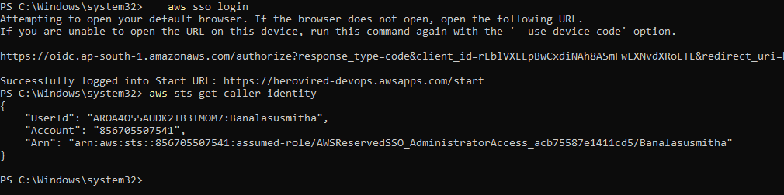
Figure 4: AWS login. Logged in through IAM Identity Center with aws sso login. aws sts get-caller-identity confirms account 856705507541 with the AdministratorAccess role, which Terraform uses.

5.2 Application code and Dockerfiles
Each service is a small Node.js HTTP server that uses only built-in modules (no npm dependencies), so the images build quickly and the same way every time. Every backend returns a sample response on / (for example {"service":"user-service","message":"User Service Running","port":3001}), a /health endpoint and sample data on its own route. The frontend renders the "Frontend is Live" page; on every page load it calls each backend over the Docker network and shows whether it is running, and /api/<name> returns that backend's data.
Dockerfile of user-service (the other four differ only in the port: 3002, 3003, 3004 and 3000 for the frontend):
FROM node:22-alpine
WORKDIR /app
COPY package.json server.js ./
ENV PORT=3001
EXPOSE 3001
CMD ["node", "server.js"]

5.3 Build the Docker images
The five images were built from the project root. The --platform linux/amd64 flag makes sure the images match the x86_64 EC2 instance.
docker build --platform linux/amd64 -t susmitha/user-service:v1 ./user-service
docker build --platform linux/amd64 -t susmitha/products-service:v1 ./products-service
docker build --platform linux/amd64 -t susmitha/orders-service:v1 ./orders-service
docker build --platform linux/amd64 -t susmitha/cart-service:v1 ./cart-service
docker build --platform linux/amd64 -t susmitha/frontend:v1 ./frontend
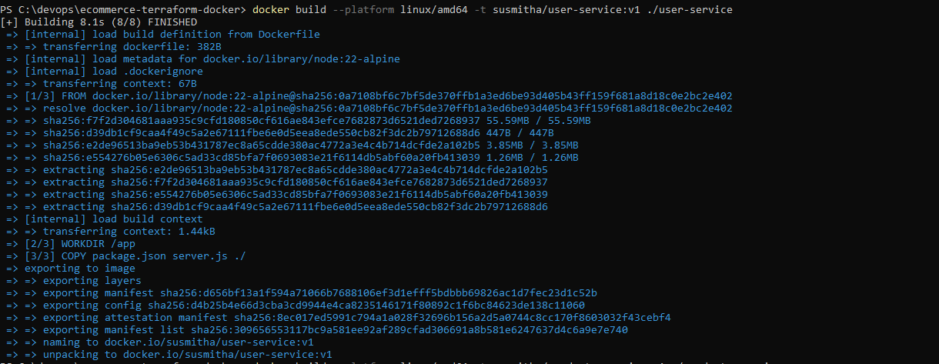
Figure 5: Build of user-service. The first build downloads the node:22-alpine base image and finishes all 8 steps.
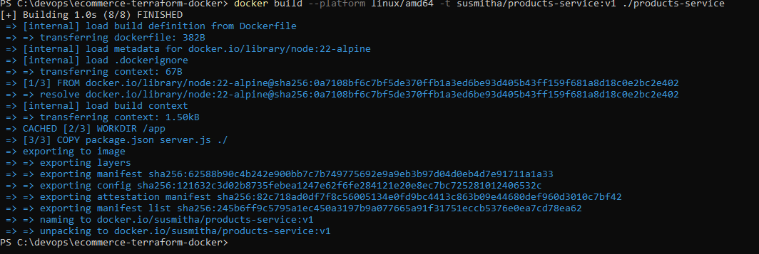
Figure 6: Build of products-service. The base image and the WORKDIR layer come from the build cache (CACHED), so the build takes about one second.
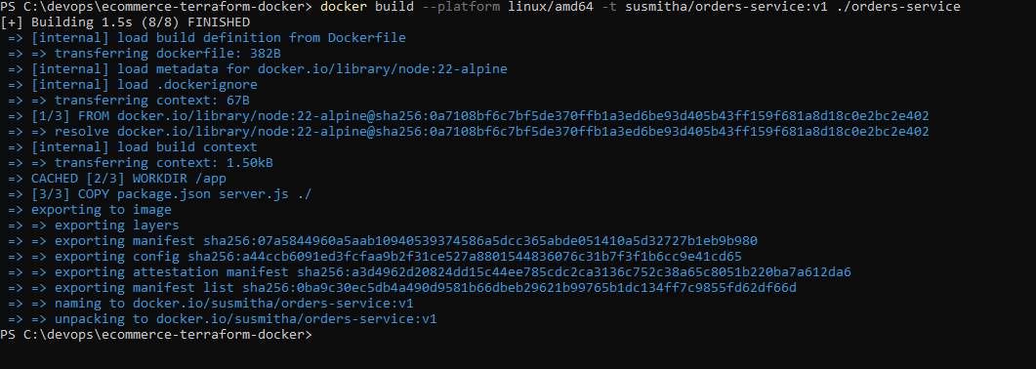
Figure 7: Build of orders-service. Built and tagged susmitha/orders-service:v1.
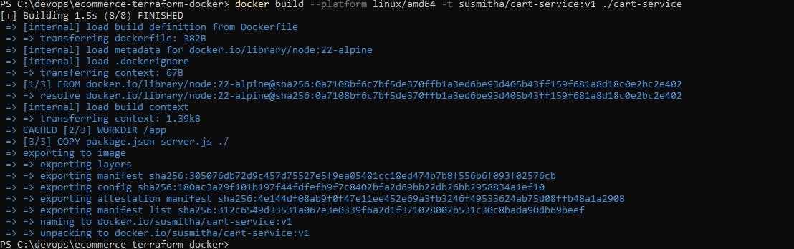
Figure 8: Build of cart-service. Built and tagged susmitha/cart-service:v1.
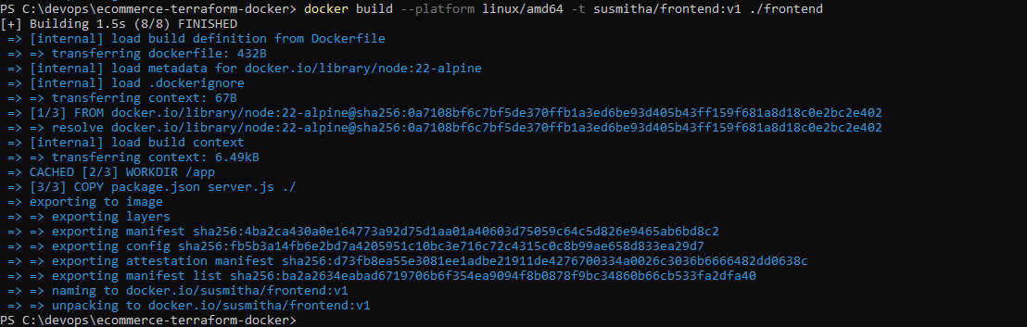
Figure 9: Build of frontend. Built and tagged susmitha/frontend:v1.
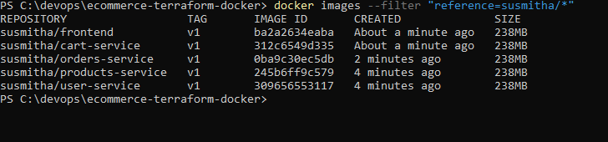
Figure 10: Images available locally. All five images exist locally with tag v1. Note the IMAGE IDs; they appear again in Figure 18.

5.4 Test the containers locally
docker network create ecommerce-net
docker run -d --name user-service --network ecommerce-net -p 3001:3001 susmitha/user-service:v1
docker run -d --name products-service --network ecommerce-net -p 3002:3002 susmitha/products-service:v1
docker run -d --name orders-service --network ecommerce-net -p 3003:3003 susmitha/orders-service:v1
docker run -d --name cart-service --network ecommerce-net -p 3004:3004 susmitha/cart-service:v1
docker run -d --name frontend --network ecommerce-net -p 8080:3000 susmitha/frontend:v1
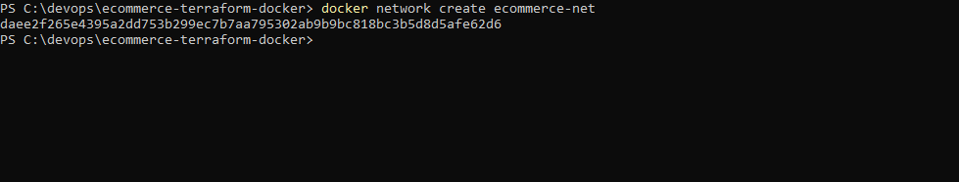
Figure 11: Docker network. A user-defined bridge network, ecommerce-net, lets the containers reach each other by container name.
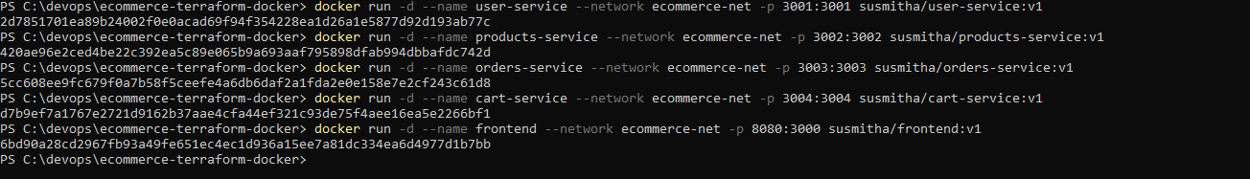
Figure 12: Containers started. The four backends run on ports 3001-3004 and the frontend on local port 8080 (container port 3000), all on ecommerce-net.
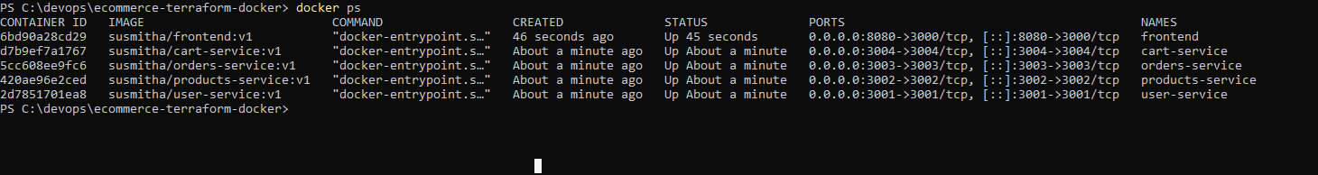
Figure 13: Running containers. docker ps shows all five containers Up with the expected port mappings.
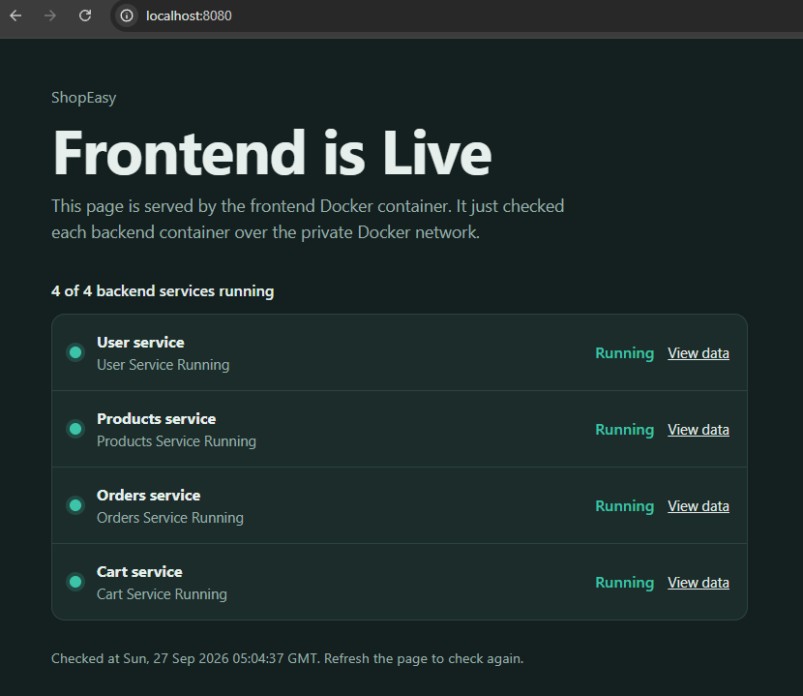
Figure 14: Local test of the frontend. http://localhost:8080 shows "Frontend is Live" and 4 of 4 backend services running, which proves the services communicate over the Docker network.
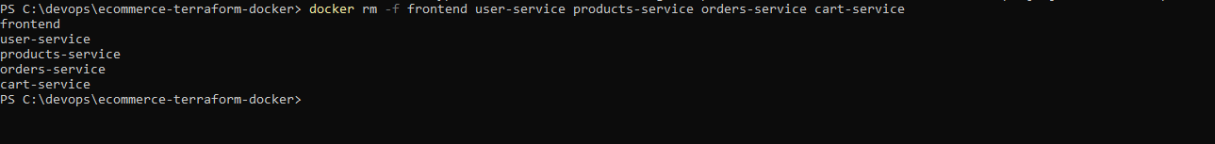
Figure 15: Clean-up after the local test. The test containers are removed; the images remain for pushing.

5.5 Push the images to Docker Hub
Why the image names changed from susmitha/ to sunilstark007/
Docker Hub only accepts an image whose name starts with the namespace of the account that is logged in. The images were first built with the prefix susmitha/ (Figures 5-10), but the Docker Hub account used for this project is sunilstark007, so pushing susmitha/... would be rejected with "access denied".
Instead of rebuilding, each image was given its correct name with docker tag (Figure 17). docker tag only adds a new name to an existing image and does not change its content, so the IMAGE IDs in Figure 18 are exactly the same as in Figure 10 (for example ba2a2634eaba for the frontend).
From this point on every reference uses sunilstark007/<service>:v1: the push, the Docker Hub repositories and dockerhub_username in terraform.tfvars, which the EC2 instance uses to pull the images.

docker login -u sunilstark007 # password = Docker Hub personal access token
docker tag susmitha/user-service:v1 sunilstark007/user-service:v1
(same for products-service, orders-service, cart-service and frontend)
docker push sunilstark007/user-service:v1
(same for the other four images)
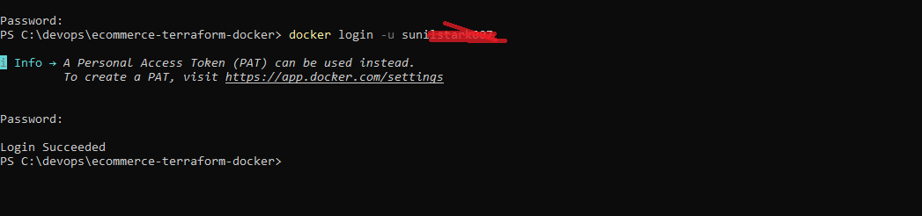
Figure 16: Docker Hub login. Logged in to Docker Hub as sunilstark007 with a personal access token (Login Succeeded).
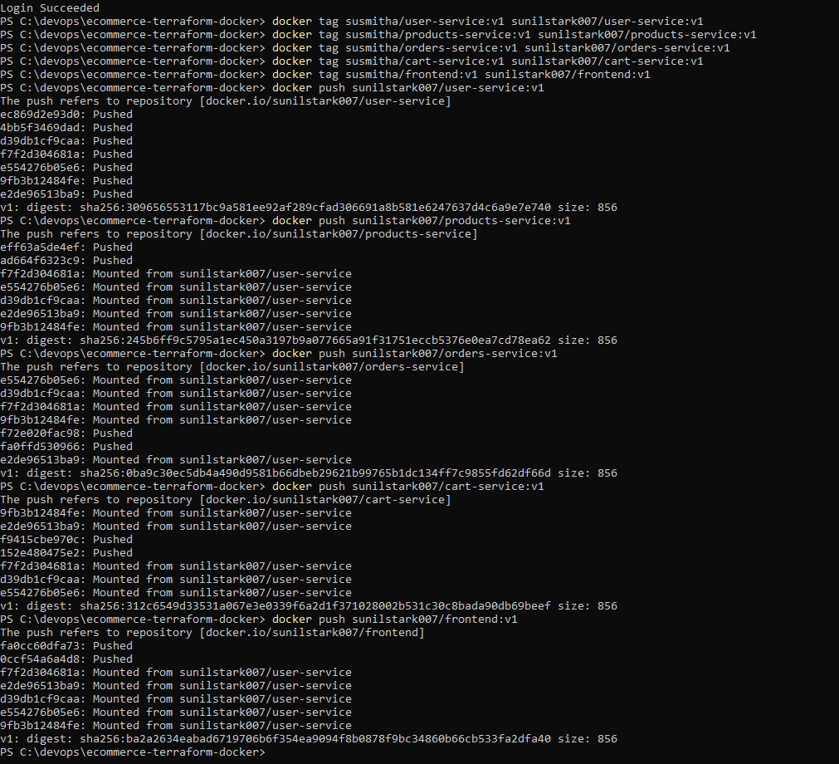
Figure 17: Tag and push. The five images get their Docker Hub names and are pushed. Only the first push uploads the shared Node.js base layers; the later pushes show "Mounted from sunilstark007/user-service" because Docker Hub reuses identical layers.
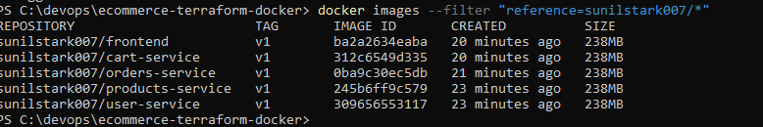
Figure 18: Images under the correct name. The images are now listed as sunilstark007/<service>:v1 with the same IMAGE IDs as Figure 10, confirming they were renamed, not rebuilt.
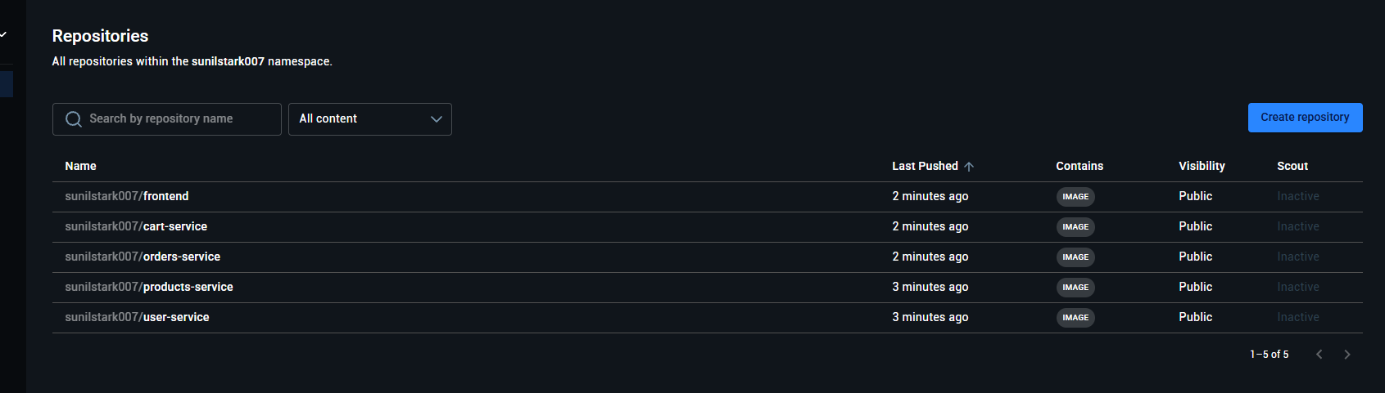
Figure 19: Docker Hub repositories. The five repositories in the sunilstark007 namespace are all Public, so the EC2 instance can pull them without credentials.

5.6 Provision the infrastructure with Terraform
All infrastructure is described in the terraform folder (see Section 4). The EC2 instance receives user_data.sh.tpl as its user-data; Terraform's templatefile() fills in the Docker Hub username (sunilstark007) and the image tag (v1). The most important part of the script:
apt-get update -y && apt-get install -y docker.io # install Docker
systemctl enable --now docker
for svc in user-service products-service orders-service cart-service frontend; do
docker pull "$DOCKERHUB_USER/$svc:$TAG" # pull all 5 images
done
docker network create ecommerce-net
docker run -d --name user-service --network ecommerce-net --restart unless-stopped \
-p 3001:3001 "$DOCKERHUB_USER/user-service:$TAG"
(products-service 3002, orders-service 3003 and cart-service 3004 in the same way)
docker run -d --name frontend --network ecommerce-net --restart unless-stopped \
-p 80:3000 -e USER_SERVICE_URL=http://user-service:3001 ... "$DOCKERHUB_USER/frontend:$TAG"
The script retries apt and docker pull if they fail at first boot, writes everything to /var/log/user-data.log, and uses --restart unless-stopped so the containers come back after a reboot. Commands used:
cd terraform
ssh-keygen -t rsa -b 4096 -f ecommerce-key # key pair for SSH verification
terraform init
terraform validate
terraform plan
terraform apply
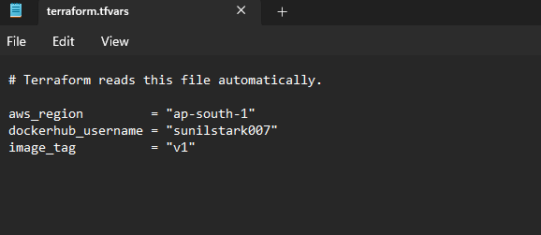
Figure 20: terraform.tfvars. The values used for this deployment: region ap-south-1, Docker Hub username sunilstark007 and image tag v1.
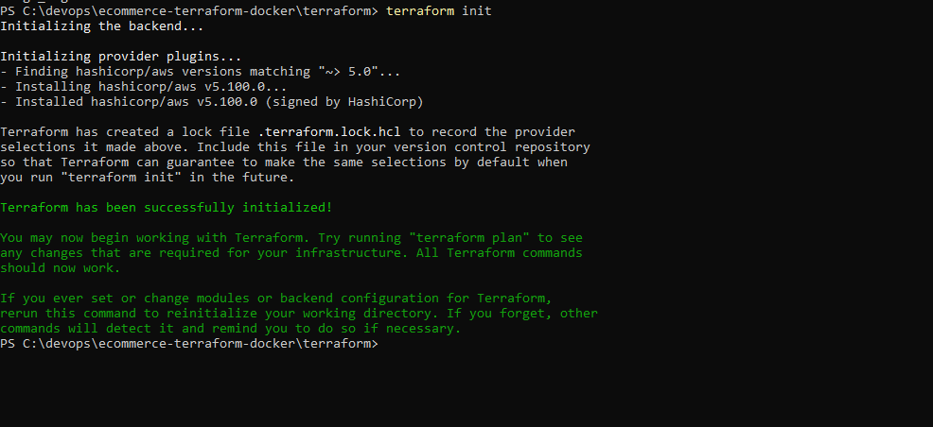
Figure 21: terraform init. Installs the hashicorp/aws provider v5.100.0 and creates the dependency lock file.
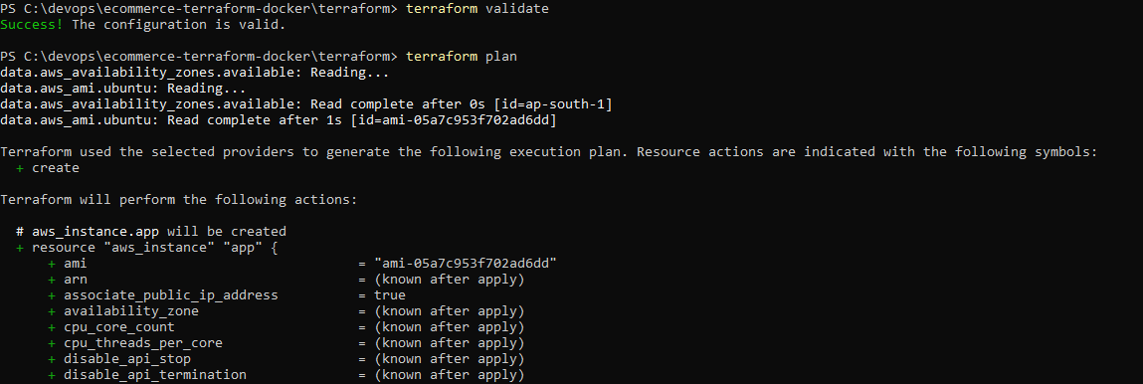
Figure 22: terraform validate and plan. The configuration is valid. The plan looks up the availability zones and the latest Canonical Ubuntu 22.04 AMI (ami-05a7c953f702ad6dd) before listing the resources to create.
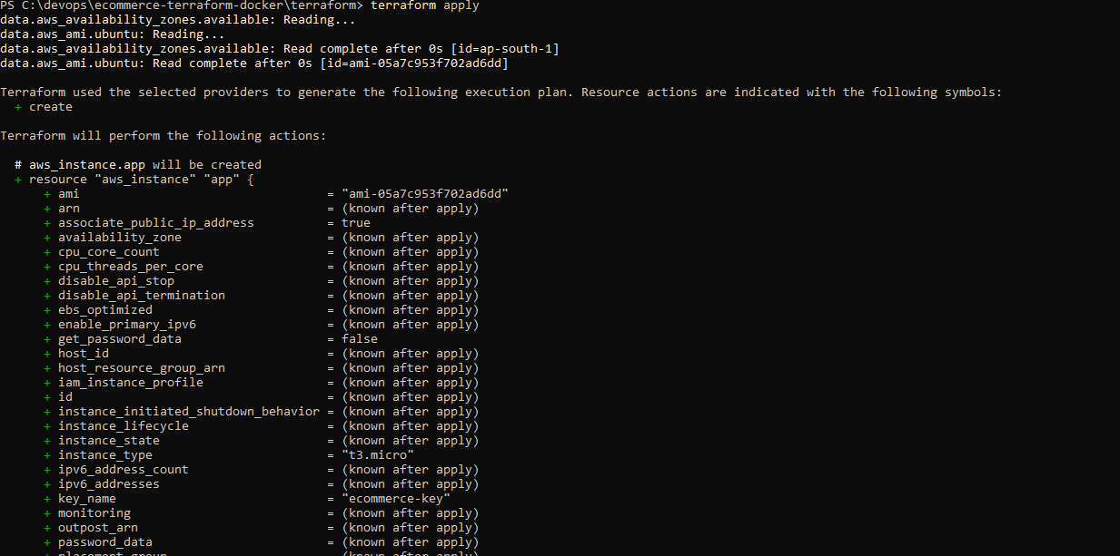
Figure 23: terraform apply (plan). Before confirmation, apply shows the EC2 instance that will be created: t3.micro, key pair ecommerce-key and a public IP address.
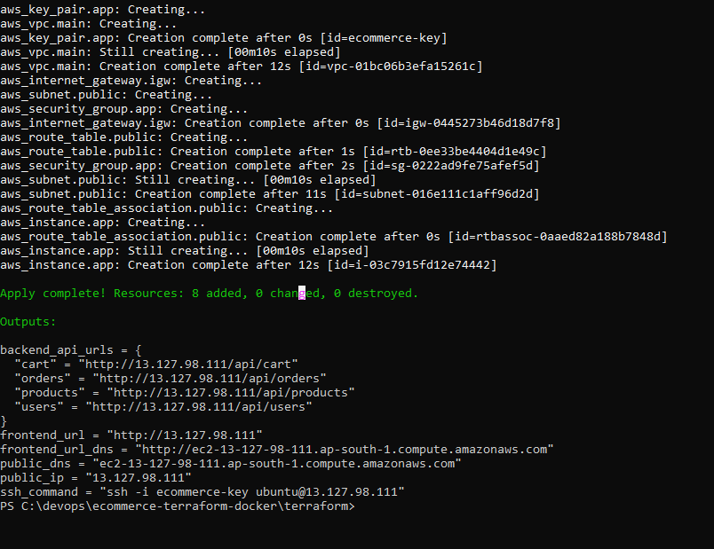
Figure 24: terraform apply complete with outputs. 8 resources added. The outputs print the public IP (13.127.98.111), the public DNS name, the frontend URL, the backend API URLs and the SSH command.

5.7 Verify the deployment
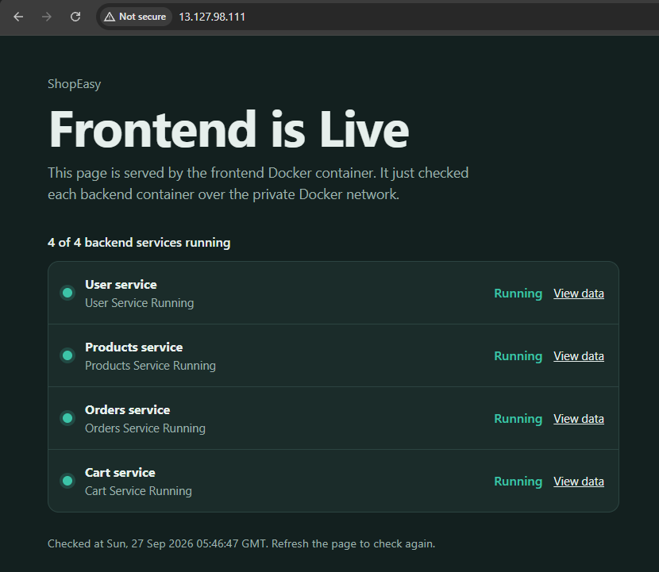
Figure 25: Frontend live on EC2. http://13.127.98.111 is served from the EC2 instance and shows "Frontend is Live" with all 4 backend services running.
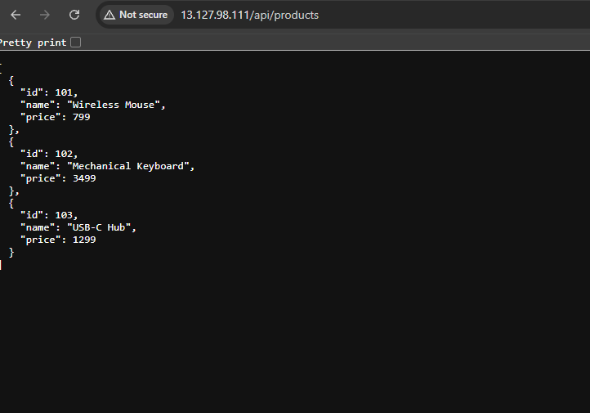
Figure 26: Backend API response. http://13.127.98.111/api/products returns the products data, which the frontend fetches from the products-service container.
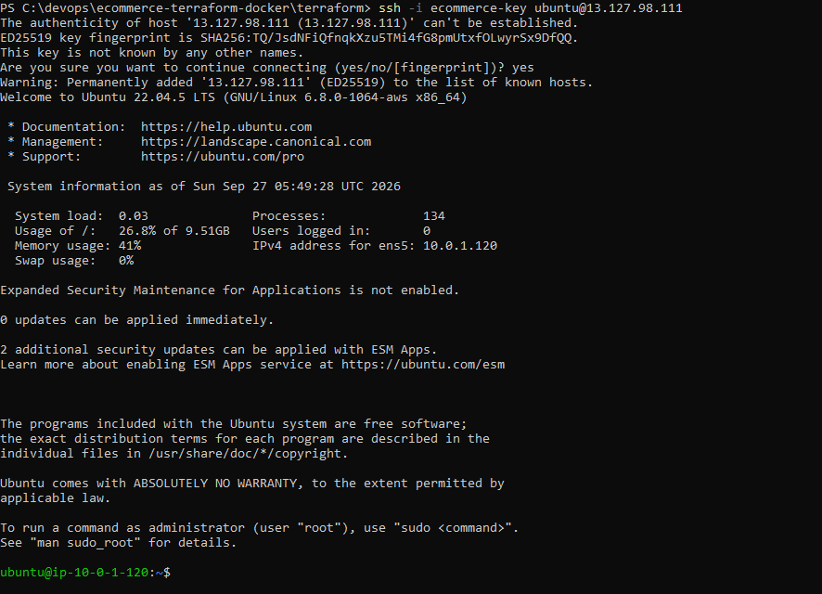
Figure 27: SSH login to the instance. Logged in with the generated key. The instance runs Ubuntu 22.04.5 LTS and has the private IP 10.0.1.120 inside the public subnet.
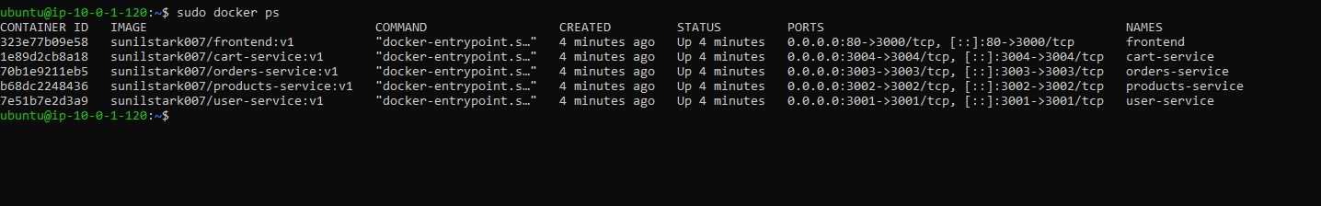
Figure 28: Containers running on EC2. sudo docker ps: the five containers pulled from sunilstark007 are Up, with the frontend on port 80 and the backends on 3001-3004.
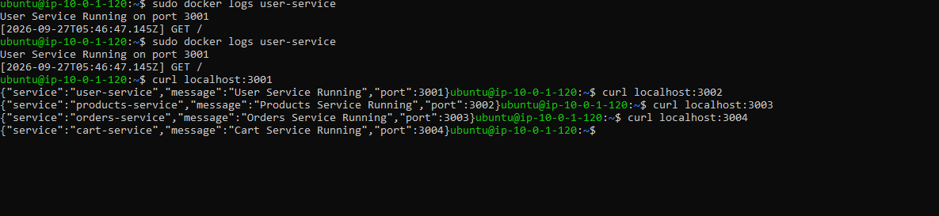
Figure 29: Backend logs and responses. The user-service log shows "User Service Running on port 3001", and curl to ports 3001-3004 returns each service's sample response.

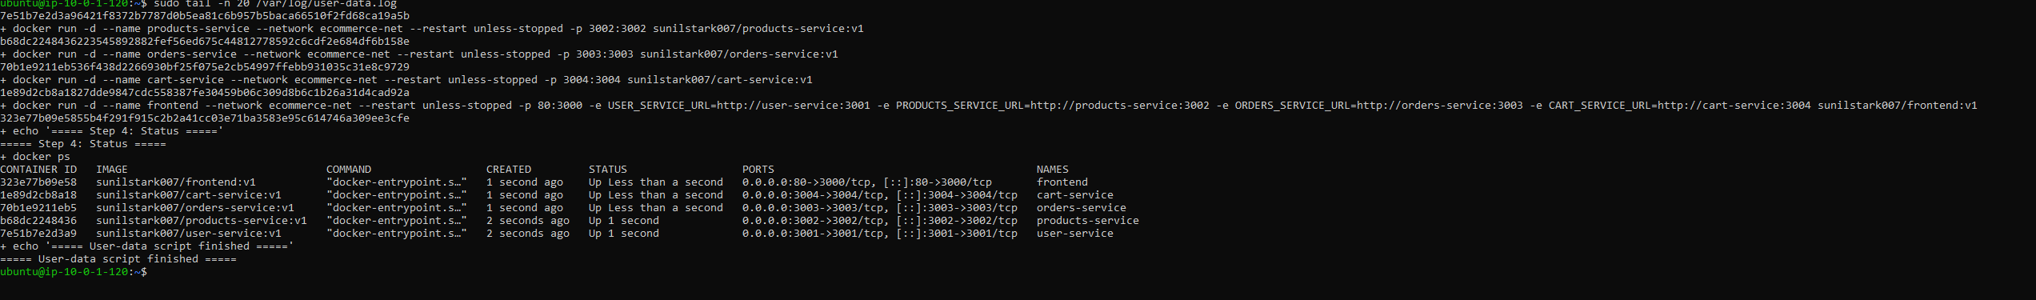
Figure 30: User-data log. The end of /var/log/user-data.log on the instance. The boot script ran docker run for all five containers, docker ps shows them Up on ports 80 and 3001-3004, and the log ends with "User-data script finished". This proves the containers were deployed by user-data without any manual step.

5.8 AWS console
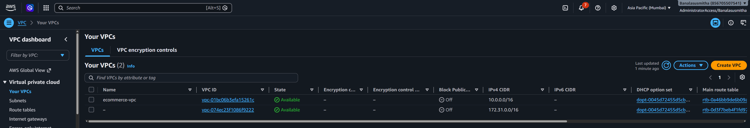
Figure 31: VPC. ecommerce-vpc (10.0.0.0/16) created by Terraform in Asia Pacific (Mumbai). The unnamed 172.31.0.0/16 VPC is the account's default VPC and is not used.
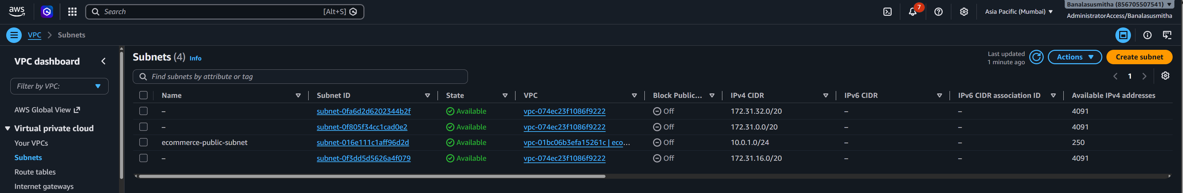
Figure 32: Subnet. ecommerce-public-subnet (10.0.1.0/24) belongs to ecommerce-vpc. The 172.31.x.x subnets belong to the default VPC.
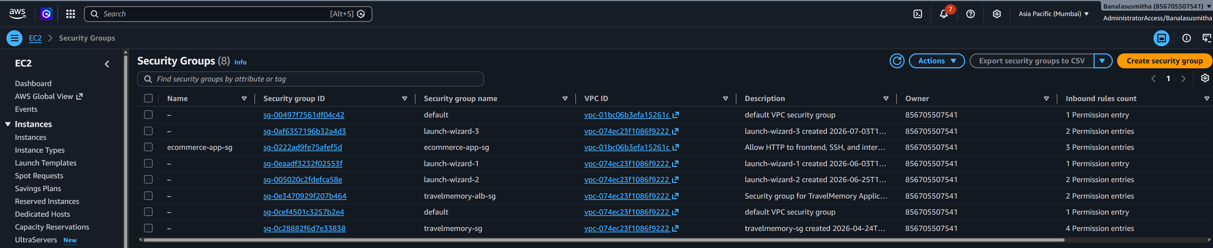
Figure 33: Security groups. ecommerce-app-sg is attached to ecommerce-vpc and has 3 inbound rules. The other groups come from earlier work in this account and are not related to this project.

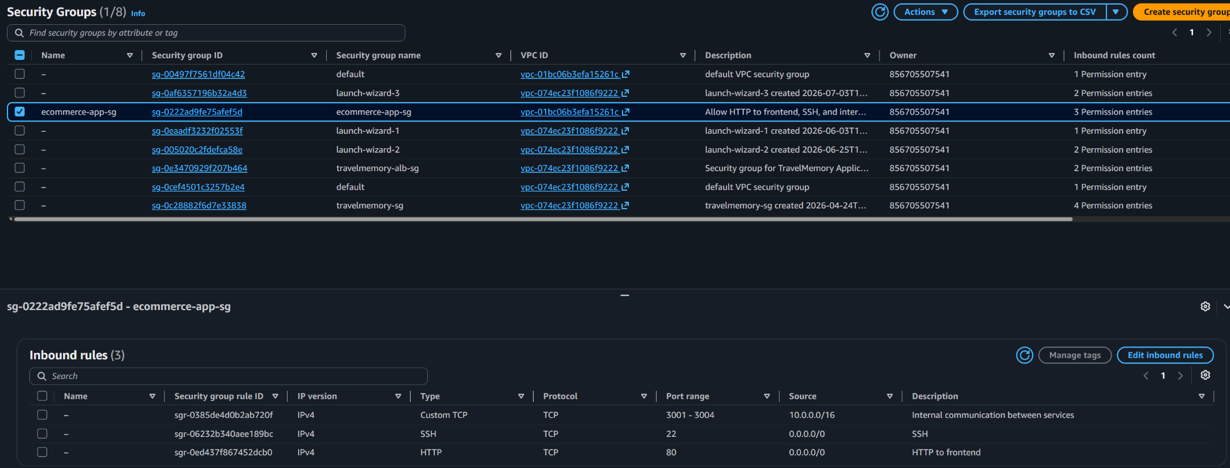
Figure 34: Security group inbound rules. The three inbound rules of ecommerce-app-sg created by Terraform: HTTP 80 from 0.0.0.0/0 for the frontend, TCP 3001-3004 from 10.0.0.0/16 for internal communication between services, and SSH 22 from 0.0.0.0/0 for verification.
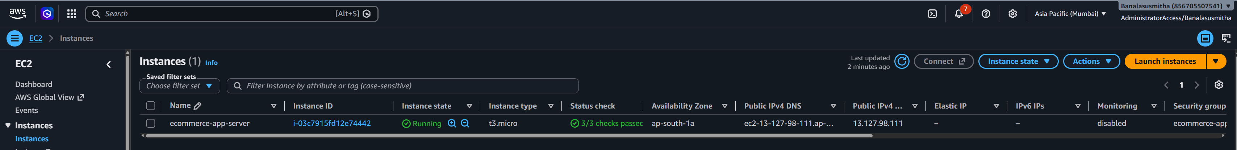
Figure 35: EC2 instance. ecommerce-app-server is Running as t3.micro in ap-south-1a with public IP 13.127.98.111 and 3/3 status checks passed.

5.9 Clean-up
After all evidence was collected, every resource was removed so that nothing keeps running in the AWS account:
terraform destroy

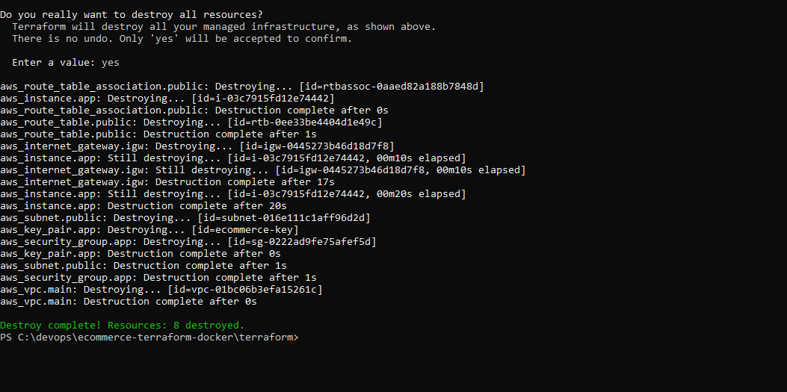
Figure 36: terraform destroy. All 8 resources are removed (Destroy complete! Resources: 8 destroyed.).

6. Requirements checklist
Requirement (from the assignment) | How it was met | Evidence
Application setup
Dockerfile for each of the 5 services | One Dockerfile per service folder, based on node:22-alpine | Section 5.2, Fig. 5-9
Each service exposes a port and returns a sample response | Ports 3000-3004; each returns "<Name> Service Running" | Fig. 14, 29
Build and test the images locally | docker build, then all 5 run together on ecommerce-net | Fig. 5-15
Tag and push the images to Docker Hub | docker tag and docker push to sunilstark007 | Fig. 16-19
Infrastructure with Terraform
VPC with at least one public subnet | ecommerce-vpc with ecommerce-public-subnet routed to an internet gateway | Fig. 24, 31, 32
1 or more EC2 instances | ecommerce-app-server (t3.micro, Ubuntu 22.04) | Fig. 24, 35
Security group: inbound HTTP 80 to the frontend | Rule TCP 80 from 0.0.0.0/0 | Fig. 33, 34
Security group: internal traffic on 3001-3004 | Rule TCP 3001-3004 from the VPC CIDR 10.0.0.0/16 | Fig. 33, 34
User-data installs Docker on EC2 | apt-get install docker.io in user_data.sh.tpl | Section 5.6, Fig. 28, 30
User-data pulls all 5 images from Docker Hub | docker pull loop over the 5 images | Fig. 28, 30
User-data runs the containers on proper ports | 80->3000 for the frontend, 3001-3004 for the backends | Fig. 28
Deployment and accessibility
Frontend publicly accessible with a "Frontend is Live" page | http://13.127.98.111 | Fig. 25
Verify the backend containers are running | docker ps, container logs, curl and /api/products | Fig. 26, 28, 29
Terraform output prints the public IP or DNS | Outputs public_ip, public_dns and frontend_url | Fig. 24
Assumptions and constraints
Ubuntu EC2 AMI | Latest Canonical Ubuntu 22.04 LTS, found with a data source | Fig. 22, 27
Images hosted on Docker Hub (public) | 5 public repositories | Fig. 19
Reproducible with terraform apply | All infrastructure and configuration in code; settings in terraform.tfvars; no manual changes in the console | Section 5.6

7. Evaluation criteria coverage
Component | Marks | Where it is covered
VPC, subnet and security group setup | 10 | network.tf, security_group.tf; Fig. 31-34
EC2 provisioning with Docker setup | 10 | ec2.tf, user_data.sh.tpl; Fig. 24, 27, 28, 30
Docker container deployment via user-data | 10 | user_data.sh.tpl; Fig. 28, 29
Public access to the frontend | 10 | frontend_url output (Fig. 24); Fig. 25, 26
Documentation | 10 | This document, README.md, architecture diagram, GitHub repository

8. Issues faced and how they were solved
Issue | Cause | Solution
docker run hello-world failed with "error during connect ... dockerDesktopLinuxEngine" | The Docker Desktop engine was not started | Opened Docker Desktop and waited for "Engine running"
terraform was "not recognized" right after installing it | The PATH change only applies to new PowerShell windows | Opened a new PowerShell window
aws sts get-caller-identity: SSO token expired | The IAM Identity Center session had expired | Logged in again with aws sso login
Images named susmitha/... could not be pushed | The image namespace must match the Docker Hub account (sunilstark007) | Renamed the images with docker tag (Section 5.5)
git push: "Repository not found" | The GitHub repository was not yet available for the pushing account | Created the repository under banalasusmitha and pushed again

9. Conclusion
All five services were containerised, tested locally and published on Docker Hub. Terraform provisioned the VPC, public subnet, internet gateway, route table, security group, key pair and EC2 instance with one command, and the user-data script turned the new instance into a Docker host running all five containers without any manual steps. The frontend was publicly reachable, the backends responded over the private Docker network, and Terraform printed the public IP and DNS name. The infrastructure is removed with terraform destroy and can be recreated at any time with terraform apply.

