NIGERIAN HISTORY: The Forgotten Gods of Igbo Culture

Isaac Ogbodo
Nov 29, 2019 · 4 min read

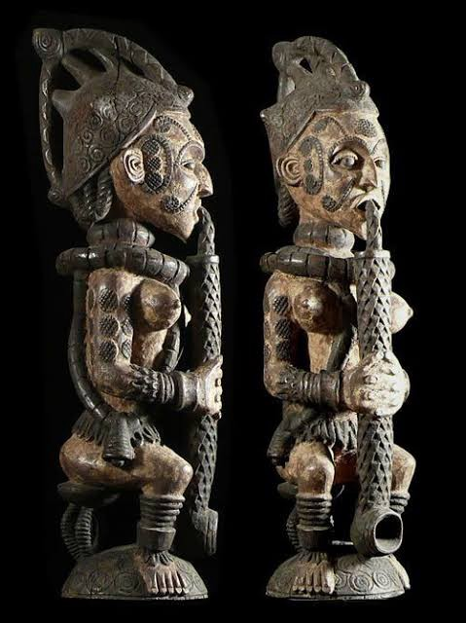
There are more than a 100 gods, both small and big, in Igbo Culture but for some reason, most people don’t know anything about them, except probably for one.
Personally, I think colonialism and the entrance of Christianity, is to blame, because they made us forget our roots as Africans. But that’s a narrative we must work hard to change.
Out of the over 100 gods we have, i will be talking about the 9 strongest and most popular Igbo gods (Alusi)

1) Ala:

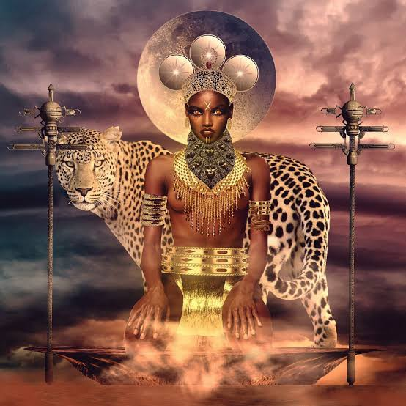
..also known as ani, ana, eli, ale etc in numerous dialects, is a female god that represents the earth, fertility, creativity and morality. She is the most respected god in Igbo land.
She is considered the wife of Amadioha, the sky god and commands authority in Igbo land. The symbol of ala is a python & crescent moon

2) Amadioha:

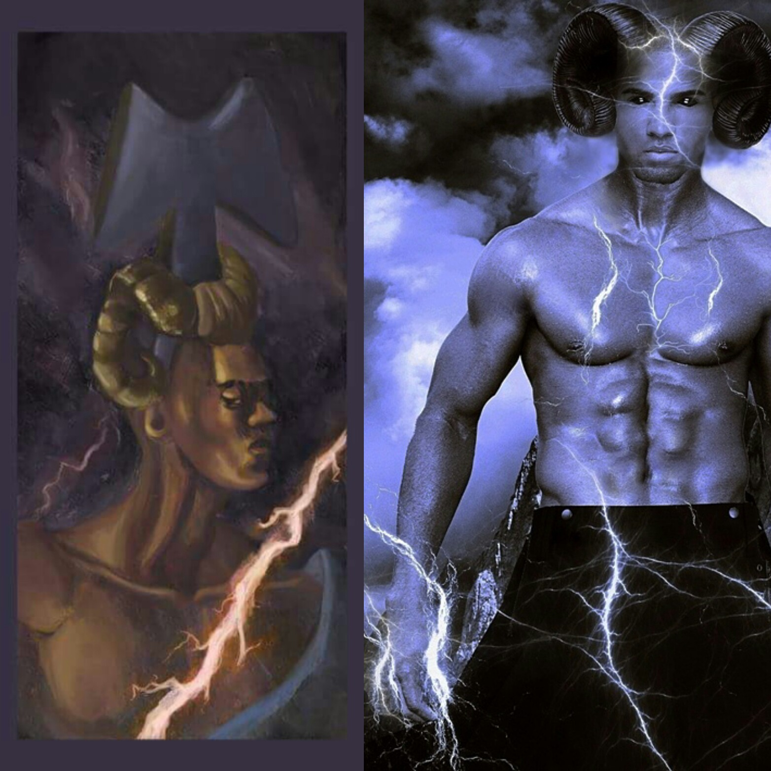
This is the most popular god in Igboland, and he is the god of thunder & lightening. He is the strongest of all.
He is a considered a gentle man among the deities and the cruelest when annoyed.
Amadioha represents the collective will of the people. He is represented by a white ram and his color is red. He is still one of the most feared gods in Igbo land till this day.
His shrine can be found in rivers state, Nigeria.

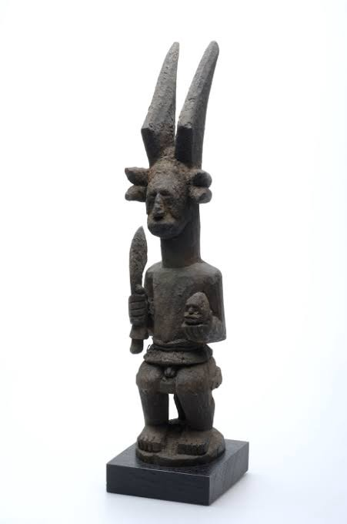
3) Ikenga:

This is the god of strength and war as it’s name literally means "place of strength". It is a horned deity and is one of the most powerful and respected gods in Igboland.
The Ikenga can be given as a title to men of good reputation, wealth and integrity.

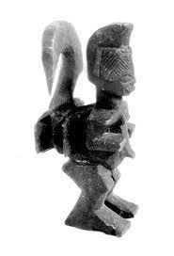
4) Agwu Nsi:

This is the god of health and divination. This god is one of the basic theological concepts, used in explaining good and bad, health and sickness, poverty and wealth in Igbo land.
Belief in the deity was widespread with most villages having some agwu priests, who also doubled as physicians in the land.

5) Igwekala:
This is the name of a popular god, which visited every 4 years as a masquerade around the December period.
It is a feared and respected deity in Igbo land, as no one can come close to it once it enters the community.
It's shrine can be found in Umunoha, a town in Imo state near the city of owerri.

6) Anyanwu:

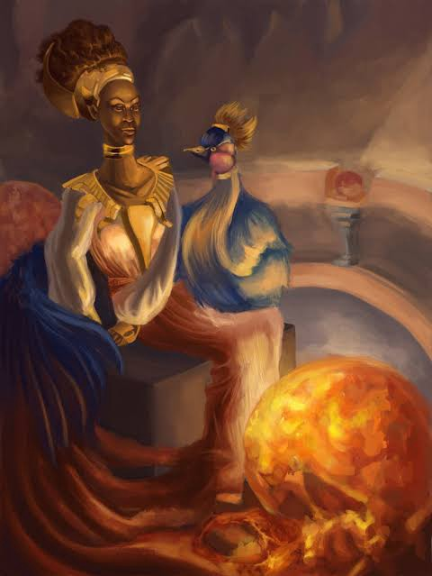
This is the goddess of the sun. As is done in almost all ancient religions and traditions, there is always a deity in respect of the sun.
It is revered as the goddess that promotes productivity, hard work and the overall positive well being of the people
The Igbo kept this deity in high esteem, that’s why a lot of households took the name to be their surname.

7) Njoku Ji

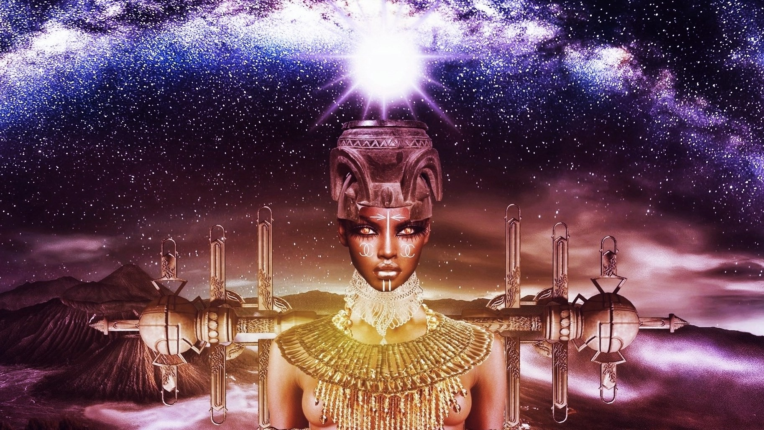
This is the guardian deity of yam in igboland. (Yes, yams 😂)
In many parts of Igbo land, rituals were made in honor of the goddess of yams, also known as ifejioku.
She is prayed to, for productivity during the farming season.
Children who were dedicated to this goddess were called Njoku, and were expected to be prosperous in life

8) Idemmili:

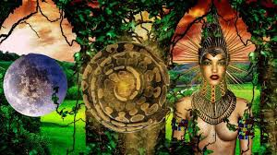
The goddess of the ocean & the seas. It is believed to have found the idemmili community in Anambra state.
It’s shrine can be found in that community and is one of the oldest shrines in igbo land
It is a secret shine & the worship of pythons (eke) goes on there. Hence the killing of pythons in that area is forbidden.

9) Ogbunabali:

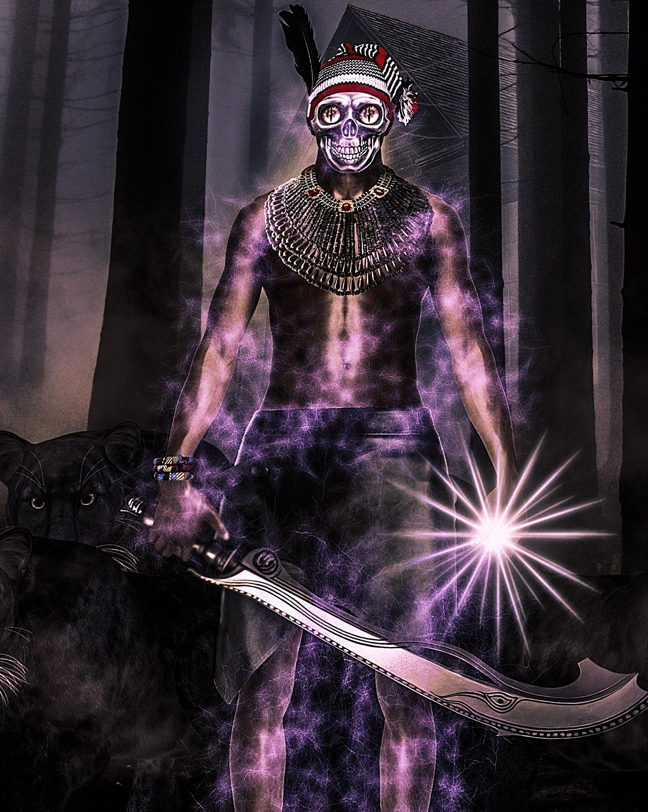
I don't think this list will be complete without a god of death.
Literally meaning "the one that kills at night" he is known as the death deity.
His victims are said to be criminals and those who have committed abominations in the land, and he is known to kill violently.

There is more information on their rituals, mode of participation and rules guiding each of these gods that we can’t talk about.
By the way, we Africans need to embrace our cultures even if we can’t practice them. We should learn our history, so we can tell it without adulteration to the world and to new generations to come.

