Operating System Design & Implementation

Lab 13: File system disk structures(FAT)

TA: 周昆霖、吳崧銘

Contributor：顏明祺

Objective:

In this Lab, you can learn

* How to manually parse file system metadata, including boot sector, root directory, and FAT tables.
* How to manually add a new file using disk editor.
* How to recover a deleted file using disk editor.

Experiment:

* 13-1 Setting up experiment environment
* 13-2 Adding a new file using LDE.
* 13-3 Recovering a deleted file using LDE.

Experiment:

**Exp. 13-1** Setting up experiment environment

13-1-1 What is a disk editor?

A disk editor tool enables direct access to disk sectors, bypassing file systems. This lab uses Linux Disk Editor (LDE) as an example, but you can use any hex editor whatever you like it. For example, bless or wxHexEdit are good alternatives.

13-1-2 Install Linux Disk Editor using yum in fedora 14

Step1: Switch to the supervisor mode

Step2: type “**yum update lde**”

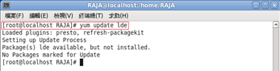

Step3: type “**yum install lde**”

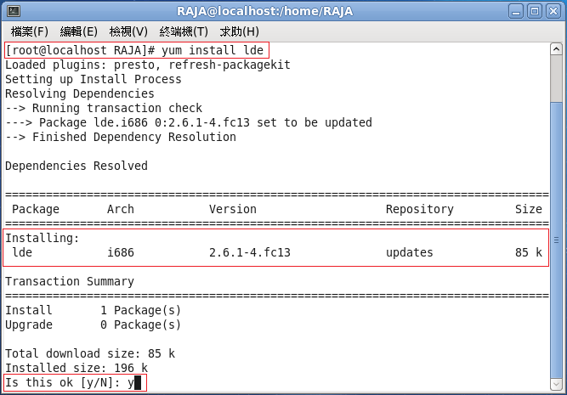

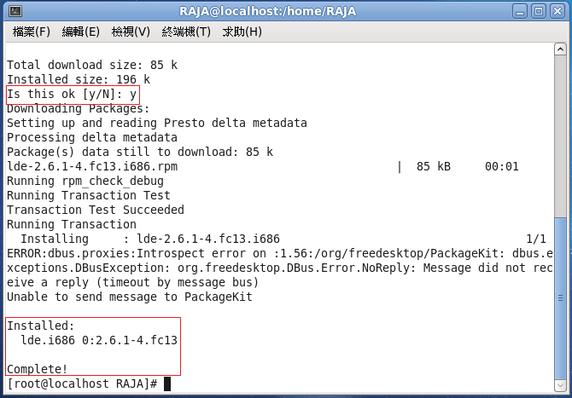

13-1-3 Add a new virtual disk to your virtual machine

Note: Set the virtual disk size to 1 GB so that it can be formatted in FAT-16

13-1-4 Check your disk is added to your fedora, and then partition and format it in FAT16

Step1: Using **ls /dev/sdb** to check whether the virtual disk is successfully added.

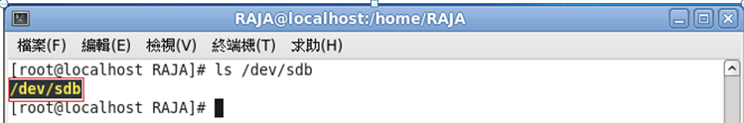

Step2: Create a primary partition in the new virtual disk (i.e.,

/dev/sdb1)

Step2.1: Launch the fdisk command to partition /dev/sdb

behavior

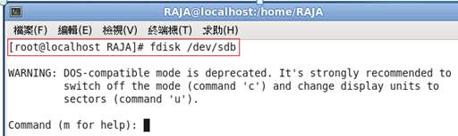

Note: Select the primary partition type as your

Partition type of sdb1

Step2.2: Using ls /dev/sdb* to check whether the partition is

successful

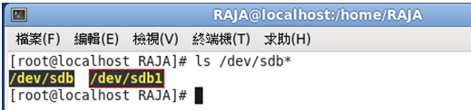

Step2.3: Format the /dev/sdb1 in FAT16 format

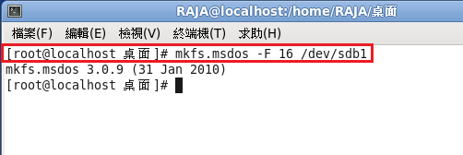

Step3: Mount the /dev/sdb1

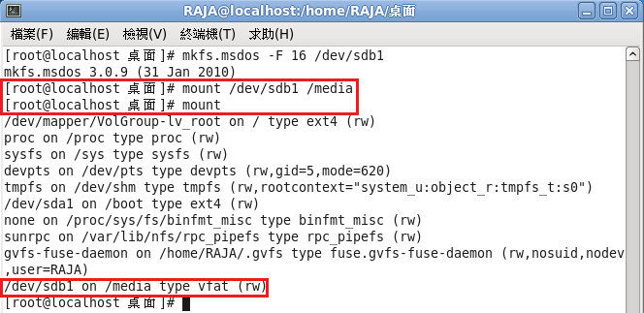

**Exp 13-2** Adding a new file using LDE

13-2-1: Open the new partition /dev/sdb1 with LDE

Step1: Launch LDE with the following command

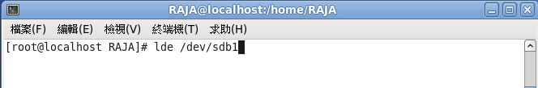

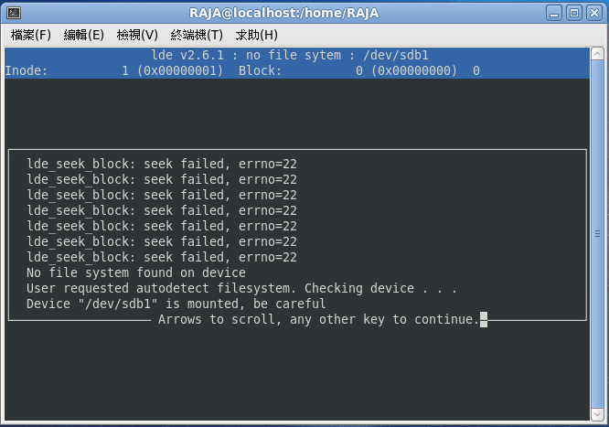

Step2: And then Press F → Press F → Press A → Press F

→ Press W → Press Q → Press B

Step3: You will see the following screen if the partition is successfully

opened

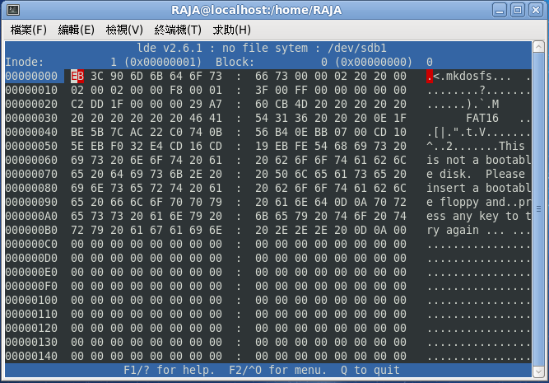

Note：This is the first sector (logical disk block #0), the boot sector of FAT.

13-2-2: Manually add a new file. Before this, you need to check the

lecture notes for the FAT format. The following link is also useful:

<http://cs.nyu.edu/~gottlieb/courses/os/kholodov-fat.html#F01_0010_overview>

Note：We shall first begin with parsing the boot sector. It contains the size of various FAT disk areas.

FAT disk layout：

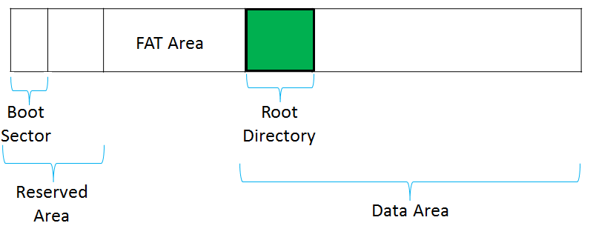

Note: (1) Boot sector is the first sector in the reserved area

(2) Root directory is in the beginning of the data area

Step1: Find the reserved area size.

Step2: Find out the FAT size and # of FAT copies.

Step3: The data area begins right after the FAT area. The root

Directory is in the beginning of the data area.

Step4: Insert a record for your new file in the root directory. Let's assume your file is not larger than 1 cluster. Let the file name be “MYHELLOW.TXT”

Step5: (1) Get a free cluster from the FAT, ground the free cluster, and

have your new directory record point to the free cluster.

(2) Close LDE and mount the partition. Now you

should see the new file via the file system driver.

Note：Your file system must pass the integrity check “fsck.vfat –n /dev/sdb1”. I.e., the check must not report any file system errors.

**Exp 13-3** Recovering a deleted file using LDE.

In this experiment, we’ll un-delete a file that was deleted from the disk. A deleted file can be recovered because the file system will not erase the file from the disk. Instead, it marks the directory record of the file as "deleted", and marks the file’s clusters free in FATs.

Step1: While your partition is still mounted, delete your newly

created file by "rm -r MYHELLOW.txt".

Step2: Unmount sbd1, and open it with LDE.

Step3: (1) Un-delete the directory entry (in root dir) of the deleted file.

(2) Salvage the cluster of the deleted file, and connect the

cluster to the directory entry that you just un-deleted.

Step4: Close LDE and re-mount sbd1 again. You should see the deleted file appears again!

Note：Your file system must pass the integrity check “fsck.vfat –n /dev/sdb1”. I.e., the check must not report any file system errors.