Design of a Switched-Capacitor Amplifier
H05E4a DAMSIC Project 2025
Part I: Parameter derivation, Ideal
Students: Sam Buydens, Efe Ali Akkaya
Group ID: 5

General Information and Summary
Parameter | Unit | Specification
Sampling Frequency | MHz | 60
SNR | dB | 45
Static Gain Error | % | 0.06
Dynamic Settling Error | % | 2.8
Phase Margin (Min.) | deg | 60
CL | pF | 2
Min. Input Swing | mVpp | 50
Max. Input Swing | mVpp | 100
Closed-Loop Gain | V/V | 10
Input Pair | - | pMOS

Given Target Specifications

Derivation of System Design Parameters

Ideal OTA

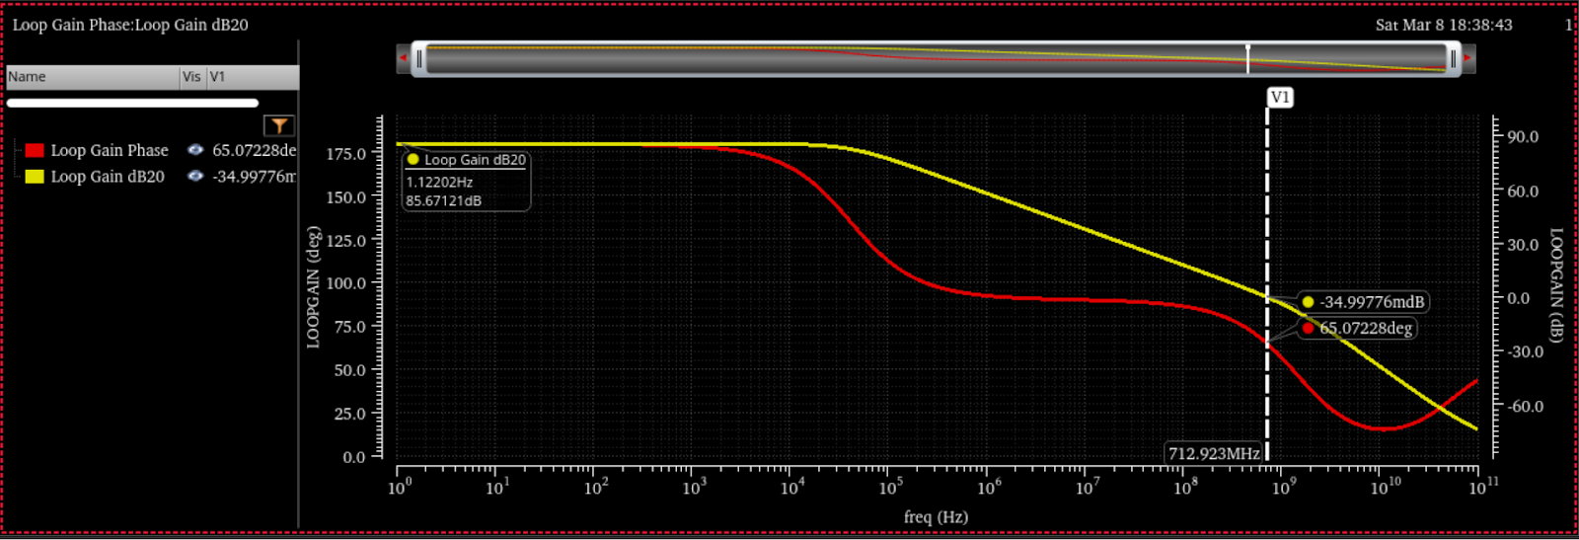
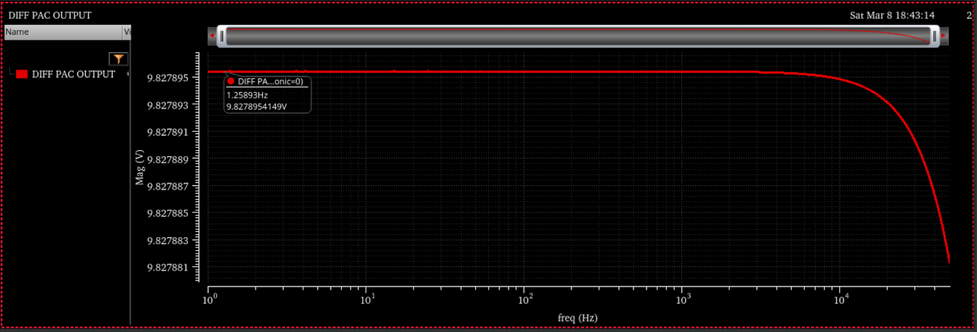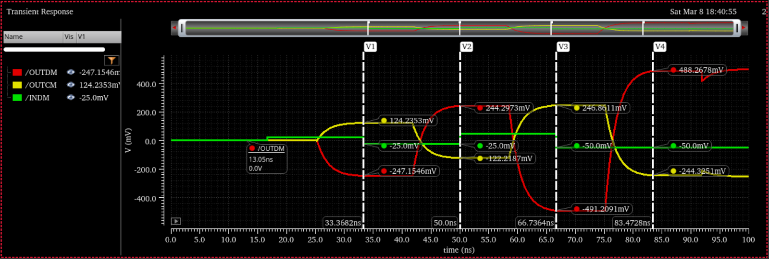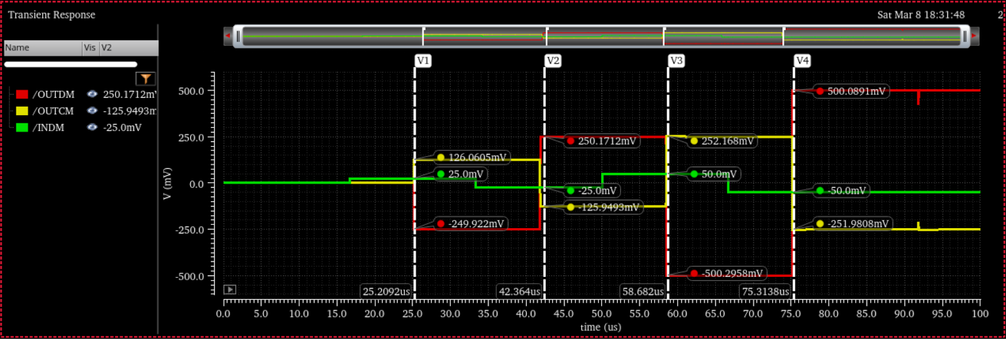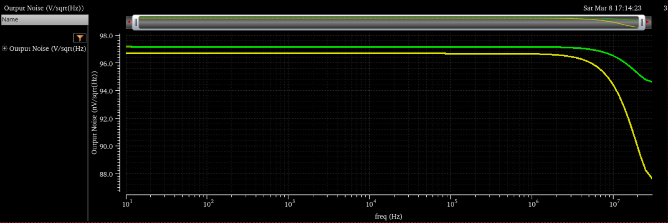

Design of a Switched-Capacitor Amplifier
H05E4a DAMSIC Project 2025
Part II: Symmetrical OTA
Students: Sam Buydens, Efe Ali Akkaya
Group ID: 5

Symmetrical OTA

Table of Achieved Results (So Far)
Enter your achieved results in the below table. You can leave some fields blank if you did not simulate (or design) for the specific parameter yet.
Parameter | Unit | Achieved
Input Swing | mVpp | 118.37
Output Swing | mVpp | 164.2
Total Integrated Output Noise | mVrms | 1.57
SNR | dB | 41
CL | pF | 2
CFB | pF | 0.23
CIN | pF | 2.3025
Open-Loop Gain | dB | 35
Closed-Loop Gain | V/V | 8.35
GBW (Sample Phase) | MHz | 2384
Phase Margin (Sample Phase) | deg | 65.6
Dynamic Settling Error | % | 20.2
Static Gain Error | % | 16.5
Power dissipation | mW | 10.19

Schematic Design
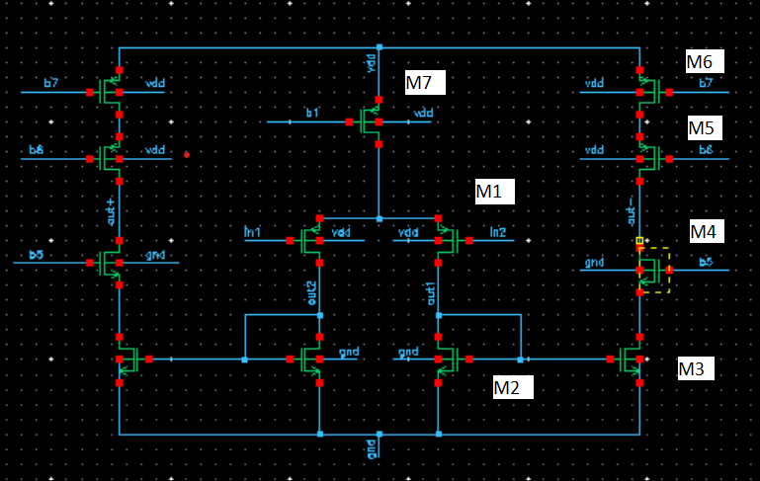
transistor | W (um) | L (nm) | Gm (mS) | VGS | VDS
M1 | 96 | 90 | 13.1 | 0.48 | 0.58
M2 | 27 | 90 | 10.8 | 0.44 | 0.44
M3 | 193.5 | 90 | 46.5 | 0.44 | 0.36
M4 | 60.5 | 90 | 26.9 | 0.64 | 0.19
M5 | 102.5 | 90 | 27.8 | 0.61 | 0.26
M6 | 77.5 | 90 | 23.5 | 0.477 | 0.29
M7 | 480 | 90 | 28 | 0.4 | 0.08
Current M1 (mA) | 0.85 | Current M2 (mA) | 3.59

Simulation Results
Open loop AC simulation:
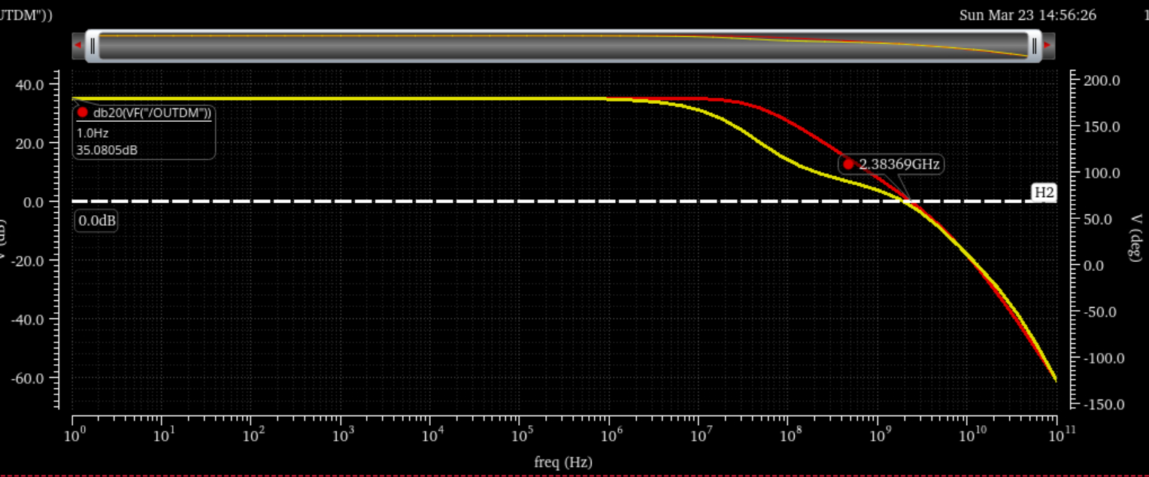
Closed loop AC simulation:
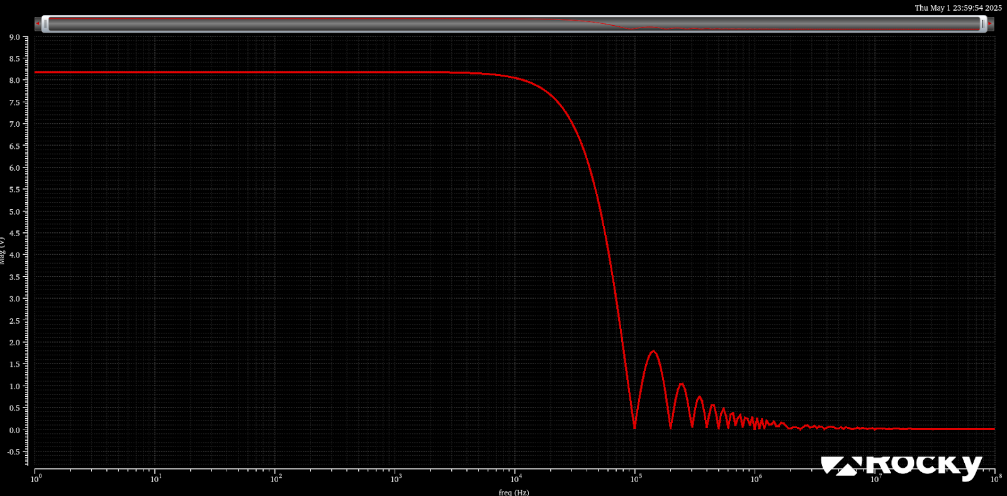

Closed loop transient (60 MHz):
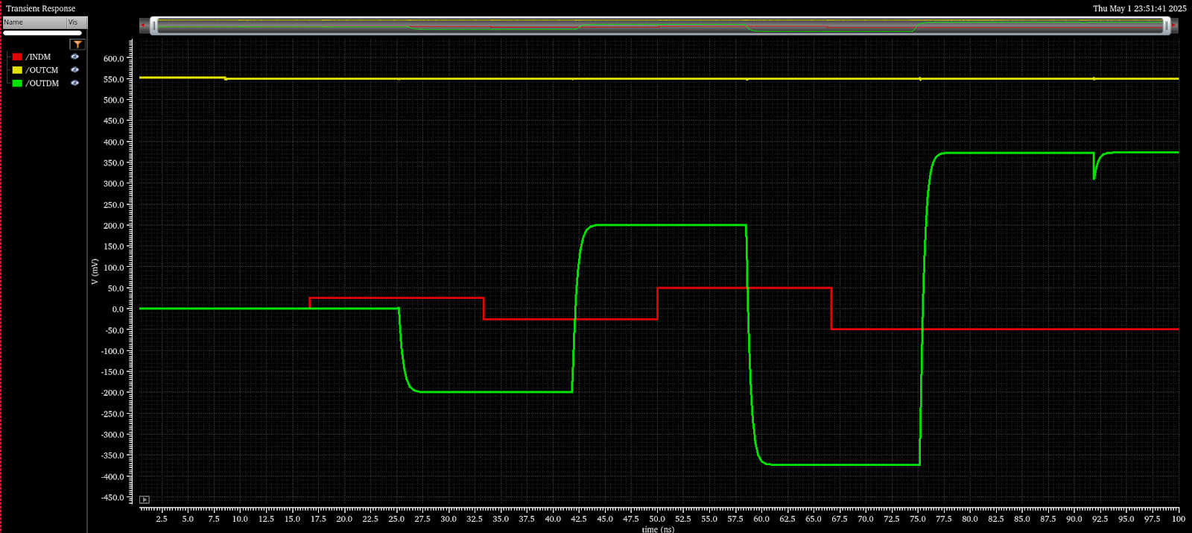
Dynamic error (60kHz):
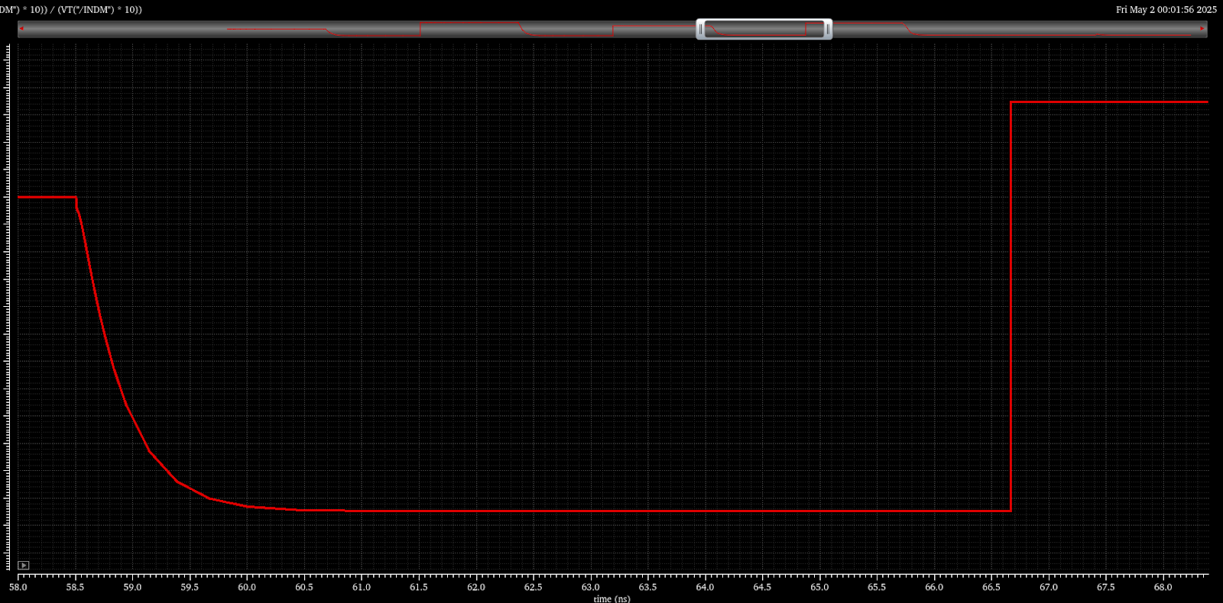
Closed loop transient (60 kHz):
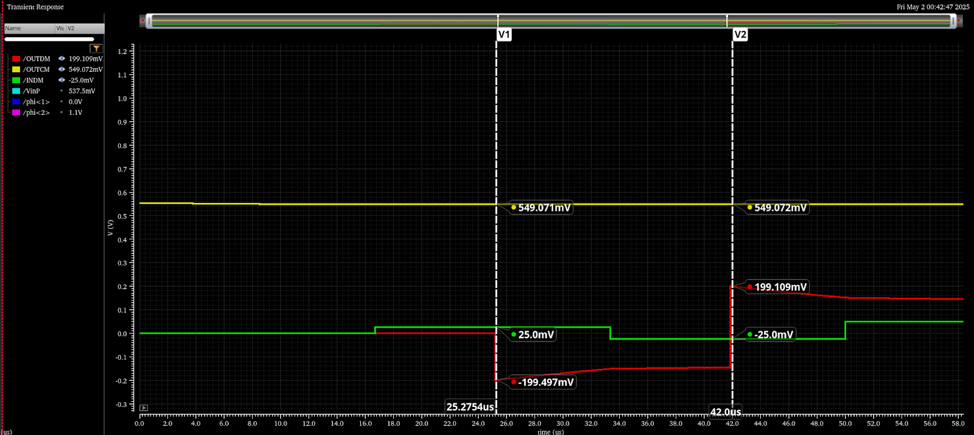

Dynamic error (60kHz):
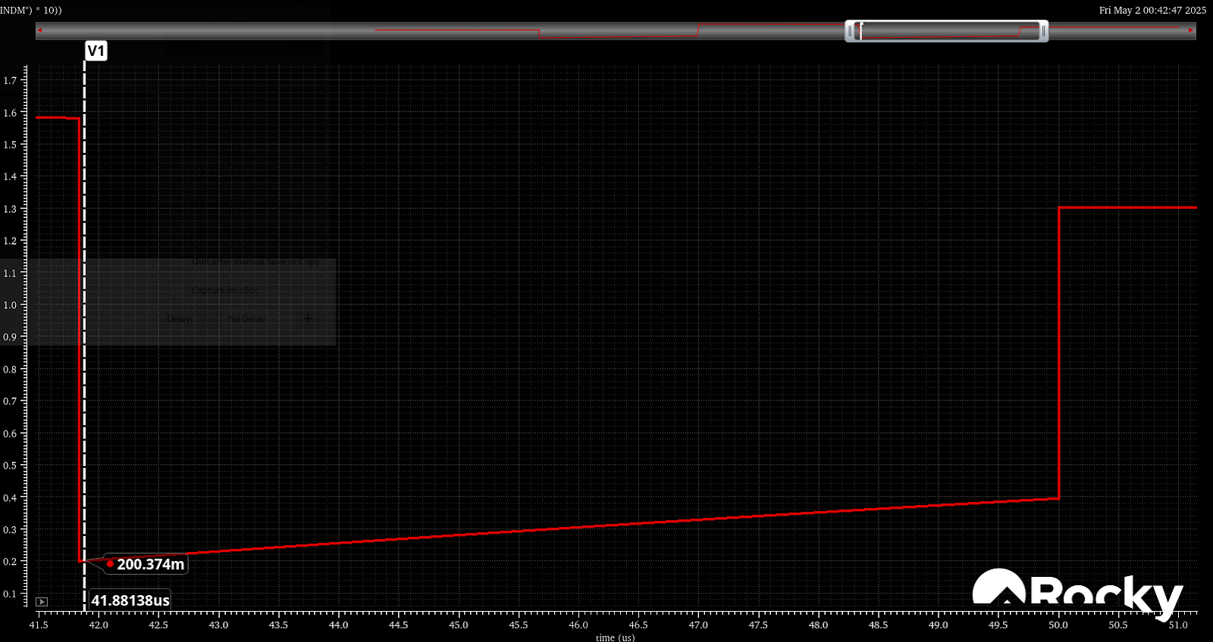
Noise spectrum:
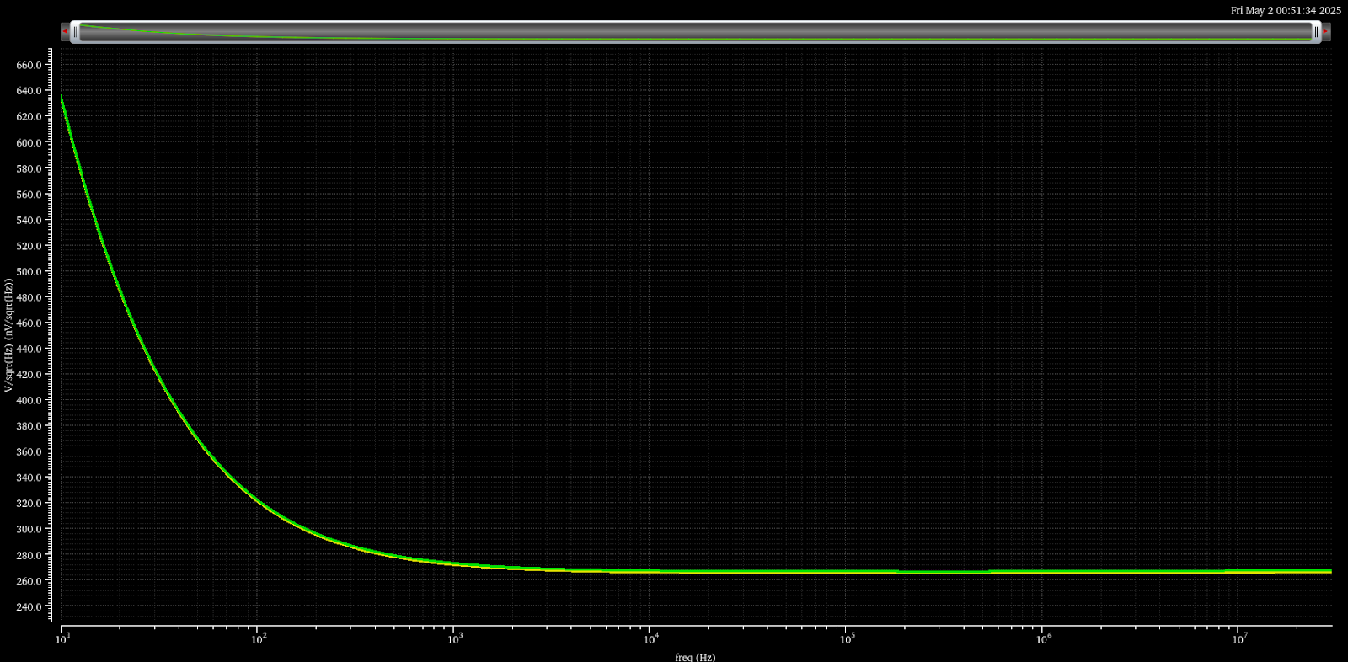

Design of a Switched-Capacitor Amplifier
H05E4a DAMSIC Project 2024
Part III: Gain-boosted OTA
Students: Sam Buydens, Efe Ali Akkaya
Group ID: 5

Gain-boosted OTA

Table of Achieved Results
Enter your achieved results in the below table.
Parameter | Unit | Achieved
Input Swing | mV_{pp} | 118.37
Output Swing | mV_{pp} | 164.2
Total Integrated Output Noise | mV_{rms} | 1.15
SNR | dB | 43.73
C_{L} | pF | 2
C_{FB} | pF | 0.23
C_{IN} | pF | 2.347
Open-Loop Gain | dB | 72.2
Closed-Loop Gain | V/V | 10.0024
GBW (Sample Phase) | MHz | 565
Phase Margin (Sample Phase) | deg | 59
Dynamic Settling Error | % | 11.2
Static Gain Error | % | 0.0426
Power dissipation | mW | 30.87

Schematic Design
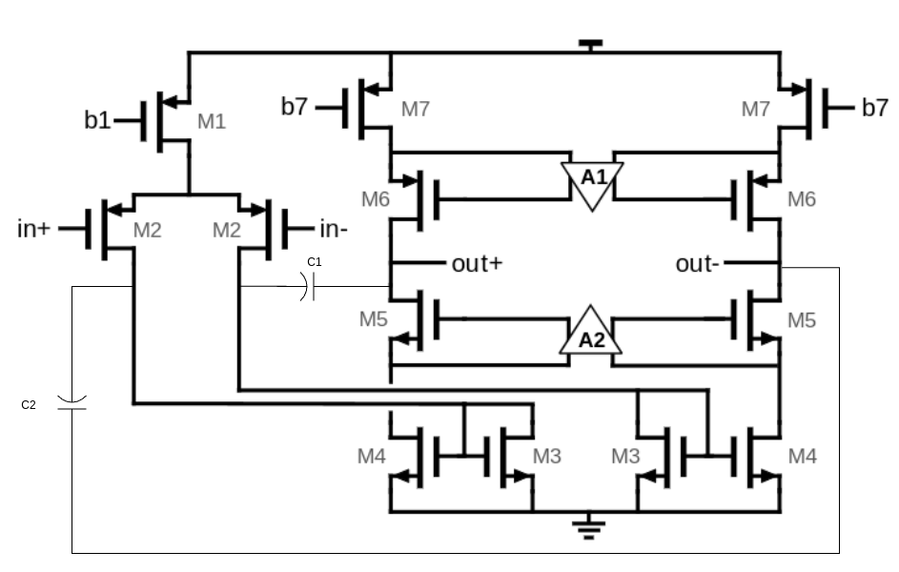
Transistor | W(um) | L(nm) | V_{G}(mV) | V_{D}(mV) | V_{GT}(mV) | V_{DS}(mV)
M1 | 480 | 90 | 700 | 100.2 | -11.2 | -99.8
M2 | 96 | 90 | 550 | 448.5 | -45.0 | -553.7
M3 | 40.5 | 90 | 448.5 | 448.5 | 74.1 | 448.5
M4 | 193.5 | 90 | 448.5 | 355.8 | 60.5 | 355.8
M5 | 60.5 | 90 | 1000.9 | 549.0 | 181.6 | 193.2
M6 | 102.5 | 90 | 200.5 | 549.0 | -184.6 | -271.8
M7 | 77.5 | 90 | 446.1 | 820.8 | -219.1 | -279.2
CMFB |  |  |  | Currents(mA)
A | CMFBEst | R |  | M1 | 1.82
10 | 0.479 | 10 |  | M4 | 3.73
C1 | 3pF | C2 | 3pF
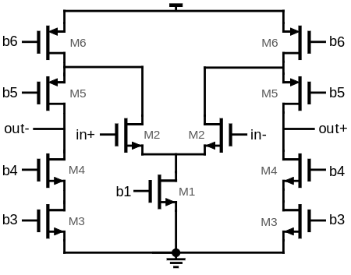
Transistor | W(um) | L(um) | V_{G}(mV) | V_{D}(mV) | V_{GT}(mV) | V_{DS}(mV)
M1 | 15000 | 1 | 300.0 | 150.7 | 3.18 | 150.7
M2 | 250 | 1.8 | 820.8 | 887.8 | 378.0 | 737.1
M3 | 100 | 1 | 506 | 247.4 | 3.18 | 247.4
M4 | 100 | 1 | 786..../  ..../  !"! | 500.5 | 220.4 | 253.2
M5 | 182 | 1 | 400m | 500.52 | -215.7 | -387.3
M6 | 529 | 0.2 | 645 | 887.8 | -120.4 | -212.2
Currents
M1 | 7.54 | M3 | 0.929

Simulation Results
Open-Loop AC simulation:
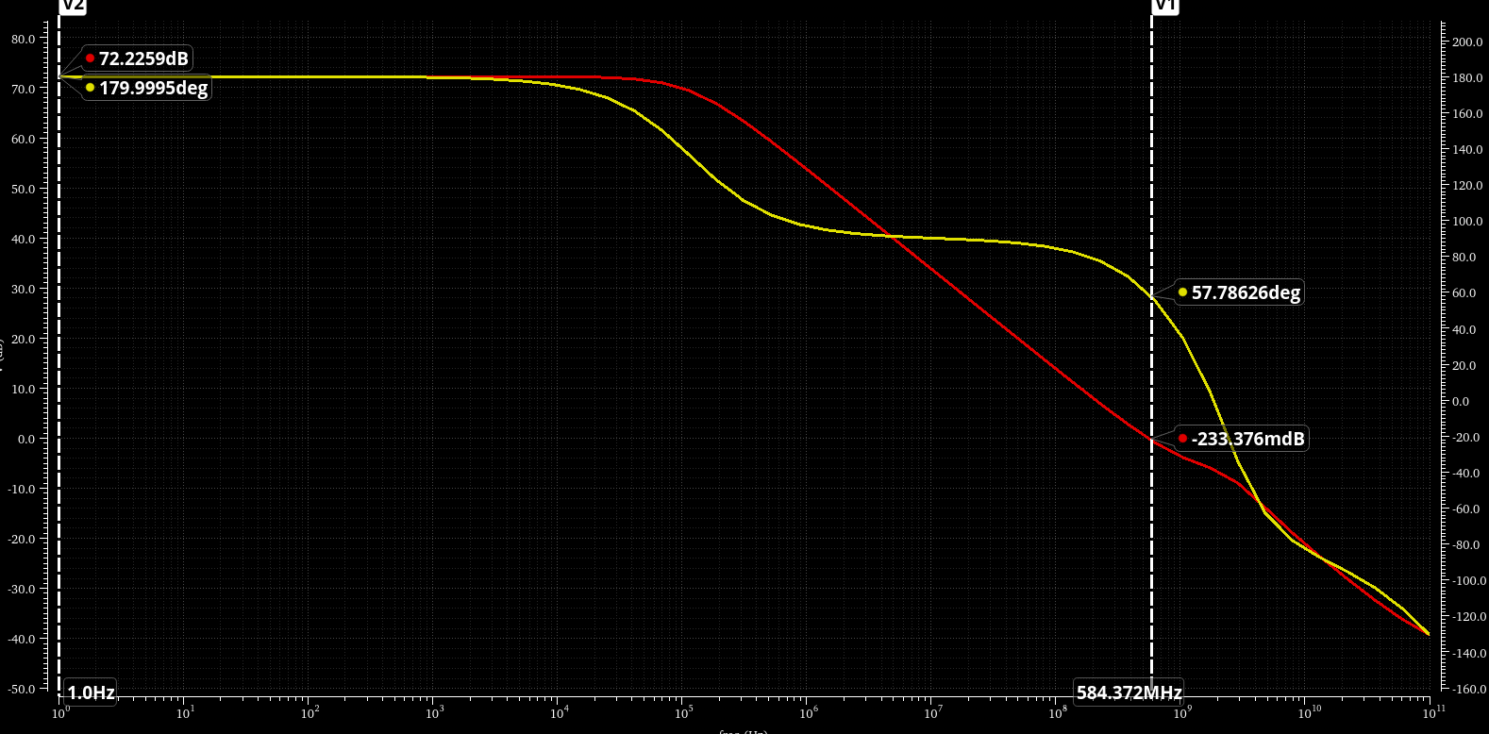

Closed-Loop simulation (main loop):
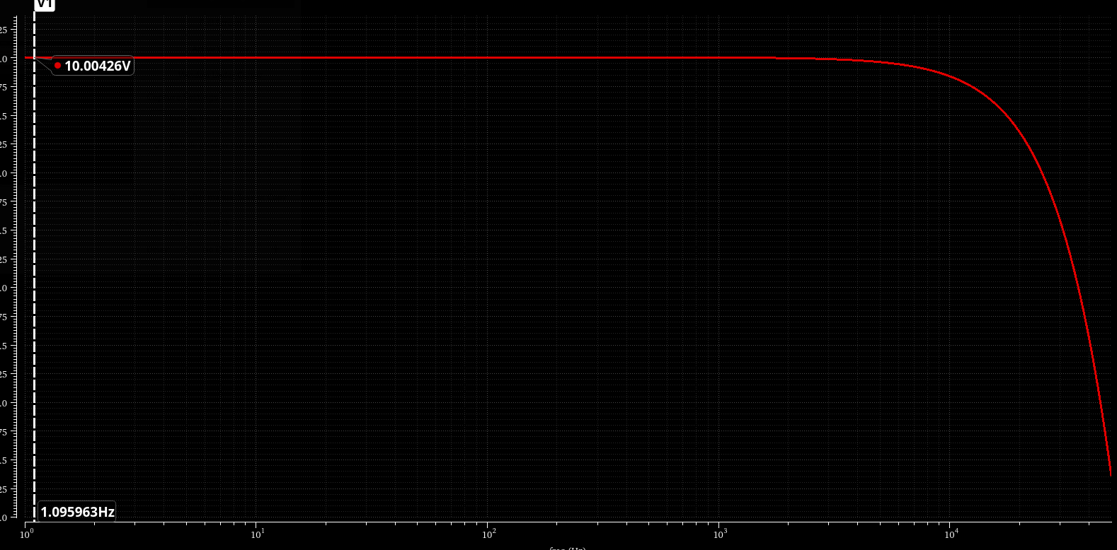
Closed-loop simulation (gain boosting loop):
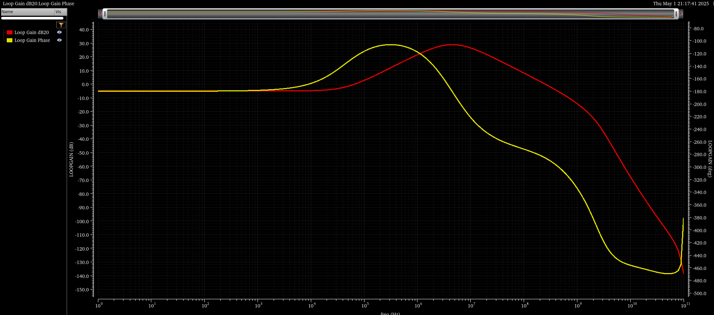
Closed-loop simulation (CMFB loop):
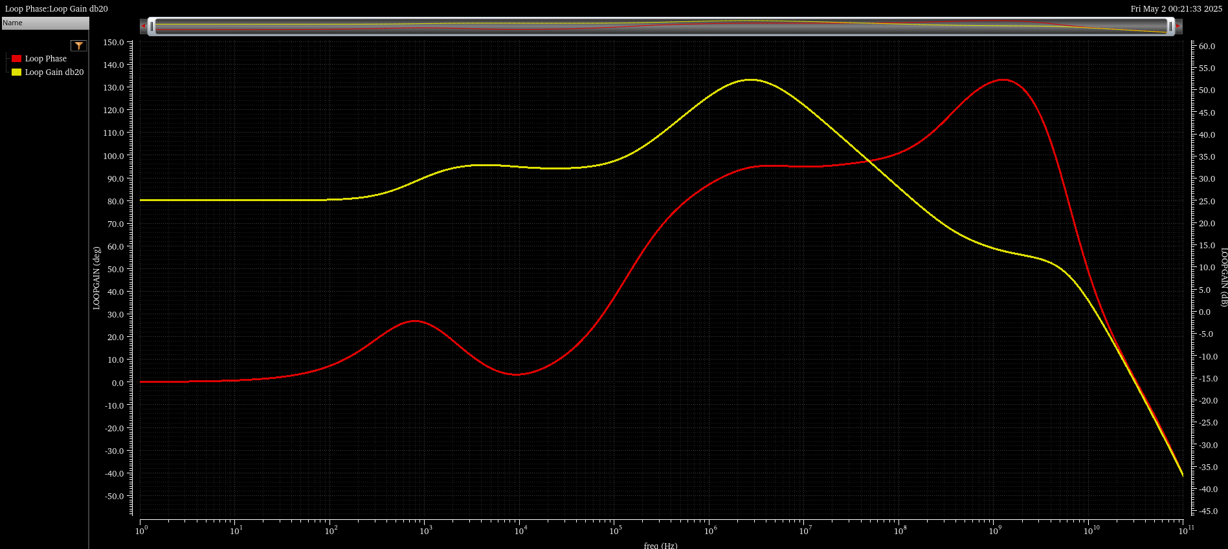

Closed-loop transient simulation:
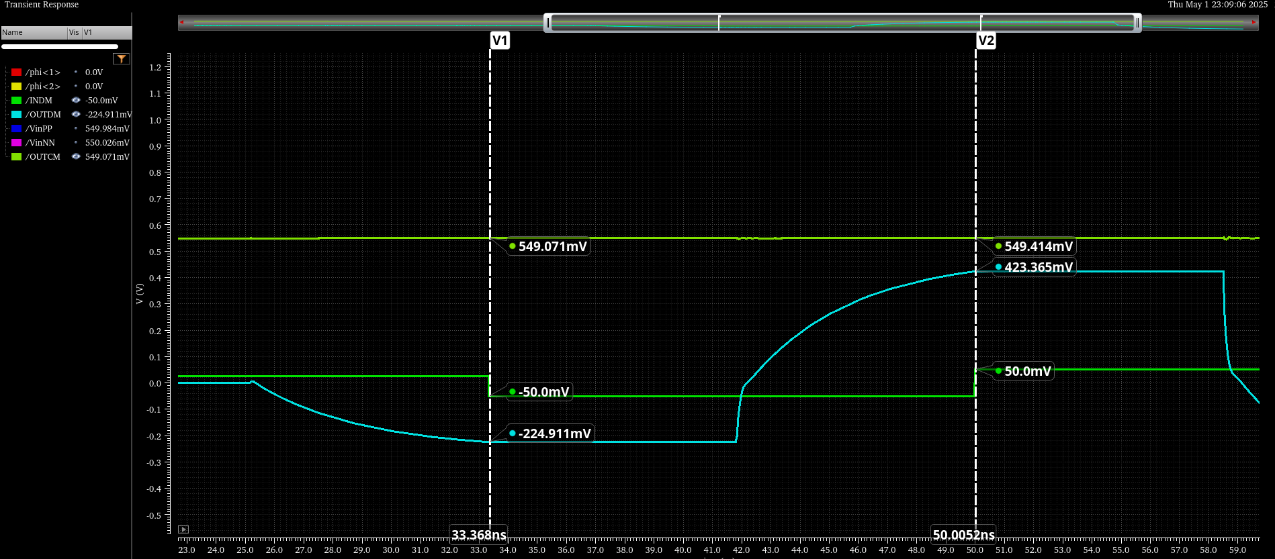
Dynamic error in second amp phase:
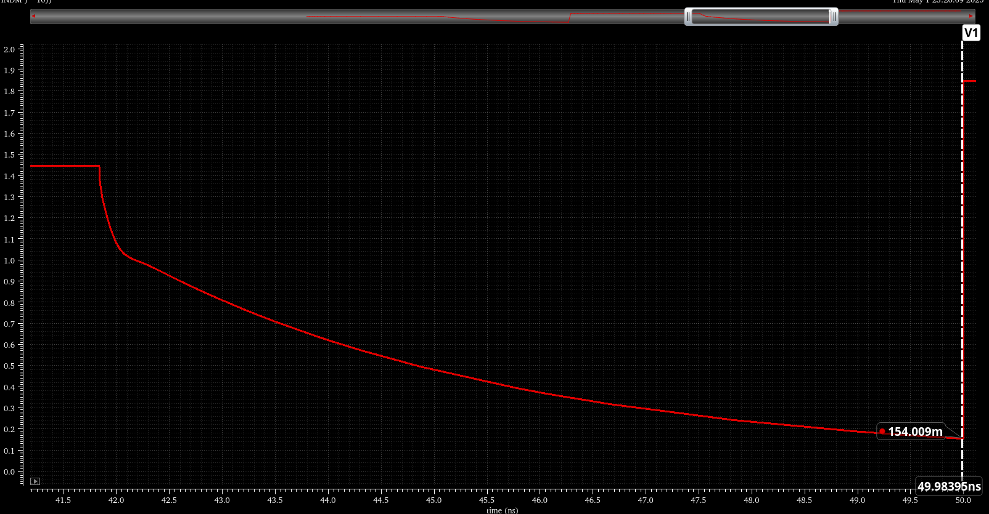
Closed-loop transient simulation (60 kHz):
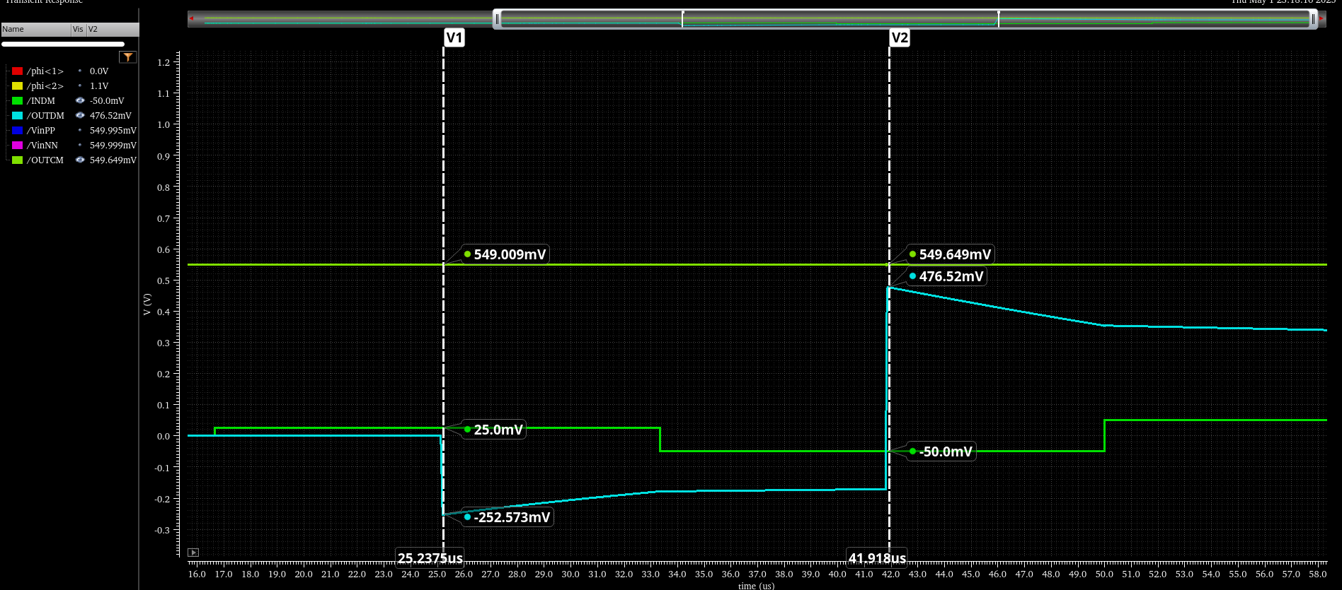
Dynamic error in second amp phase (60 kHz):
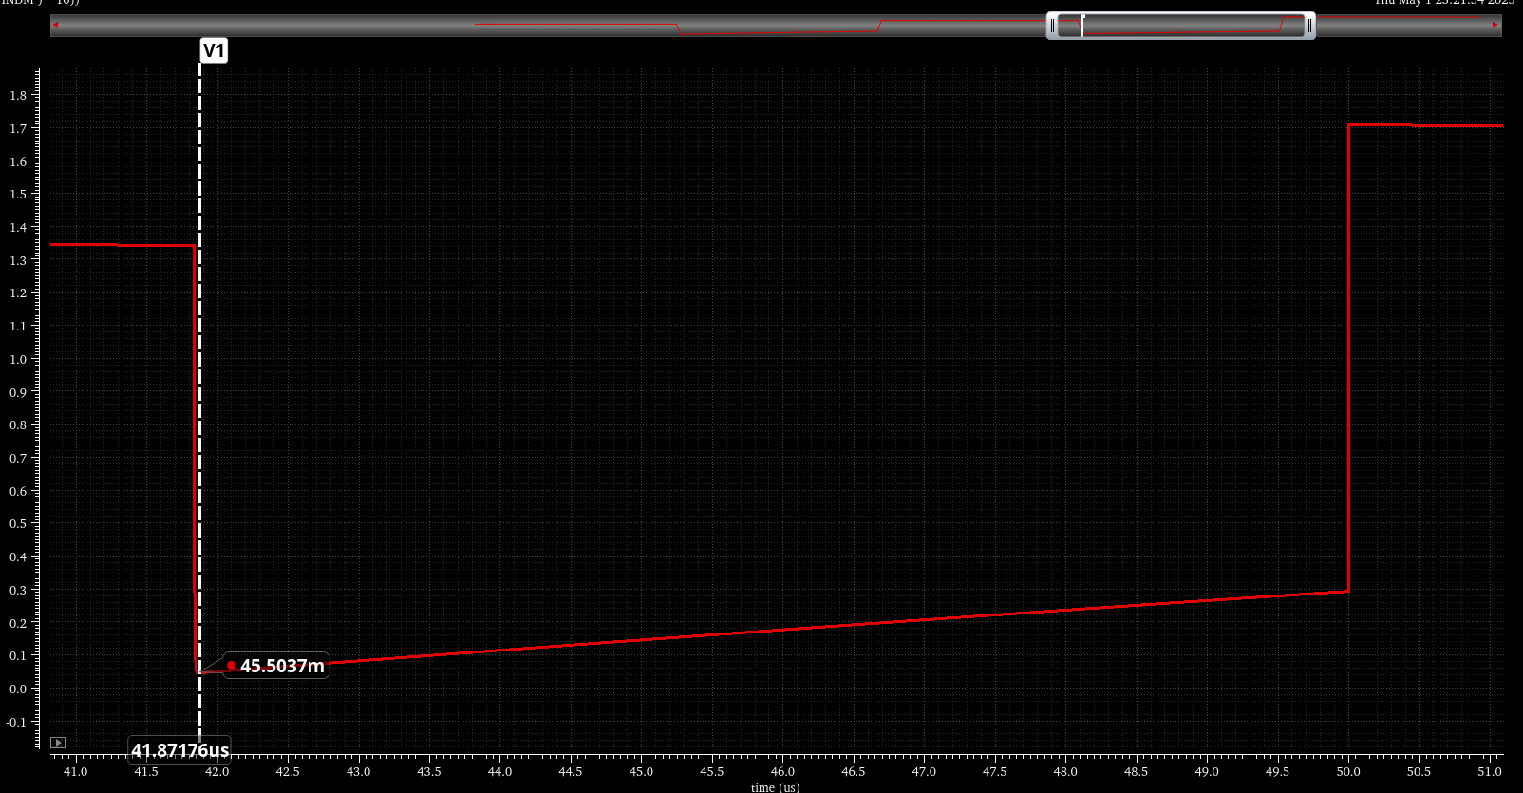
Clock pulse:
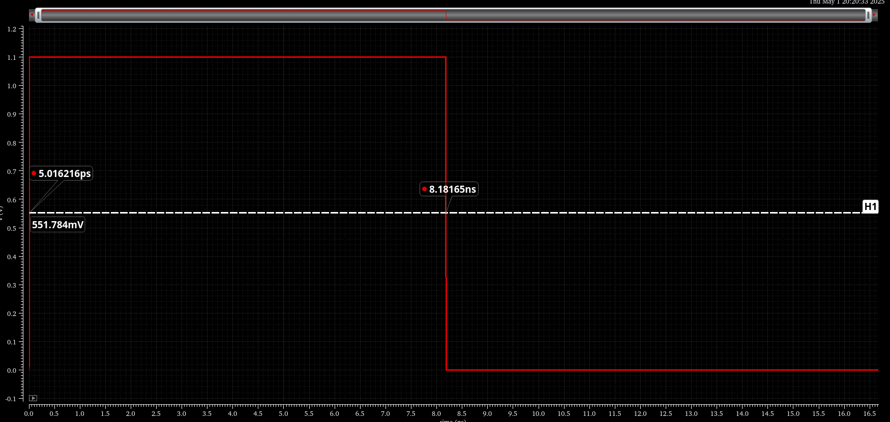
Noise spectrum:
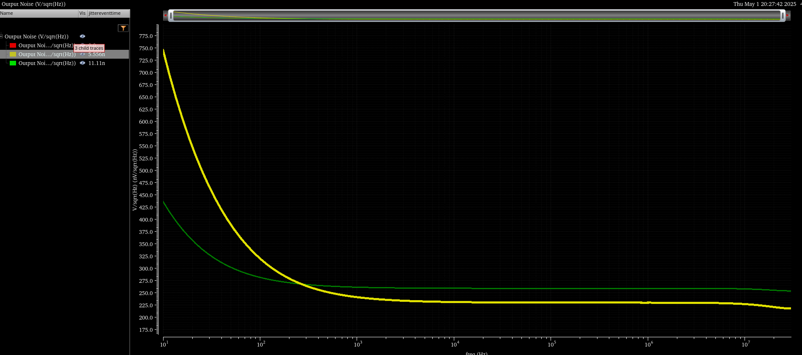
Integrated noise:
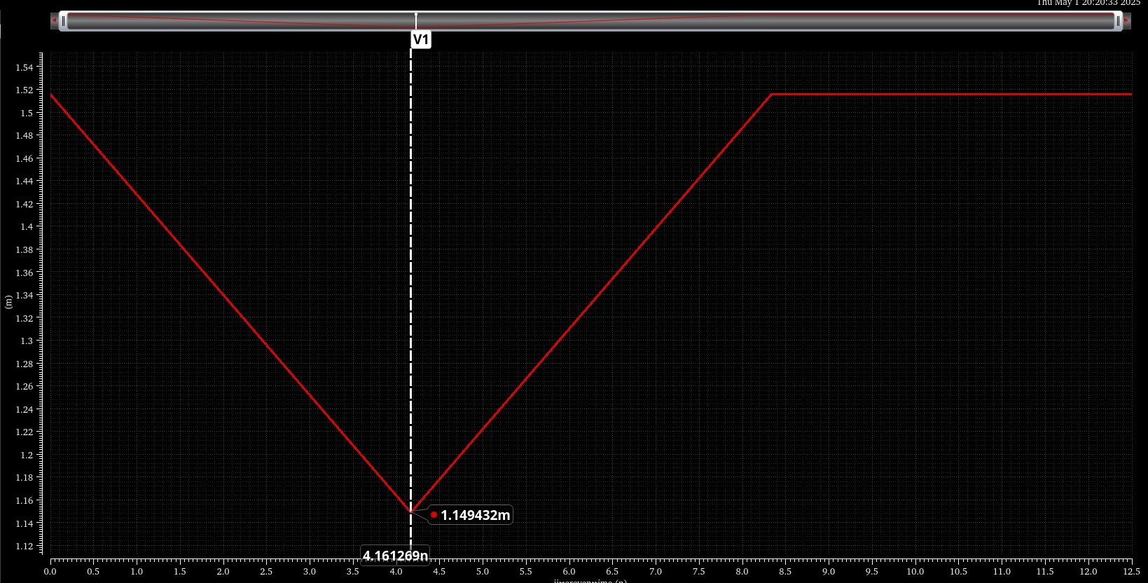

Summary and Additional Remarks

We were able to get a closed-loop gain of around 10 but were unable to get a lot of the other specifications. Our phase-margin and SNR come close to the specifications but our dynamic error is far from the expected value.

Other Results
The only extra thing we did was adding capacitances between the output and the current mirror in the symmetrical OTA to split the poles which improved our phase margin.

