Task 1 :

1. Simulating geometric Brownian motion

First of all, we are going simulate a GBM with following equation

dS(t) = 0.1 dt + 0.26 dB(t); S(0) = 39

Hence , to start off we define all the parameters needed , mu , sigma and initial S0. In order to get a better and more accurate results , we simulate 1000 runs on each different path for 1000 paths.

In the end, we take out the first five 5 runs as simulation of the GBM and plotted as below. However calculation are based on the total 1000 paths. [ maybe different each and every time]

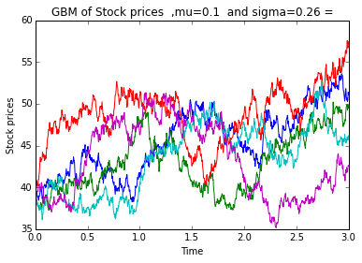

* Calculate the expectation value of S(3) based on the simulation.

To calculate the expected value at S(3), we get the last column value from each different row and form a new matrix. We sum them up by sum() and take the average of it will give us the expected S(3).

* Calculate the variance of S(3).

The variance is calculated by the build in function var() on the matrix consists of 1000 final price only too.

* Calculate P[S(3)> 39].

Here to obtain the value, we form a new matrix with only the value exceed the initial value of 39. The matrix consists of true false element only which is also value of 1 and 0. We can sum up to see the total number of path that exceeds the initial value. The probability can be calculated by dividing them over number of path (1000).

* Calculate E[S(3) | S(3) > 39].

From the true false matrix above, we found the path with value over 39. Hence, we multiply it with original final price matrix to get a new matrix where only with prices exceed the initial price S0. By taking the mean of the them , we will have the expected value provided the final prices higher then initial price.

2. Simulating mean reversal process

The method is quite similar to task 1.1 . We start off by setup the parameters alpha, sigma and theta. Determine the time interval from zero to one , and split the interval into 1000 partitions , generating 1000 paths again. Similarly, we also take only 5 process from the generated huge matrix , however , the calculations are still based on total 1000runs. The simulation is shown below. [ will be different on each run]

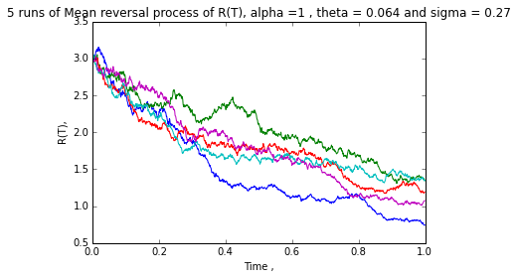

Each step is calculated by adding towards the previous 1. However the size might exceed the range on last calculation, hence we add range limit of n ( 1000 ) . After that , similar to the previous task , we form a matrix that takes only the last value with [: , -1] over all the 1000 paths .

* Calculate the expectation value of R(1) based on the simulation.

Let the matrix with last value called R1, we sum all the element by sum(R1) and then divide by n , number of path (1000) , we will have a expected value over 1000 paths.

* Calculate P[R(1)> 2].

Similarly to the previous task , we find a new matrix exceed_R1 , that the value is more than 2 , which will be a true false matrix that carry value 1 and 0. Using sum(exceed_R1) we can get the number of path that get above 2, then divided over 1000 to get the probability.

Task 2 -- Downloading and manipulating stock data

The stock data of FTSEKLCI is achieved from <http://www.investing.com/indices/ftse-malaysia-klci-components> , and each different 30 components are input into an excel.

|  |  |  |  |  |  |
| --- | --- | --- | --- | --- | --- |
| Stock Name | Stock Code | Stock Sector | Weightage in FTSEKLCI | PE Ratio | Net Market Capital (B,as billion) |
| Public Bank Bhd | 1295 | Banks | 11.6 | 15.24 | **73.84B** |
| Malayan Banking | 1155 | Banks | 9.32 | 12.37 | **87.66B** |
| Tenaga Nasional | 5347 | Alternative Electricity | 9.28 | 9.17 | 69.42B |
| CIMB Group Holdings | 1023 | Banks | 5.76 | 17.52 | 46.694B |
| Axiata Group Bhd | 6888 | Mobile Telecommunications | 5.62 | 24.29 | 55.44B |
| Sime Darby Bhd | 4197 | Diversified Industrials | 5.51 | 22.71 | 52.4B |
| Digi.com | 6947 | Mobile Telecommunications | 4.16 | 20.74 | 41.29B |
| Genting | 3182 | Hotels | 3.68 | 19.8 | 30.88B |
| PETRONAS Chemicals Group Bhd | 5183 | Commodity Chemicals | 3.55 | 22.2 | 51.52B |
| Maxis Bhd | 6012 | Mobile Telecommunications | 3.45 | 30.2 | 49.48B |
| Petronas Gas | 6033 | Exploration & Production | 3.4 | 22.84 | 42.82B |
| IHH Healthcare | 5225 | Health Care Providers | 3.28 | 63.46 | 48.76B |
| IOI | 1961 | Farming & Fishing | 2.99 | 73.65 | 27.45B |
| Telekom Malaysia | 4863 | Fixed Line Telecommunications | 2.96 | 32.71 | 25.14B |
| Genting Malaysia Bhd | 4715 | Hotels | 2.5 | 20.45 | 25.53B |
| MISC | 3816 | Marine Transportation | 2.45 | 16.08 | 35.44B |
| AMMB Holdings | 1015 | Banks | 2.38 | 8.88 | 17.09B |
| Kuala Lumpur Kepong | 2445 | Farming & Fishing | 2.28 | 29.18 | 24.02B |
| SapuraKencana Petroleum | 5218 | Oil Equipment & Services | 1.98 | 12.03 | 14.26B |
| PBB Group | 4065 | Food Products | 1.8 | 17.73 | 17.83B |
| British American Tobacco (Malaysia) | 4162 | Tobacco | 1.7 | 20.11 | 18.50B |
| Hong Leong Bank | 5819 | Banks | 1.67 | 11.18 | 25.68B |
| YTL Corp | 4677 | Multiutilities | 1.63 | 14.85 | 17.38B |
| UMW Holdings | 4588 | Automobiles | 1.37 | 20.57 | 11.96B |
| Astro Malaysia Holdings | 6399 | Broadcasting & Entertainment | 1.22 | 28.59 | 15.97B |
| Petronas Dagangan Bhd | 5681 | Intrgrated Oil & Gas | 1.21 | 36.99 | 20.43B |
| RHB Capital | 1066 | Banks | 1.06 | 9.37 | 19.52B |
| Westports Holdings | 5246 | Transportation Services | 0.93 | 26.84 | 14.05B |
| Hong Leong Financial | 1082 | Banks | 0.64 | 10.01 | 16.32B |
| KLCC Prop & Reits - Stapled Sec | 5235SS | Real Estate Holding & Development | 0.63 | 13.63 | 12.71B |

The table is as shown above. I had choose digi.com as my component to investigate. Using the code 6947 I retrieved data from yahoo finance using following codes.

start = dt(2012,6, 1)

end = dt(2015, 5,31)

data1 = DR("6947.KL", 'yahoo', start, end)

starting from 2012 1,June until 2015, 31,May.

I assigned the data into an array call ‘data’ , and I get the closing price into a matrix by [:,-1] as the final column for each row is adjusted closing price. ( Each row represent different date , with component open price , highest and lowest price , closing price , volume traded and adjusted close price. )

In order to calculate the 5 days moving average , which is taking the mean close price for the pass 5 days, firstly I summed up all the cumulative closing price, and form an empty matrix consists of 2 rows and each have same size with the number of days from data collected.

First row is assigned with value of cumulative sum from fifth day onwards to the last day.

Second row is assigned with value of the sum from first day to the last five days.

5days moving average is calculated by subtracting second row from first row (each day/column will get a 5 days sum) and divide by 5.

The data of moving average is then plotted and as shown as below.

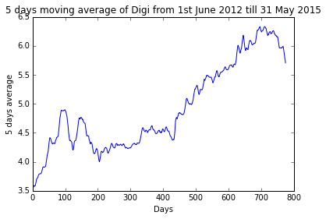

After that , we get a combine data of KLSE and Digi.com and retrieved the price . As the matrix is too big to display , we only get what we need --- the adjusted close price column by the highlighted part.

data2 = DR(combine_data,'yahoo',start,end) ['Adj Close'] , combine_data = ["6947.KL","^KLSE"]

#6947 = digi

Correlation is then calculated between the two , the results are as below.

Correlation =

6947.KL ^KLSE

6947.KL 1.000000 0.597401

^KLSE 0.597401 1.000000

We can conclude that they are just slightly related as the correlation is around 0.6 .