DX1223 Cloud Computing Assignment 2 Report

(Rename this file as: LabNo_Name_Admin_A2_report)

URL to Game published online: _________________________

Game Demo Video at Youtube:__________________________

User accounts for testing

|  |  |  |
| --- | --- | --- |
| username | password | remarks |
| user1 | user1pass |  |
| user2 | user2pass | e.g. lots of power ups |
| user3 | user3pass | e.g. lots of money |

Using flowchart, diagrams and words, describe how you go about implementing the game services

Be sure to include the screenshot of playfab dashboard to show the results. Be sure to include cloudscripts if you have used.

[Put N/A] if you did not implement the features, feel free to add more if you implemented the feature

REMOVE ALL TEXT highlighted in yellow

## User Authentication (Examples)

### Register User

(Code)

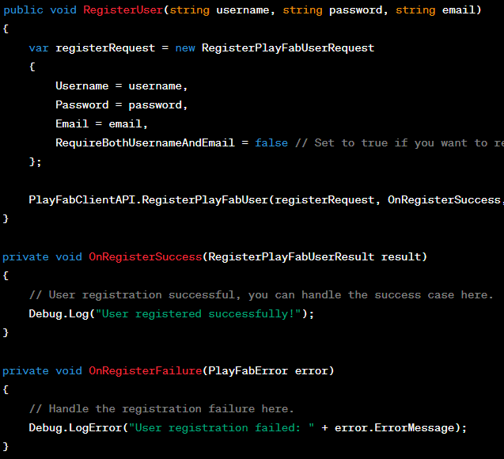

PlayFab Screenshot (if applicable)

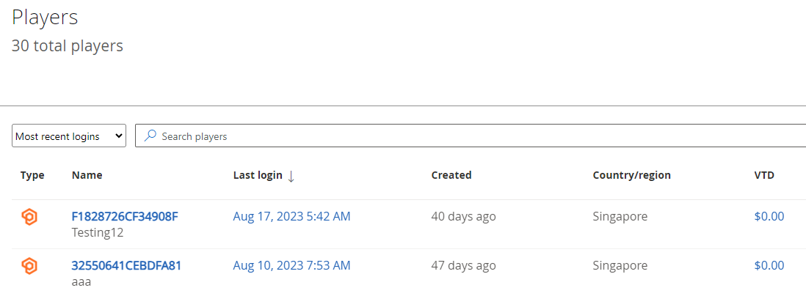

### Login User

### Guest/Device Login

### Password Reset

* Logout

## Leaderboard Features

### Leaderboard Update

### Global Leaderboard

### Nearby Leaderboard

## Player Data

* MOTD
* Simple Data
* JSON Data

## In-Game Economy

* Virtual Currency
* Catalog/Store/Shop
* Buying
* Inventory

## Describe your UI Design

* Consistency
* ..