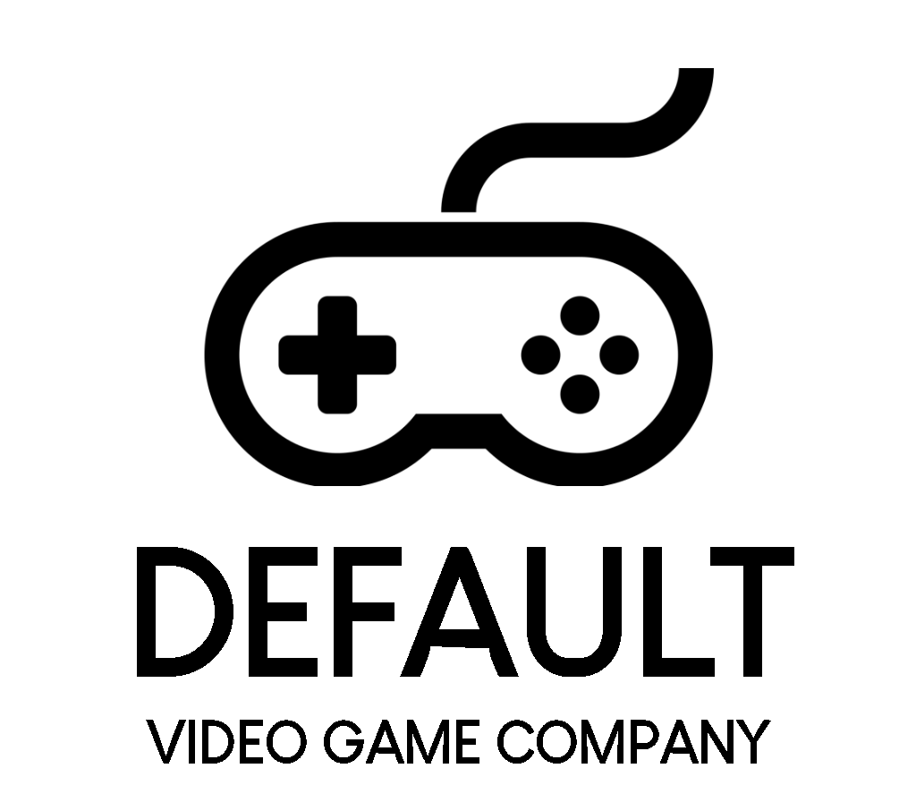
The Default Video Game Company

The Crawl
Request for Proposal
Version 1.1

Document Version
Version | When | Who | What
1.0 | 10 September 2025 | Ryan Costin  Josh Gillum  Ben Givens  Chris Soto  Jacob Mckenzie  Michael | Initial Drafting
1.1 | 18 September 2025 | Josh Gillum | Grammar and formatting

Table of Contents
1.0 Problem description / opportunity / expression of need 3
2.0 Project objectives 3
2.1 Game features 3
3.0 Current system(s) - if any / similar systems 5
4.0 Intended users and their basic interaction with the system 6
5.0 Known interactions with other systems within or outside of the client organization 6
6.0 Known constraints to development 7
7.0 Project schedule 7
8.0 How to submit proposals 8
9.0 Dates 8
10.0 Glossary of terms 8
Grading Criteria 9
Explanation of categories 10
Grading process 10

1.0 Problem description / opportunity / expression of need
Video games serve not only as a source of entertainment but also as a powerful medium for conveying complex stories. Players are granted a sense of agency and freedom unlike other art forms. Roguelikes stand out in particular due to their procedural level generation and perma-death mechanics. These work together to improve replayability and to create a compelling risk-reward dynamic that keeps players deeply engaged. By developing a quality entry in this genre, we have the opportunity to capture the attention and passion of gamers while making a meaningful contribution to the broader gaming landscape.
The objective of this project is to develop The Crawl, a single-player, top-down dungeon crawler. The game will follow an unnamed adventurer navigating a procedurally generated dungeon, where each room presents new challenges. Players will have to strategically utilize scavenged equipment and resources to have a chance at surviving combat against a diverse cast of monsters. Progression between levels will warrant increased difficulty, which will create a compelling sense of challenge and reward. The driving force for the character to navigate the treacherous dungeon is to stop its controller and architect, The Overlord.
We anticipate strong commercial potential for The Crawl, driven by the demonstrated success of comparable titles such as Enter the Gungeon and Hades. This genre continues to show momentum, as evidenced by the sustained popularity of sequels (Enter the Gungeon 2) and enduring franchises (The Binding of Isaac). Given this market demand, we believe The Crawl represents a unique opportunity to deliver a refreshing, new entry into the genre.

2.0 Project objectives
The Default Game Company is looking for a contractor to build a single player video game The Crawl that is inspired by existing rogue-like games such as Enter the Gungeon, and The Binding of Isaac.

2.1 Game features
The game will have the following features, through its various components:
Player:
- Ability to move around the level, including walking around the rooms and moving between them.
- Ability to attack enemies with an equipped weapon
- Health point count that can be replenished through consumable items
- Complete, permanent death, which results in having to restart the game
- Invincibility for a short period of time after taking damage
Collectible objects:
- Weapons that can provide the player with different attack stats or attack patterns
- Items that replenish the player’s health
- Items can drop when a room is cleared of all enemies
- Currency that drops from enemies, which can be used to purchase items
Enemies:
- Generate in a set pattern, as defined by the room the player is in
- Ability to be killed, with the potential of dropping items for the player once the room is cleared
- Have the ability to deal damage to the player
- Boss encounters that occur before the player can access the stairways
  - Boss fights will feature unique mechanics that differentiate the encounters
  - Boss fights will be spread out across a few difficulties, so that they can be used after levels of a similar difficulty.
User interface:
- Pause menu that can be brought up at any point in the game
- Heads up display (HUD) that clearly displays the player’s health, current weapon, and time spent on current run.
- Window that displays a map of the explored portion of the current level
- Welcome / Title screen at the start of the game, which has a button that will start a new game. Also can bring up the high-score table, showing the fastest runs.
- Game over screen.
  - On defeat, it simply returns to the title screen after a short delay or confirmation from the player.
  - On success, brings up UI for the user to save their name along with their time in the high score table.
Audio:
- Non-distracting background music on each level. Varies between levels, but not necessarily unique to only one level
- Combat sound effects for actions like attacking, hitting an enemy, taking damage, etc.
- Sound effects for interacting with the environment, like footstep sounds outside of combat, picking up an item, etc.
Levels:
- Procedurally-generated layout of interconnected rooms
- Single room in each level that contains a boss fight encounter.
  - Single room that is only accessible after successfully completing the boss fight encounter, which contains a staircase that transports the player to the next level.
- Levels get progressively more difficult by having different enemies. Higher levels may have any combination of enemies with different attributes (higher health, more damage, new attack patterns, etc.), as well different rooms that are more difficult.
- Levels are a randomly chosen collection / layout of rooms. Each individual room does not change between runs.
- Each level features The Crawler, a creature that crawls along the ground towards the player. It is to create a sense of impending doom upon the player, as it can move between rooms. Making contact with the player will instantly kill the player. The speed of the crawler will increase after each successful level.
- The main game is complete after 3 levels, with the player being presented the option of continuing an infinitely scalable run. This ‘free-play’ mode ends only once the player dies.
Other:
- Games are scored in two different ways: time taken to complete the 3 main levels, and highest level reached in free-play mode.
  - When necessary (a score that can be stored in the table being reached), the player will be prompted to enter their name.
  - This high-score table contains data for only the local game copy.

3.0 Current system(s) - if any / similar systems
Enter the Gungeon:
Published by Devolver Digital in 2016, Enter the Gungeon is a rogue-lite bullet hell shooter game. Enemies fire circular projectiles in specific patterns that are tied to their enemy type. It is the player’s job to use his gun to kill the enemies while dodging their attacks at the same time. The player traverses the procedurally-generated level until they discover the boss room, which contains one of a few boss fights that are unique to the current level. After successfully completing the boss fight, the player is able to traverse deeper into the so-called “Gungeon”. After completing the boss fight on the fifth level, the player has won. The game features perma-death, in that all progress of the run is lost upon death. It features progression in the form of items (weapons, utilities) that can be bought, which will be in the available loot table on subsequent runs.

The Binding of Isaac:
The Binding of Isaac is a top-down, procedurally generated rogue-like. It was published by Headup Games in 2011. The game follows Isaac, a young boy fleeing into his abusive, religious mother’s basement, where he must battle grotesque creatures and confront disturbing manifestations of his fears. Players use Isaac’s tears as projectiles to fight enemies, while collecting a wide array of power-ups and items that drastically alter gameplay. Progression is marked by increasingly challenging bosses and deeper dungeons. During runs, the player can unlock new upgrades for future runs by completing certain achievements. This ensures that the game never feels stale, as every run is different.

4.0 Intended users and their basic interaction with the system
Intended Users:
Video game players of intermediate to advanced skill, who enjoy challenging, repeatable content. The game is intended to be used by said users to provide an enjoyable experience.

Intended Interactions:
- With the various menus to start a run, pause the game, exit the game, and manage player inventory
- With the controls to move the character, as well as use weapons and items
- With enemies to take damage and deal damage to them
- With various collectibles

5.0 Known interactions with other systems within or outside of the client organization
Github: The game will be published and available through github, where the user will have to download the game. The source code will be provided alongside precompiled binaries.

Discord: A discord setup for answering users problems and providing player support.

Unity: All projects done through our company are completed in the Unity game engine. It is a requirement of the project that the game will have to be completed with Unity.

6.0 Known constraints to development
- Time necessary to complete development
  - Game balance will be difficult to optimize. There are enemies that must be a reasonable challenge to the player, without being impossible or unfun to fight. The item scaling must be consistent, with all items being balanced and viable. These features will take considerable time to develop and fine tune.
  - Creating art assets for all of the different features, such as the terrain, enemies (at all their possible viewing angles), and the player will take a long time.
- Complexity of code
  - Creating a randomly generated level of interconnected rooms will be quite complex.
- Must use Unity game engine

7.0 Project schedule

Date | Objective
19 Sep. | Request for Proposal Issued
25 Sep. | RFP Presentation
26 Sep. | Final day to submit proposals
27 Sep. | Proposal approval
7 Oct. | Minimum viable product complete (working, demonstrable game)
19 Oct. | All collectible items designed and functioning in game.
26 Oct. | All enemies designed, animated, and functioning
3 Nov. | All rooms designed, scripted, and functioning
Date | Objective
8 Nov. | Game is mostly complete and only needs final bug fixes and polish.
15 Nov. | Finished project
11 Dec. | Final demonstration

8.0 How to submit proposals
Submissions via email are preferred to hard copies.
Email | Hard Copy
defaultemail@email.email | The Default Game Company  ℅ North Idaho College  1000 W Garden Ave  Coeur d’Alene, ID 83814

9.0 Dates
Proposals are to be submitted no later than September 26th at 12 noon PST. Proposals submitted after this will be ignored. All companies with submissions will be notified if they won or lost the contract by September 27th. The project must be completely finished by Nov. 15th. No extensions on any of the dates can be given.

10.0 Glossary of terms
Run
A playthrough of a video game. It is a single attempt at beating the game, and may be successful or not.

Dungeon Crawler
A style of videogame in which the player navigates a dungeon. The game is usually set within a medieval, fantasy setting. The player typically will find the dungeon to be maze-like, and finds themself battling monsters, solving puzzles, and looting treasure.

Rogue-like
A subgenre of role playing games traditionally characterized by procedurally generated levels, grid-based movement, and character customization and experimentation. The genre’s titular game, Rogue, was released in 1980 and pioneered many of the features present in the genre today.

Top Down
A perspective used in games where the camera is focused above the player. This can be done by having the camera focus on the player or the room the player is in.

Perma-death
All or most of a player’s progression is deleted upon death or failure. Some games with this mechanic feature some persistent upgrades that forego the deletion. For instance, item unlocks usually carry over between each run, but the individual items you get on a run will be removed from your character.

Procedurally generate levels
A level that is generated through some algorithm. This algorithm may simply randomly build the level, or may follow a more predefined path. This adds randomness to runs and aids replayability of a game.

Grading Criteria
Category | Weight
Team Qualifications | 15
Prior experience | 5
Resumes of team members | 10
Proposed Solutions | 20
Proposed implementation of systems | 15
Creative improvements to game | 5
Miscellaneous | 15
Local business | 8
Sooner project completion date | 4
Category | Weight
Cost | 3
Total | 50

Explanation of categories

Prior experience: Teams with experience making similar games using Unity will score highest in this category. Those with experience making any games in Unity will be next, then those with experience with another engine.
Resumes: Teams with members with a lot of experience will score highest.
Proposed implementation of systems: Teams that propose well thought-out or creative ideas for implementation of the required systems will score higher.
Creative improvements to the game: Any creative improvements allowed within the specifications will be scored according to how well they fit the game.
Local business: Teams within the Coeur d’Alene / Spokane area will score higher than those far away.
Sooner project completion date: Proposing to complete the project in advance will score higher points. Proposed completion dates must be feasible.
Cost: Lower cost scores higher.

Grading process
Scores will be assigned in each category, up to their maximum weight. These scores will then be totaled and divided by the total possible score. The contractor(s) with the highest score will then be selected for final consideration. Should the contractor(s) not be suitable for any reason, then the next highest scoring contractor(s) will be selected for final consideration.

