Name: Josh Gillum | Mark _____________________/50

1. Brief introduction __/3
Boss fight encounters. Boss fights will occur at the end of levels; they prevent the player from proceeding to the next level until complete. Every boss fight will be unique. Bosses will be visually unique, and will feature unique mechanics that are more complex than those of regular enemies. The unique mechanics of the boss will be implemented as special abilities, which have a cooldown, similar to swinging a weapon.

2. Use case diagram with scenario __14

Use Case Diagrams
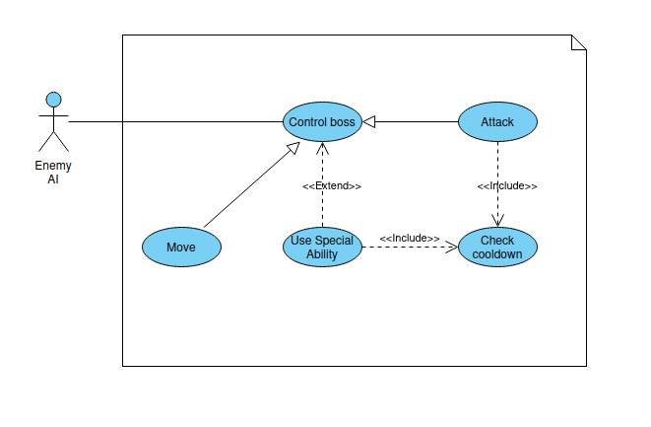

Scenarios
Example outline:
Name: Use special ability.
Summary: The enemy AI uses one of the boss’s special abilities.
Actors: Enemy AI.
Preconditions: Boss fight encounter is active.
Basic sequence:
Step 1: Enemy AI determines it is a good time to use the boss's ability.
Step 2: Special ability is used.
Step 3: Special ability's defined effect occurs.
Step 4: Start cooldown of ability
Exceptions:
Step 2: Special ability is still on cooldown: Reset sequence.
Post conditions: None
Priority: 1*
ID: JG1.
*The priorities are 1 = must have, 2 = essential, 3 = nice to have.

3. Data Flow diagram(s) from Level 0 to process description for your feature _______14

Data Flow Diagrams
Level 0
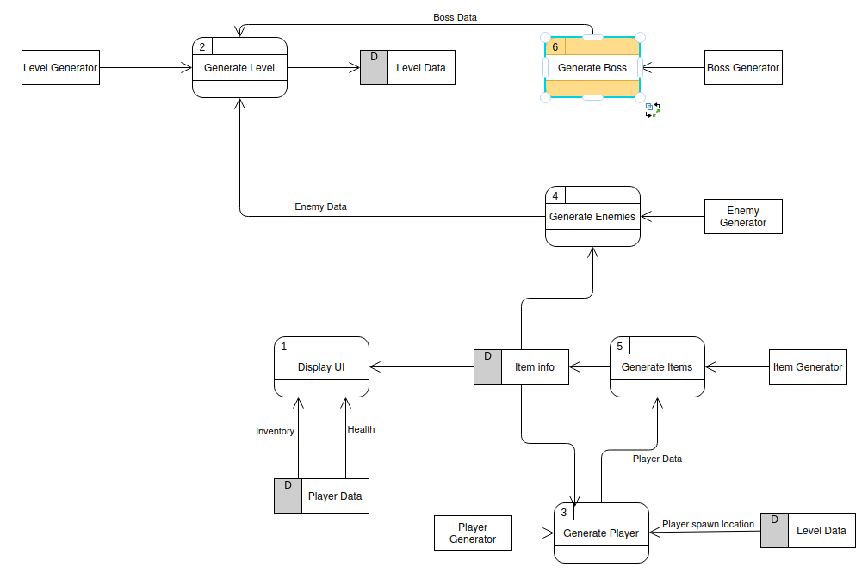

Level 1
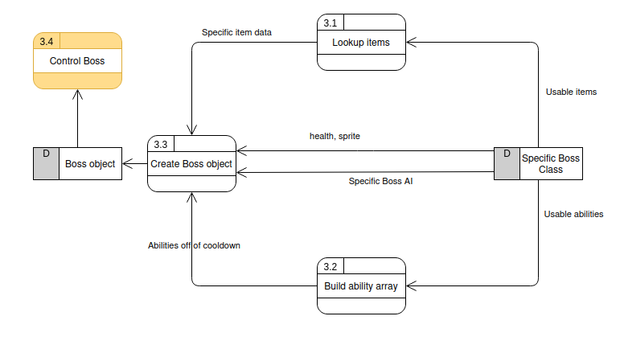
Level 2
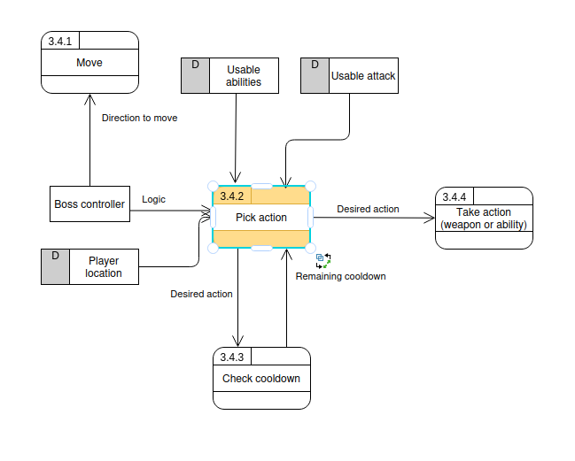

Process Descriptions
Pick action:
bool weaponUsed = false
bool abilityUsed = false
if player is within range of weapon:
if checkCooldown(weapon) <= 0:
use weapon
start cooldown of weapon
weaponUsed = true
if not weaponUsed:
for ability in usable abilities:
if checkCooldown(ability) <= 0:
use ability
start cooldown of ability
abilityUsed = true
break
if not weaponUsed and not abilityUsed:
do nothing

4. Acceptance Tests ________9
Use Boss Ability:
Pick first ability and use it
Start timer
Repeatedly attempt to reuse ability
Stop timer when ability is able to be reused
Check that timer is within 100ms of defined cooldown length of ability.
Repeat for all remaining abilities
Use Attack
Pick faux player location at random
Use weapon in the direction of the player location
Check if weapon swing hit the location
Should only hit the location of the distance is less than or equal to the defined range of the weapon. Repeat a number of times.

5. Timeline _________/10

Work items

Task | Duration (hours) | Predecessor Task(s)
- Requirements gathering | 5 | -
- Design bosses | 10 | 1
- Implement bosses | 20 | 2
- Test function of encounters | 5 | 3
- Rebalance boss encounters | 5 | 4
- Acquire art for bosses | 5 | 2
- Final play test and rebalance | 5 | 5
- Documentation | 2 | 3
- Installation | 1 | 6,7,8

Pert diagram
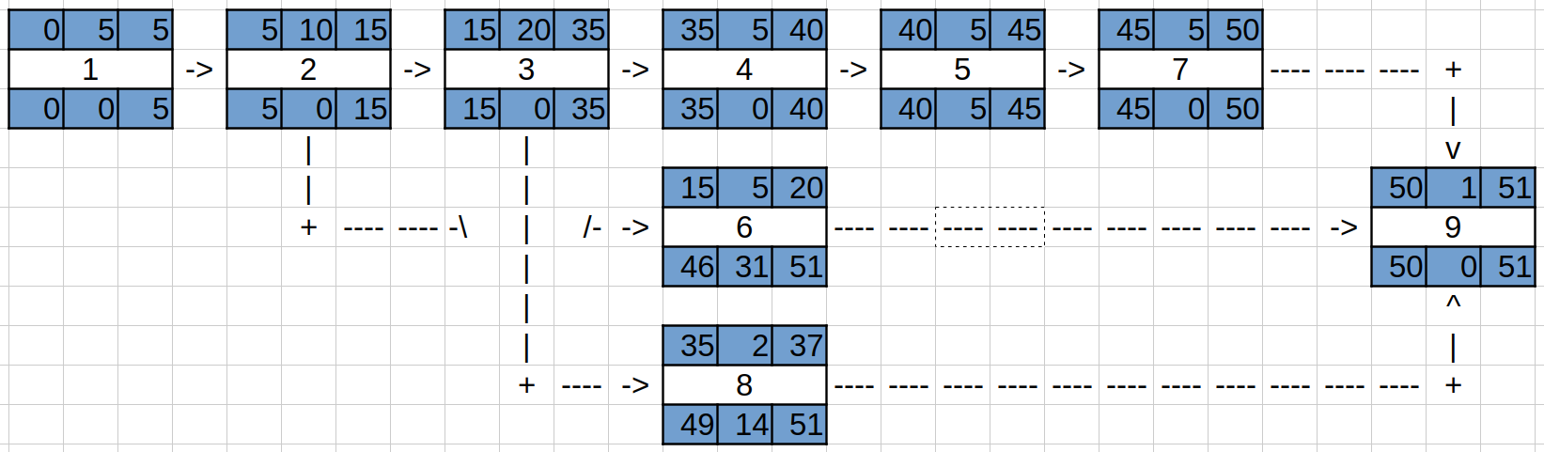

Gantt timeline
