

SCHOOL OF INFORMATICS & IT

Part 2: Basic Application and Authentication

Student Name (Matric Number) : Leon Jr Chua 2500593E

Tutorial Group : PC08
Jenny LING (TP)
Tutor : Mr Kent Tan

Submission Date : 5/7/2026

Declaration of Originality

I am the originator of this work and I have appropriately acknowledged all other original sources used as my references for this work.

I understand that Plagiarism is the act of taking and using the whole or any part of another person’s work, including work generated by AI, and presenting it as my own.

I understand that Plagiarism is an academic offence
and if I am found to have committed or abetted the offence of plagiarism in relation to this submitted work, disciplinary action will be enforced.

Declaration on the use of Generative AI tools for assignments

Describe how you have used Generative AI tools such as ChatGPT or Dall.E-2 in your assignment.

Show snapshots of the conversations with the AI tool (i.e., the prompts you used and the response you get from the AI tool).

Used AI for debugging support, understanding Firebase authentication methods, improving explanation wording, and drafting placeholder AI output text shown in the Part 2 UI.
https://chatgpt.com/g/g-p-69e6edd86c388191801ad5832ef7c749-lemo/c/6a3d2c4b-cc70-83ec-be42-e724e0b53af7

How do you indicate the reference?
The content generated by AI tools are not retrievable except by the user who generated them, so they are considered non-recoverable sources. Although non-recoverable data or quotations in APA Style papers are usually cited as personal communications, with ChatGPT-generated text there is no person communicating. Quoting text from ChatGPT chat is therefore more like sharing the output of an algorithm, with a reference list entry and the corresponding in-text citation.

According to the official APA Style site, ChatGPT references should be cited as:

E.g. OpenAI. (2023). ChatGPT (Sep 25 version) [Large language model].
https://chat.openai.com/chat

Important Note:

- Do not copy answers produced by the AI tool in totality as it is considered as plagiarism.

- Do not rely on any information produced by the AI tool blindly. You should always verify the answer with other sources. Do not assume that these answers provided by the AI tool are correct.

To achieve quality outputs from the AI tool, you should provide good prompt that is clear and specific. Be precise and provide context. Avoid asking open-ended questions.


School of Informatics & IT

Mobile App Development (CIT2C18)

AY 25/26 Apr Semester

Basic Application

(Part 2)

Table of Contents
Screen 1: Authentication-related screens 5
Screen 2 12
Screen 3 15
Screen 4 18
Screen 5 20

The yellow text in each section is provided as a guide. Please make sure to REMOVE them before submitting your work.

Screen 1: Authentication-related screens
Screen Name: LoginScreen

Wireframe Screenshot | Flutter Screenshot (Chrome/Virtual Device)
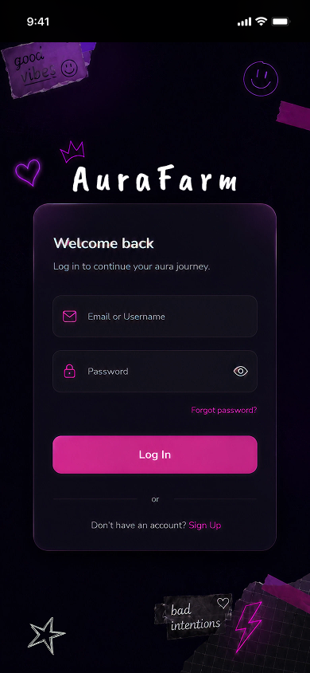 | 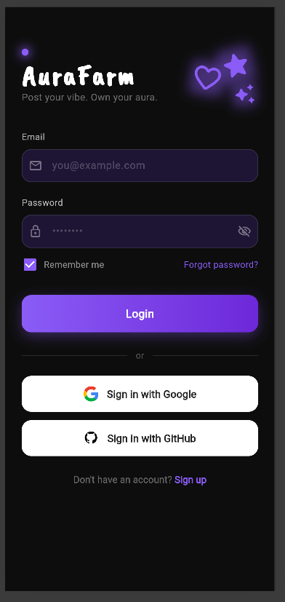

Reason for deviation (if any):
The implemented LoginScreen follows the main structure of the Part 1 authentication wireframe, including the AuraFarm branding, dark background, email/password fields, forgot password link, login button, and sign up navigation.
Some visual details were adjusted in Flutter to better match the final AuraFarm app style. The colour scheme was changed from a stronger, pink-based design to a darker purple neon theme so that the login page feels more consistent with the HomeScreen, CreateScreen, DetailScreen, and ProfileScreen. The decorative elements were also reduced to only a few neon icons so the screen looks cleaner and less cluttered on a mobile display.
Google Sign-In and GitHub Sign-In buttons were added because Part 2 requires Firebase Authentication and encourages exploring authentication methods beyond the basic email/password login. These buttons also give users more login options while still fitting the clean authentication layout.
A Remember Me checkbox was added to match common login screen patterns and improve the visual completeness of the authentication form. For Part 2, the checkbox is used as a simple UI toggle only and is not connected to a separate custom persistence setting. Firebase Authentication already keeps the user signed in unless the user logs out, so the main login persistence is handled by Firebase Authentication instead of the checkbox. If more detailed login persistence is required later, the checkbox can be connected to Firebase Auth persistence settings or local saved preferences.
The implemented screen keeps the same overall purpose as the wireframe, which is to allow users to log in and continue into AuraFarm. The layout was simplified slightly to improve readability, spacing, and consistency with the rest of the Flutter app.

Screen Name: RegisterScreen

Wireframe Screenshot | Flutter Screenshot (Chrome/Virtual Device)
No separate wireframe was created for this screen in Part 1. | 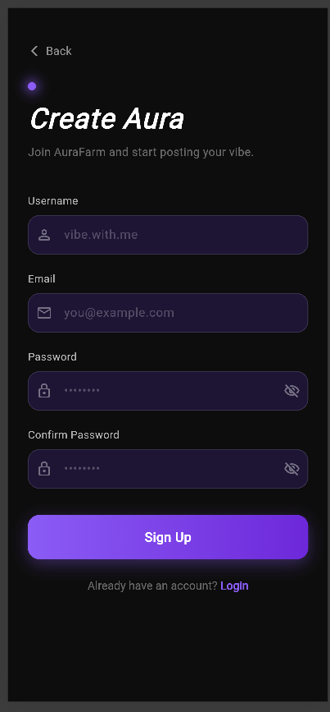
Reason for deviation (if any): A separate RegisterScreen wireframe was not created in Part 1. The Part 1 design only included the main authentication/login wireframe as the reference for the authentication flow.
The Flutter RegisterScreen was implemented by extending the same visual style from the Part 1 authentication/login screen, including the dark background, purple neon accent colour, rounded input fields, and simple mobile layout. This keeps the authentication screens visually consistent even though the RegisterScreen was not drawn separately in Part 1.
This screen was added because registration was included in the proposed authentication features and is required for Part 2 Firebase Authentication. The screen allows users to create an AuraFarm account using email and password, with form validation and SnackBar feedback
Screen Name: ResetPasswordScreen

Wireframe Screenshot | Flutter Screenshot (Chrome/Virtual Device)
No separate wireframe was created for this screen in Part 1. | 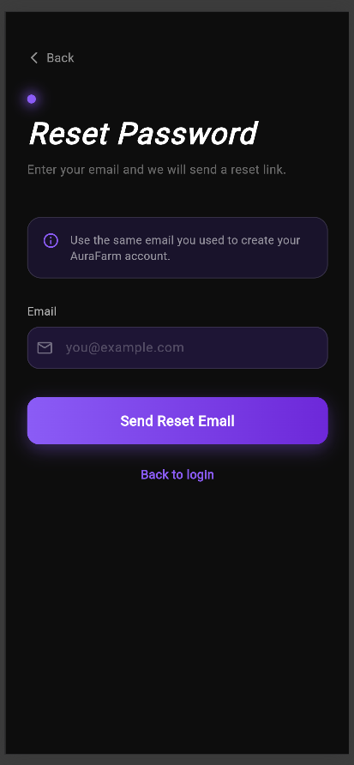
Reason for deviation (if any): A separate ResetPasswordScreen wireframe was not created in Part 1. The Part 1 design only included the main authentication/login wireframe as the reference for the authentication flow.
The Flutter ResetPasswordScreen was implemented using the same visual style from the Part 1 authentication/login screen, including the dark theme, purple accent colour, rounded form field, and simple vertical layout. The layout is simpler because password reset only requires the user’s email address.
This screen was added because forgot password was included in the proposed authentication features and is required for Part 2 Firebase Authentication. It allows users to request a password reset link and provides validation and feedback when the reset request succeeds or fails.

Screen Name: ChangePasswordScreen
Wireframe Screenshot | Flutter Screenshot (Chrome/Virtual Device)
No separate wireframe was created for this screen in Part 1. | 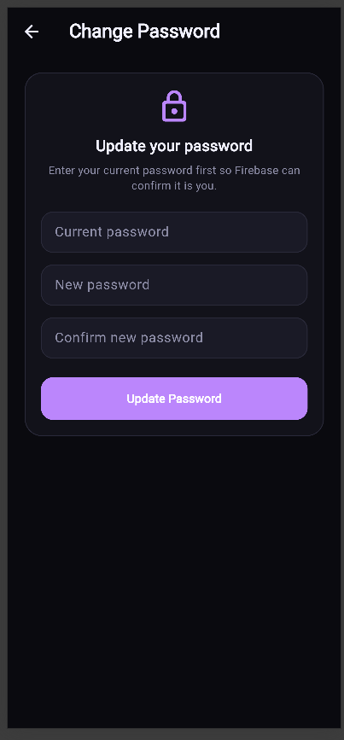
Reason for deviation (if any): A separate ChangePasswordScreen wireframe was not created in Part 1. The Part 1 design only included the main authentication/login wireframe, so the ChangePasswordScreen was added during Part 2 as an extension of the authentication flow.
This screen was added to meet the Part 2 specification, which requires Firebase Authentication and encourages account management features beyond the basic login, register, logout, and forgot password functions. The ChangePasswordScreen allows logged-in users to update their password, making the authentication flow more complete.
The screen follows the same dark neon purple visual style used across AuraFarm, including rounded input fields, clear labels, validation messages, and a simple mobile layout. This keeps the page consistent with the LoginScreen, RegisterScreen, ResetPasswordScreen, HomeScreen, and ProfileScreen. Although it was not in the original wireframe, the screen still supports the same purpose of AuraFarm’s authentication system, which is to give each user a secure and personalised account.

Screen Name: EmailVerificationScreen
Wireframe Screenshot | Flutter Screenshot (Chrome/Virtual Device)
No separate wireframe was created for this screen in Part 1. | 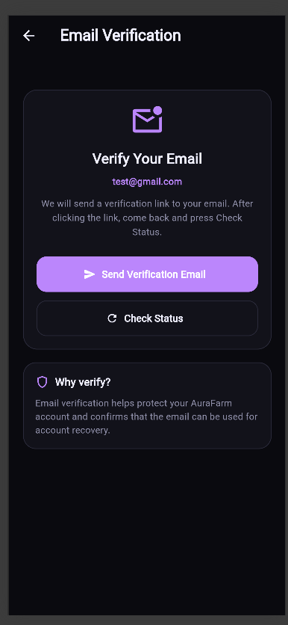
Reason for deviation (if any):
A separate EmailVerificationScreen wireframe was not created in Part 1. The Part 1 design only included the main authentication/login wireframe as the reference for the authentication-related screens.
The EmailVerificationScreen was added in Part 2 because email verification is a useful account management feature for Firebase Authentication. Since AuraFarm allows users to create posts, save Vibe Cards, interact with other users’ content, and manage their own profile, email verification helps improve account trust and reduces the chance of users creating accounts with invalid email addresses.
The explanation was added to reduce the negative space on the Email Verification screen while giving users a clear reason for verifying their email. It helps the page feel more complete without adding unnecessary features.
The implemented screen keeps the same dark neon theme, rounded card layout, and purple accent colour used in the other authentication screens. The layout was kept simple because the main purpose is only to inform users that a verification email has been sent and allow them to continue after verifying their account. This screen was not part of the original wireframe, but it was added because it helps fulfil the Part 2 requirement to explore authentication features beyond the basic Firebase authentication functions.

Screen 2
Screen Name: HomeScreen

Wireframe Screenshot | Flutter Screenshot (Chrome/Virtual Device)
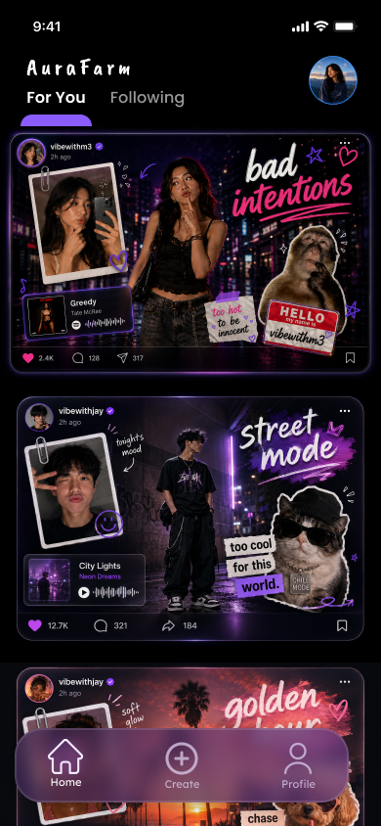 | 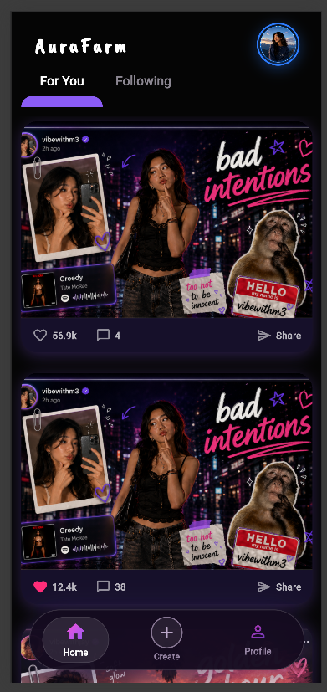

Reasons for Deviation:
The implemented HomeScreen follows the main layout and visual direction of the Part 1 Home/Feed wireframe. It keeps the dark neon aesthetic, large Vibe Card feed, profile shortcut, and For You / Following tabs.
The fake iPhone status bar from the original wireframe was removed because the Android Studio emulator already shows the real device status bar with the time, Wi-Fi, and battery icons. Keeping the fake status bar would duplicate the device UI and reduce the usable screen space for the feed.
The bottom navigation bar was also refined to be more aesthetically pleasing and easier to navigate. It still keeps the same purpose as the original wireframe by allowing users to move between Home, Create, and Profile, but the updated design uses clearer icons, better spacing, and a more polished rounded style that matches AuraFarm’s final dark neon theme.
The Vibe Card posts are displayed as completed flat image assets because this matches the intended design of AuraFarm. After a user finishes editing a Vibe Card, the final card is saved as one completed image and displayed in the feed using its final image path. This also follows the proposed Aura Posts data structure, where each post stores a final_image_url for the completed Vibe Card.
For Part 2, the feed uses sample static image assets to represent saved Aura Posts. In Part 3, these static assets can be replaced with Firestore records, where each Aura Post will load its saved final Vibe Card image from the database.
Users can tap a post to navigate to the Vibe Card detail screen, tap the Create button to go to the creation flow, and tap the profile image or Profile button to go to the profile screen. The Following tab is included to match the proposed tabbed layout, but it currently shows an empty state because follow data is not implemented yet.

Screen 3
Screen Name: CardDetailScreen
Wireframe Screenshot | Flutter Screenshot (Chrome/Virtual Device)
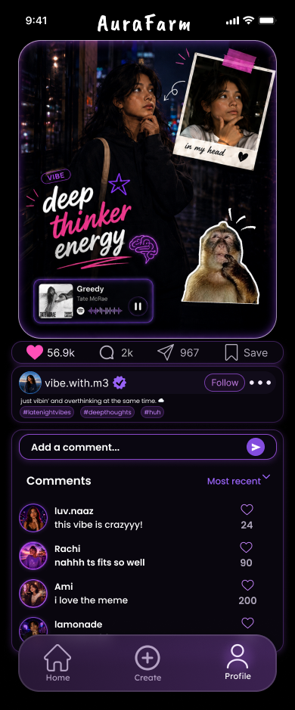 | 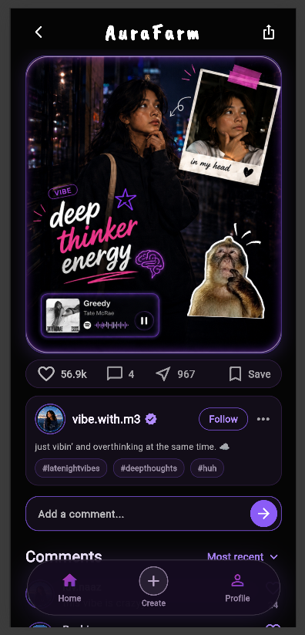

Screen Name: ExportPopup
Wireframe Screenshot | Flutter Screenshot (Chrome/Virtual Device)
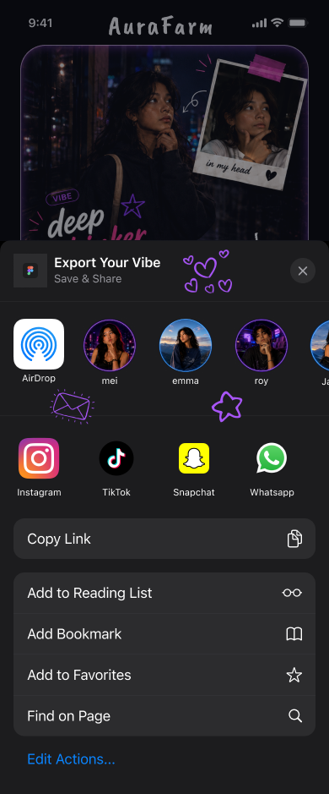 | 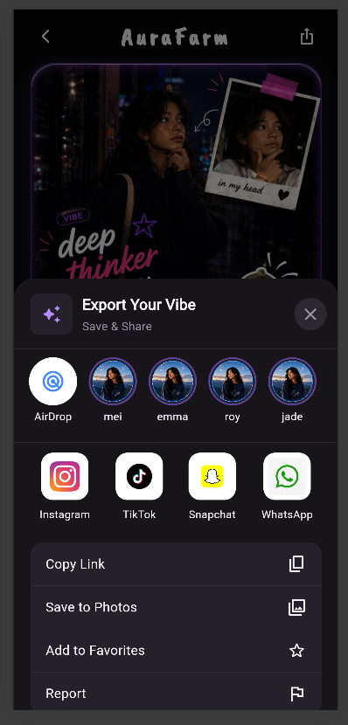
Reason for deviation (if any): The implemented CardDetailScreen follows the main structure and visual direction of the Part 1 Vibe Card Detail Page wireframe. It keeps the dark neon theme, large completed Vibe Card image, engagement bar, post information section, comment input field, comments section, and export/share icon.
The fake iPhone status bar from the wireframe was removed because the emulator or real device already displays the actual system status bar. This prevents the time, Wi-Fi, and battery icons from appearing twice and gives more usable vertical space to the Vibe Card, comments, and engagement features.
The bottom navigation bar was also refined to look cleaner and make the main pages easier to access. It still supports the same navigation purpose as the original wireframe, but the updated style is more consistent with the final AuraFarm interface and makes the app feel more polished.
The screen also includes an export bottom sheet that appears when the user taps the export icon. This matches the proposed Vibe Card Export feature from Part 1, where users can save or share their completed Vibe Card through options such as AirDrop, social media apps, copy link, and save to photos.
Some spacing and sizing were adjusted in Flutter so the page fits better on a mobile screen and remains scrollable. The completed Vibe Card is displayed as one flat image because AuraFarm’s intended flow is to save the final edited card as one completed image and display it in the feed/detail page.
For Part 2, the export/share options and comments use sample UI and placeholder data. In Part 3, these can be connected to real saving, sharing, and Firestore data.

Screen 4
Screen Name: ProfileScreen

Wireframe Screenshot | Flutter Screenshot (Chrome/Virtual Device)
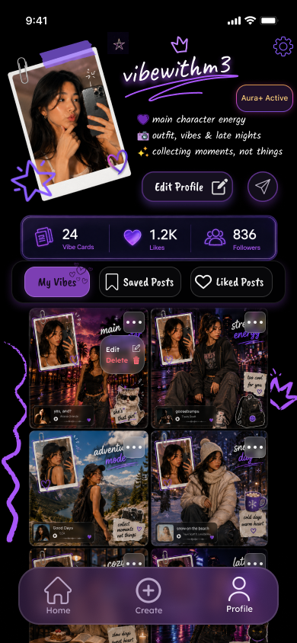 | 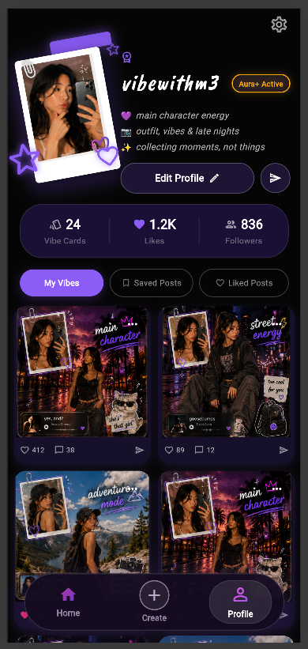
Reason for deviation (if any):
The implemented ProfileScreen follows the main visual direction of the Part 1 Profile Page wireframe. It keeps the dark neon purple theme, expressive profile header, polaroid-style profile image, Aura+ badge, profile statistics, tab buttons, and Vibe Card grid.
The fake iPhone status bar from the wireframe was removed because the Android Studio emulator already shows the real system status bar. Removing it avoids duplicated time, Wi-Fi, and battery icons, while also giving the profile header and content more space on the screen.
Some spacing and sizing were adjusted in Flutter so the screen fits better on a mobile device. The profile image, stats section, tabs, and grid were arranged to keep the page readable while still matching AuraFarm’s scrapbook and neon aesthetic.
The bottom navigation bar was refined to be more aesthetically pleasing and easier to navigate. It remains fixed at the bottom so users can quickly move between Home, Create, and Profile, but the updated design uses clearer active states, better spacing, and a rounded glass-like style that fits the final AuraFarm theme.
Additionally, I added like and comment actions under each card so users can interact with the Vibe Cards directly from the profile page. The like, comment, and share numbers are shown as supporting stats so users can also see each card’s engagement easily
For Part 2, the profile details and Vibe Card posts use sample static data and local image assets. This allows the UI and navigation flow to be demonstrated first. In Part 3, these values can be connected to Firestore so the user’s profile details, saved posts, liked posts, and created Aura Posts can be loaded from the database.

Screen 5
Screen Name: CreateUploadScreen

Wireframe Screenshot | Flutter Screenshot (Chrome/Virtual Device)
No separate wireframe was created for this screen in Part 1. | 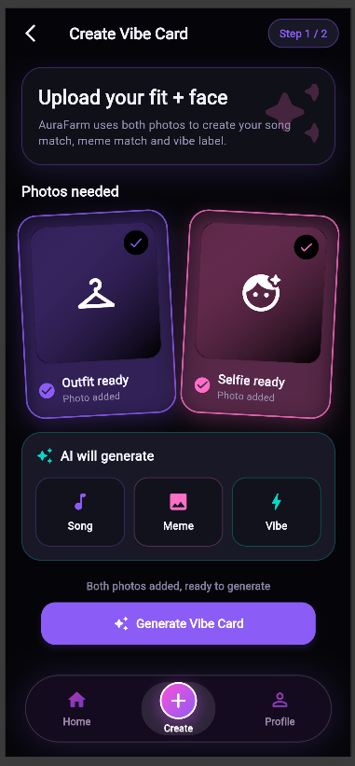

Reason for deviation (if any):
A separate CreateUploadScreen wireframe was not created in Part 1. The original Part 1 create page focused more on the Vibe Card editing screen, where users can view the generated card, AI meme match, AI music suggestions, and vibe label.
During implementation, the create flow was separated into two screens to make the user journey clearer. The CreateUploadScreen is used as the first step, where users select or upload the required images before editing the final Vibe Card. This makes the flow easier to understand because users first provide the outfit image and expression/selfie image, then move on to the editor page where the generated result can be previewed and customised.
This still matches AuraFarm’s proposed function because the Part 1 proposal explains that users create Aura Posts by uploading or capturing two images, then using AI to generate a Vibe Label, meme match, and song suggestions. For Part 2, the image upload and camera functions are represented using placeholder UI and sample assets. In Part 3, this screen can be connected to actual image gallery/camera access and Firestore storage.

Screen Name: CreateEditorScreen

Wireframe Screenshot | Flutter Screenshot (Chrome/Virtual Device)
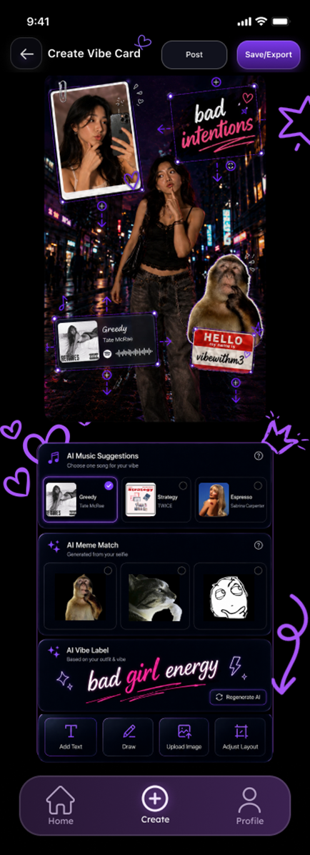 | 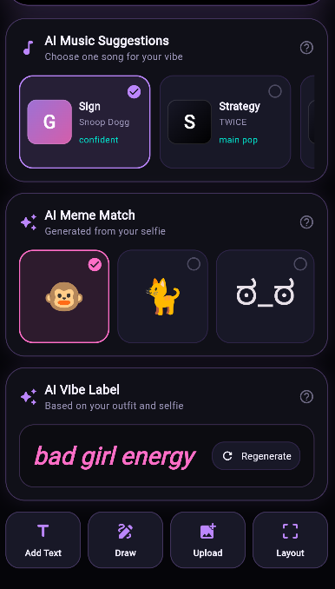  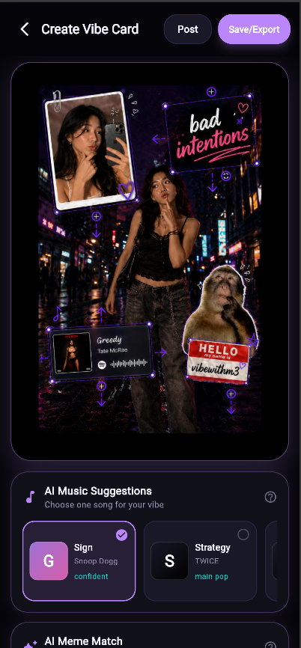
Reason for deviation (if any): The implemented CreateEditorScreen follows the main purpose of the Part 1 create page wireframe. It focuses on allowing users to preview and customise their generated Vibe Card after providing their outfit and selfie images.
Some parts of the layout were adjusted in Flutter so the editor fits better on a mobile screen. The Vibe Card preview was made the main focus, while AI-generated outputs such as the vibe label, meme match, and music suggestion are placed around it in separate sections. This improves readability and keeps the page organised.
The create feature was implemented as a two-screen flow, with CreateUploadScreen first and CreateEditorScreen second. This is slightly different from the original wireframe, but it makes the user flow clearer because image selection and card editing are separated. This still matches the Part 1 proposal because AuraFarm’s create flow is based on users uploading an outfit image and expression selfie before generating and saving a final Aura Post.
For Part 2, the upload, AI generation, posting, and export functions use sample UI and placeholder data. In Part 3, these can be connected to image handling, Firestore records, and the actual AI-generated Vibe Card output.

References
OpenAI. (2026). ChatGPT [Large language model]. https://chatgpt.com/

