Temasek Polytechnic
School of Informatics & IT
Diploma in Applied Artificial Intelligence
Robotic Process Automation (CAI2C01)
AY2026/2027 April Semester

Proposal

Student Name : Leon Jr Chua

Student Admin No. : 2500593E

Tutorial Group : P02
Jenny LING (TP)
Tutor : Ms Shuyun

Submission Date : 28/5/2026

Declaration of Originality
I am the originator of this work and I have appropriately acknowledged all other original sources used as my references for this work.
I understand that Plagiarism is the act of taking and using the whole or any part of another person’s work, including work generated by AI, and presenting it as my own.
I understand that Plagiarism is an academic offence
and if I am found to have committed or abetted the offence of plagiarism in relation to this submitted work, disciplinary action will be enforced.

I used AI to generate Visual Aid images

Robot Name
AnalyseTS

Business Domain
Finance, Investment Analytics, Data Reporting
This project falls under the finance domain, specifically stock market monitoring and investment analytics. In finance-related work, users often need to track selected stocks, collect price data, compare performance, identify risk indicators, and present the findings in a clear report or dashboard.
Although this project is related to stock monitoring , AnalyseTS does not perform stock trading decisions, or financial advising. Its role is solely to automate data collection, organise stock movement information, generate visual reports, and send update summaries for review purposes only.

Target Department/Users
The target users of AnalyseTS are individuals, who regularly monitor selected stocks and want a faster way to receive clear stock update summaries. This include stock watchers, beginner investors, business/data analytics students, and finance-related teams who track a custom list of stocks
These users may not necessarily need advanced trading tools, they may want to understand what is happening with stocks they’re interested in. For examples, they may want to know which stocks fluctuated the most or which ones are the most stable.
AnalyseTS helps these users by automating the repeated process of collected stock data, organising it, analysing, generating dashboard visuals and producing short stock update summaries. The final output is sent to the user through Discord, so they can quickly review the stock update without manually searching websites, taking down data and creating charts themselves.

Project Scope
Overall Purpose
AnalyseTS is an RPA bot designed to automate stock update monitoring and reporting for selected stocks. The purpose of the robot is to help users understand what is happening with the stocks they are monitoring without needing to manually check multiple stock websites, copy data into spreadsheets, calculate movement, create visuals, and write summaries themselves.
The bot automates an end-to-end stock update workflow. It starts from a user-maintained Excel watchlist, collects stock data from a public stock website, extracts visible stock information using OCR, processes and validates the extracted data using Python, displays the results in a Streamlit dashboard, generates a short stock update digest using ChatGPT/LLM, and sends the final update through Discord.
Data Input and watchlist configuration
The robot uses a Microsoft Excel file as the main input source. The Excel watchlist allows the user to control which stocks should be monitored. The watchlist will contain fields such as stock symbol (eg AAPL for apple.inc), company name, category, and an Include field.
Stock Data Collection Using Web browser and OCR
After filtering the selected stocks, the bot will open a public stock website through a web browser. For each selected stock, the bot will search or load the stock page and collect visible stock information.
AnalyseTS will use UiPath Get OCR Text to extract visible information from the stock webpage. This includes stock data such as the stock symbol, latest price, daily change, and percentage change.
If a stock page cannot be found, the bot will not stop the entire automation. Instead, it will mark that stock as “Needs Review” in the CSV/log file and continue processing the remaining selected stocks.
Data Storage, Cleaning and Validation
The OCR extracted stock data will be saved into another CSV file. Python will then read the CSV file and clean the extracted values before analysis. Python will check for missing values or wrong formats. If the data is valid, the stock will be marked as “Valid”. If the data is incomplete or unreliable, the stock will be marked as “Needs review”.
Stock Movement Analysis
After cleaning and validation, Python will calculate simple stock movement indicators using extracted data. Examples such as:
- Biggest gainer
- Biggest drop
- Biggest mover today
- Overall watchlist mood (bullish/bearish)
- Number of stocks processed successfully
The overall watchlist mood will be based on whether most selected stocks moved up, moved down, or showed mixed movement. This allows the user to understand the general performance of their selected stocks quickly instead of manually comparing every stock one by one.
The processed results will then be saved into an output CSV file for the dashboard and final reporting stage
Dashboard Visuals using streamlit
AnalyseTS will use StreamLit to display the processed stock results as a single page dashboard. UIPath will start the streamlit dashboard activity after python saves the processed results
Visuals displayed include:
- Summary cards showing key results
- Percentage movement bar chart
- Biggest mover section
- Watchlist performance table
- OCR status table
ChatGPT/LLM Stock Update Digest
AnalyseTS will also generate a short stock update digest using ChatGPT/LLM. The bot will read the processed stock results from the CSV file and combine them with a fixed prompt prepared inside the UiPath workflow. The final prompt will ask ChatGPT/LLM to summarise the stock movement in simple language.
Notification Through Discord Upon completion
After the dashboard screenshot and ChatGPT/LLM digest are ready, the bot will send the final stock update through Discord to the selected user. The message will include the ChatGPT/LLM generated stock digest and the saved dashboard screenshot as an image attachment
Applications Used:
- Microsoft Excel – Stores the Users custom stock Watchlist
- Web browser – Opens the stock Website and Streamlit Dashboard
- CSV/Log files – stores OCR results, processed results, validation status and execution logs
- Python – Cleans data, validates extracted values, and calculates stock movement indicators
- Streamlit – Displays processed results as a dashboard
- ChatGPT/LLM – Generates a short stock update digest
- Discord – Sends the final digest and dashboard screenshot to the user
Scope + Limits
AnalyseTS Bot is not designed to provide buy or sell recommendations. It only provides organised stock monitoring insights, recent movement summaries, and dashboard visuals for reporting and personal review purposes. Max number of stocks to be analysed will be capped at 10
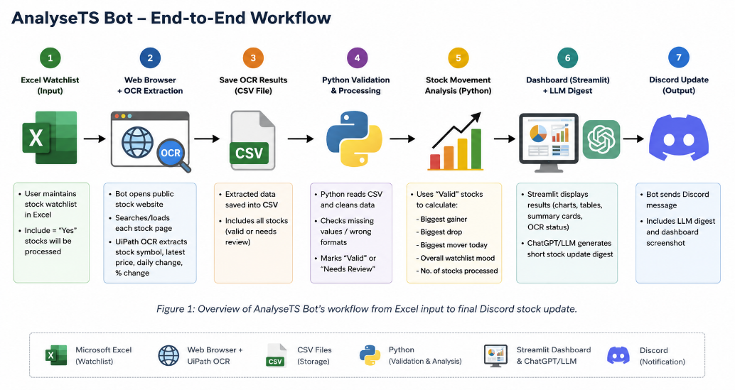

Justification
Need for automation
Stock monitoring is a repetitive process because users often need to check the same selected stocks regularly. Without automation, the user must open stock websites, search for each stock, copy the latest price and percentage movement, organise the data in a spreadsheet, calculate movement indicators, create charts, and write a short summary manually. This becomes time-consuming when the user is tracking several stocks at once.
The manual process is also prone to errors. For example, a user may copy the wrong price, miss out a stock, use inconsistent number formats, or calculate the percentage movement incorrectly. Since stock data changes frequently, delays in collecting and organising the data may also make the final update less useful. IBM supports this by stating that manual data entry is still a common source of data quality issues, with research studies reporting manual data entry error rates ranging from 0.55% to 26.9%.
Therefore, this process is suitable for RPA because it involves repeated steps such as data collection, OCR extraction, data recording, validation, calculation, dashboard generation, summary writing, notification sending, and logging. Automating these steps helps reduce manual typing, copying, and switching between applications.
Value of automation
AnalyseTS Bot adds value by automating the full stock update workflow from the user’s watchlist to the final report. The user only needs to maintain a custom stock watchlist in Microsoft Excel, while the bot handles the repeated work of collecting stock information, extracting data using OCR, validating the extracted values, calculating movement indicators, generating dashboard visuals, producing a short stock digest, and sending the final update through Discord.
The bot also improves consistency because the same process happens every time the bot runs. In the manual process, the user has to repeatedly click between applications, type stock symbols, copy values, create charts, and send the final update. By automating these repeated UI interactions, AnalyseTS reduces the chance of missing a stock, copying the wrong value, or pasting information into the wrong place.
AnalyseTS also improves reliability through validation and error handling. Instead of assuming all OCR results are correct, the Python script checks whether extracted values such as latest price, daily change, and percentage change are complete and usable. If a stock page cannot be found or the OCR result is unclear, that stock is marked as “Needs Review” instead of stopping the whole process. This allows the bot to continue processing the remaining selected stocks while still informing the user which items require manual checking.
Another value of the bot is that it makes the final output easier to understand. Instead of leaving the user with raw stock values in a spreadsheet, AnalyseTS presents the results in a Streamlit dashboard with summary cards, charts, performance tables, and OCR/validation status. The ChatGPT/LLM digest also converts the processed stock results into a short written explanation, allowing the user to quickly understand the biggest gainer, biggest drop, biggest mover, and overall watchlist mood.
Data quality issues
AnalyseTS Bot improves productivity by reducing the number of manual steps needed to prepare a stock update. Instead of spending time repeatedly checking websites, copying values, formatting spreadsheets, creating graphs, and writing summaries, the user can trigger the bot and receive a structured update automatically.
Task | Manual Process | With AnalyseTS Bot
Open Stock Websites and search selected stocks | >5mins | <1min
Copy Latest price and percentage Movement | > 10mins | < 3mins
Clean and check stock data | >5mins | <1min
Calculate gainer, drop, trend, and volatility | >8mins | <1min
Create dashboard charts | >10min | < 3min
Analyse, write and send stock summary | >5mins | <2mins
Total Time Estimate | >43mins | <11mins

Based on this estimate, AnalyseTS can reduce one stock monitoring update from around 43 minutes to 11 minutes, saving approximately 32 minutes per run. This allows users to focus more on understanding the stock movement instead of spending most of their time collecting, copying, calculating, and formatting data.
Users simply need to update the excel form for what stocks they want updates on(limit of 10 stocks) and can continue on with their other daily tasks.

Robot Category
AnalyseTS will be an Unattended Bot
This is because once the user or schedule triggers it, the robot can complete the stock monitoring, data processing, dashboard generation, digest creation, and Discord notification without further human input.

Current Scenario
- Users Update their stock watchlist in Microsoft Excel.
- User opens a Web Browser to check stock websites
- User searches for each selected stock one by one
- User reads the latest stock information from the website.
- User manually copies or types the stock data into Excel
- User repeats same process for all selected stocks
- User checks and cleans the collected data manually
- User calculates stock movement indicators manually
- User creates charts manually
- User writes a short stock update
- User sends the update manually

Automation Scenario
- Robot is triggered by the user
- Bot opens the stock watchlist in Microsoft Excel.
The bot opens the Excel file that contains the stock symbols, company names, categories, and Include field.
- Bot reads the Excel data into a DataTable variable.
The stock records are stored in a DataTable so that the robot can process the rows systematically.
- Bot filters the selected stocks using DataTable filtering
After reading the Excel watchlist into a DataTable variable, the bot uses DataTable filtering to keep only the stocks marked as “Yes” under the include field. Stocks marked as “No” will be excluded.
- Bot opens the web browser and loads the stock website
The bot opens a public stock website using Google Chrome as the web browser and prepares to collect the latest stock info
- Bot searches or loads each selected stock
(either enters AAPL into the website search bar or loads the page directly from URL)
For each selected stock, the bot searches the stock symbol/ticker
- Bot uses Get OCR Text from UIPath to capture stock information
The bot applies OCR to extract visible text from the screenshot. This allows the robot to collect stock information from image-based or visually displayed web content.
- Bot saves the extracted stock data into a CSV file.
The extracted stock symbol, latest price, daily change, and percentage change are saved into a CSV file for further processing.
- Python reads the OCR-extracted stock data from the CSV file.
After the bot finishes stock data using OCR, the extracted values are saved into a CSV file. Python will read this CSV file and prepare the data for cleaning, calculation, and visualisation.
- Python cleans and validates the extract
Python reads the OCR extracted CSV data and checks whether the latest price, daily change, and percentage change are missing or in the wrong format. Valid stocks are marked as “Valid”, while incomplete or unclear records are marked as “Needs Review”.
- Python calculates stock movement indicators
Python uses only “Valid” stocks to calculate the biggest gainer, biggest drop, biggest mover today, and overall watchlist mood. “Needs Review” stocks are skipped from calculations but still shown in the OCR status table.
- Python prepares the processed results for the dashboard.
The cleaned and calculated results are saved into an output CSV file. This file will be used by Streamlit to generate the dashboard visuals
- UIPath starts the StreamLit dashboard
After Python saves the cleaned and processed stock results into a CSV file, UiPath starts the Streamlit dashboard using a Start Process activity. Streamlit reads the processed CSV file and displays the results in a web browser as dashboard visuals, including summary cards, percentage movement charts, a watchlist performance table, and an OCR status table
- Streamlit displays dashboard visuals.
The dashboard shows summary cards, a percentage movement chart, a biggest mover chart, a watchlist performance table, and an OCR status table. This allows the user to view the stock update visually instead of reading raw CSV data.
- UIPath captures the dashboard visuals as screenshot images
After the streamlit dashboard is displayed in the web browser, UIpath captures screenshots of the dashboard.
- Bot prepares the LLM prompt using UIPath
The bot reads the processed CSV results and combines them with a UiPath variable that contains a prompt to create one final ChatGPT/LLM prompt. The prompt asks ChatGPT/LLM to summarise the biggest gainer, biggest drop, biggest mover, and overall watchlist mood, while avoiding financial advice, predictions, or buy/sell recommendations.
- Bot sends the final prompt to ChatGPT/LLM
The bot opens ChatGPT/LLM through the web browser and pastes the final prompt into the chat box using UiPath activities such as Type Into, Set Clipboard, or keyboard shortcut paste. This allows the analysed stock data to be sent together with the prepared prompt in one step.
- ChatGPT/LLM generates a short stock update digest
ChatGPT/LLM generates a short summary explaining the main stock movements. The digest will be used as the text summary in the final Discord update.
- Bot sends the final stock update via Discord
The bot sends the final update to Discord using a webhook. The Discord message will include the LLM-generated stock digest as text and the saved dashboard screenshot as an image attachment. This allows the user to quickly review both the summary and the visuals in one place.
- Log success into CSV/Log File
21. Automation Ends
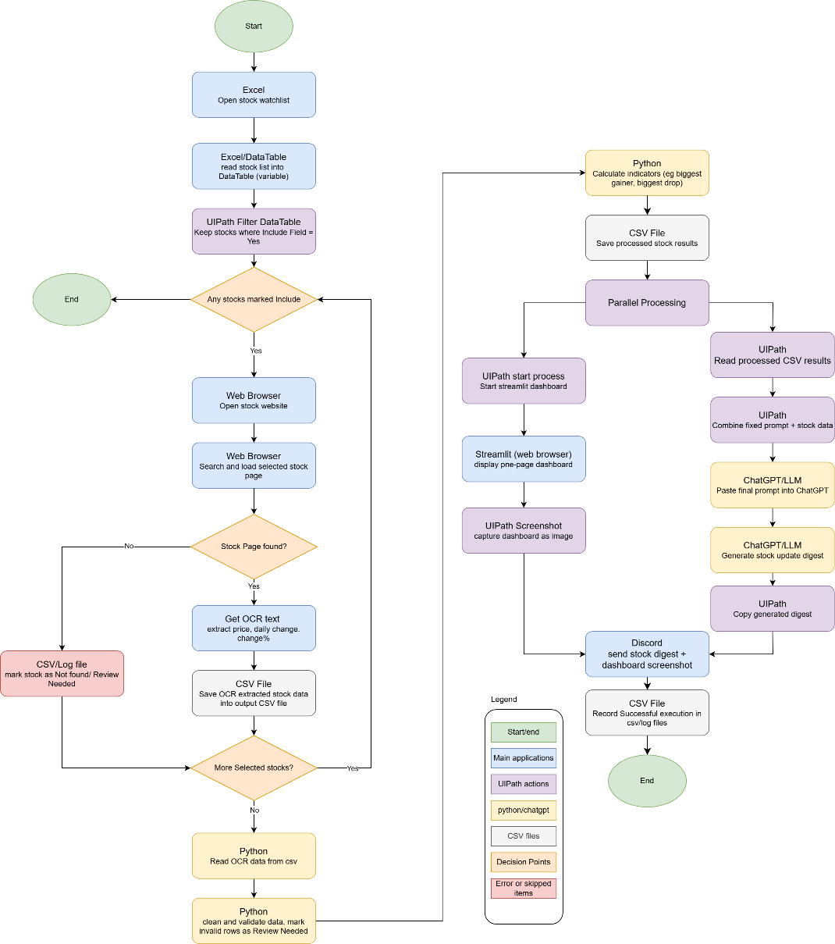
Process Flow Chart
The process flow chart shows the AnalyseTS workflow from Excel watchlist input to final Discord output. It includes the main applications used at each stage, such as Microsoft Excel, web browser, UiPath OCR, CSV/log files, Python, Streamlit, ChatGPT/LLM, and Discord. The flowchart also shows key decision points, such as whether selected stocks exist, whether a stock page is found, and whether extracted data is marked as Valid or Needs Review.

References
Web URL/Books/Research papers/Citations of literature

IBM article (Data quality issues, defined) - https://www.ibm.com/think/insights/data-quality-issues (used in Justification- Need for Automation)

OpenAI ChatGPT : https://chatgpt.com/ ( used to generate visual aid)

