AnalyseTS Stock Watchlist Report

Run: 2026-08-03 15:22:27
Digest source: ChatGpt (web)

Market Digest

* **Today:** The overall mood was bullish with 6 stocks rising and 4 falling. The biggest gain was **GOOGL +6.73%** at $356.13, while the biggest drop was **AAPL -7.35%** at $308.91.

* **Sectors:** Technology was mixed but resilient overall, helped by strong gains from **GOOGL +6.73%** and **MSFT +3.02%**, while Semiconductors lagged with both names in that group ending lower. Gaming also finished lower, while Data Analytics, Entertainment/Electronics, and the ETF category held modest gains.

* **Standouts:** **AAPL -7.35%** was the largest percentage move of the day. It exceeded the next-largest move, **GOOGL +6.73%**, by 0.62 percentage points.

* **Dollar moves:** The largest dollar gain was **GOOGL +6.73%** (+$22.47) and the largest dollar loss was **MU -5.90%** (-$51.63); the biggest dollar decline was different from the biggest percentage decline, which was **AAPL -7.35%**.

* **Quiet names:** **PLTR +0.65%** and **VOO +0.71%** were the steadiest names, showing only small percentage changes.

* **Data quality:** Valid data was returned for 10 out of 10 stocks. No stocks were excluded.

This is monitoring information only and is not financial advice.

Price Summary

SYMBOL PRICE CHANGE
AAPL 308.91 -7.35%
MSFT 464.72 3.02%
NVDA 200.75 2.93%
GOOGL 356.13 6.73%
AMD 476.15 -1.9%
TTWO 242.92 -1.82%
PLTR 123.06 0.65%
SONY 23.26 2.15%
MU 823.03 -5.9%
VOO 686.65 0.71%

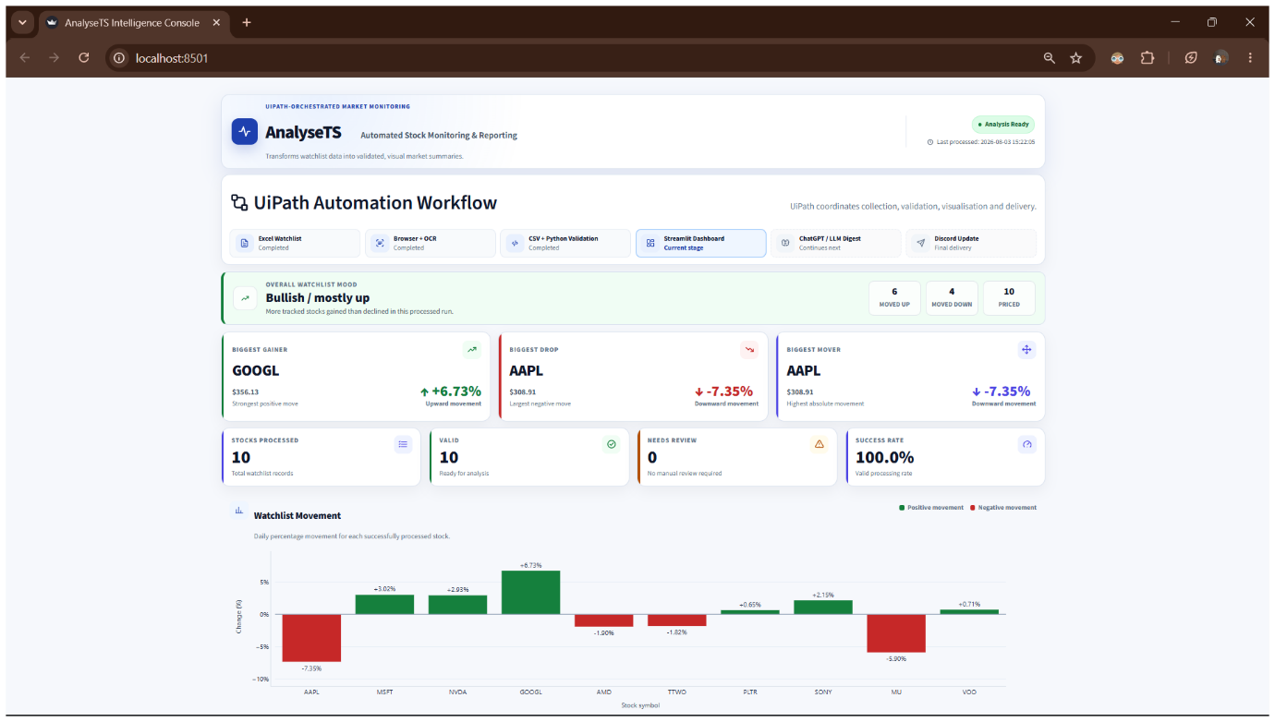
Run Statistics
Stocks processed: 10
OCR failures: 0

Data processed at: 2026-08-03 15:22:05.
Total stocks processed: 10.
Stocks with valid data: 10.
Stocks needing review: 0.
Biggest gainer: GOOGL at 6.73 percent.
Biggest drop: AAPL at -7.35 percent.
Biggest mover by absolute movement: AAPL at 7.35 percent.
Overall watchlist mood: Bullish / mostly up.

This report is monitoring information only and is not financial advice.

