AnalyseTS Stock Watchlist Report

Run: 2026-08-03 15:56:57
Digest source: ChatGPT (web)

Market Digest

* **Today:** Overall mood was bullish with **6** stocks rising and **4** falling, showing gains outnumbered declines despite a few sharp losses. Biggest gain was **GOOGL +6.73%** at **356.13**, while the biggest drop was **AAPL -7.35%** at **308.91**.
* **Sectors:** Technology was mixed, with **GOOGL +6.73%** and **MSFT +3.02%** offset by **AAPL -7.35%**, while Data Analytics, Entertainment/Electronics, and the ETF category all finished higher. Semiconductors lagged overall as both tracked names ended lower.
* **Standouts:** **GOOGL +6.73%** was the strongest percentage gainer, finishing **3.71 percentage points** ahead of the next-largest gain, **MSFT +3.02%**. That made it the clearest upside outlier in today's watchlist.
* **Dollar moves:** The largest dollar gain was GOOGL (+22.47), while the largest dollar fall was MU (-51.63); the biggest dollar loss was different from the biggest percentage loss because **AAPL -7.35%** had the largest percentage decline.
* **Quiet names:** **PLTR +0.65%** and **VOO +0.71%** moved the least, making them the most stable names in the watchlist today.
* **Data quality:** Valid data was returned for **10 of 10** stocks processed. No stocks were excluded.

This is monitoring information only and is not financial advice.

Price Summary

SYMBOL PRICE CHANGE $ CHG
AAPL 308.91 -7.35% -24.52
MSFT 464.72 3.02% 13.62
NVDA 200.75 2.93% 5.71
GOOGL 356.13 6.73% 22.47
AMD 476.15 -1.9% -9.24
TTWO 242.92 -1.82% -4.51
PLTR 123.06 0.65% 0.8
SONY 23.26 2.15% 0.49
MU 823.03 -5.9% -51.63
VOO 686.65 0.71% 4.86

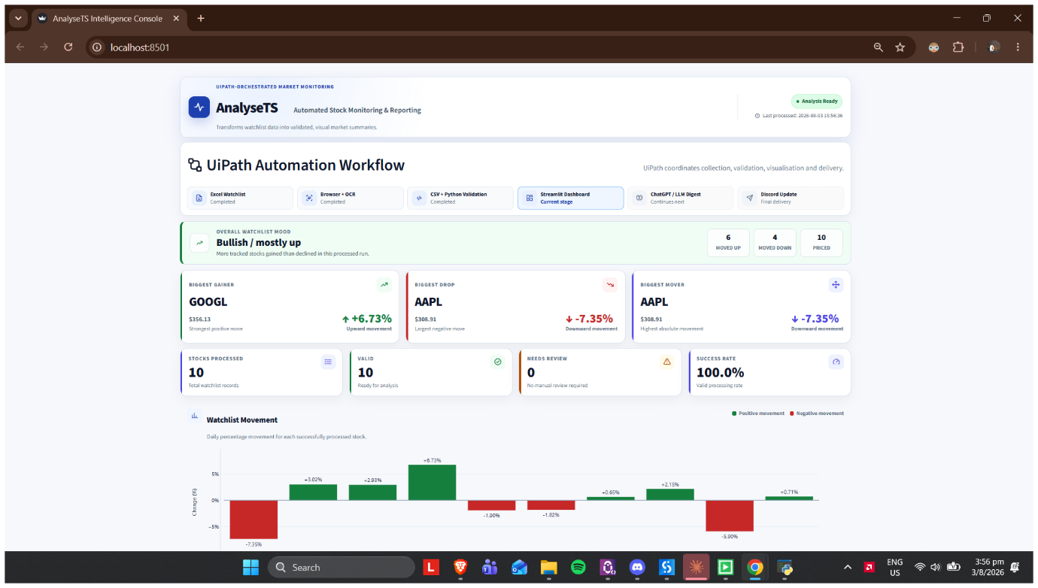
Run Statistics
Stocks processed: 10
OCR failures: 0

Data processed at: 2026-08-03 15:56:36.
Total stocks processed: 10.
Stocks with valid data: 10.
Stocks needing review: 0.
Biggest gainer: GOOGL at 6.73 percent.
Biggest drop: AAPL at -7.35 percent.
Biggest mover by absolute movement: AAPL at 7.35 percent.
Overall watchlist mood: Bullish / mostly up.

This report is monitoring information only and is not financial advice.

